Product Analytics Case Study
E-Commerce App: User Funnel, Retention & Revenue Analysis
Prepared as a portfolio project demonstrating SQL, funnel analysis, cohort retention analysis, and data storytelling for a Product Analyst role.

1. Business Context & Objective
A growing e-commerce app has been acquiring users through five channels — Paid Social, Paid Search, Organic, Referral, and Email — but leadership has no clear view of which channels bring users who actually convert and stick around.
As the Product Analyst on this project, the objective was to answer three questions:
- Where in the signup → purchase funnel are users dropping off, and where should the product team focus first?
- Which acquisition channels bring high-quality users (not just high volume)?
- How well does the app retain users week over week, and does that vary by channel or device?

2. Data & Methodology
A synthetic but realistic event-level dataset was generated for 6,000 users over a 90-day window, covering signup, product_view, add_to_cart, purchase, and open_app (return visit) events, along with user attributes (channel, device, country) and order revenue.
Analysis was performed with SQL (SQLite) for aggregation and cohort logic, and Python (pandas/matplotlib) for visualization. Full SQL queries and raw result tables are included in the appendix and accompanying files.

Tech stack demonstrated
- SQL: multi-table joins, CTEs, conditional aggregation (CASE WHEN), window-style date math for cohorting
- Python: pandas for data wrangling, matplotlib for visualization
- Analytical frameworks: funnel analysis, cohort retention analysis, channel/segment comparison

3. Key Findings

3.1 Overall Funnel
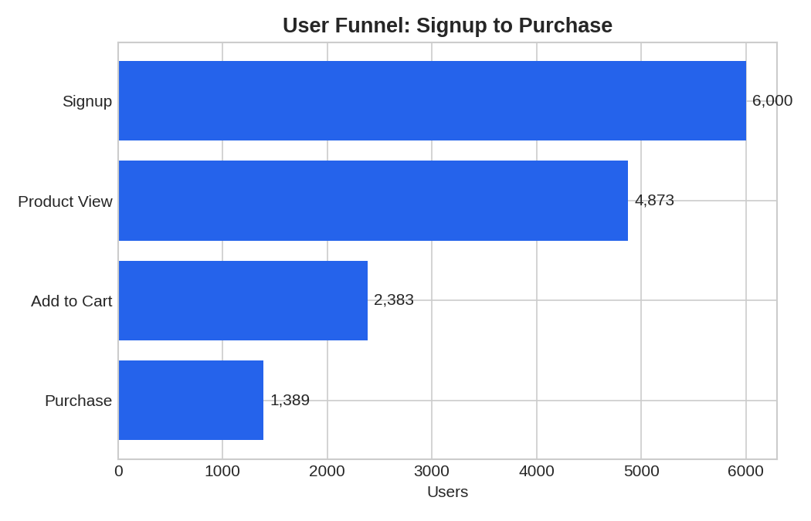
Figure 1 — User funnel from signup to purchase, all channels combined
Of 6,000 signups, 81.2% viewed a product, but only 40.0% added an item to cart — and 23.1% completed a purchase overall. The single biggest drop-off is between product view and add-to-cart, which loses roughly half of engaged users. This is the highest-leverage stage for product improvements (e.g. simplifying the cart flow, surfacing better product recommendations, or addressing pricing/shipping friction shown at that step).

3.2 Funnel Conversion by Channel
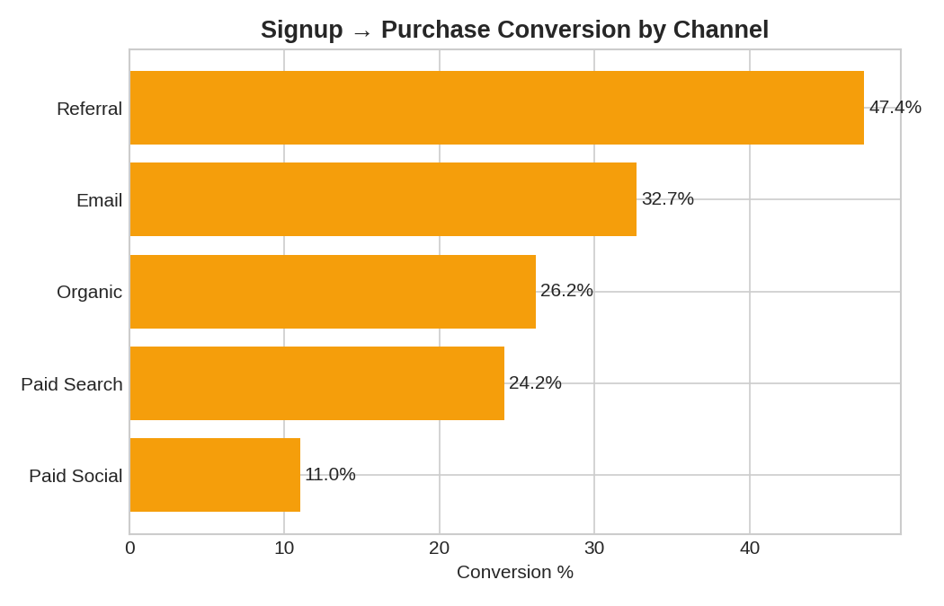
Figure 2 — Signup-to-purchase conversion rate by acquisition channel
This is the most actionable finding in the analysis. Paid Social brings the highest volume of signups (1,944) but by far the weakest conversion (11.0%). Referral, despite bringing only 479 signups, converts at 47.4% — more than 4x better. Email and Organic also comfortably outperform Paid Social.
Recommendation: Paid Social is likely acquiring low-intent users (e.g. driven by broad awareness ads rather than purchase-intent targeting). The team should either tighten Paid Social targeting, test different ad creative/audiences, or reallocate a portion of that budget toward Referral incentives and Email, which show much stronger downstream value.

3.3 Device Comparison
iOS users convert notably better than Android users (27.9% vs 17.0%). This is a signal worth investigating further — it could reflect differences in the Android app's UX/performance, or differences in the underlying user base by platform. Worth a targeted UX audit of the Android checkout flow.

3.4 Retention
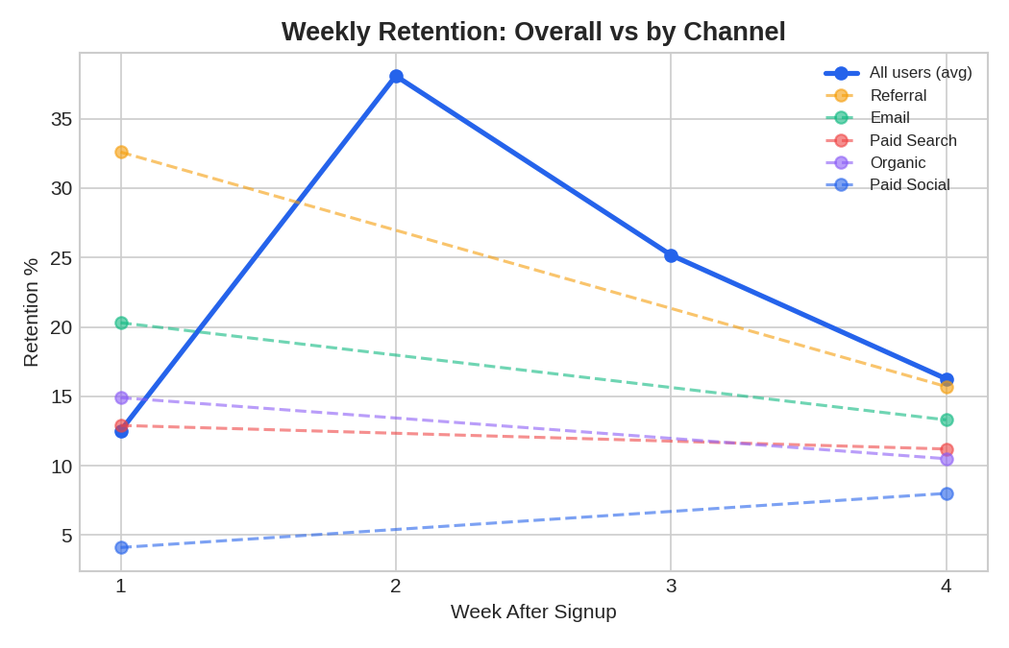
Figure 3 — Weekly retention curve (all users) vs by channel
Retention decays sharply after week 1 for most channels, which is typical, but Referral stands out on both ends: it starts with the highest week-1 retention (32.6%) and — notably — still holds the highest week-4 retention (15.7%), while Paid Social starts weakest (4.1%) and never catches up.
This reinforces the channel-quality story from the funnel analysis: Referral users are not just more likely to purchase once, they're also more likely to stay engaged over time. That makes Referral a strong candidate for increased investment (e.g. a referral-rewards program) even though its raw volume is the smallest of the five channels.

3.5 Revenue
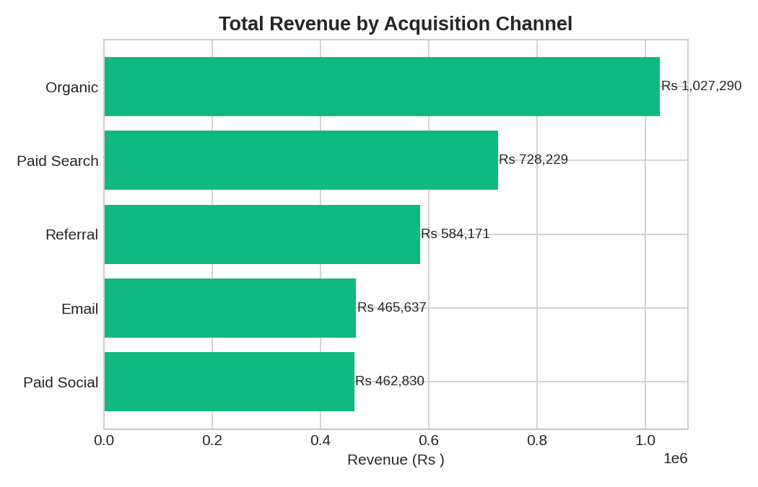
Figure 4 — Total revenue by acquisition channel
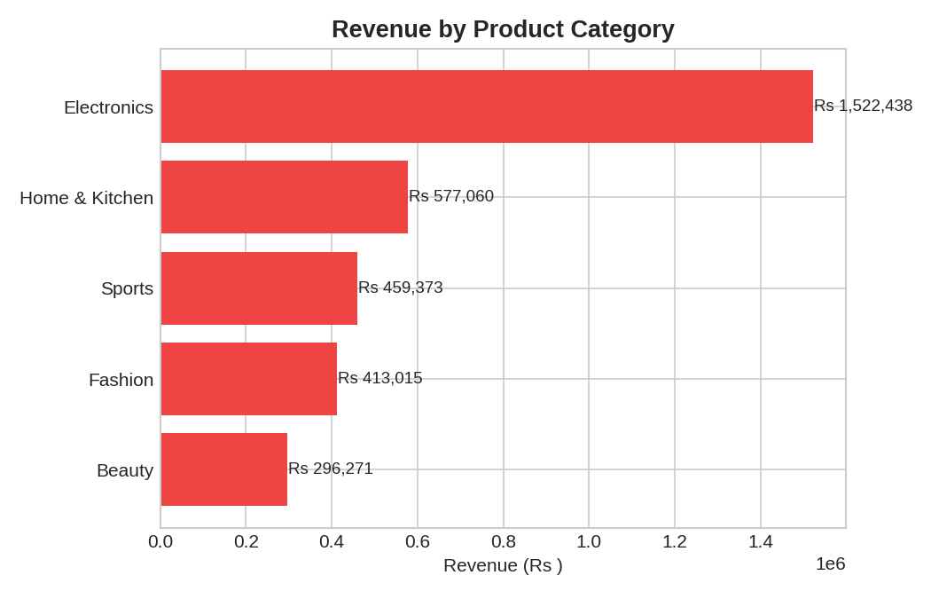
Figure 5 — Revenue by product category
Organic and Paid Search generate the most total revenue, largely due to higher volume — average order value is actually fairly consistent across channels (₹2,050–₹2,140), so revenue differences here are mostly driven by conversion volume rather than basket size. Electronics is the clear top revenue category, more than double the next closest category.

4. Recommendations Summary
Area | Finding | Recommendation
Funnel | Biggest drop-off is view → cart (~50% loss) | Prioritize cart-flow UX improvements over top-of-funnel changes
Channel mix | Paid Social: high volume, lowest conversion & retention | Audit targeting/creative; consider shifting budget to Referral
Channel mix | Referral: low volume, best conversion & retention | Invest in a referral-rewards program to scale this channel
Platform | iOS converts ~11pp better than Android | UX audit of Android checkout flow
Retention | Sharp drop after week 1 across all channels | Test onboarding/re-engagement triggers (push, email) in first 7 days

5. Appendix: SQL Queries Used
Sample of the core SQL logic used for this analysis (full file: queries.sql):

Funnel conversion by channel
SELECT u.channel,
COUNT(DISTINCT u.user_id) AS signups,
COUNT(DISTINCT CASE WHEN e.event_name='purchase' THEN e.user_id END) AS purchased,
ROUND(100.0*COUNT(DISTINCT CASE WHEN e.event_name='purchase' THEN e.user_id END)
/COUNT(DISTINCT u.user_id),1) AS signup_to_purchase_pct
FROM users u LEFT JOIN events e ON u.user_id=e.user_id
GROUP BY u.channel ORDER BY signup_to_purchase_pct DESC;

Weekly cohort retention
WITH cohorts AS (
SELECT user_id, DATE(signup_date,'weekday 0','-6 days') AS cohort_week FROM users
),
returns AS (
SELECT c.cohort_week, c.user_id,
CAST((JULIANDAY(e.event_time)-JULIANDAY(u.signup_date))/7 AS INT)+1 AS week_number
FROM events e JOIN users u ON u.user_id=e.user_id JOIN cohorts c ON c.user_id=e.user_id
WHERE e.event_name IN ('open_app','purchase')
AND JULIANDAY(e.event_time) > JULIANDAY(u.signup_date)
)
SELECT c.cohort_week, COUNT(DISTINCT c.user_id) AS cohort_size,
ROUND(100.0*COUNT(DISTINCT CASE WHEN r.week_number=1 THEN r.user_id END)
/COUNT(DISTINCT c.user_id),1) AS week1_retention_pct
-- ...repeated for week2-week4
FROM cohorts c LEFT JOIN returns r ON r.user_id=c.user_id
GROUP BY c.cohort_week ORDER BY c.cohort_week;
The complete SQL file (8 queries covering funnel, device, cohort retention, channel retention, revenue, and category breakdowns), the raw dataset, the SQLite database, and the Python analysis script are all included alongside this report.

