**Software Performance Test**

**Check List**



**STQC IT SERVICES**

**STQC Directorate, Govt of India**

**Ministry of Electronics and Information Technology,**

**ETDC, 100 feet Road, Peenya Industrial Estate,**

###### BANGALORE 560 58

***TEL: 080- 23893519; Telefax: 080 23722314***

***E-mail: itbangalore@stqc.nic.in;***

***Website: www.stqc.gov.in***

**Software Product nomenclature: India Urban Data Exchange (IUDX)**

**Product version: Release 2.0**

**Date of Release:**

**Product description: IUDX is a set of interfaces for enabling data exchange between multiple parties in the context of Smart Cities.**

**Application Details:**

|  |  |
| --- | --- |
| Application URL: | Catalogue Server: <https://api.catalogue.iudx.io>Resource Server: <https://rs.iudx.io>  Auth Server: <https://authtest.iudx.io> |
| Protocols used | HTTPS |
| Technologies | Java, Java Script, Vert.x, Node JS |
| Encryption used | TLS / SSL |
| Proxy details (IP address) | Catalogue Server: <https://api.catalogue.iudx.io>Resource Server: <https://rs.iudx.io>  Auth Server: <https://authtest.iudx.io> |
| LAN Bandwidth | NA |

**Server Details:**

|  |  |  |  |  |
| --- | --- | --- | --- | --- |
| **Servers** | **Quantity** | **IP Address** | **Hardware Specification** | **Software Specification** |
| Catalogue Server | 1 | 65.0.58.22 | 2 vCPU / 8 GB / 40GB SSD | Ubuntu 20.04 LTS |
| Resource Server | 1 | 65.0.40.140 | 2 vCPU / 8 GB / 40GB SSD | Ubuntu 20.04 LTS |
| Auth Server | 1 | 65.0.115.16 | 2 vCPU / 8 GB / 40GB SSD | Ubuntu 20.04 LTS |

**Deployment architecture Diagram to be enclosed (Yes/No): Yes**

**Site Map to be enclosed (Yes/No): No**

**User Groups:**

|  |  |
| --- | --- |
| User groups | Consumer |
| On boarder |
| Provider |

1. Consumer– Business processes details

|  |  |  |  |  |  |  |  |  |
| --- | --- | --- | --- | --- | --- | --- | --- | --- |
| **Critical End user business Processes**  **(with navigation**  **steps)** | **Iterations** | **variables to be Parameterized** | **Measurements of Transactions** | **Think time for**  **Transactions** | **Service levels** | | | |
| **Average transaction response time (sec)** | **Average transaction response time for end to end (sec)** | **Average through put (bytes/sec)** | **Average hits per sec** |
| 1) Search Latest data in Resource Server | 1 | 1) id : IUDX ‘id’ of the resource in the catalogue |  | As recorded | Measured data to be reported | Measured data to be reported | Measured data to be reported | Measured data to be reported |
| 2) Search temporal data in Resource Server | 1 | 1) id: IUDX ‘id’ of the resource in the catalogue  2) startTime : of the query  3) endTime of the query  4) timerel : time relation of the query (should be either during, before or after) |  | As recorded | Measured data to be reported | Measured data to be reported | Measured data to be reported | Measured data to be reported |
| 3) Search based on complex query in Resource Server | 1 | 1) id: IUDX ‘id’ of the resource in the catalogue  2) startTime : of the query  3) endTime of the query  4) timerel : time relation of the query (should be either during, before or after)  5) geoproperty : The geo property of the query  6) georel : The geo relation value  7) geometry: The geometry value  8) coordinates: The coordinates value |  | As recorded | Measured data to be reported | Measured data to be reported | Measured data to be reported | Measured data to be reported |
| 4) Search based on complex text and geo query in Catalogue Server |  | 1) geoproperty : The geo property of the query  2) georel : The geo relation value  3) geometry : The geometry value  4) coordinates : The coordinates value  5) maxDistance : Maximum radius distance value  6) q : Text to query |  | As recorded | Measured data to be reported | Measured data to be reported | Measured data to be reported | Measured data to be reported |
| 5) Request a token to access protected resource in the Auth Server | 1 | 1) id: IUDX ‘id’ of the resource in the catalogue  2) apis: The APIs for which the request is made |  | As recorded | Measured data to be reported | Measured data to be reported | Measured data to be reported | Measured data to be reported |

**Iteration example**

1. Login(1) – Flight reservation (1)- Sign off(1)
2. Login(1) – Flight reservation (5)- Sign off(1)

2. On boarder – Business processes details:

|  |  |  |  |  |  |  |  |  |
| --- | --- | --- | --- | --- | --- | --- | --- | --- |
| **Critical End user business Processes**  **(with navigation**  **steps)** | **Iterations** | **variables to be Parameterized** | **Measurements of Transactions** | **Think time for**  **Transactions** | **Service levels** | | | |
| **Average transaction response time (sec)** | **Average transaction response time for end to end (sec)** | **Average through put (bytes/sec)** | **Average hits per sec** |
| 1) Onboard an item into the catalogue | 1 | 1) @context: Link to the context entity  2) Name: Name of the resource  3) Type: Type of the resource |  | As recorded | Measured data to be reported | Measured data to be reported | Measured data to be reported | Measured data to be reported |

3. Provider – Business processes details:

|  |  |  |  |  |  |  |  |  |
| --- | --- | --- | --- | --- | --- | --- | --- | --- |
| **Critical End user business Processes**  **(with navigation**  **steps)** | **Iterations** | **variables to be Parameterized** | **Measurements of Transactions** | **Think time for**  **Transactions** | **Service levels** | | | |
| **Average transaction response time (sec)** | **Average transaction response time for end to end (sec)** | **Average through put (bytes/sec)** | **Average hits per sec** |
| 1) Give users access to resources using Set Access API in the Auth Server | **1** | 1) user_email : email id of the consumer  2) user_role : Role against which access request has to be made  3) item_id : ID of the item  4) capabilities: Allowed operations |  | As recorded | Measured data to be reported | Measured data to be reported | Measured data to be reported | Measured data to be reported |

**Load Test Scenarios:**

|  |  |  |  |  |  |  |  |
| --- | --- | --- | --- | --- | --- | --- | --- |
| **Load test No** | **Critical End user business Processes**  **for user groups** | **Maximum Virtual users** | **Profile Distribution** | | | **Test Duration** | **Workload definition [Increasing/Steady/All Day]** |
| **Virtual users** | **Network Speed** | **Browser Types** |
| 1 | **Catalogue Server**  Consumer API - /iudx/cat/v1/search Onboarder API - /iudx/cat/v1/item | 100 | **100** |  | Chrome, Mozilla, IE | 60 minutes | Steady |
|  |  |  |
| **Resource Server**  Open Consumer API - /ngsi-ld/v1/entities/{ID}  Open Consumer API - /ngsi-ld/v1/temporal/entities  Secure Consumer API - /ngsi-ld/v1/entities | 100 | **100** |  | Chrome, Mozilla, IE |
|  |  |  |
| **Auth Server**  Consumer API - /auth/v1/token  Provider API - /auth/v1/provider/access | 100 | **100** |  | Chrome, Mozilla, IE |
|  |  |  |

|  |  |  |  |  |  |  |  |
| --- | --- | --- | --- | --- | --- | --- | --- |
| **Load test No** | **Critical End user business Processes**  **for user groups** | **Maximum Virtual users** | **Profile Distribution** | | | **Test Duration** | **Workload definition [Increasing/Steady/All Day]** |
| **Virtual users** | **Network Speed** | **Browser Types** |
| 2 | **Catalogue Server**  Consumer API - /search Onboarder API - /items | 300 | **300** |  | Chrome, Mozilla, IE | 60 minutes | Steady |
|  |  |  |
| **Resource Server**  Open Consumer API - /ngsi-ld/v1/entities/{ID}  Open Consumer API - /ngsi-ld/v1/temporal/entities  Secure Consumer API - /ngsi-ld/v1/entities | 300 | **300** |  | Chrome, Mozilla, IE |
|  |  |  |
| **Auth Server**  Consumer API - /auth/v1/token  Provider API - /auth/v1/provider/access | 300 | **300** |  | Chrome, Mozilla, IE |
|  |  |  |

For each of the business Processes mentioned above, specify the following details

1. If not used Standard bandwidth, mention the Upstream and Downstream connection speed
2. Whether Caches and cookies are enabled?
3. Custom errors, if any

**Explanations:**

1. **Protocols used:** Protocol used in the application (eg: Web (HTTP/HTML), Web (Click and Script), Web Protocol, AJAX (Click and Script))
2. **Technologies:** What technologies have been used to develop the application?(java, asp.net, java script , web services , SOA)
3. **Critical business Transactions**: The functions & their combinations that comprise the majority of user activity.
4. **Encryption used**: Level of encryption used (e.g.: Application level, Server level).
5. **Maximum Virtual User**: Maximum no of users working on scenario at peak load condition
6. **Specific performance objective (SLAs)**: Any specific performance objective (SLAs) for the test? E.g.

1. Transaction response time should not exceed 5 sec

2. 1000 Invoices to be processed in a Day.

1. **Parameterization**: Allow the simulation of diverse user group actions accessing a site.

Replacing the constant values by data stored in a file.

E g: 1) Login user ID/password

2) Credit card number etc.

1. **Measurements of business process:** Timer set to get the response time of specified requests (e.g. save, login buttons).
2. **Custom Errors**: To assign the custom level severity of errors

* Success - Error is ignored
* Informational - Error is ignored, but reported
* Warning - Error is ignored, but causes a warning
* Error-Error is treated as an error

**Date: 14-12-2020**  **Client Signature:**

**APPENDIX**

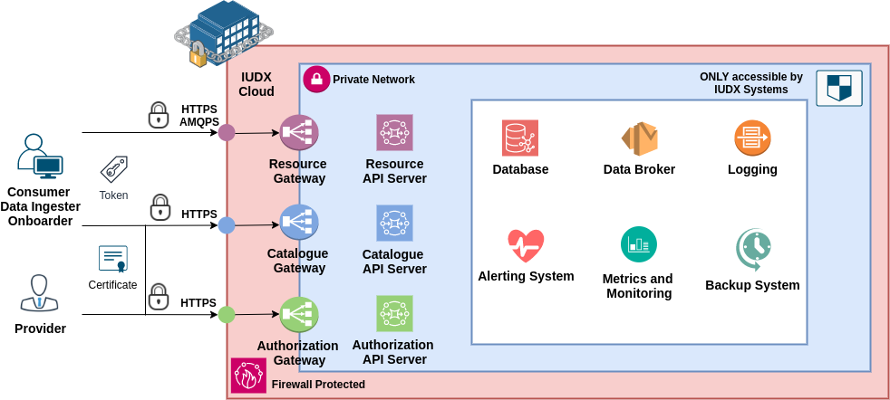

**Deployment Architecture**