**Theme – Disaster Management**

**Problem statement:**

This problem is taken from a real-world example. The aftermath of disasters such as floods/tsunami/earthquake is troublesome in terms of the lack of power and connectivity. People who reside in the highly affected area do not have the signal source to establish connection to their contacts to specify about their whereabouts. People usually face problem when trying to contact the rescue team, but they are unable to. The rescue teams face problems in providing right tools/support at the right time to the strangled people because they are not fully aware of the conditions until they reach the spot.

**Solution proposal:**

Our solution is simple, efficient and uses Ericsson 5G Radio dot system with a drone which can act as a mobile base station and provides signal/coverage to the people in the affected area. We cover the following points in our solution:

1. Pluggable component in the drone using artificial intelligence which can frequently query the weather station/meteorological department and learn the weather condition in the area to know when the drone must start operating.
2. When the disaster has impacted the area, drone is automatically triggered to reach that area.
3. The radio dot system provides coverage to minimal radius in that area (let’s say 2 buildings at once).
4. Drone is also fitted with camera to take pictures of the affected area which is helpful to assist the rescue operation.

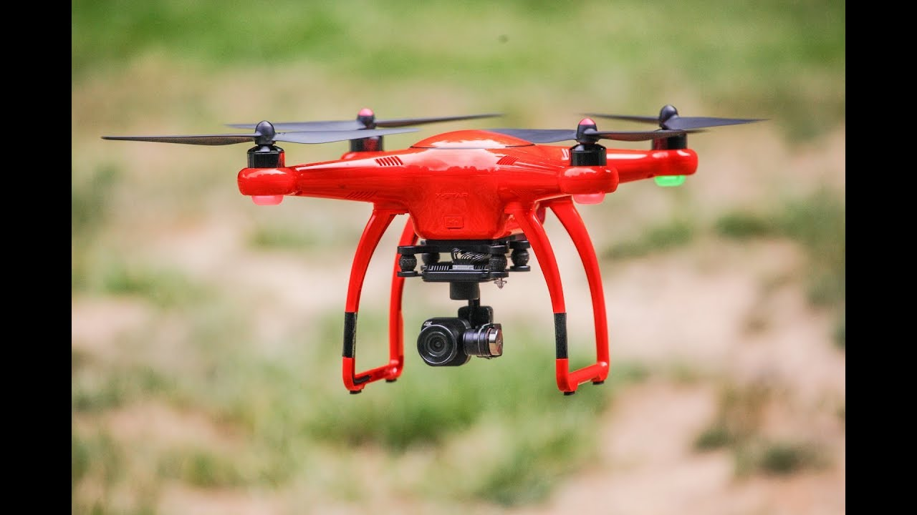

Fig 1: Drone fit with a camera to assist the rescue operation

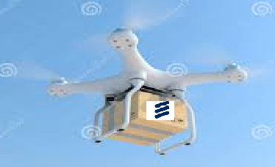

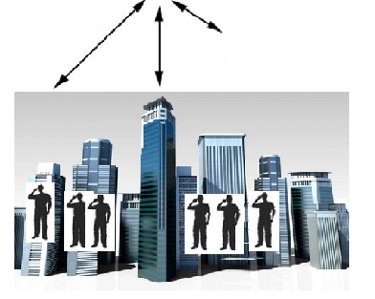

Fig 2: Drone with Ericsson 5G Radio dot system providing the signal coverage to the users within certain radius after disaster.

To avoid over usage, we also define certain rules when the call is made such as:

1. Restricting the duration of the call since people will use the service to call their frequent contacts/rescue team to inform on their safety.
2. Type of the call made. Example: To restrict the international calls.
3. Data usage can be restricted to a certain limit per user.

**Technology used in designing:**

Backend:

For the component in the drone to frequently query the weather department, we are planning to use REST webservice with Java. Storage of the records in a suitable non-relational database like Mongo DB.

Frontend:

Angular UI to depict a sample prototype of our design.

**Algorithms:**

We would use a statistical learning method to learn and store the weather report of the specific area. Based on the learning analysis, the component kick starts the drone automatically to reach the affected area.