LINUX ASSIGNMENT

**LINUX Commands**

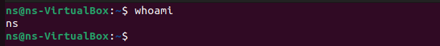

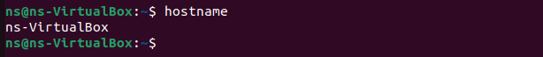

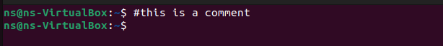



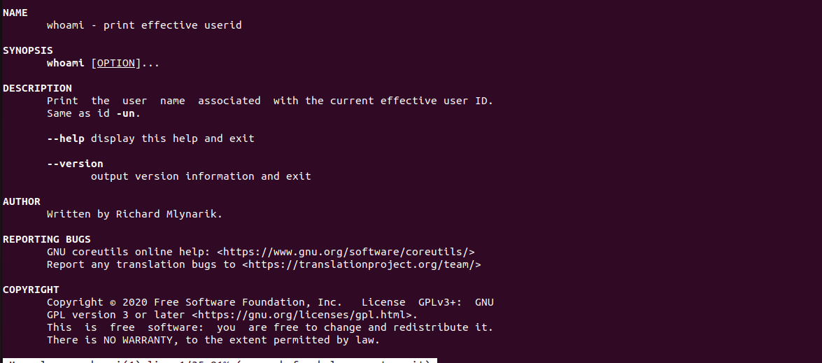

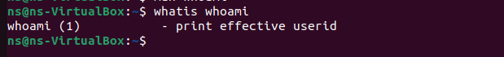



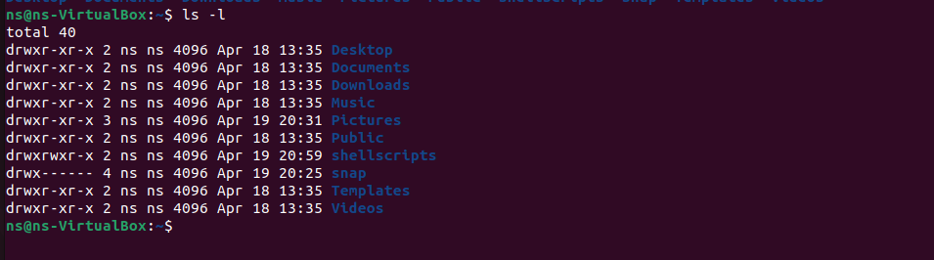











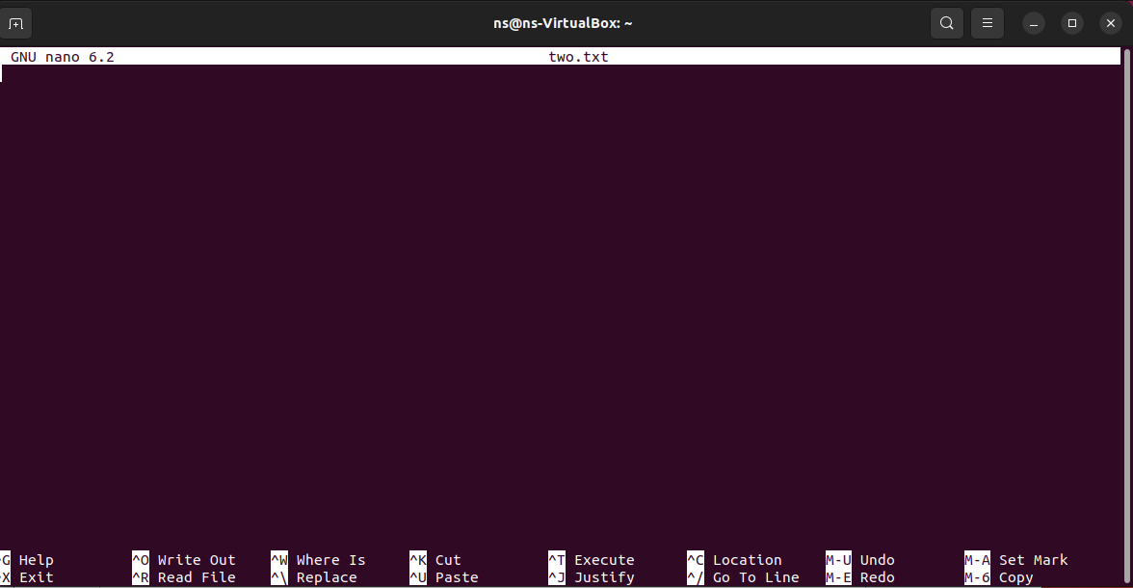





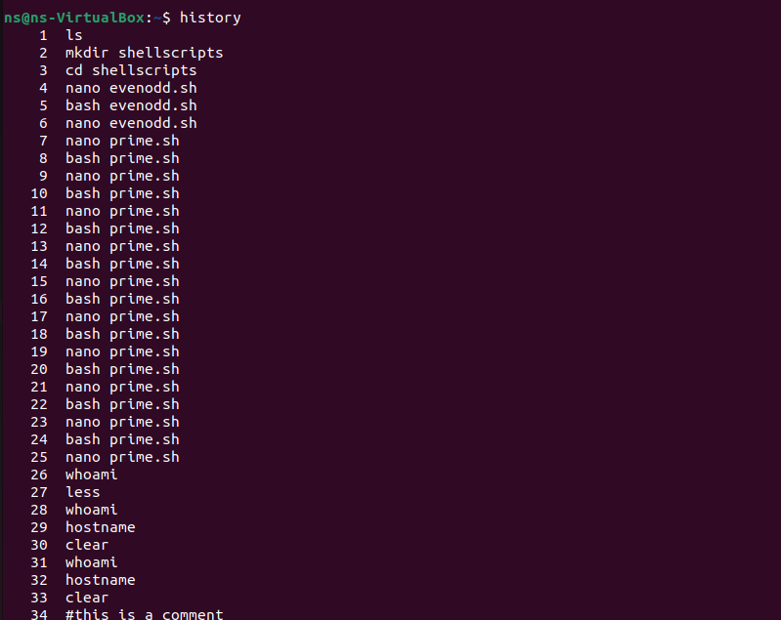





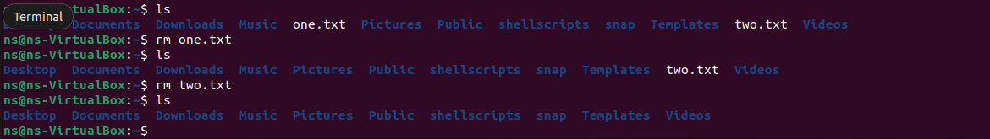



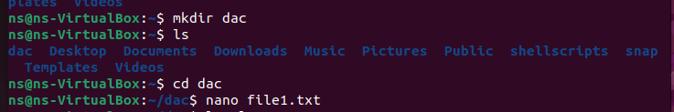



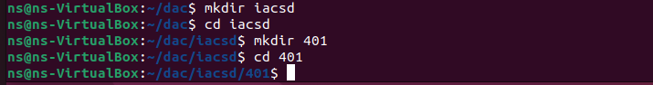

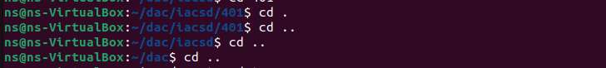

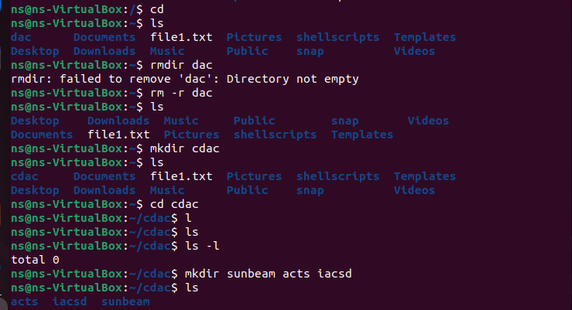

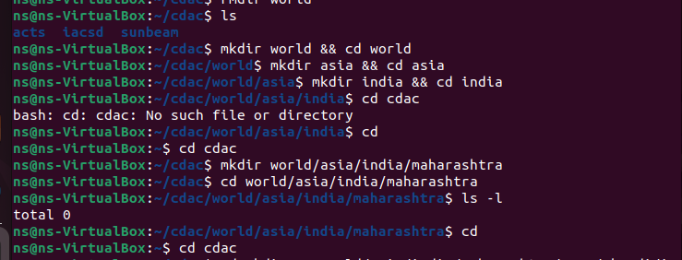

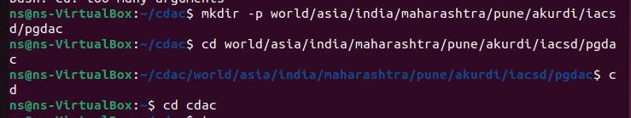

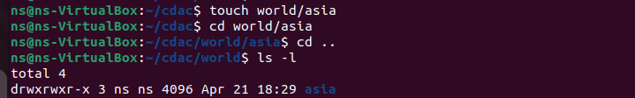

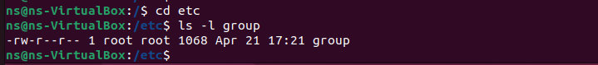

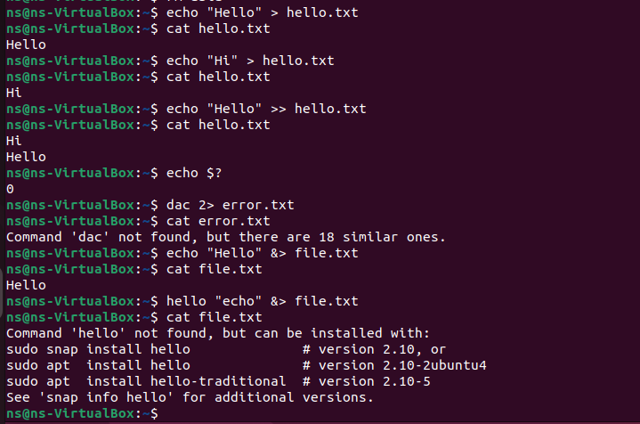

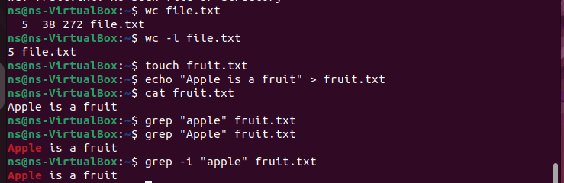

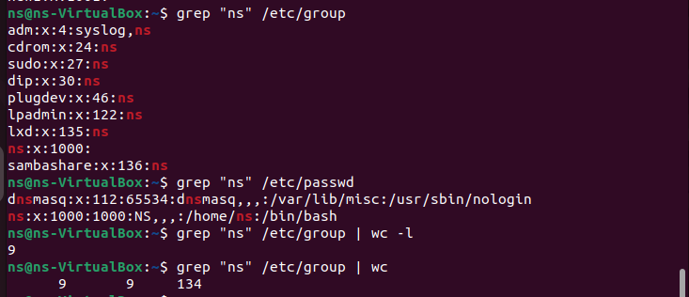

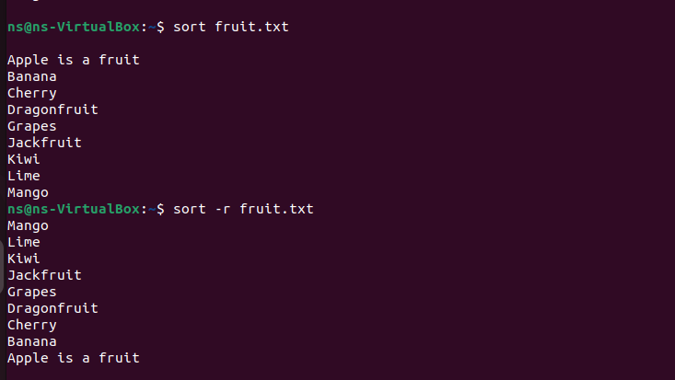

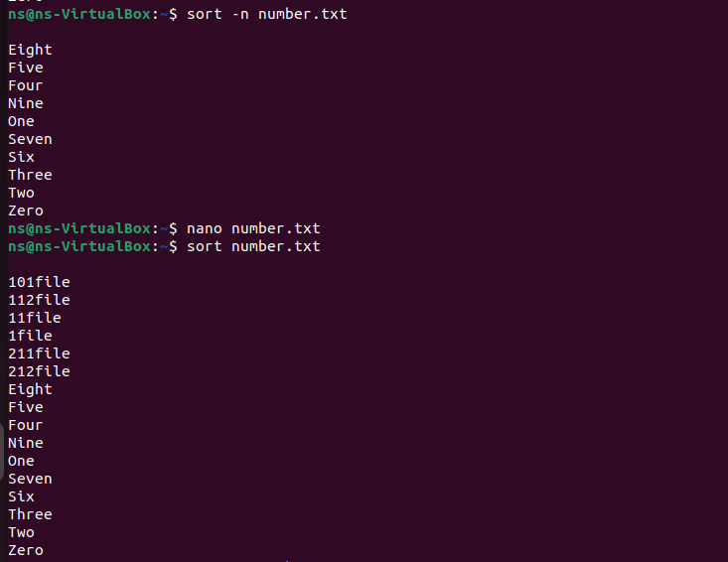

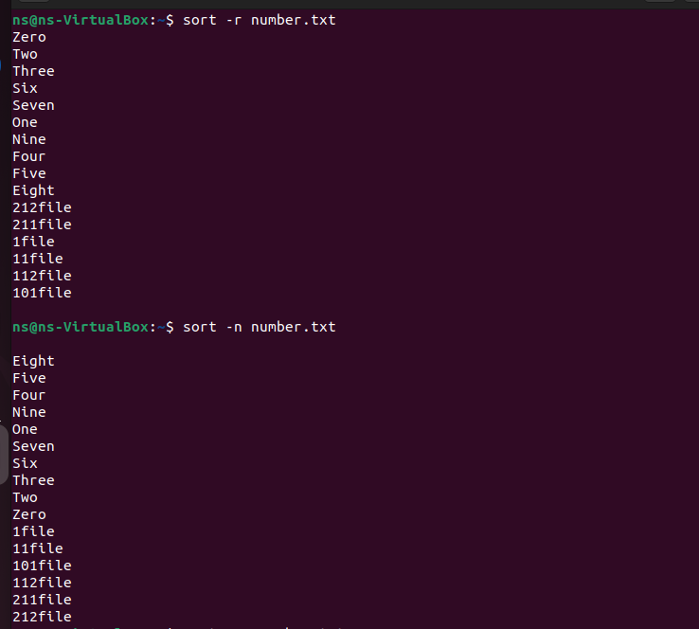

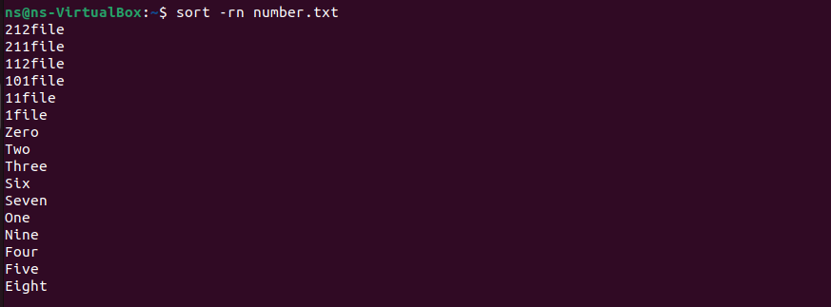

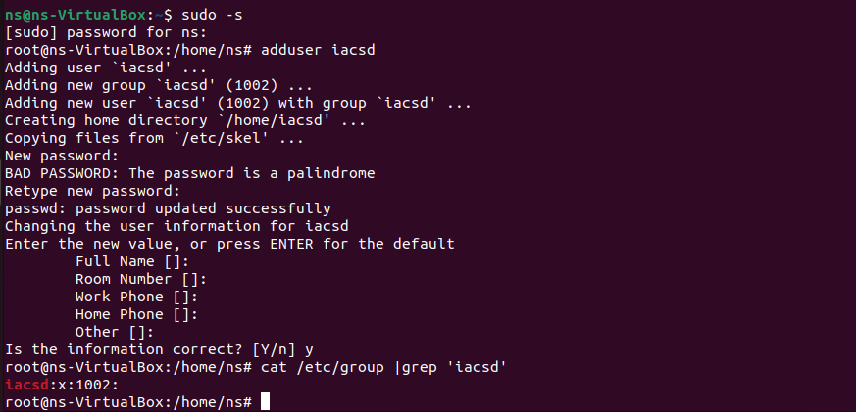

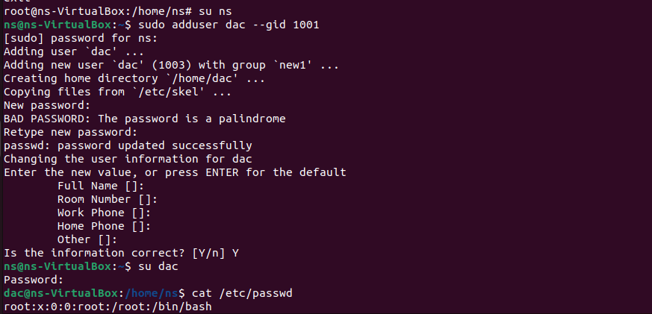



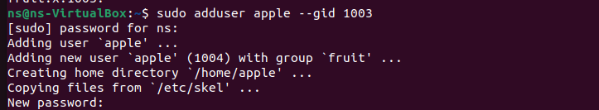

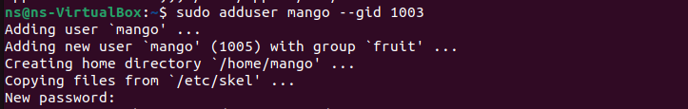

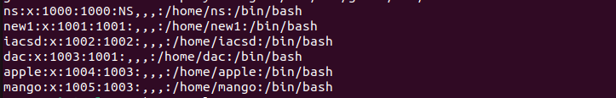

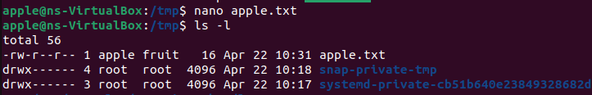

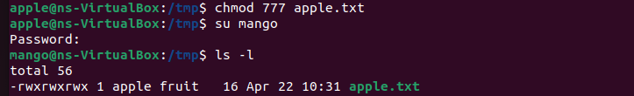

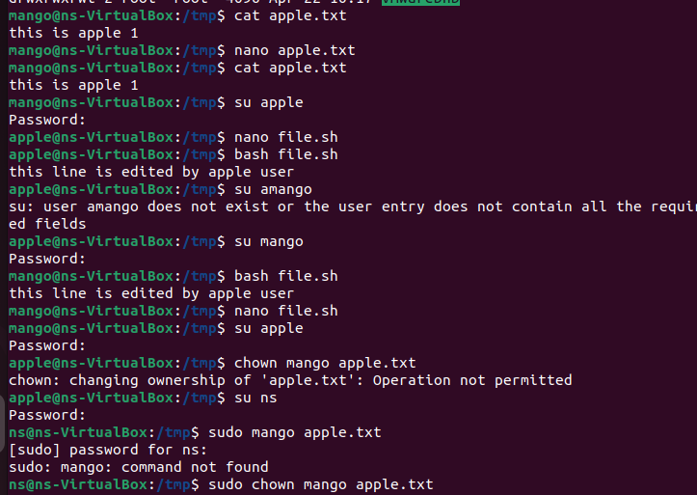



SHELL SCRIPTS

**Implementing for loop**

**Syntax1**

#!/bin/bash

for a in {1..5}

do

echo $a

done

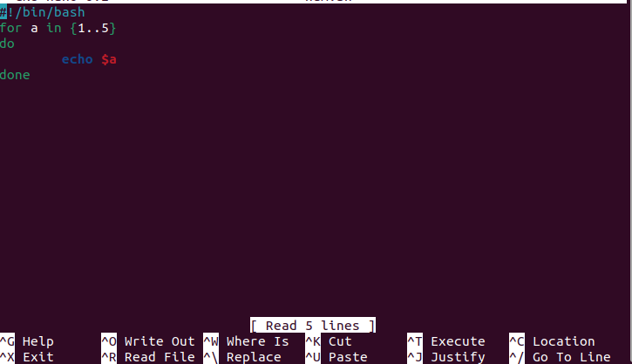

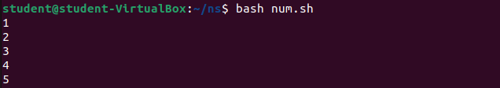

**Syntax 2**

#!/bin/bash

for a in 1 2 3 4 5

do

echo $a

done

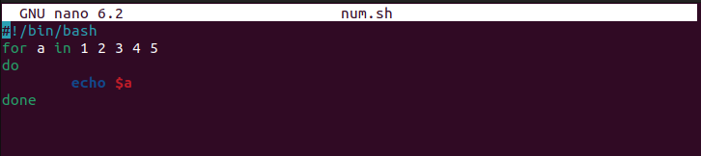



**Syntax3**

#!/bin/bash

for ((i=0;i<=5;i++))

do

echo $i

done

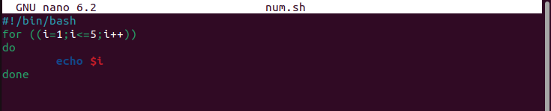



**Patterns**

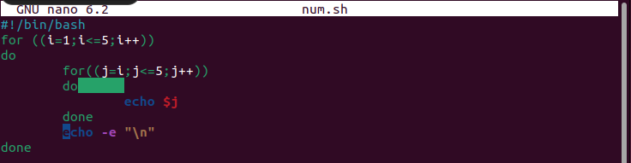

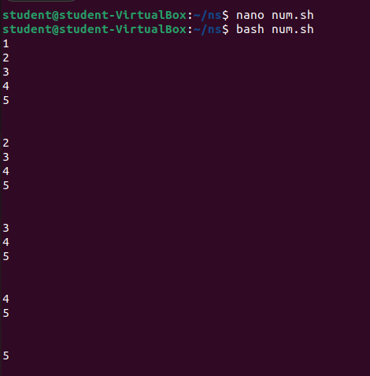

**Rectangle pattern**

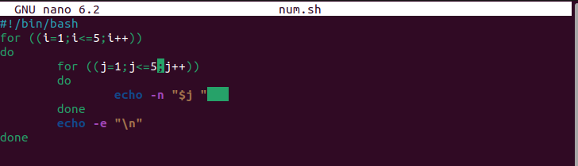

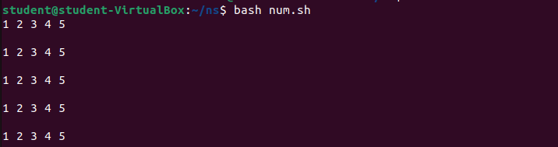

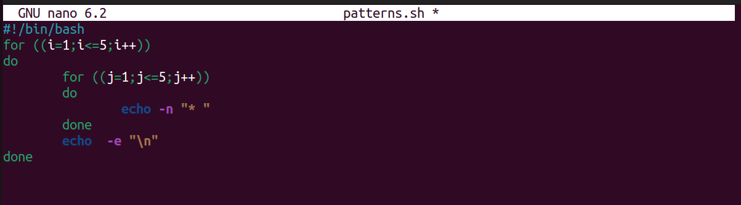

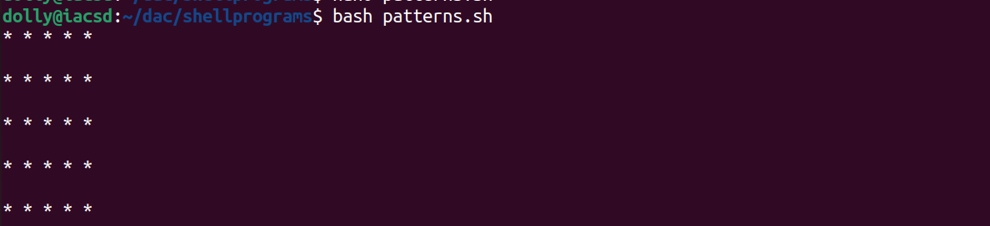

**Triangular patterns**

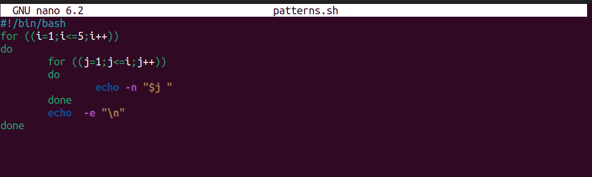

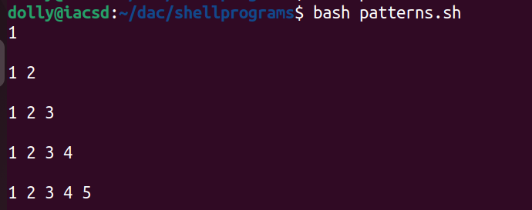

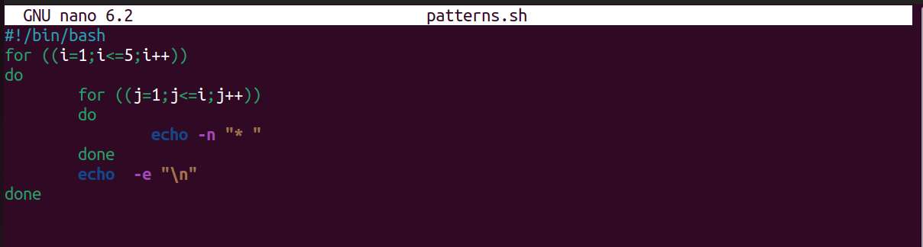

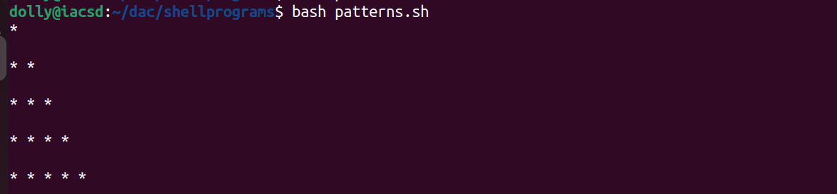

**Reverse Triangular Pattern**

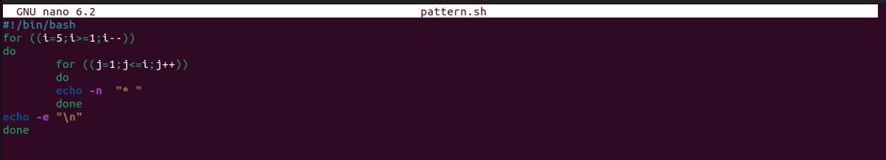

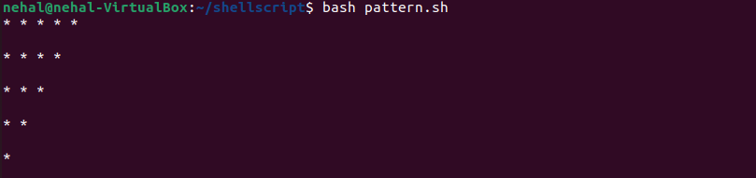

Program to find area and perimeter of circle

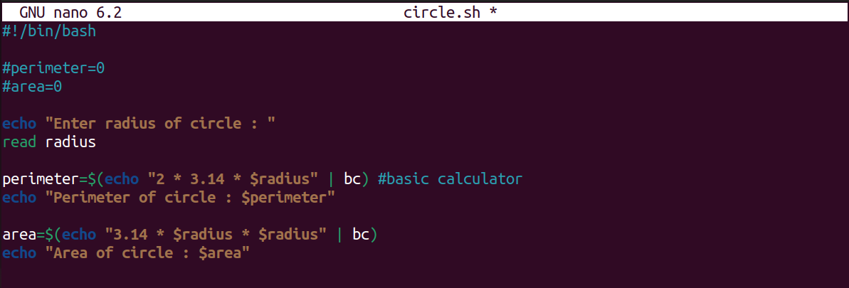

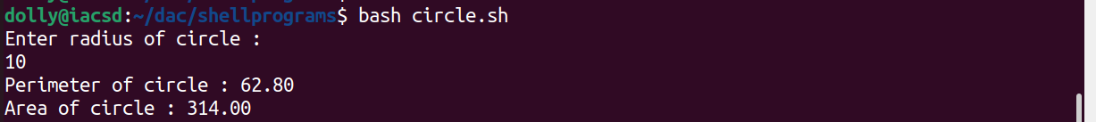

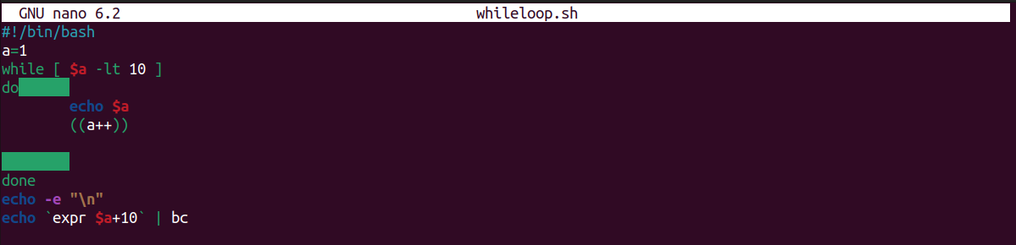

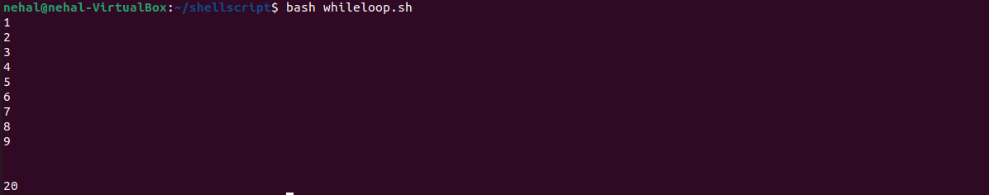

**evenodd.sh**

#!/bin/bash

read -p "Enter a number : " n

echo "you entered $n"

if [ $(( $n % 2 )) -eq 0 ]

then

echo "$n is even number"

else

echo "$n is odd number"

fi

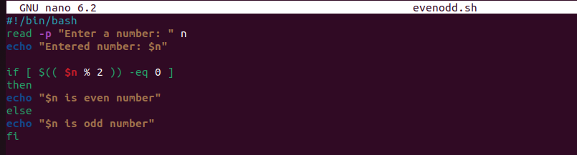

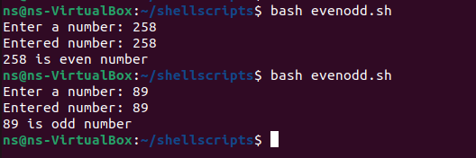

**prime.sh**

#!/bin/bash

read -p "enter a number : " n

echo "you entered $n"

flag=0

for ((i=2;i<n;i++))

do

if [ $(($n % $i)) -eq 0 ]

then

flag =1

else

flag=0

fi

done

if [ $flag -eq 0 ]

then

echo "prime number"

else

echo "not prime number"

fi

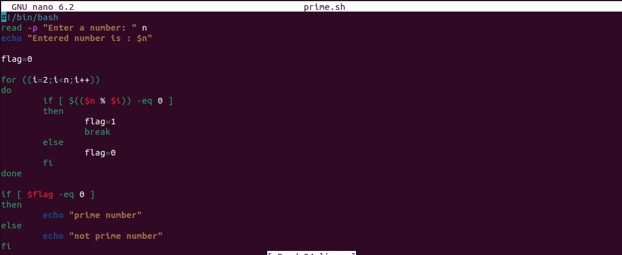

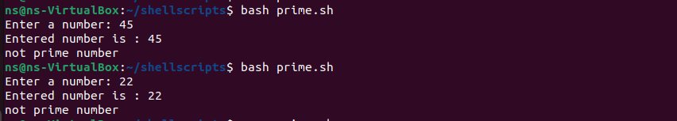

**factorial.sh**

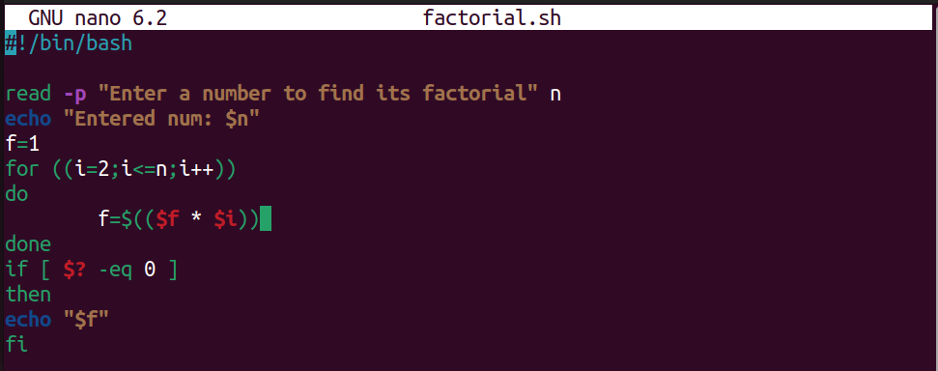

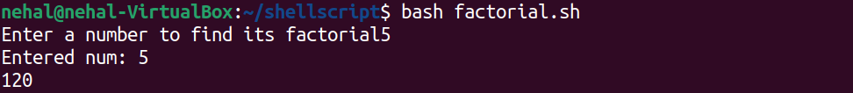

**fibonacci.sh**

#!/bin/bash

read -p "enter number of terms : " n

a=0

b=1

echo “fibonacci series upto $n : $a $b ”

for i in {2..n}

do

c=a+b

b=c

a=b

done

echo “$c “

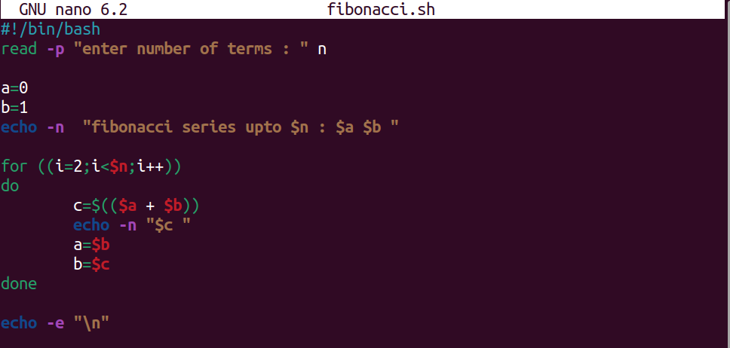

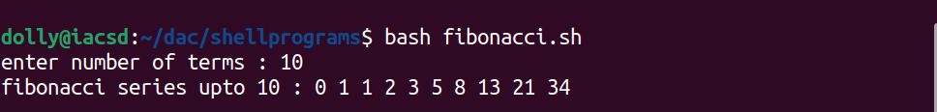

**n to the power x**

#!/bin/bash

read -p "enter a number : " n

read -p "enter it power : " x

for ((i=1;i<=$x;i++))

do

p=$(($p * $n))

done

echo “$n raised to $ = $p”

