**SOLDIER TRACKING AND HEALTH MONITORING SYSTEM**

**V Divya**

**Computer and Communication Engineering 2022-2026, Department of ECE,**

**Amrita Vishwa Vidyapeetham, Chennai campus**

**ABSTRACT :**

***This project introduces a soldier tracking and health monitoring system, vital for ensuring the safety and well-being of military personnel during modern operations. Integrating GPS, GSM, and an RTOS, the system prioritizes monitoring critical parameters including heartbeat, location, temperature, and gas levels. By assigning priorities, the system optimizes data processing for timely response to emergencies. Hardware components such as GPS/GSM modules, heart rate, temperature, and gas sensors enable real-time tracking and health status monitoring. Leveraging M-Health, which encompasses mobile computing, medical sensors, and communication technologies, smart sensors are attached to soldiers, connecting to a personal server for mobility. GSM modules facilitate communication with base stations in emergencies. The system tracks soldiers' locations and health status, aiding decision-making during missions or special operations. MQTT application is utilized for communication purposes, ensuring efficient data transmission between soldiers and base stations. This project aims to enhance soldier safety effectively and economically through a lightweight, portable, and precise guarding system.***

Keywords: Arduino Board, GPS, GSM modem, temperature sensor, MQTT.

**INTRODUCTION :**

In today's era of modern warfare, the security and well-being of soldiers are of paramount importance to any nation's defense strategy. Soldiers, who serve on the ground, at sea, or in the air, play a vital role in safeguarding national interests and protecting citizens. However, the nature of military engagements exposes soldiers to various risks, including physical harm, environmental hazards, and health emergencies.

and seamless coordination among various components.

This project focuses on developing a comprehensive soldier tracking and health monitoring system to enhance the safety and effectiveness of soldiers during operations. The system integrates cutting-edge technologies such as GPS, GSM, and Real-Time Operating System (RTOS), with the aim of providing real-time insights into soldiers' vital parameters. These parameters include heartbeat, location, temperature, and gas levels, which are crucial indicators of soldiers' health and well-being in combat situations.

By prioritizing these parameters, the system optimizes data processing and decision-making, enabling swift responses to potential threats or emergencies. The integration of hardware components, including GPS and GSM modules, heart rate sensors, temperature sensors, and gas sensors, enables continuous monitoring of soldiers' movements and health status in real-time.This project aims to address the challenges faced by military personnel by providing them with a robust tracking and monitoring system that enhances their safety,situational awareness, and overall effectiveness in the field.

**LITERATURE SURVEY :**

The first paper introduces the IGUIM (Integrated Soldier Health Monitoring and Position Tracking), which amalgamates sophisticated components like a GPS module, A6 GSM/GPRS Module, and various sensors. This integration enables precise monitoring of soldier health parameters and accurate real-time tracking of their positions. By leveraging advanced technology, the IGUIM offers a comprehensive solution for enhancing soldier safety and effectiveness during military operations.

The second paper introduces a novel unit, the Unified Soldier and Monitoring Unit (SMU/MSU), which merges the functionality of the Soldier Mobile Unit (SMU) and Monitoring Station Unit (MSU). This innovative approach serves as both a frontline device and a central hub, facilitating seamless communication, emergency responses, and real-time data collection. The SMU/MSU represents a significant advancement in soldier monitoring and communication systems, offering enhanced reliability and efficiency in various operational scenarios.

The third paper focuses on utilizing GPS and GSM technology for monitoring soldiers' health and precise location. By incorporating sensors such as a pulse sensor, temperature sensor, and oxygen level sensor into a wireless body area sensor network (WBANS), the system enables continuous monitoring of vital signs and environmental parameters. The integration of a GP-20U7 GPS receiver and GSM modem facilitates precise location tracking and real-time data transmission. In emergency situations, abnormalities in health readings trigger communication between soldiers and the base unit, ensuring prompt intervention and support.

The fourth paper employs biosensors, GPS NEO-6M, and the ESP8266 Wi-Fi module as key components for soldier monitoring. Integrated with microcontroller boards like Arduino Uno and Node MCU, the system monitors physiological parameters such as heart rate, body temperature, and gas levels. By leveraging advanced technology, this system provides real-time monitoring and tracking capabilities, enhancing situational awareness and facilitating timely intervention in critical situations.

The fifth paper explores the integration of various sensors, including pulse rate sensors, LM35 temperature sensors, and notably, the accelerometer, in a comprehensive health monitoring and tracking system. The accelerometer plays a crucial role in measuring soldiers' acceleration, providing insights into body movement, posture detection, fall alerts, and analysis of physical activities. Additionally, the system utilizes gyro sensors for monitoring orientation. By implementing GPS and GSM techniques for real-time data integration, the algorithm ensures prompt collection and transmission of information to the cloud or control room, triggering alerts for abnormal values. Experimental results demonstrate the system's speed, accuracy, and security, surpassing existing methods with key improvements in detecting parameters like air quality and movement, eliminating delays, and utilizing a GSM and GPRS-based communication system.

The sixth paper introduces the Bioprobes system, which encompasses various biosensors, a transmission system, and processing capabilities. This innovative addition enables low-cost, non-intrusive wearable solutions for health monitoring, enhancing the Soldiers Health Monitoring and Tracking System. The integration of GPS technology aids in determining the soldier's longitude and latitude, providing an efficient means of tracking their direction. Furthermore, the incorporation of these devices into weapons and clothing underscores the comprehensive approach taken to soldier health monitoring, emphasizing adaptability and versatility in the evolving landscape of military technology.

The seventh paper presents the development of an AIOT (Artificial Intelligence of Things) system for soldier safety, focusing on detecting gunshots and toxic gases. Utilizing MQTT for real-time data exchange between soldiers and surveillance units, the system implements deep learning for predicting environmental conditions like toxic gas presence. Soldier status is monitored through a Node Red web interface at the surveillance unit, ensuring effective soldier security and surveillance using IoT and AI technologies.

**METHODOLOGY :**

A pulse sensor is utilized to detect and monitor the soldier's heart rate, while a temperature sensor (LM35 sensor) measures and monitors the soldier's body temperature. Additionally, a GPS module continuously tracks and monitors the live location of the soldier.

In case of critical conditions such as high heart rate or abnormal temperature, the GSM module is programmed to send alert messages to the base unit. Simultaneously, an audible alert system using a buzzer is incorporated to notify the soldier or nearby individuals regarding the critical condition.

Furthermore, the methodology incorporates a gas sensor to detect hazardous gas levels. This comprehensive approach ensures real-time monitoring of vital parameters, timely alerts during emergencies, and effective communication between the soldier and the base unit for enhanced safety and well-being in military operations.

**PROPOSED SYSTEM :**

The proposed soldier tracking and health monitoring system leverage GPS, GSM, and RTOS technologies along with various sensors to provide real-time monitoring of soldiers' vital parameters and location. The system prioritizes the monitoring of heartbeat, temperature, and gas levels, with high priority given to critical conditions such as high heart rate or abnormal temperature. When such conditions are detected, the system sends alert messages via the GSM module to the base unit and triggers an audible alert using a buzzer to notify nearby individuals. Additionally, the system utilizes MQTT protocol for efficient communication between components.

**EXISTING SYSTEM :**

In contrast, traditional soldier tracking and health monitoring systems may lack the integration of real-time tracking, prioritized monitoring of vital parameters, and immediate alert mechanisms for critical conditions. Many existing systems rely solely on GPS for location tracking without prioritizing other vital parameters like heartbeat, temperature, and gas levels. Overall, the existing systems may not offer the same level of comprehensive monitoring, prioritization, and alerting capabilities as the proposed system.

**APPLICATIONS :**

Defence Forces:The project is crucial for battlefield or high-altitude operations, providing real-time monitoring of soldiers' health and location, ensuring vital information is available to the control room for informed decision-making and rapid response to emergencies.

Civilians: Individuals working in remote or high-altitude areas can benefit from the system, allowing their guardians or supervisors to monitor their health status and location, enhancing safety and providing timely assistance if needed.

Monitoring Patient Health: The project's implemented sensors enable continuous monitoring of patients' vital signs such as heart rate and body temperature, making it suitable for healthcare settings to ensure early detection of abnormalities and prompt medical intervention, improving patient outcomes.

**HARDWARE REQIREMENTS :**

**ARDUINO MEGA :**

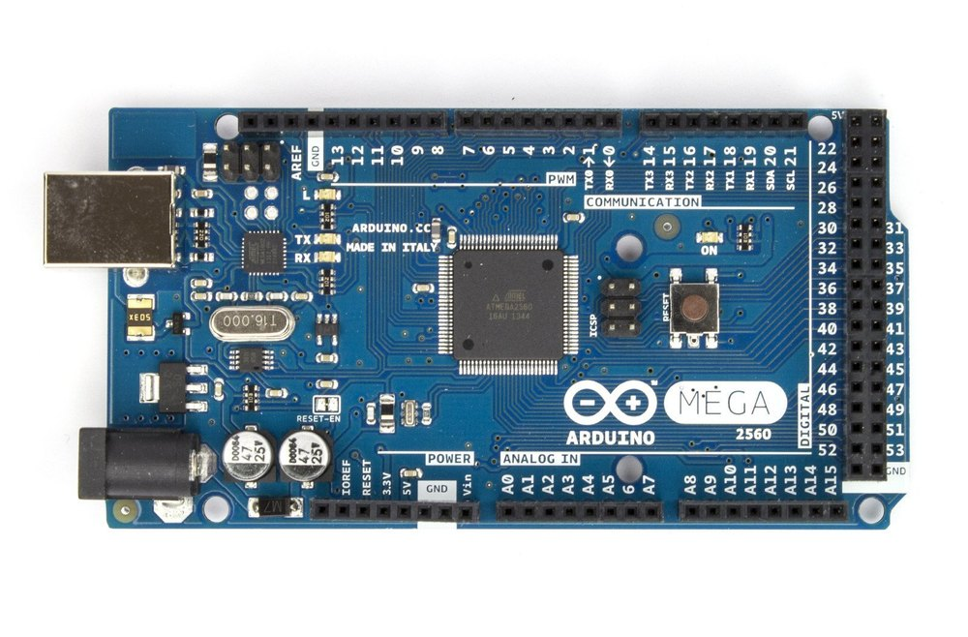

Arduino Mega is a versatile microcontroller board based on the ATmega2560 chip, offering an extensive array of GPIO pins including digital, analog, and PWM outputs. With 256 KB of flash memory, 8 KB of SRAM, and 4 KB of EEPROM, it provides ample space for storing program code, variables, and non-volatile data. The Mega supports various communication protocols like UART, SPI, and I2C, enabling seamless connectivity with sensors, displays, and communication modules such as GSM and GPS. Its compatibility with the Arduino IDE simplifies programming tasks, while expandability through shields and a 5V operating voltage make it adaptable to a wide range of electronic projects.

**GPS NEO 6M MODULE :**

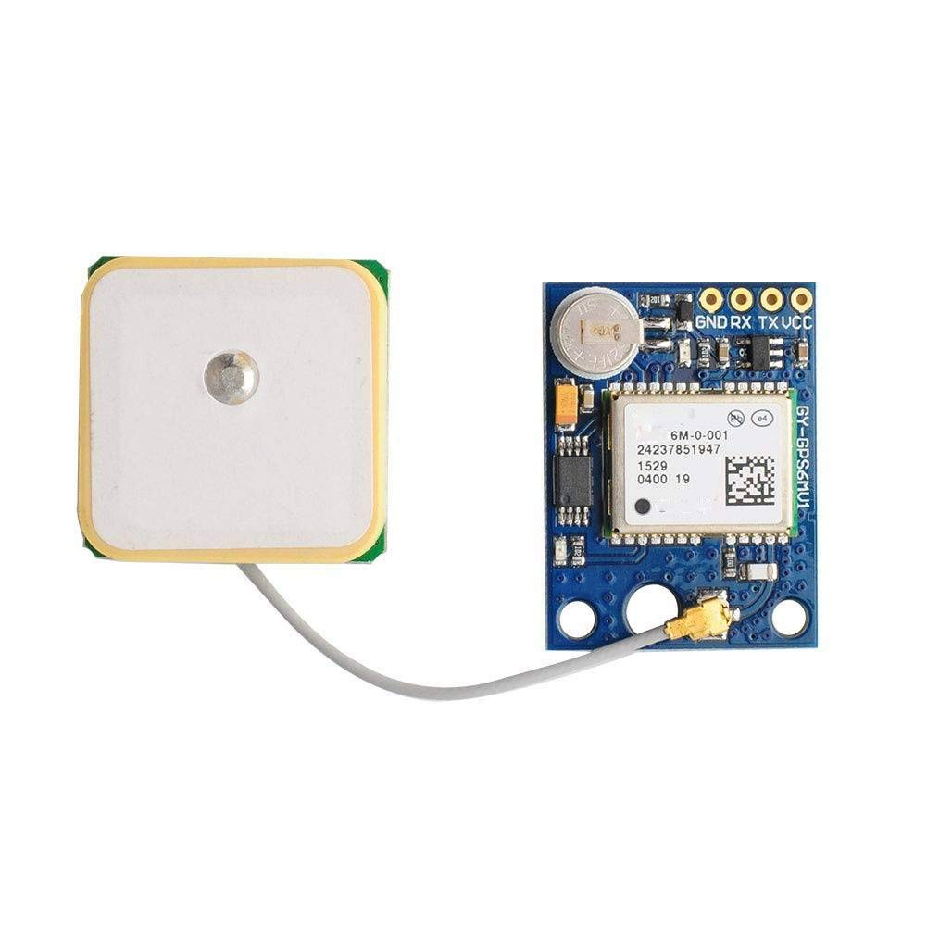

The GPS Neo 6M module is a compact and highly sensitive GPS receiver designed for accurate location tracking. Its high sensitivity enables fast acquisition of satellite signals, ensuring reliable position fixes even in challenging environments. The module communicates with microcontrollers via serial communication protocols like UART, making integration into embedded systems seamless. Its small form factor and low power consumption make it suitable for portable and battery-powered applications such as vehicle tracking and outdoor navigation. Additionally, the Neo 6M module is configurable, allowing users to adjust settings for update rate, baud rate, and NMEA sentence output, enhancing flexibility and usability.

**HEART BEAT SENSOR :**

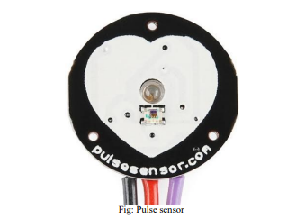

The pulse sensor used in this project is the SEN-11574, specifically the Pulse Sensor Amped version. This sensor is designed to measure heart rate data, which is valuable for assessing a person's health status. The Pulse Sensor Amped is designed for easy integration with Arduino boards, featuring built-in amplification and noise cancellation circuitry for reliable and fast pulse readings. It operates with low power consumption, drawing just 4 mA current at 5V. Using the sensor is straightforward; it can be clipped onto the earlobe or fingertip for convenient and accurate heart rate monitoring.

**TEMPERATURE SENSOR :**

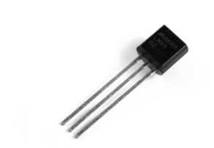

The temperature sensor used in this project is the LM35, a precision integrated-circuit temperature sensor. The LM35 sensor provides accurate analog voltage output proportional to the temperature in Celsius, making it ideal for temperature monitoring applications. Its linear output and low self-heating make it reliable and suitable for precise temperature measurements. With a voltage range of 0°C to 100°C and a sensitivity of 10mV/°C, the LM35 sensor offers easy interfacing with microcontrollers like Arduino.

**BUZZER :**

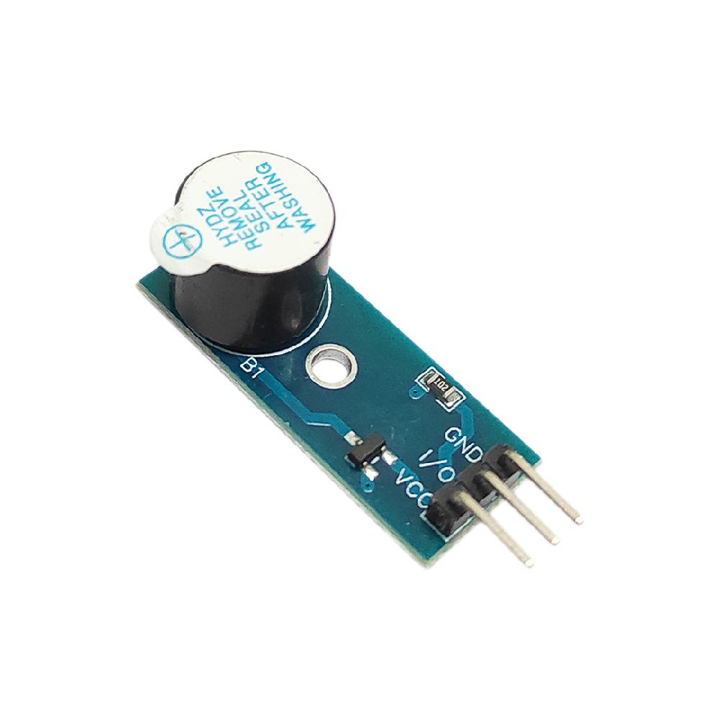

The buzzer used in this project serves as an audible alert system to notify individuals about critical conditions such as abnormal heart rate or body temperature. Buzzer components typically consist of an electromagnetic coil that generates sound when activated by an electrical signal. In this project, the buzzer is controlled by the microcontroller e.g., Arduino Mega and is activated when specific thresholds for heart rate or temperature are exceeded. The buzzer's audible sound provides immediate feedback, alerting individuals to take necessary actions or seek assistance.

**GAS SENSOR**

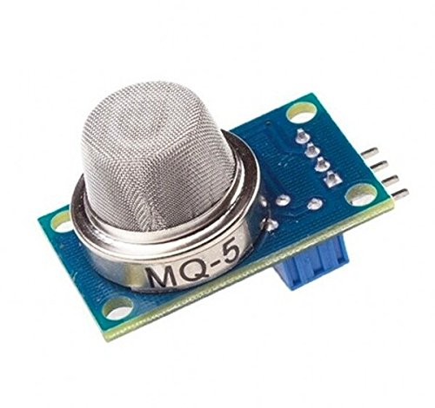

The MQ-5 gas sensor is utilized in this project to detect and measure concentrations of combustible gases such as LPG and natural gas in the environment. It operates based on the conductivity changes of its tin dioxide (SnO2) semiconductor when exposed to different gas concentrations, providing analog output voltage proportional to the gas concentration. This sensor's high sensitivity, fast response times, and compatibility with microcontrollers like Arduino make it an essential component for gas detection and safety monitoring applications.

**SYSTEM ARCHITECTURE :**

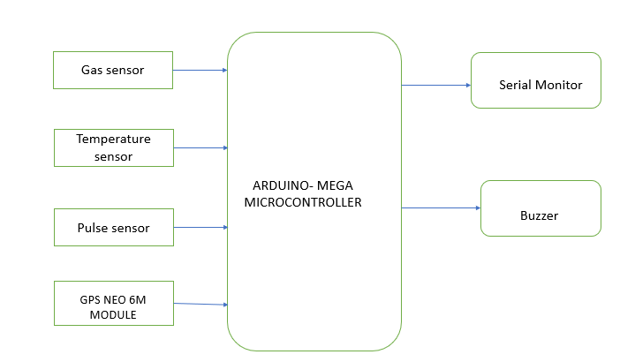

- The heart rate task continuously monitors the soldier's heart rate using the pulse sensor connected to analog pin A1. The output provides the heart rate value in beats per minute (bpm), allowing real-time tracking of the soldier's health. If the heart rate exceeds the predefined threshold of 200 bpm, indicating an abnormal heart rate, the system triggers the buzzer to alert nearby individuals.

- The location task utilizes the GPS Neo 6M module to obtain accurate geographic coordinates, including latitude and longitude, altitude, These outputs provide crucial information about the soldier's real-time location, enabling effective tracking and navigation capabilities for military operations.

- The temperature task measures the soldier's body temperature using the LM35 temperature sensor connected to analog pin A0. The output displays the temperature value in degrees Celsius (°C), allowing continuous monitoring of the soldier's thermal condition. If the temperature exceeds the predefined threshold of 40°C, indicating an abnormal temperature, the system prioritizes the GPS task to ensure rapid response to potential health risks.

- The gas sensor task reads the analog value from the MQ-5 gas sensor connected to digital pin 5. It provides information about the gas concentration level, with higher analog values indicating potentially dangerous gas levels. If the gas level surpasses the predefined threshold, the system elevates the priority of the GPS task to address safety concerns promptly, such as evacuating the soldier from hazardous environments.

**SIMULATION RESULTS :**

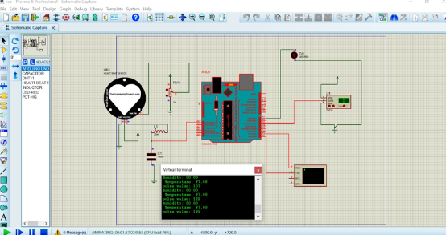

*This figure represents simulated data output from the integrated heart rate sensor and DHT11 sensor, displayed in the virtual terminal of Proteus.*

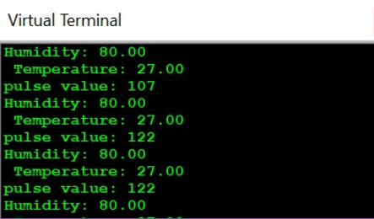

*Simulation results obtained in virtual terminal .*

**HARDWARE OUTPUTS :**

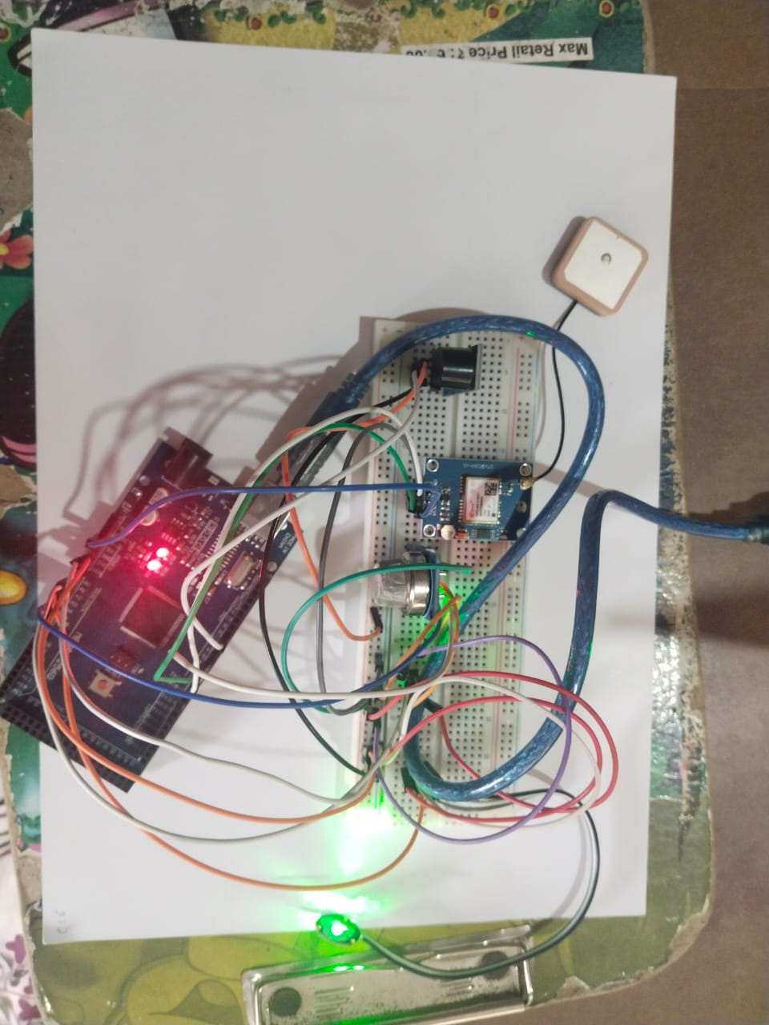

*This figure represents the hardware result*

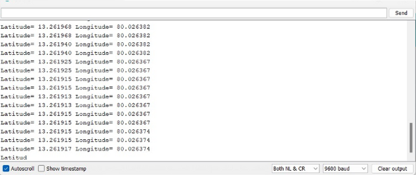

*This figure represents the Latitude and longitude coordinates of GPS .*

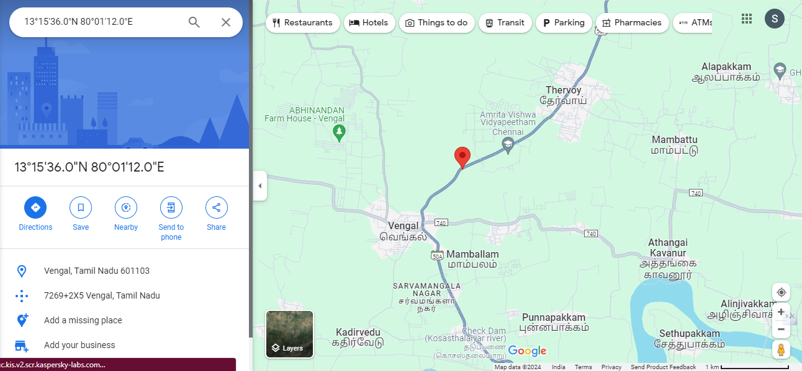

*The figure visually shows the soldier's accurate location data, including latitude, longitude, for effective tracking and navigation during military operations.*

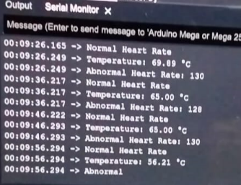

*The figure represents the Serial monitor output of the heart rate sensor, temperature sensor, and gas sensor, providing essential health and environmental data for monitoring and alerting purposes.*

**CONCLUSION :**

The soldier tracking and health monitoring system implemented using Arduino Mega, ESP32, and various sensors such as the pulse sensor, LM35 temperature sensor, GPS Neo 6M module, and MQ-5 gas sensor has demonstrated effective real-time monitoring capabilities. The system successfully tracked vital parameters like heart rate, temperature, and location, providing valuable data for ensuring soldier safety and well-being during military operations. Additionally, the integration of priority-based task scheduling using FreeRTOS and alert mechanisms such as the buzzer contributed to timely responses to abnormal conditions, enhancing the system's overall effectiveness. Future enhancements could focus on improving sensor accuracy, implementing machine learning algorithms for predictive analysis, and integrating communication protocols for remote monitoring and control, further enhancing the system's capabilities in critical situations.

**REFERENCES**

1] W. Swedan, H. Al_Issa, A. Aloqoul, H. Alkofahi, and R. Obeidat, "An Interactive Graphical User Interface Module for Soldier Health and Position Tracking System," in International Journal of Electronics and Telecommunications, vol. 68, no. 3, pp. 571-575, 2022. DOI: 10.24425/ijet.2022.141276.

[2] A. V. Patil, V. P. Doiphode, S. S. Bhosle, S. V. Ghadge, and A. M. Kumbhar, "Soldier Health Monitoring and Tracking System Using IoT and AES," Journal of Emerging Technologies and Innovative Research (JETIR), vol. 8, no. 6, pp. 460, 2021.

[3] D. J, R. J, S. Raj, and Dr. P. B. D, "Soldier Health and Position Tracking System using GPS and GSM Modem," International Journal of Engineering Research & Technology (IJERT), Special Issue - 2018.

4] A. Padikar, C. C. K., E. Chaithra, C. Chethan, and D. N. Puneeth Kumar,"Health Monitoring and Soldier Tracking System using IoT," in NCETESFT - 2020 Conference Proceedings, Sri Siddhartha Institute of Technology, Tumakuru, India, 2020.

5] E. Shalini, S. Priya, S. Sabitha, S. R. Shalini, and C. Shanmugam, "Soldiers Health Monitoring and Tracking System," International Journal of Research in Engineering, Science and Management, vol. 4, no. 7, pp. 194-196, July 2021.

6] P. Kulkarni and T. Kulkarni, "Secure Health Monitoring of Soldiers with Tracking System using IoT: A Survey," Int. J. Trend Sci. Res. Dev., vol. 3, no. 4, pp. 693, May-Jun 2019. www.ijtsrd.com. e-ISSN: 2456-6470.