CMPE 202 - Kanban Board Snapshot #8

**Submit a PDF document with the following:**

1. Take a screenshot of your Kanban Board from [https://waffle.io/ (Links to an external site.)](https://waffle.io/)

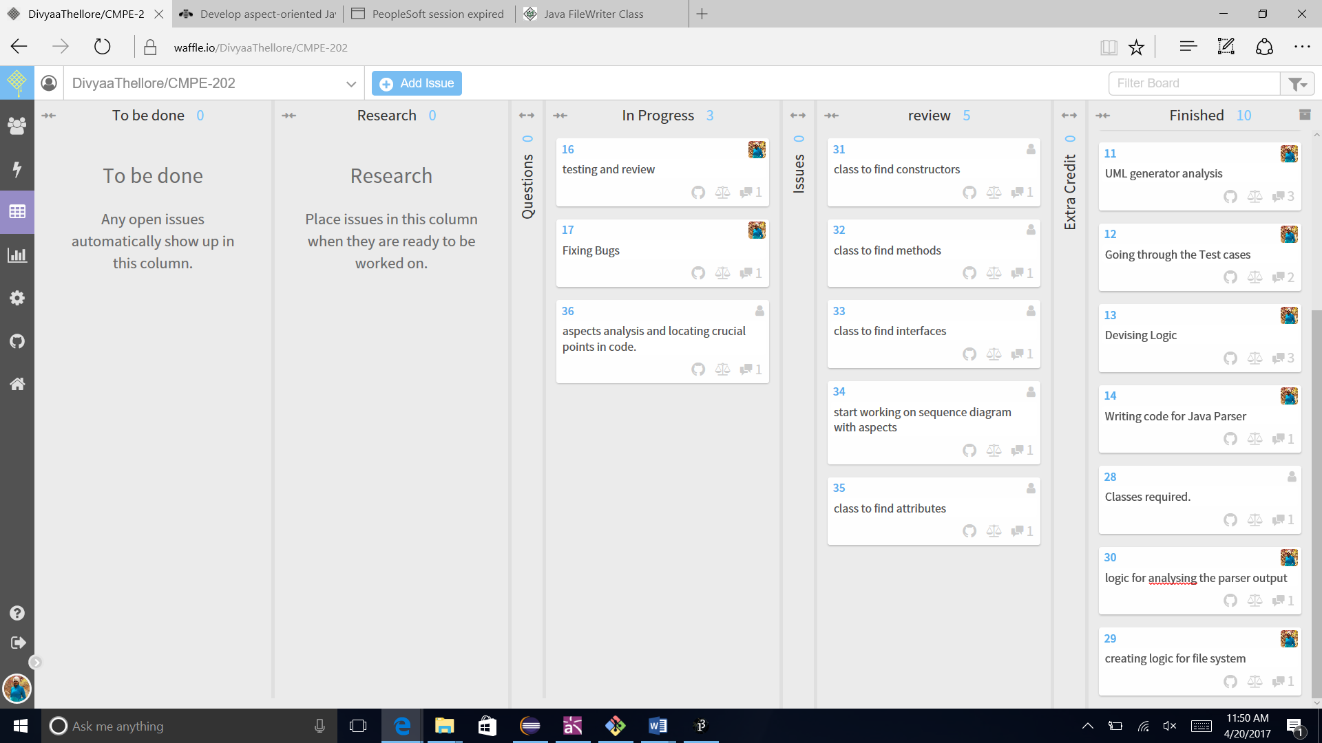

2. Provide a URL Link to your Waffle Board

<https://waffle.io/DivyaaThellore/CMPE-202>

3.Provide a URL Link to your GitHub Repo

<https://github.com/DivyaaThellore/CMPE-202>

4.Calculate the "wait time" for all cards in the "In-Progress" column on your board

|  |  |  |
| --- | --- | --- |
| Issue Catagory | Card # | Wait time (in days) |
| In Progress | 16 | 5 |
| 17 | 5 |
| 36 | 3 |
|
| Review | 31 | 16 |
| 32 | 16 |
| 33 | 16 |
| 34 | 16 |
| 35 | 12 |

5.Calculate the "total cycle time" for all cards in the "Done" column on your Board

|  |  |
| --- | --- |
| Card # | Total Cycle time |
| 3 | 0.5 hour |
| 4 | 0.5 hour |
| 5 | 1 hour |
| 6 | 0.5 hour |
| 7 | 1 hour |
| 8 | 2 hours |
| 9 | 8 days |
| 15 | 8 days |
| 19 | 8 days |
| 23 | 2 hours |
| 25 | 5 days |
| 26 | 0.5 hours |
| 27 | 2 hours |
| 10 | 47 days |
| 11 | 47 days |
| 12 | 47 days |
| 13 | 45 days |
| 14 | 45 days |
| 28 | 33 days |
| 30 | 27 days |
| 29 | 27 days |