FleetOps
A Web-Based Linux Fleet Management System
with Prometheus & Grafana Monitoring

PROJECT REPORT

Submitted by: Divyani Khandait
Roll No. / ID: ____________________________
Department: ____________________________
College / Institution: ____________________________
Guide / Mentor: ____________________________
Date: ____________________________

PROJECT LINKS
GitHub Repository: https://github.com/Divyaaaani/Linux_fleet-3621
Live Demo: ____________________ (run locally — see Section 11)

Zoho SETU — Project 3: Distributed Linux Fleet Management

1. Executive Summary
FleetOps is a web-based control plane that onboards, monitors, and remotely manages a fleet of Linux machines from a single dashboard, and exposes its telemetry through industry-standard Prometheus and Grafana monitoring.
Managing many Linux servers by hand does not scale: there is no central view of health, SSH access is painful to configure, machines behind firewalls/NAT are unreachable for pull-based tools, failures go unnoticed, and ad-hoc remote shell access is dangerous. FleetOps solves all five problems with one coherent design — a lightweight push-based bash agent on each node and a central control plane that stores metrics, raises alerts, dispatches safe (allow-listed) commands, and exports everything to Prometheus for Grafana to visualise.
The system fully satisfies the project brief: it is web-based, it onboards and manages multiple Linux nodes remotely, and it collects, stores, and visualises system metrics using Prometheus and Grafana.

2. Objectives
# | Objective | Delivered
1 | Web-based interface to manage a Linux fleet | React dashboard in the browser
2 | Onboard multiple Linux nodes remotely | Token-based, single-command agent install
3 | Manage nodes remotely | Allow-listed remote command dispatch
4 | Collect system metrics | Bash agent reads /proc every 15s
5 | Store metrics | SQLite (Turso) time-series tables
6 | Visualise metrics | Custom charts + Grafana dashboards
7 | Use industry-standard monitoring | Prometheus exporter + Grafana

3. Design Priorities
This project deliberately prioritises correctness, system design, observability, and an understanding of Linux internals over UI aesthetics. Each priority is backed by a concrete design choice:

✔ Correctness
One-time tokens consumed atomically at registration; idempotent metric ingest; a state machine (pending → online → degraded/offline) driven by heartbeat freshness; commands tracked through queued → running → success/failure with results written back. The control plane is the single source of truth.

◇ System Design
Clear separation of agent / control plane / presentation tiers. A push-based agent that works behind NAT and firewalls, an allow-listed (never arbitrary) command channel, and a normalised relational schema. Trade-offs are explicit and defensible.

◎ Observability
A native Prometheus exporter in standard exposition format, scraped into Prometheus and visualised in Grafana — plus an automatic alert engine for threshold breaches and missed heartbeats. Every node is measurable end-to-end.

⌘ Linux Internals
The agent reads directly from the kernel: CPU from /proc/stat, memory from /proc/meminfo, load from /proc/loadavg, uptime from /proc/uptime, disk via df, and process count from /proc. Pure bash + coreutils, with no runtime dependencies.

Note: UI aesthetics were intentionally kept functional rather than decorative — the dark operations-centre theme exists only to make dense telemetry readable, not as a design goal in itself.

4. System Architecture
The system has three logical tiers: the fleet (agents), the control plane (API, storage, alerting, exporter), and the presentation layer (web dashboard + Grafana).
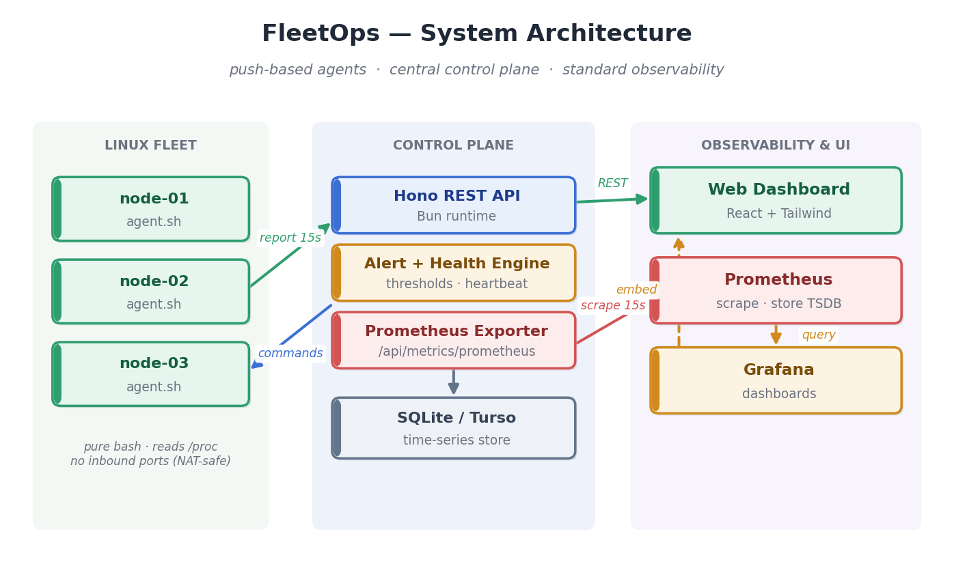
Figure 1 — FleetOps system architecture

4.1 Components
- Agent (agent.sh) — a dependency-free bash script on every node; reads CPU, memory, disk, load, uptime and process count from /proc and reports over HTTP.
- Control plane — a Hono REST API on the Bun runtime, backed by Drizzle ORM over SQLite/Turso. Registers nodes, ingests telemetry, evaluates alerts, queues commands, exposes a Prometheus exporter.
- Web dashboard — a React + Tailwind single-page app polling every 5 seconds for a live feel.
- Prometheus — scrapes the control plane's exporter and stores metrics as a time series.
- Grafana — queries Prometheus and renders dashboards; also embedded inside the FleetOps UI.

4.2 The key design decision: push, not pull
The agent pushes metrics to the control plane and pulls queued commands back in the same HTTP request. A node never needs an open inbound port — only the control plane must be reachable. As a result the system works for machines behind NAT or firewalls, exactly where traditional pull-based monitoring fails. Because the agent is push-based, Prometheus scrapes the control plane's aggregated exporter, not each node — keeping configuration to a single target.

4.3 Safety by design
Remote control is restricted to an explicit allow-list of actions — refresh metrics, health check, restart agent, restart a named service. The system never executes arbitrary shell sent over the wire, so remote management is safe by construction.

5. Node Lifecycle & Data Flow
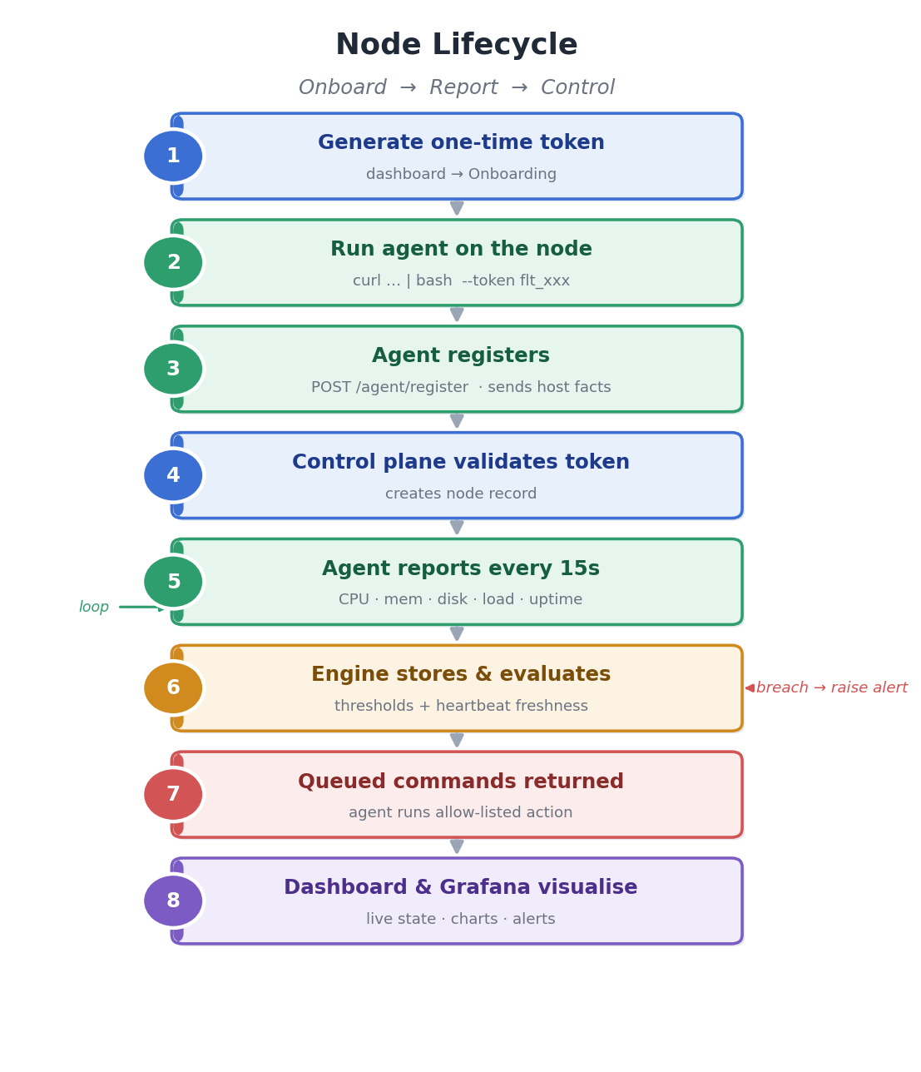
Figure 2 — Node lifecycle: onboard → report → control
- An administrator generates a one-time token in the dashboard.
- The operator runs agent.sh on the target node with that token (single curl | bash command).
- The agent calls POST /api/agent/register with host facts; the control plane validates the token and creates the node record.
- The agent loops, calling POST /api/agent/:id/report every 15 seconds with fresh metrics.
- The alert + health engine stores each sample and evaluates thresholds and heartbeat freshness.
- The report response carries queued commands; the agent executes the allow-listed action and reports the result.
- The dashboard and Grafana visualise live state, time-series charts, and alerts.

6. Data Model
Table | Purpose
nodes | Registered machines, host facts, current status, last heartbeat
onboarding_tokens | One-time tokens consumed at registration
metrics | Time-series telemetry per node
commands | Queued / running / completed remote actions
alerts | Threshold + heartbeat alerts, with resolution timestamps

A node moves through pending → online, and may become degraded (a threshold breach) or offline (missed heartbeats), automatically returning to online when healthy again.

7. REST API
Method | Route | Purpose
POST | /api/tokens | Generate onboarding token
POST | /api/agent/register | Agent registers with token
POST | /api/agent/:id/report | Heartbeat + metrics; returns queued commands
POST | /api/agent/:id/command-result | Agent reports command result
GET | /api/nodes | Fleet list with latest metrics
GET | /api/nodes/:id/metrics | Time-series (last hour)
POST | /api/nodes/:id/commands | Queue a remote command
GET | /api/alerts | Active + resolved alerts
GET | /api/summary | Fleet health counts
GET | /api/metrics/prometheus | Prometheus exposition format for scraping

8. Prometheus & Grafana Integration

8.1 Exporter
The control plane exposes GET /api/metrics/prometheus in the standard Prometheus text exposition format. Each metric is labelled with node, ip, env, and os for filtering and aggregation in Grafana.
# HELP fleet_cpu_percent CPU utilization percent
# TYPE fleet_cpu_percent gauge
fleet_node_up{node="web-prod-01",ip="10.0.109.188",env="prod",os="Rocky Linux"} 1
fleet_cpu_percent{node="web-prod-01",...} 43.7
fleet_memory_percent{node="web-prod-01",...} 41.6
fleet_disk_percent{node="web-prod-01",...} 72
fleet_load1{node="web-prod-01",...} 0.16
Exported series include fleet_node_up, fleet_cpu_percent, fleet_memory_percent, fleet_disk_percent, fleet_load1, fleet_uptime_seconds, fleet_processes, fleet_alerts_open, and fleet_nodes_total.

8.2 One-command stack
A docker-compose.yml brings up the full monitoring stack — the app, Prometheus, and Grafana — together. Prometheus scrapes the exporter every 15s, and Grafana is provisioned automatically with the Prometheus datasource and a ready-made fleet dashboard. Grafana is also embedded directly inside the FleetOps UI.
docker compose up -d
# App → http://localhost:4200
# Prometheus → http://localhost:9090
# Grafana → http://localhost:3000

9. Implementation Screenshots

9.1 Fleet Overview
Real-time health cards, a live node list with per-node CPU/memory bars, and an active-alerts panel.
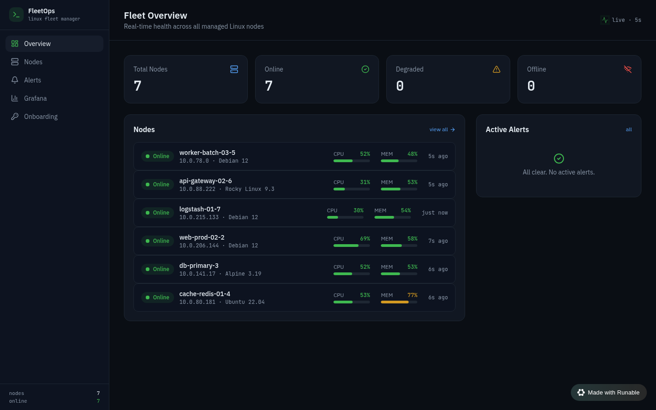
Figure 3 — Fleet overview dashboard

9.2 Node Detail
Full system facts, live resource bars, time-series charts, and a Remote Actions panel with command history.
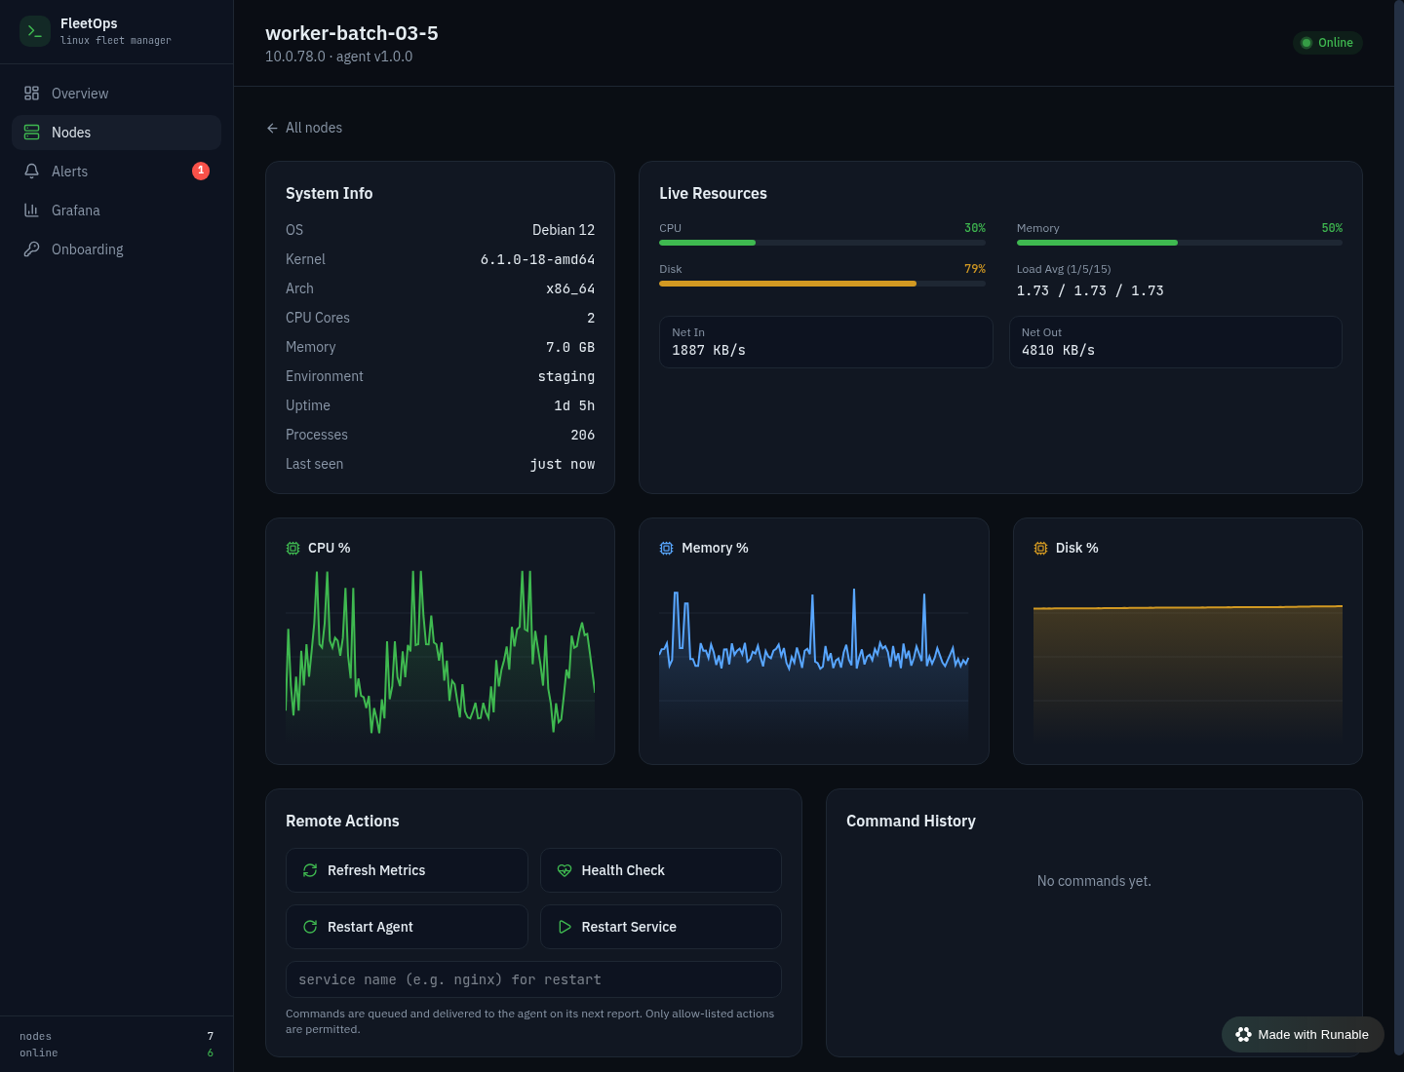
Figure 4 — Node detail with live charts and remote actions

9.3 Fleet — Nodes View
Searchable, filterable table of all managed nodes with status, environment, and latest metrics.
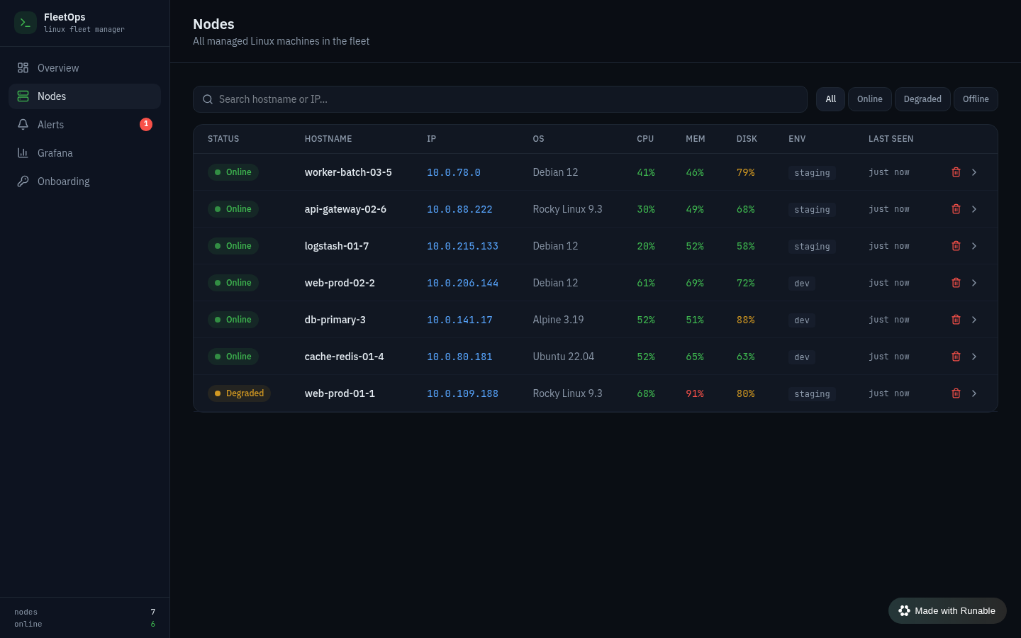
Figure 5 — Nodes table

9.4 Onboarding
Generate a one-time token and copy the single-command agent installer.
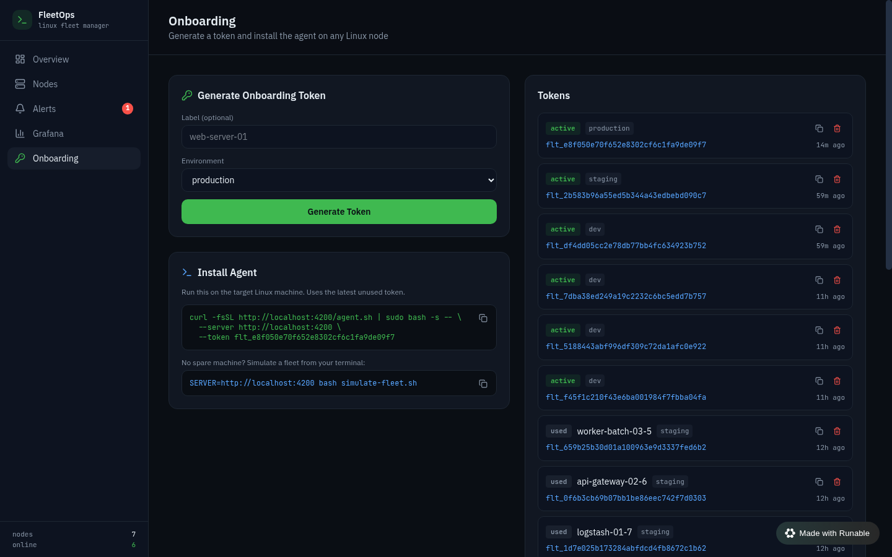
Figure 6 — Node onboarding

10. Technology Stack
Layer | Technology
Agent | Bash + coreutils (no dependencies)
Runtime | Bun
API | Hono (REST)
ORM / DB | Drizzle ORM over SQLite (Turso)
Frontend | React 19 + Wouter + Tailwind CSS
Monitoring | Prometheus + Grafana
Orchestration | Docker Compose

11. How to Run
# 1. Install dependencies
bun install
# 2. Configure database (.env: DATABASE_URL, DATABASE_AUTH_TOKEN)
cd packages/web && bun run db:push && cd ../..
# 3. Start the control plane + dashboard
bun run dev --port 4200 # http://localhost:4200
# 4. Onboard a real node
curl -fsSL http://<server>:4200/agent.sh | sudo bash -s -- \
--server http://<server>:4200 --token flt_xxxxxxxx
# 4b. ...or simulate a whole fleet for testing
bash simulate-fleet.sh 7
# 5. Bring up Prometheus + Grafana
docker compose up -d

12. Results & Conclusion
FleetOps delivers a complete, working Linux fleet management system that meets every requirement of the brief:
- Web-based management of a multi-node Linux fleet from one dashboard.
- Remote onboarding in a single command, working even behind NAT/firewalls.
- Remote management through a safe, allow-listed command channel.
- Metric collection from each node via a lightweight bash agent.
- Storage of time-series telemetry in SQLite/Turso.
- Visualisation through both a custom real-time dashboard and Prometheus + Grafana.
The defining engineering choice — a push-based agent — is what makes the system practical for real infrastructure, where servers commonly sit behind firewalls. Combined with allow-listed remote control and standard Prometheus/Grafana observability, FleetOps is a small but production-shaped take on distributed Linux fleet management.

Future work
- Role-based access control and audit logging for commands.
- Alerting integrations (email / Slack / PagerDuty) via Prometheus Alertmanager.
- Agent auto-update and rolling command rollout across the fleet.
- Historical metric retention beyond the live window.

