

Software Requirements Specification
For
UpTrend

Prepared by:

Specialization | SAP ID | Name
BTech CSE Graphics and  Gaming | 500107118 | Divya Joshi
BTech CSE Graphics and  Gaming | 500106985 | Aditya Narayan Gour

School Of Computer Science

UNIVERSITY OF PETROLEUM & ENERGY STUDIES,
DEHRADUN- 248007. Uttarakhand

 14th March, 2026
Mentor’s Signature Date of submission

Table of Contents

Topic |  | Page  No
Table of Content
Revision History
1 | Introduction
 | 1.1 Purpose of the Project
 | 1.2 Target Beneficiary
 | 1.3 Project Scope
 | 1.4 References
2 | Project Description
 | 2.1 Reference Algorithm
 | 2.2 Data/ Data structure
 | 2.3 SWOT Analysis
 | 2.4 Project Features
 | 2.5 User Classes and Characteristics
 | 2.6 Design and Implementation Constraints
 | 2.7 Design diagrams
 | 2.8 Assumption and Dependencies
3 | System Requirements
 | 3.1 User Interface
 | 3.2 Software Interface
 | 3.3 Database Interface
 | 3.4 Protocols
4 | Non-functional Requirements
 | 4.1 Performance requirements
 | 4.2 Security requirements
 | 4.3 Software Quality Attributes
5 | Other Requirements
Appendix A: Glossary
Appendix B: Analysis Model
Appendix C: Issues List

- INTRODUCTION
  - Purpose of the Project
The purpose of the UpTrend platform is to provide a structured environment where beginners can learn trading concepts and practice them without financial risk.
• Provide a risk-free paper trading environment using virtual currency.
• Help beginners understand financial markets, trading strategies, and risk management.
• Bridge the gap between theoretical knowledge and practical trading experience.
• Reduce confusion caused by fragmented online trading resources.
• Allow users to test trading strategies in a simulated real-market environment.
• Provide performance analytics to track trading progress.
• Build user confidence before entering real financial markets.
• Integrate educational modules with trading simulation for better learning.
  - Target Beneficiary

The UpTrend platform is designed for individuals who want to learn trading in a structured and practical manner.
• Beginner traders who want to understand stock and cryptocurrency markets.
• Students studying finance, economics, or business who require practical exposure.
• Self-learners and professionals interested in financial literacy and investments.
• Individuals who want to test trading strategies without risking real money.
• Users who prefer structured learning rather than scattered online tutorials.
• People who want to track and improve their trading discipline and performance.
• Educational institutions that require interactive financial learning tools.

  - Project Scope
The UpTrend project focuses on developing a web-based trading education and paper trading platform.
• Development of a paper trading simulator that allows users to execute virtual trades.
• Integration of real-time or delayed market price data using financial APIs.
• Implementation of a portfolio management system to track investments.
• Creation of a performance analytics dashboard displaying key trading metrics.
• Development of structured learning modules for trading education.
• Building a responsive web interface accessible on desktops and mobile devices.
• Implementation of secure authentication and user management.
• Ensuring the platform provides a realistic yet risk-free trading environment.

- PROJECT DESCRIPTION
  - Reference Algorithm
The system uses several algorithms to simulate trading operations and analyze user performance.

Trading Simulation Algorithm
- Processes buy and sell orders using virtual currency.
- Updates user portfolios based on executed trades.

Portfolio Valuation Algorithm
- Calculates portfolio value based on current market prices.
- Tracks profit and loss for each trade.

Performance Analytics Algorithm
- Computes trading metrics such as win rate and average return.
- Tracks trading consistency and discipline.

Learning Progress Algorithm
- Monitors completion of academy modules.
- Unlocks trading features after basic learning milestones.

  - Data/Data Structure
The UpTrend platform manages various types of structured and unstructured data.

Input Data
• User registration information.
• Login credentials and authentication data.
• Trading orders (buy/sell requests).
• Market price data from financial APIs.
• Educational progress data.

Output Data
• Portfolio valuation reports.
• Profit and loss calculations.
• Trading performance metrics.
• Trading history logs.

Data Storage
• MongoDB database used for storing structured data.
• Collections include:
- Users
- Trades
- Portfolio
- Learning Modules

  - SWOT Analysis
The UpTrend platform presents several strengths, weaknesses, opportunities, and threats.
Strengths
• Provides a risk-free trading environment for beginners.
• Combines education and practical trading experience.
• Uses modern web technologies for scalability.
Weaknesses
• Dependency on third-party financial APIs.
• Simulated trading may not replicate real emotional trading behavior.
Opportunities
• Integration of AI-based trading insights.
• Development of social trading communities.
• Addition of gamification and leaderboards.
Threats
• Competition from professional trading simulators.
• API policy changes affecting data availability.
  - Project Features
The UpTrend platform includes several core features that enhance the learning and trading experience.
• Paper Trading Engine
Simulates buying and selling of assets using virtual money.
• Trading Dashboard
Displays capital, win rate, total trades, and analytics.
• Portfolio Management
Tracks user holdings and investment value.
• Academy Learning Module
Provides lessons on trading basics and strategies.
• Trading History
Stores all past transactions.
• Performance Analytics
Tracks trading discipline, win rate, and consistency.

  - User Classes and Characteristics
The platform supports different categories of users with varying knowledge levels.

Beginner Users
• Limited knowledge of financial markets.
• Require structured learning modules.
• Use paper trading to practice basic strategies.
Intermediate Users
• Have basic understanding of trading.
• Use simulation to test trading strategies.

Advanced Learners
• Focus on improving trading discipline.
• Use analytics to optimize trading performance.

Administrators
• Manage system updates.
• Monitor platform performance and user activity.

  - Design and Implementation Constraints
The development of the platform is influenced by several technical constraints.
Technology Constraints
• System built using MERN Stack.
• UI designed with Tailwind CSS.
• Backend services developed using Node.js and Express.js.
Performance Constraints
• Trading engine must process transactions quickly.
• Dashboard must display data updates efficiently.
Security Constraints
• Secure user authentication using JWT tokens.
• Password encryption using Bcrypt hashing.
External Dependencies
• Financial data APIs for real-time market prices.
  - Design Diagrams
    - Use Case Diagram:
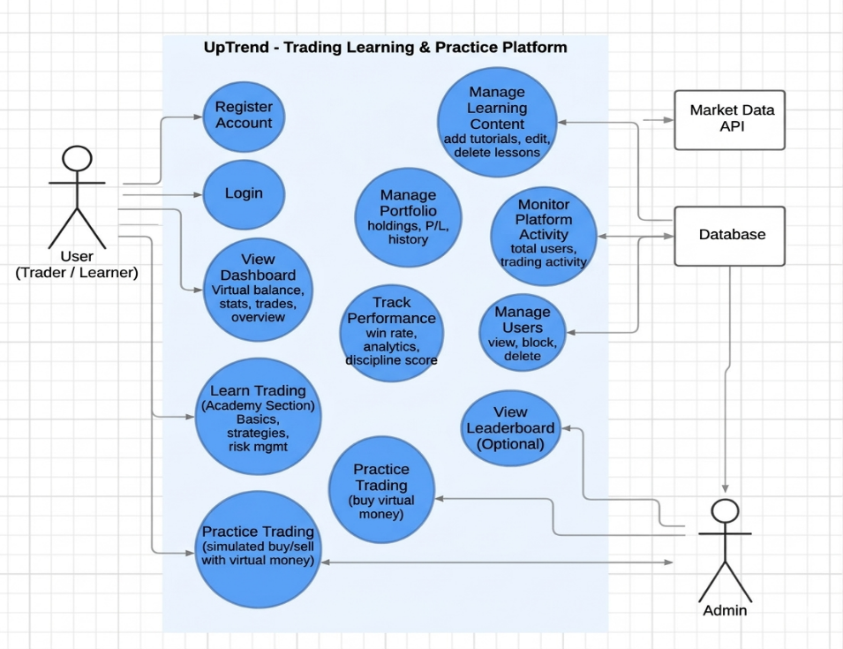
    - Activity Diagram:
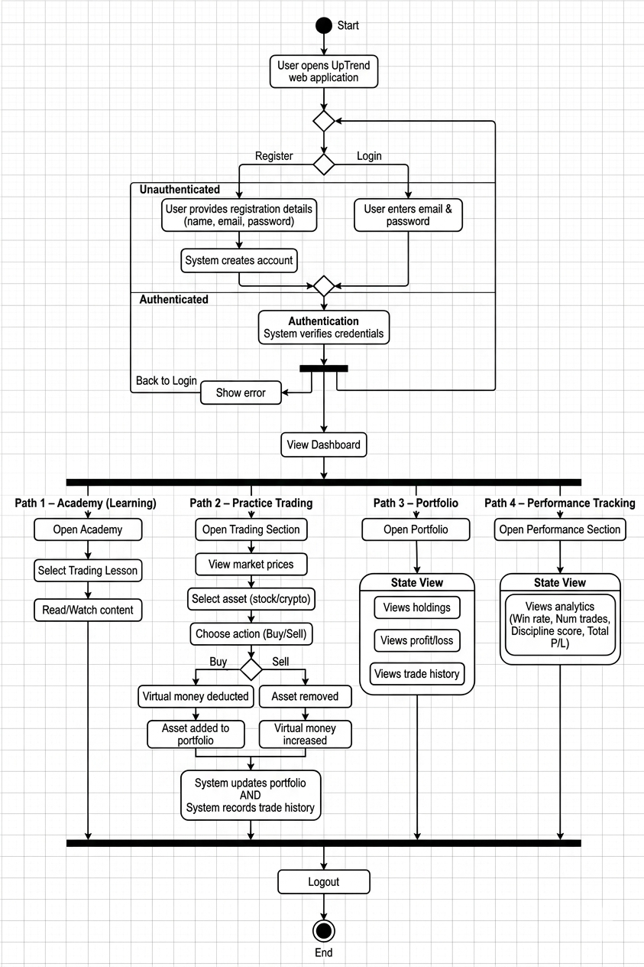

    - Class Diagram:

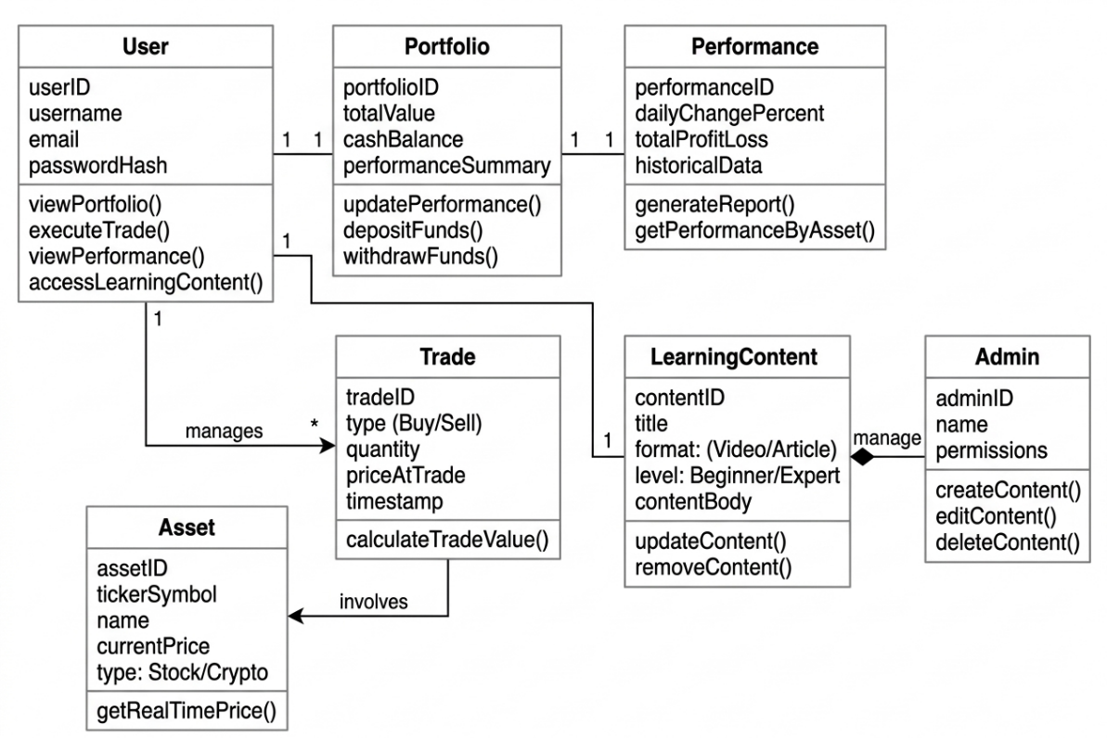

    - System Architecture Diagram:

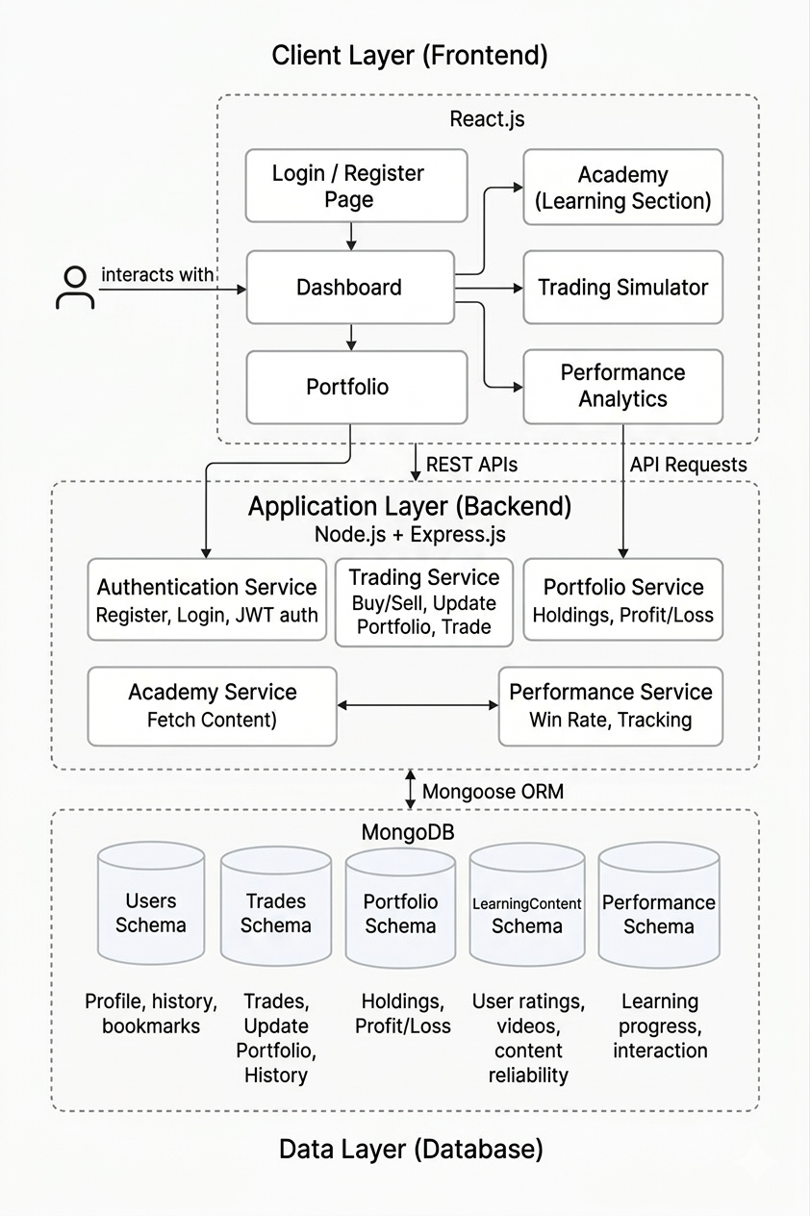
- SYSTEM REQUIREMENTS

3.1 User Interface
The UpTrend platform includes several interface components designed for ease of use.
Dashboard
• Displays trading capital and portfolio performance.
• Shows analytics such as win rate and trading discipline.
Trading Page
• Allows users to execute simulated buy and sell orders.
• Displays real-time market prices.
Portfolio Page
• Displays user holdings and investment values.
• Shows profit and loss summaries.
Academy Section
• Provides educational lessons and quizzes.
• Unlocks trading features after completing modules.
Responsive Design
• Accessible on desktops, tablets, and smartphones.
The system integrates with several external software tools.
• Financial APIs such as Alpha Vantage and Yahoo Finance.
• Charting libraries like Recharts or Chart.js.
• Backend APIs developed using Node.js and Express.js.
• Frontend developed using React.js.
• Version control managed using Git and GitHub.
These integrations ensure real-time data updates and smooth communication between system components.
  - Database Interface
The platform uses MongoDB as the primary database.
• Stores user profiles and authentication data.
• Maintains records of all simulated trades.
• Tracks portfolio holdings and profit/loss history.
• Saves user progress in academy modules.
Database Collections
• Users
• Trades
• Portfolios
• Learning Modules
This database design allows efficient storage and retrieval of large volumes of trading and user activity data.
  - Protocols
The system relies on several communication protocols.

• HTTP/HTTPS Protocol
- Used for communication between frontend and backend.
• REST APIs
- Handle requests such as user login and trade execution.
• WebSockets
- Enable real-time updates for market prices.
• Secure Authentication
- Uses encrypted tokens for session management.

These protocols ensure secure and reliable communication between the application components.

- NON-FUNCTIONAL REQUIREMENTS
  - Performance Requirements
    - Summarization and ranking must complete in under 5 seconds per query.
    - 3D visualization rendering should handle up to 50 nodes without lag on mid-range devices.
    - Offline access retrieves cached data instantly.
  - Security Requirements
    - User data encrypted in transit and at rest.
    - No storage of copyrighted source content; summaries generated on the-fly.
    - Authentication for personalized features.
  - Software Quality Attributes
    - Usability: Intuitive navigation and responsive design.
    - Reliability: Handles diverse inputs without crashes; 99% uptime.
    - Adaptability: Supports multiple devices and browsers.

- OTHER REQUIREMENTS

OTHER REQUIREMENTS
Future improvements may include:
- AI trading insights
- Leaderboards and gamification
- Social trading features
- Advanced order types (limit orders, stop-loss)

Appendix A: Glossary
Paper Trading – Simulated trading using virtual money.
P&L – Profit and Loss calculation.
MERN Stack – MongoDB, Express.js, React.js, Node.js.
API – Application Programming Interface used for data fetching.
Appendix B: Analysis Model
Includes:
- Entity Relationship Model
- System Architecture
- Data Flow between frontend and backend
Appendix C: Issues List
To be filled during testing and development stages.

