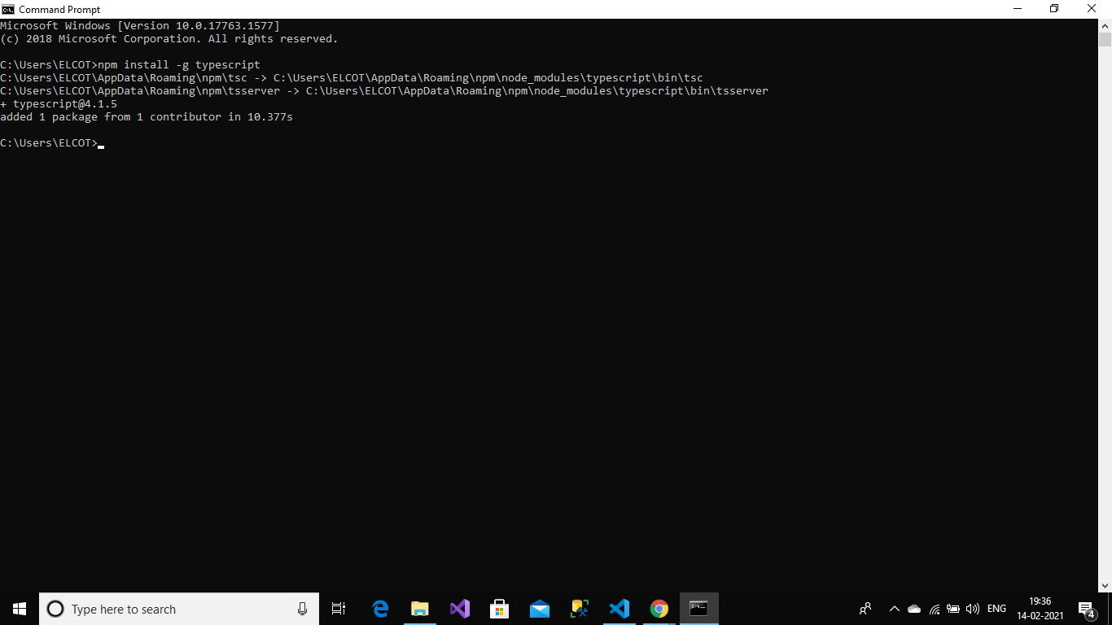

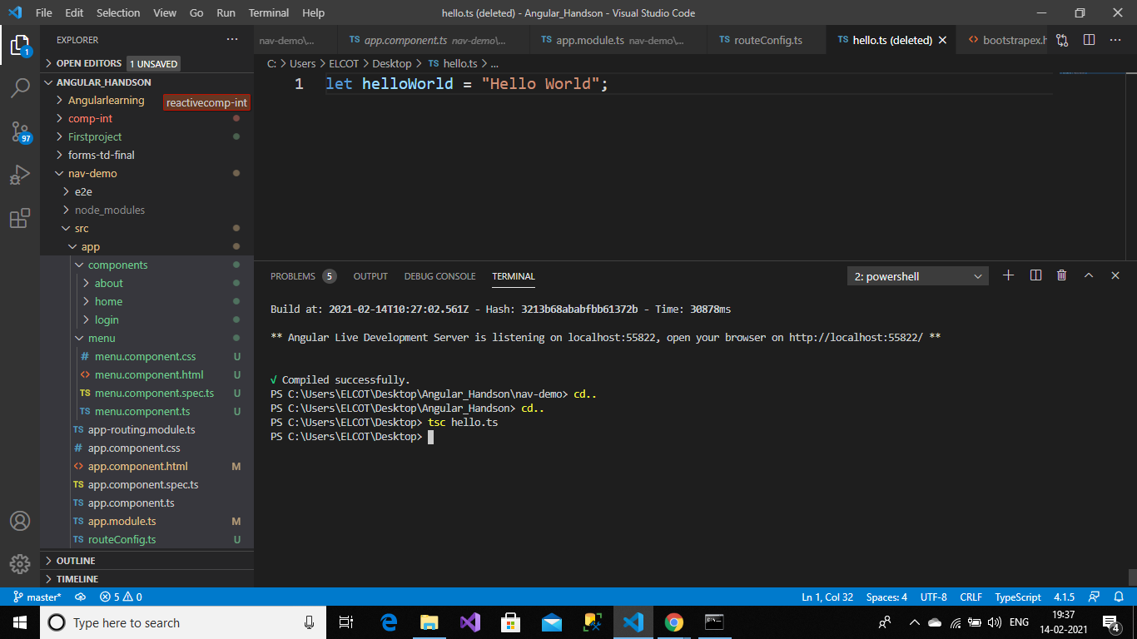

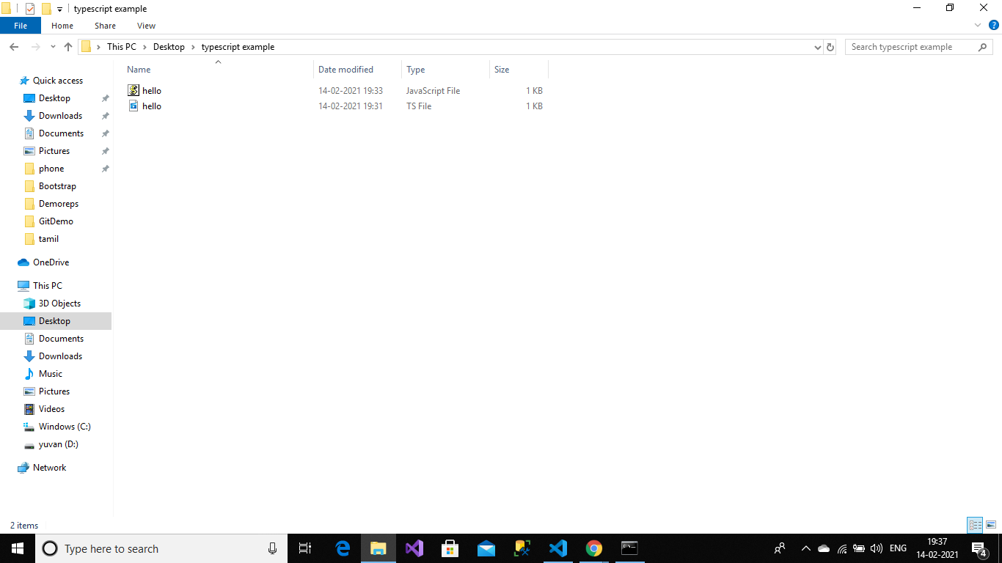

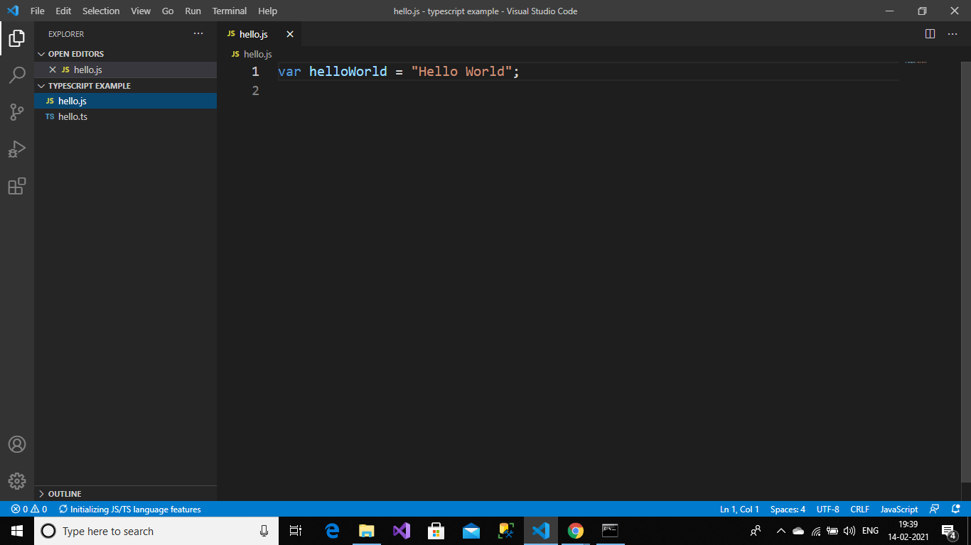

employee-test.html:

<html>

<head>

<title></title>

</head>

<body>

<script> var exports = {}; </script>

<script type="text/javascript" src="employee-test.js"></script>

</body>

</html>

employee.ts:

export interface employee{

id:number;

name:string;

salary:number;

permanent:boolean;

}

employee-test.ts:

import {employee} from './employee';

const emp:employee={

id:101,

name:"divya",

salary:10000,

permanent:false

};

console.log(emp);

employee.js:

"use strict";

exports.__esModule = true;

employee-test.js:

"use strict";

exports.__esModule = true;

var emp = {

id: 101,

name: "divya",

salary: 10000,

permanent: false

};

console.log(emp);

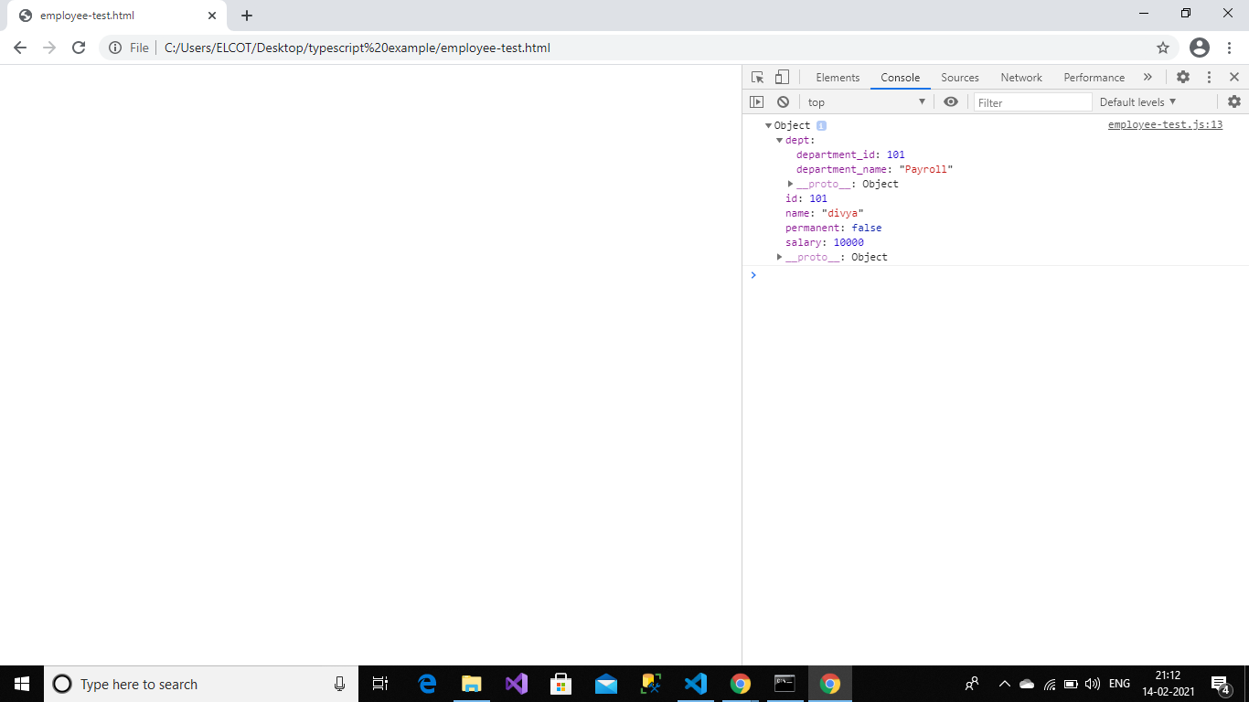

department.ts:

export interface Department{

department_id:number;

department_name:string;

}

employee.ts:

import {Department} from './department';

export interface employee{

id:number;

name:string;

salary:number;

permanent:boolean;

dept:Department;

}

employee-test.ts:

import {employee} from './employee';

const emp:employee={

id:101,

name:"divya",

salary:10000,

permanent:false,

dept:{

department_id:101,

department_name:"Payroll"

}

};

console.log(emp);

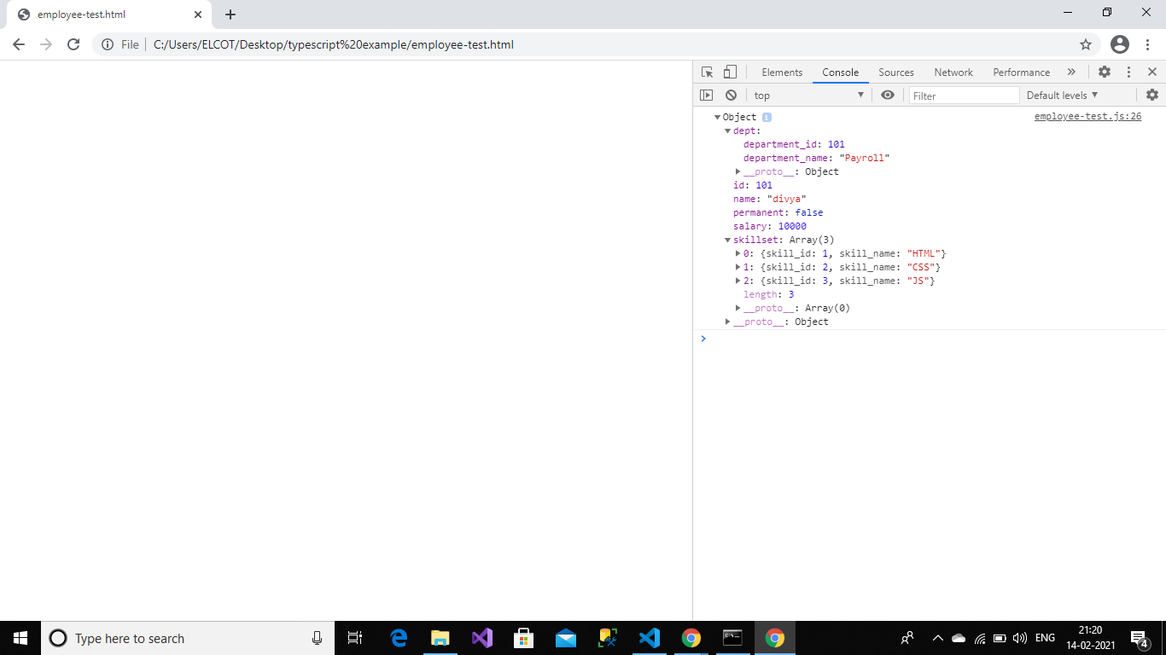

skill.ts:

export interface Skill{

skill_id:number;

skill_name:string;

}

employee.ts:

import {Department} from './department';

import {Skill} from './skill';

export interface employee{

id:number;

name:string;

salary:number;

permanent:boolean;

dept:Department;

skillset:Skill[];

}

employee-test.ts:

import {employee} from './employee';

const emp:employee={

id:101,

name:"divya",

salary:10000,

permanent:false,

dept:{

department_id:101,

department_name:"Payroll"

},

skillset:[{

skill_id:1,

skill_name:"HTML"

},

{

skill_id:2,

skill_name:"CSS"

},

{

skill_id:3,

skill_name:"JS"

}

]

};

console.log(emp);