@Component({

selector: 'app-edit-emp-reactive',

templateUrl: './edit-emp-reactive.component.html',

styleUrls: ['./edit-emp-reactive.component.css']

})

export class EditEmpReactiveComponent implements OnInit {

name=new FormControl('John');

constructor() { }

ngOnInit(): void {

}

}

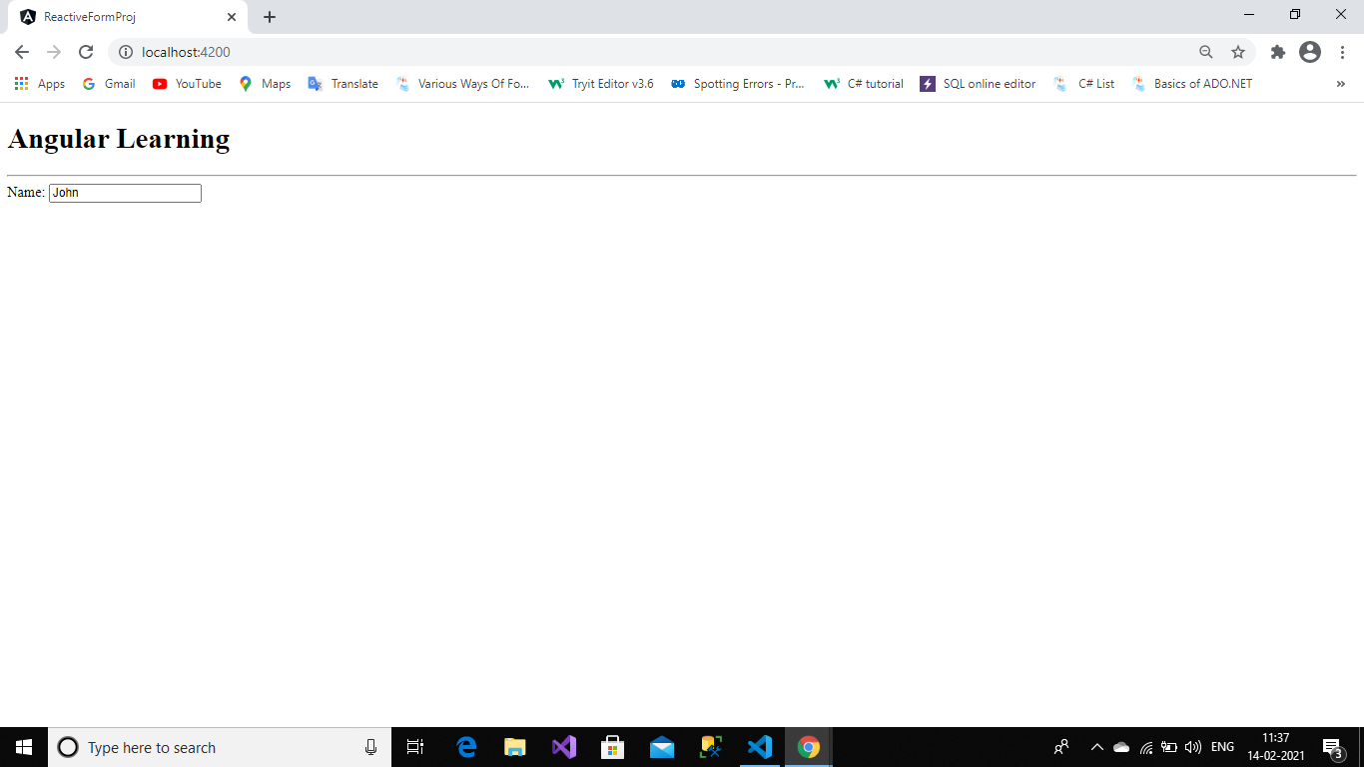

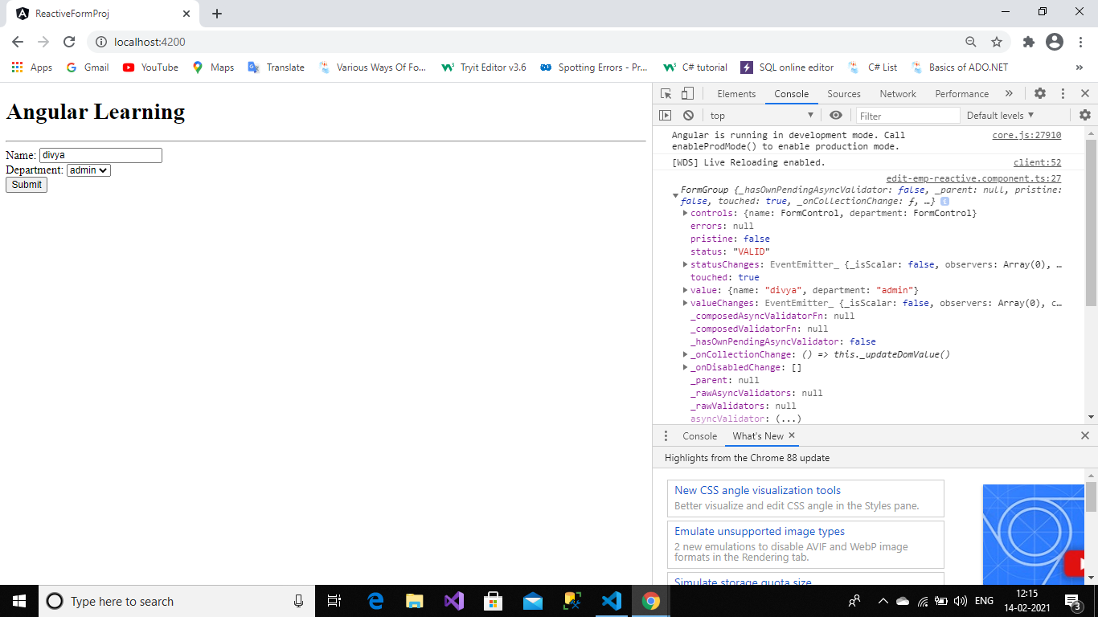

<h1>Angular Learning</h1>

<hr>

<form [formGroup]="empform" (ngSubmit)="onSubmit()">

<div>

Name: <input type="text" formControlName="name">

</div>

<div>

Department:

<select formControlName="department">

<option \*ngFor="let item of Department" [value]="item">

{{item}}

</option>

</select>

</div>

<div>

<button value="submit">Submit</button>

</div>

</form>

Component:

import { Component, OnInit } from '@angular/core';

import { FormControl,FormGroup,Validators } from '@angular/forms';

import {employee} from '../employee';

@Component({

selector: 'app-edit-emp-reactive',

templateUrl: './edit-emp-reactive.component.html',

styleUrls: ['./edit-emp-reactive.component.css']

})

export class EditEmpReactiveComponent implements OnInit {

// name=new FormControl('John');

Department:any[]=['admin','hr'];

empform: FormGroup;

constructor(){

this.empform=new FormGroup({

'name':new FormControl('',Validators.required),

'department':new FormControl(null,Validators.required)

});

}

ngOnInit(): void {

}

onSubmit(){

console.log(this.empform);

}

}

Using Form builder:

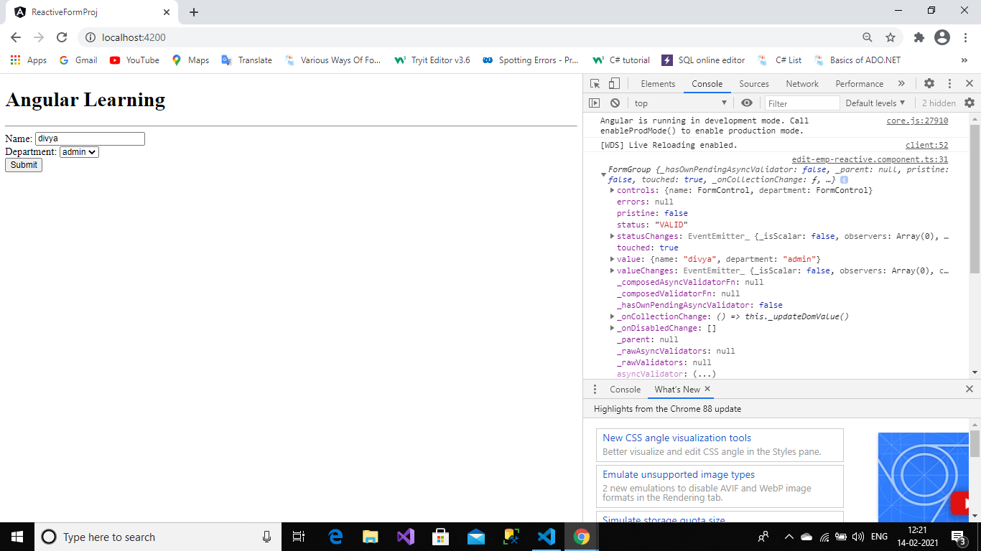

import { Component, OnInit } from '@angular/core';

import { FormBuilder, FormControl,FormGroup,Validators } from '@angular/forms';

import {employee} from '../employee';

@Component({

selector: 'app-edit-emp-reactive',

templateUrl: './edit-emp-reactive.component.html',

styleUrls: ['./edit-emp-reactive.component.css']

})

export class EditEmpReactiveComponent implements OnInit {

// name=new FormControl('John');

Department:any[]=['admin','hr'];

// empform: FormGroup;

constructor(private fb:FormBuilder){

// this.empform=new FormGroup({

// 'name':new FormControl('',Validators.required),

// 'department':new FormControl(null,Validators.required)

// });

}

empform=this.fb.group({

'name':[''],

'department':['']

});

ngOnInit(): void {

}

onSubmit(){

console.log(this.empform);

}

}