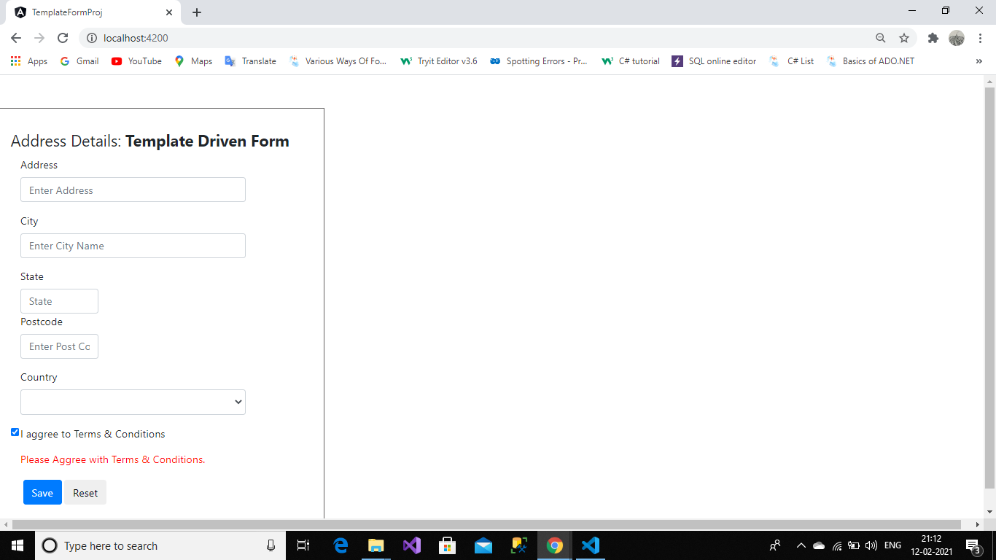

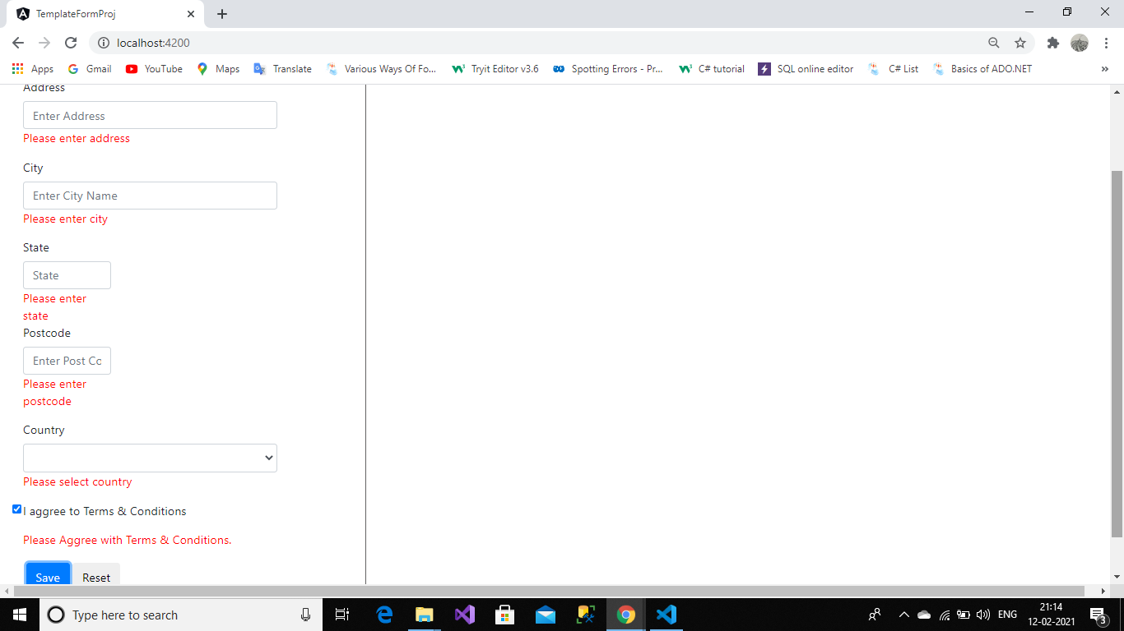

<html>

<head>

<link rel="stylesheet" href="https://maxcdn.bootstrapcdn.com/bootstrap/4.0.0/css/bootstrap.min.css" integrity="sha384-Gn5384xqQ1aoWXA+058RXPxPg6fy4IWvTNh0E263XmFcJlSAwiGgFAW/dAiS6JXm" crossorigin="anonymous">

</head>

<body>

<div class="row">

<div class="col-md-4 col-md-offset-4" style="margin-top: 50px; border: 1px solid rgb(100, 98, 98); padding: 30px;">

<form class="form-horizontal" role="form" #f="ngForm" (ngSubmit)="f.form.valid && onFormSubmit()">

<fieldset>

<legend>Address Details:

<strong>Template Driven Form</strong>

</legend>

<div class="form-group">

<label class="col-sm-2 control-label" for="textinput">Address</label>

<div class="col-sm-10">

<input type="text" name="address" placeholder="Enter Address" class="form-control" [(ngModel)]="model.address"

[ngClass]="{'invalid-data':address.invalid && f.submitted,'valid-data':address.valid && f.submitted}"

required #address="ngModel"/>

<div \*ngIf="address.invalid && f.submitted">

<span style="color:red;">Please enter address</span>

</div>

</div>

</div>

<div class="form-group">

<label class="col-sm-2 control-label" for="textinput">City</label>

<div class="col-sm-10">

<input type="text" name="city" placeholder="Enter City Name" class="form-control"

[(ngModel)]="model.city"

[ngClass]="{'invalid-data':city.invalid && f.submitted,'valid-data':city.valid && f.submitted}"

required #city="ngModel">

<div \*ngIf="city.invalid && f.submitted">

<span style="color:red;">Please enter city</span>

</div>

</div>

</div>

<div class="form-group">

<label class="col-sm-2 control-label" for="textinput">State</label>

<div class="col-sm-4">

<input type="text" name="state" placeholder="State" class="form-control"

[(ngModel)]="model.state"

[ngClass]="{'invalid-data':state.invalid && f.submitted,'valid-data':state.valid && f.submitted}"

required #state="ngModel">

<div \*ngIf="state.invalid && f.submitted">

<span style="color:red;">Please enter state</span>

</div>

</div>

<label class="col-sm-2 control-label" for="textinput">Postcode</label>

<div class="col-sm-4">

<input type="text" name="postcode" placeholder="Enter Post Code" class="form-control"

[(ngModel)]="model.postcode"

[ngClass]="{'invalid-data':postcode.invalid && f.submitted,'valid-data':postcode.valid && f.submitted}"

required #postcode="ngModel">

<div \*ngIf="postcode.invalid && f.submitted">

<span style="color:red;">Please enter postcode</span>

</div>

</div>

</div>

<div class="form-group">

<label class="col-sm-2 control-label" for="textinput">Country</label>

<div class="col-sm-10">

<select class="form-control" name="country"

[(ngModel)]="model.country"

[ngClass]="{'invalid-data':country.invalid && f.submitted,'valid-data':country.valid && f.submitted}"

#country="ngModel"

required>

<option>---Select---</option>

<option \*ngFor="let item of countryData" [value]="item">

{{item}}

</option>

</select>

<div \*ngIf="country.invalid && f.submitted">

<span style="color:red;">Please select country</span>

</div>

</div>

</div>

<div class="form-group">

<div class="col-sm-2 form-check">

<input type="checkbox" name="aggrement" class="form-check-input"

[(ngModel)]="model.aggrement" [ngClass]="{'invalid-data':aggrement.invalid &&

f.submitted,'valid-data':aggrement.valid && f.submitted}" #aggrement="ngModel"/>

</div>

<label class="col-sm-10 form-check-label">I aggree to Terms & Conditions

</label>

</div>

<div class="form-group">

<div class="col-sm-12">

<span style="color: red;">Please Aggree with Terms & Conditions.</span>

</div>

</div>

<div class="form-group">

<div class="col-sm-offset-2 col-sm-10">

<div class="pull-right">

<button type="submit" class="btn btn-primary" style="margin: 4px;">Save</button>

<button type="reset" class="btn btn-default">Reset</button>

</div>

</div>

</div>

</fieldset>

</form>

</div>

</div>

<script src="https://cdn.jsdelivr.net/npm/bootstrap@5.0.0-beta2/dist/js/bootstrap.bundle.min.js" integrity="sha384-b5kHyXgcpbZJO/tY9Ul7kGkf1S0CWuKcCD38l8YkeH8z8QjE0GmW1gYU5S9FOnJ0" crossorigin="anonymous"></script>

<script src="https://cdn.jsdelivr.net/npm/@popperjs/core@2.6.0/dist/umd/popper.min.js" integrity="sha384-KsvD1yqQ1/1+IA7gi3P0tyJcT3vR+NdBTt13hSJ2lnve8agRGXTTyNaBYmCR/Nwi" crossorigin="anonymous"></script>

<script src="https://cdn.jsdelivr.net/npm/bootstrap@5.0.0-beta2/dist/js/bootstrap.min.js" integrity="sha384-nsg8ua9HAw1y0W1btsyWgBklPnCUAFLuTMS2G72MMONqmOymq585AcH49TLBQObG" crossorigin="anonymous"></script>

</body>

</html>