







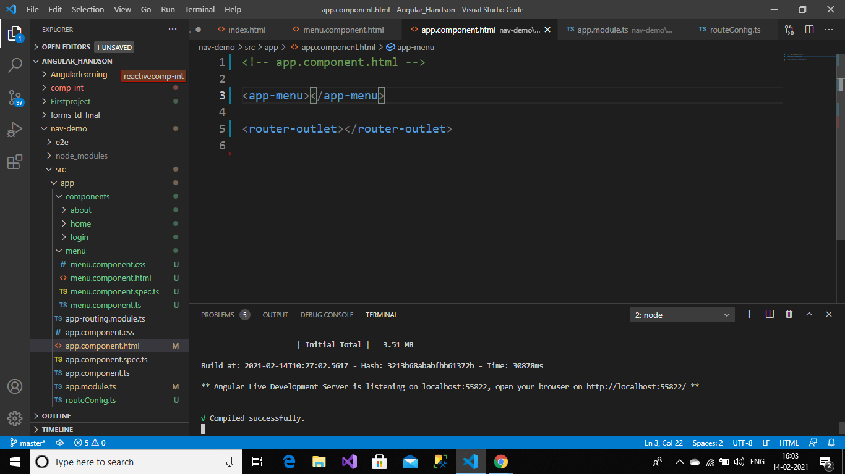

appmodule.ts

import { NgModule } from '@angular/core';

import { BrowserModule } from '@angular/platform-browser';

import {RouterModule} from '@angular/router'

import { AppRoutingModule } from './app-routing.module';

import { AppComponent } from './app.component';

import { HomeComponent } from './components/home/home.component';

import { AboutComponent } from './components/about/about.component';

import { LoginComponent } from './components/login/login.component';

import { MenuComponent } from './menu/menu.component';

import {appRoutes} from './routeConfig';

@NgModule({

declarations: [

AppComponent,

HomeComponent,

AboutComponent,

LoginComponent,

MenuComponent

],

imports: [

BrowserModule,

AppRoutingModule,

RouterModule.forRoot(appRoutes)

],

providers: [],

bootstrap: [AppComponent]

})

export class AppModule { }

menu.component.html

<div class="container">

<nav class="navbar navbar-inverse">

<div class="container-fluid">

<div class="navbar-header">

<a class="navbar-brand"

href="https://www.justcompile.com/">Just Compile</a>

</div>

<ul class="nav navbar-nav">

<li><a routerLink="home">Home</a></li>

<li><a routerLink="about">About</a></li>

<li><a routerLink="login">Login</a></li>

</ul>

</div>

</nav>

</div>

routeConfig.ts

import { Routes } from '@angular/router';

import { HomeComponent } from './components/home/home.component';

import { AboutComponent } from './components/about/about.component';

import { LoginComponent } from './components/login/login.component';

export const appRoutes: Routes = [

{ path: 'home', component: HomeComponent },

{ path: 'about',component: AboutComponent},

{ path: 'login',component: LoginComponent}];