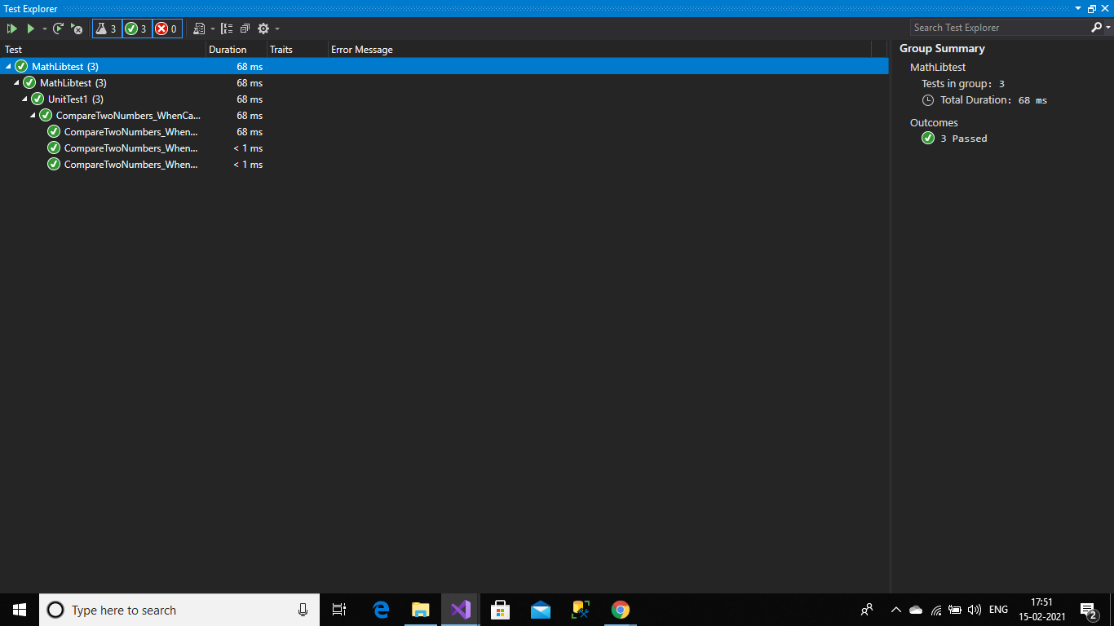

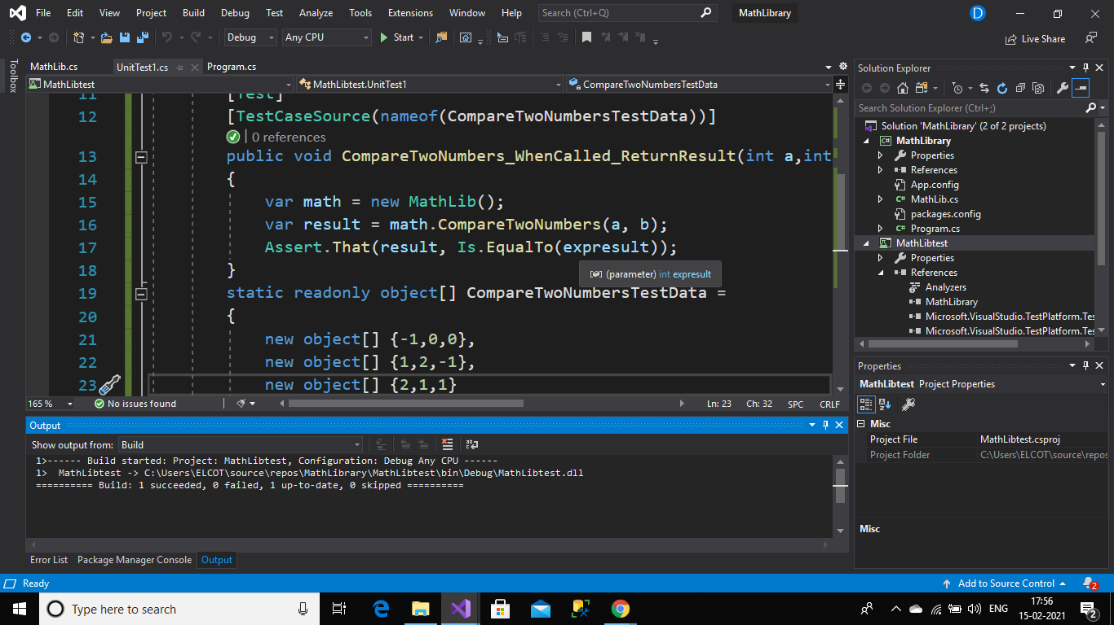

Test class:

using MathLibrary;

using NUnit.Framework;

using System;

using System.Collections.Generic;

namespace MathLibtest

{

[TestFixture]

public class UnitTest1

{

[Test]

[TestCaseSource(nameof(CompareTwoNumbersTestData))]

public void CompareTwoNumbers_WhenCalled_ReturnResult(int a,int b,int expresult)

{

var math = new MathLib();

var result = math.CompareTwoNumbers(a, b);

Assert.That(result, Is.EqualTo(expresult));

}

static readonly object[] CompareTwoNumbersTestData =

{

new object[] {-1,0,0},

new object[] {1,2,-1},

new object[] {2,1,1}

};

}

}

Math class:

using System;

using System.Collections.Generic;

using System.Linq;

using System.Text;

using System.Threading.Tasks;

namespace MathLibrary

{

public class MathLib

{

public int CompareTwoNumbers(int a, int b)

{

if (a <=0 || b<=0)

{

return 0;

}

else if (a >= b)

{

return 1;

}

else

{

return -1;

}

}

}

}