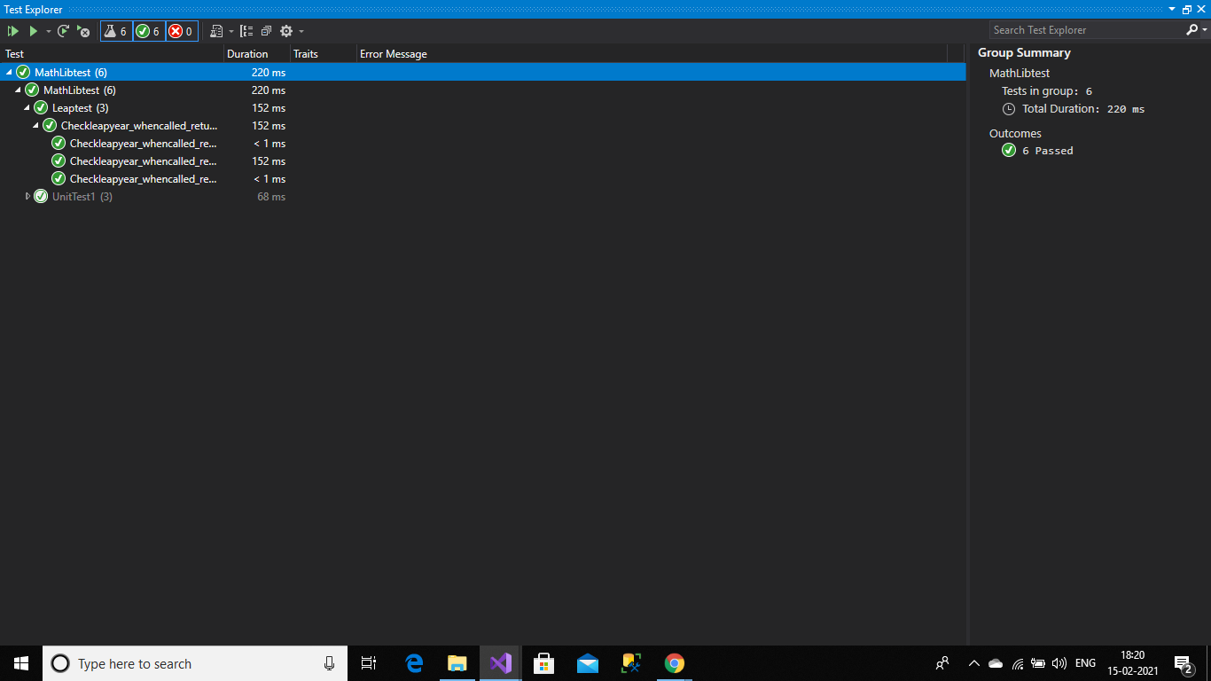

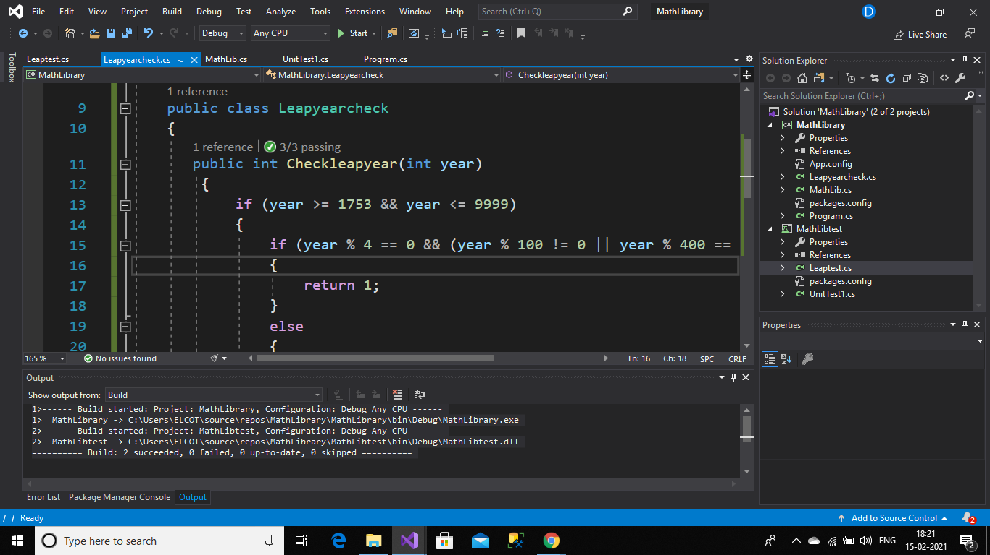

Leap Class:

using System;

using System.Collections.Generic;

using System.Linq;

using System.Text;

using System.Threading.Tasks;

namespace MathLibrary

{

public class Leapyearcheck

{

public int Checkleapyear(int year)

{

if (year >= 1753 && year <= 9999)

{

if (year % 4 == 0 && (year % 100 != 0 || year % 400 == 0))

{

return 1;

}

else

{

return 0;

}

}

else

{

return -1;

}

}

}

}

TestClass:

using MathLibrary;

using NUnit.Framework;

using System;

using System.Collections.Generic;

using System.Linq;

using System.Text;

using System.Threading.Tasks;

namespace MathLibtest

{

[TestFixture]

class Leaptest

{

[Test]

[TestCase(2020,1)]

[TestCase(2021,0)]

[TestCase(1700,-1)]

public void Checkleapyear_whencalled_returnresult(int year,int expres)

{

var leap_check = new Leapyearcheck();

var result = leap_check.Checkleapyear(year);

Assert.That(result, Is.EqualTo(expres));

}

}

}