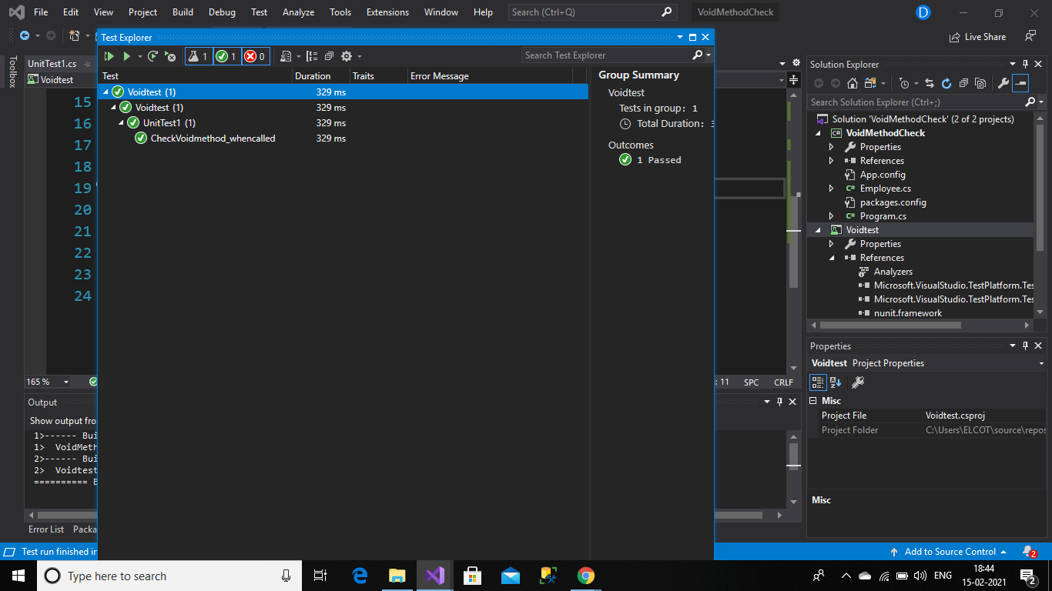

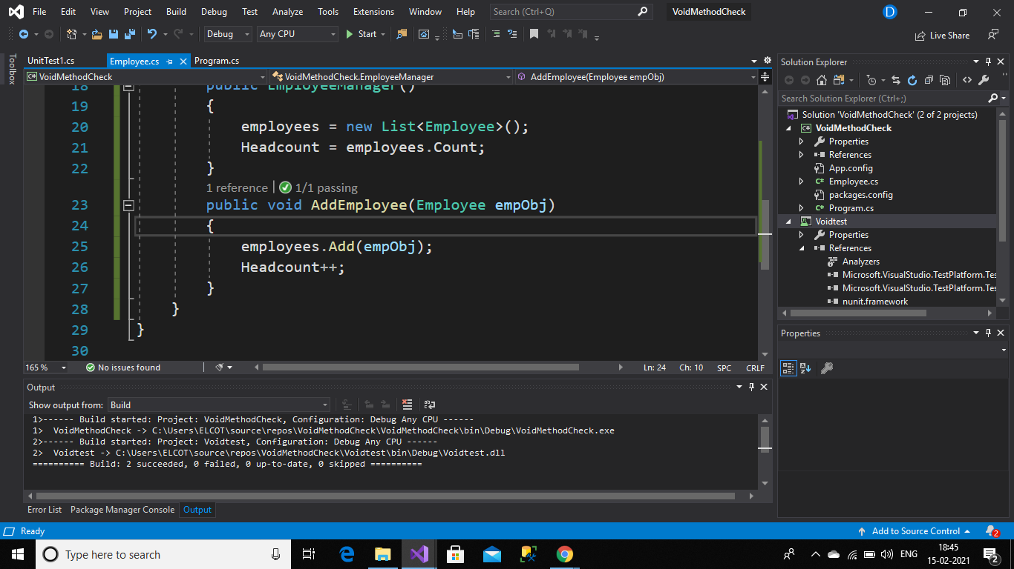

Testclass:

using NUnit.Framework;

using System;

using VoidMethodCheck;

namespace Voidtest

{

[TestFixture]

public class UnitTest1

{

[Test]

public void CheckVoidmethod_whencalled()

{

var emp = new EmployeeManager();

var employee = new Employee();

employee.Id = 101;

employee.Name = "divya";

emp.AddEmployee(employee);

Assert.That(emp.Headcount, Is.EqualTo(1));

}

}

}

Employee class:

using System;

using System.Collections.Generic;

using System.Linq;

using System.Text;

using System.Threading.Tasks;

namespace VoidMethodCheck

{

public class Employee

{

public int Id { get; set; }

public string Name { get; set; }

}

public class EmployeeManager

{

private readonly List<Employee> employees;

public int Headcount { get; set; }

public EmployeeManager()

{

employees = new List<Employee>();

Headcount = employees.Count;

}

public void AddEmployee(Employee empObj)

{

employees.Add(empObj);

Headcount++;

}

}

}