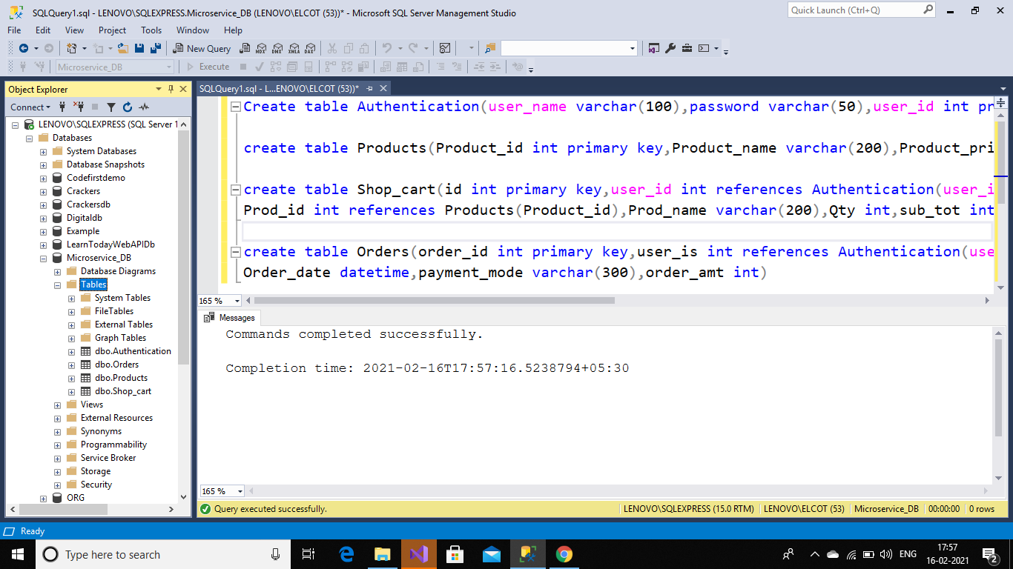

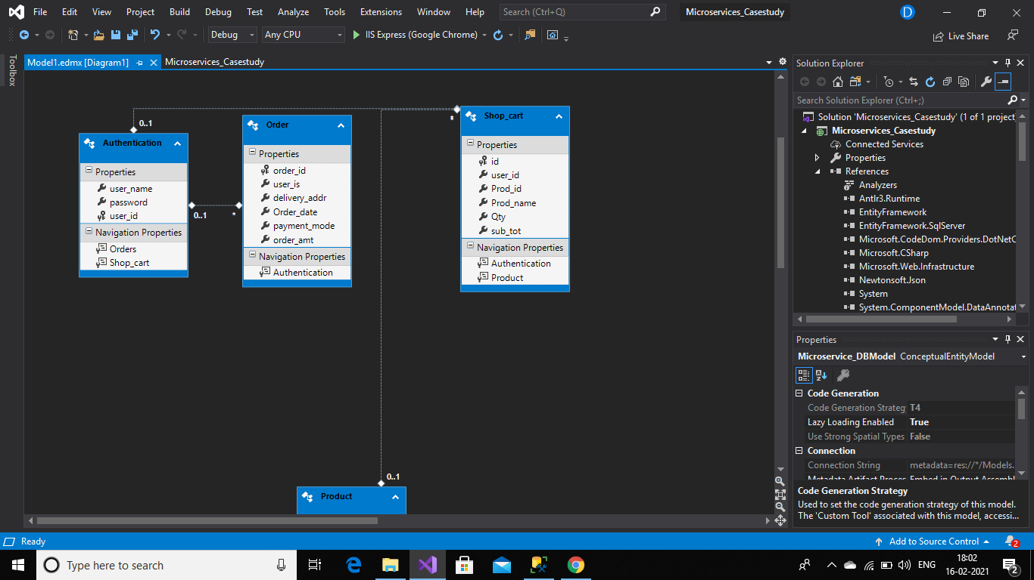

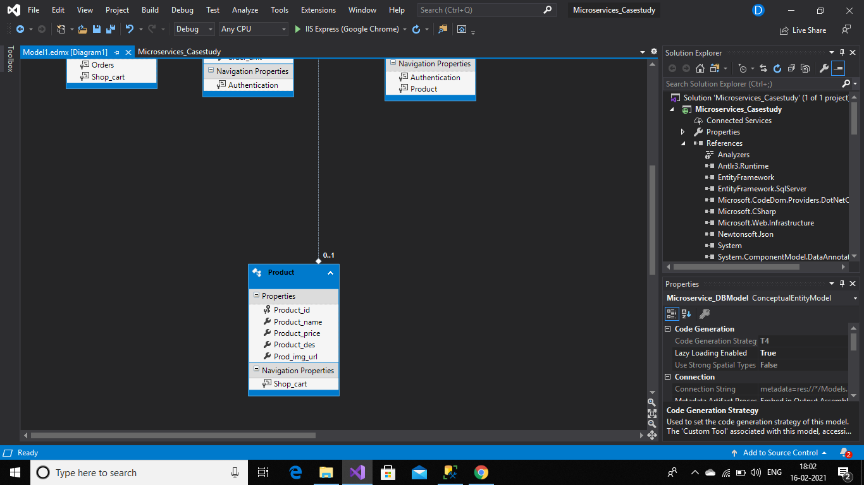

//Classes:

//Authentication:

namespace Microservices_Casestudy.Models

{

using System;

using System.Collections.Generic;

public partial class Authentication

{

[System.Diagnostics.CodeAnalysis.SuppressMessage("Microsoft.Usage", "CA2214:DoNotCallOverridableMethodsInConstructors")]

public Authentication()

{

this.Orders = new HashSet<Order>();

this.Shop_cart = new HashSet<Shop_cart>();

}

public string user_name { get; set; }

public string password { get; set; }

public int user_id { get; set; }

[System.Diagnostics.CodeAnalysis.SuppressMessage("Microsoft.Usage", "CA2227:CollectionPropertiesShouldBeReadOnly")]

public virtual ICollection<Order> Orders { get; set; }

[System.Diagnostics.CodeAnalysis.SuppressMessage("Microsoft.Usage", "CA2227:CollectionPropertiesShouldBeReadOnly")]

public virtual ICollection<Shop_cart> Shop_cart { get; set; }

}

}

//Order.cs

namespace Microservices_Casestudy.Models

{

using System;

using System.Collections.Generic;

public partial class Order

{

public int order_id { get; set; }

public Nullable<int> user_is { get; set; }

public string delivery_addr { get; set; }

public Nullable<System.DateTime> Order_date { get; set; }

public string payment_mode { get; set; }

public Nullable<int> order_amt { get; set; }

public virtual Authentication Authentication { get; set; }

}

}

//Product.cs:

namespace Microservices_Casestudy.Models

{

using System;

using System.Collections.Generic;

public partial class Product

{

[System.Diagnostics.CodeAnalysis.SuppressMessage("Microsoft.Usage", "CA2214:DoNotCallOverridableMethodsInConstructors")]

public Product()

{

this.Shop_cart = new HashSet<Shop_cart>();

}

public int Product_id { get; set; }

public string Product_name { get; set; }

public Nullable<int> Product_price { get; set; }

public string Product_des { get; set; }

public string Prod_img_url { get; set; }

[System.Diagnostics.CodeAnalysis.SuppressMessage("Microsoft.Usage", "CA2227:CollectionPropertiesShouldBeReadOnly")]

public virtual ICollection<Shop_cart> Shop_cart { get; set; }

}

}

//Shop_cart.cs:

namespace Microservices_Casestudy.Models

{

using System;

using System.Collections.Generic;

public partial class Shop_cart

{

public int id { get; set; }

public Nullable<int> user_id { get; set; }

public Nullable<int> Prod_id { get; set; }

public string Prod_name { get; set; }

public Nullable<int> Qty { get; set; }

public Nullable<int> sub_tot { get; set; }

public virtual Authentication Authentication { get; set; }

public virtual Product Product { get; set; }

}

}

//CONTROLLERS:

//Auth_controller:

using Microservices_Casestudy.Models;

using System;

using System.Collections.Generic;

using System.Linq;

using System.Net;

using System.Net.Http;

using System.Web.Http;

namespace Microservices_Casestudy.Controllers

{

public class AuthController : ApiController

{

public HttpResponseMessage Post([FromBody] Authentication obj)

{

Microservice_DBEntities microservice_DBEntities = new Microservice_DBEntities();

var res=microservice_DBEntities.Authentications.Add(obj);

if (res!=null)

{

return Request.CreateResponse(HttpStatusCode.OK, res);

}

else

{

return Request.CreateErrorResponse(HttpStatusCode.NotFound, "Not found");

}

}

}

}

//Products

using Microservices_Casestudy.Models;

using System;

using System.Collections.Generic;

using System.Linq;

using System.Net;

using System.Net.Http;

using System.Web.Http;

namespace Microservices_Casestudy.Controllers

{

public class ProductsController : ApiController

{

public HttpResponseMessage Get()

{

Microservice_DBEntities microservice_DBEntities = new Microservice_DBEntities();

return Request.CreateResponse(HttpStatusCode.OK, microservice_DBEntities.Products.ToList());

}

}

}

//order:

using Microservices_Casestudy.Models;

using System;

using System.Collections.Generic;

using System.Linq;

using System.Net;

using System.Net.Http;

using System.Web.Http;

namespace Microservices_Casestudy.Controllers

{

public class OrderController : ApiController

{

public HttpResponseMessage Post([FromBody] Order obj)

{

Microservice_DBEntities microservice_DBEntities = new Microservice_DBEntities();

microservice_DBEntities.Orders.Add(obj);

return Request.CreateResponse(HttpStatusCode.OK, "added");

}

}

}

//cart:

using Microservices_Casestudy.Models;

using System;

using System.Collections.Generic;

using System.Linq;

using System.Net;

using System.Net.Http;

using System.Web.Http;

namespace Microservices_Casestudy.Controllers

{

public class CartController : ApiController

{

public HttpResponseMessage Get([FromUri] int id)

{

Microservice_DBEntities microservice_DBEntities = new Microservice_DBEntities();

var res = microservice_DBEntities.Shop_cart.FirstOrDefault(x => x.id == id);

if (res != null)

{

return Request.CreateResponse(HttpStatusCode.OK, microservice_DBEntities.Shop_cart.ToList());

}

else

{

return Request.CreateErrorResponse(HttpStatusCode.NotFound, "record not found");

}

}

public HttpResponseMessage Post([FromBody] Shop_cart obj)

{

Microservice_DBEntities microservice_DBEntities = new Microservice_DBEntities();

var res = microservice_DBEntities.Shop_cart.Add(obj);

microservice_DBEntities.SaveChanges();

return Request.CreateResponse(HttpStatusCode.OK, res);

}

public HttpResponseMessage Delete([FromUri] int id,int p_id)

{

Microservice_DBEntities microservice_DBEntities = new Microservice_DBEntities();

var res = microservice_DBEntities.Shop_cart.FirstOrDefault(x => x.id == id && x.Prod_id == p_id);

if (res != null)

{

microservice_DBEntities.Shop_cart.Remove(res);

microservice_DBEntities.SaveChanges();

return Request.CreateResponse(HttpStatusCode.OK, res);

}

else

{

return Request.CreateErrorResponse(HttpStatusCode.NotFound, "not found");

}

}

}

}