**CRM APPLICATION FOR MALL MANAGEMENT**

**Team Members: Naan Mudhalvan ID:**

DIVYABHARATHI D 04F580E549F0D05AC994544677EB232C

BHUVANESHWARI S E9A0B24643A241AA9DF491C57672EDA2

GAJALAKSHMI S AC064FFB6E3C9ADBDD04B5BC7F4FD332

HEMALATHA B A587325A42B15709BA3403EC72433E5A

**1.Project Overview:**

This project focuses on developing a CRM application tailored for mall management. It is designed to streamline operations, enhance tenant and customer relationships, and optimize revenue management. By leveraging the Salesforce platform, the project aims to provide centralized control and real-timeinsights for mall administrators.

**2.Objectives:**

**Business Goals: -**

* Improve tenant relationship management.
* Enhance customer engagement and satisfaction.
* Optimize operational efficiency and revenue tracking.

**Specific Outcomes: -**

* A unified tenant management system.
* Custom dashboards for real-time insights.
* Automated workflows for common tasks such as lease renewals and maintenance scheduling.

**3.** **Salesforce key Features and Concepts Utilized:**

**Salesforce Service Cloud:**

* For tenant and customer support management.

**Salesforce Sales Cloud:**

* For leasing and revenue tracking.

**Custom Workflows:**

* Automated task management for operational efficiency.

**Reports and Dashboards:**

* Real-time data visualization for mall management.

**4. Detailed Steps to Solution Design:**

* **Create Custom Objects:**

We should create a custom objects in salesforce, follow these details:

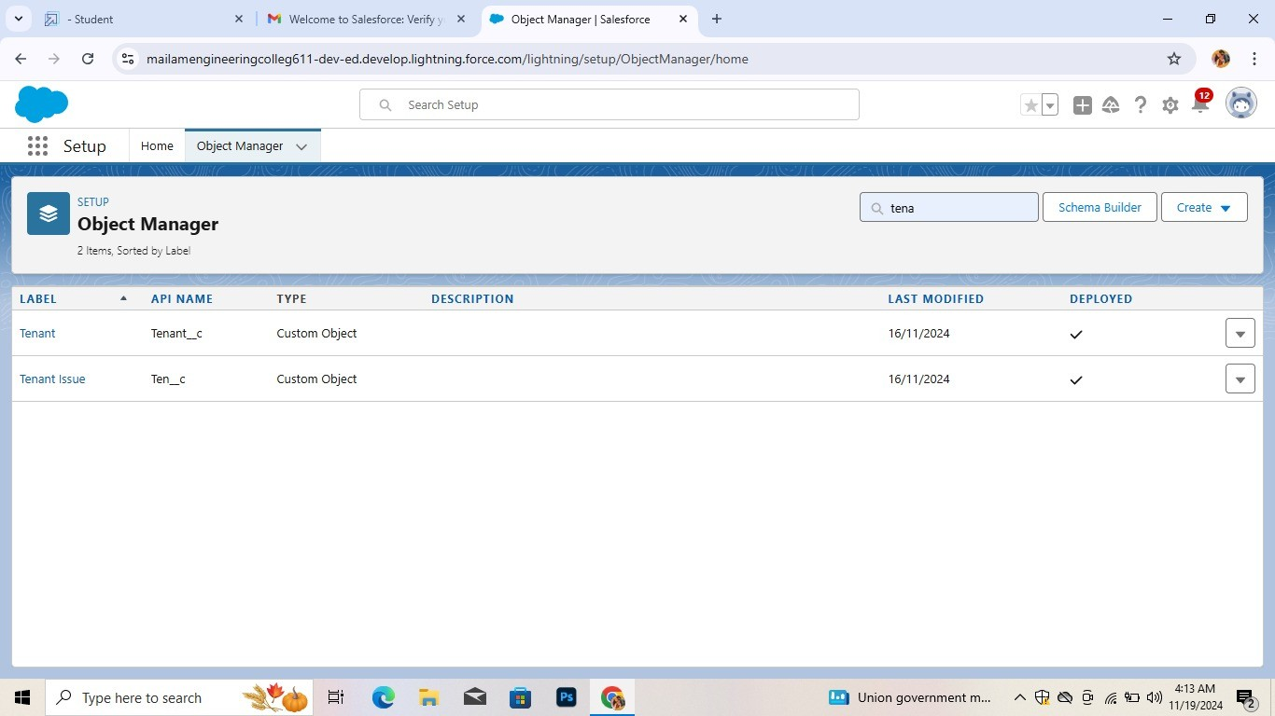

* **Create a Tabs:**

Tabs in a CRM (Customer Relationship Management) application for a mall typically serve as organized sections to manage various aspects of customer and business interactions. Here are common tab ideas.

Overview of key metrics, such as footfall, sales data, and tenant performance.

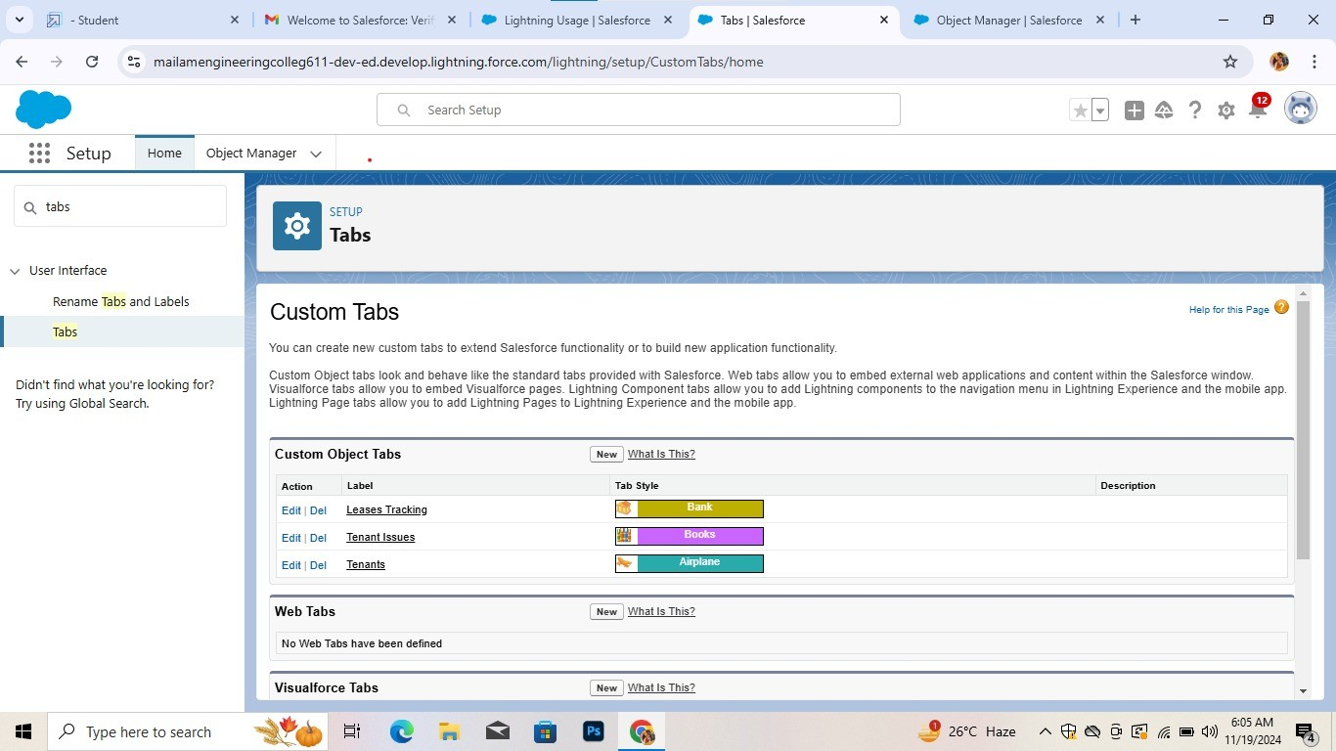

* **Create fields on tenant object:**

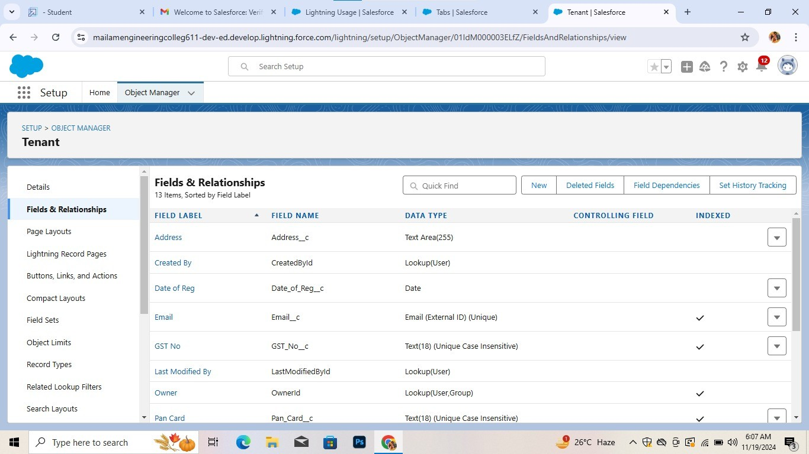

* **Create fields on Lease tracking object**:

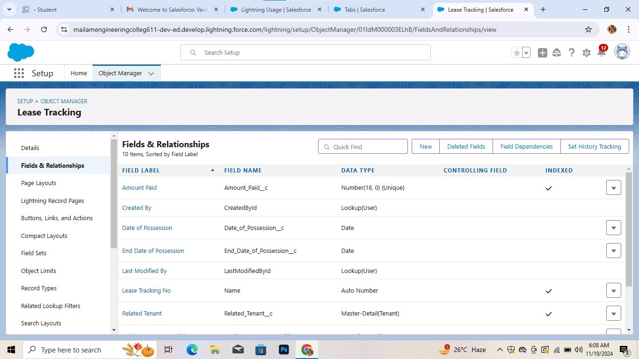

* **Create fields on tenant issues:**



* **Create a lightning app:**

Create a Custom Lightning App that integrates the following components:

* Opportunity Records o Automobile Information records o Invoices related to Opportunities The app should include:
* Navigation to all relevant objects (Opportunities, Automobiles, Invoices).
* A dashboard to visualize Total Sales, Invoices due, opportunity stage.

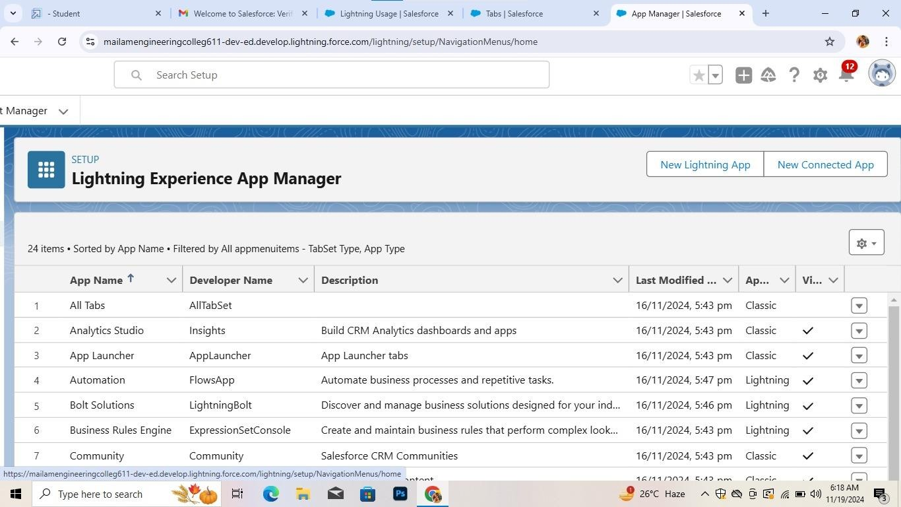

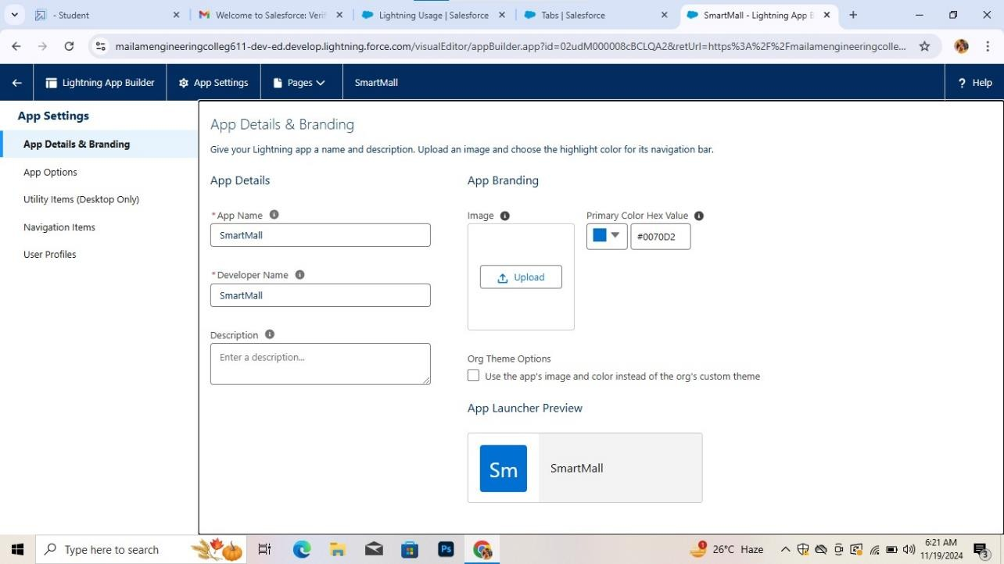

* **Inserting records in tenant object:**

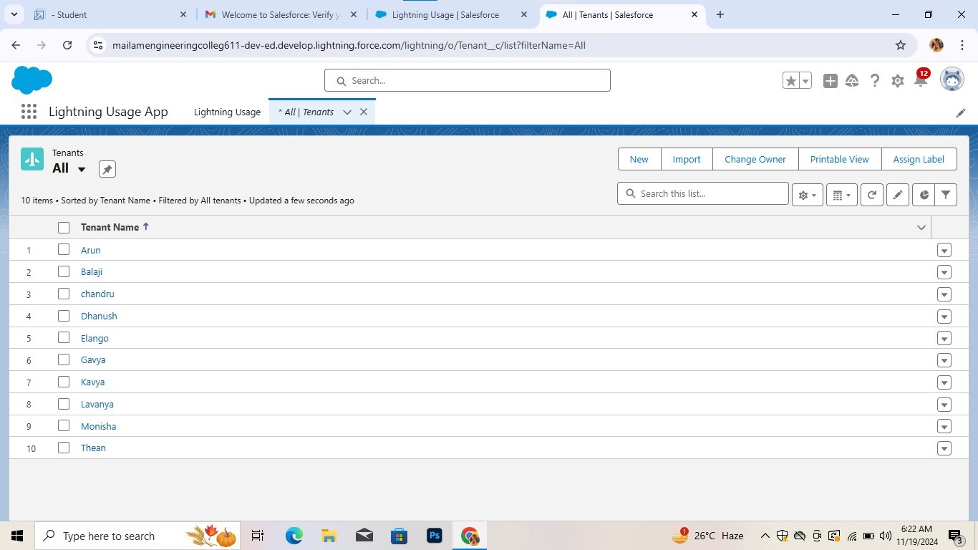

* **Inserting records in lease tracking object:**

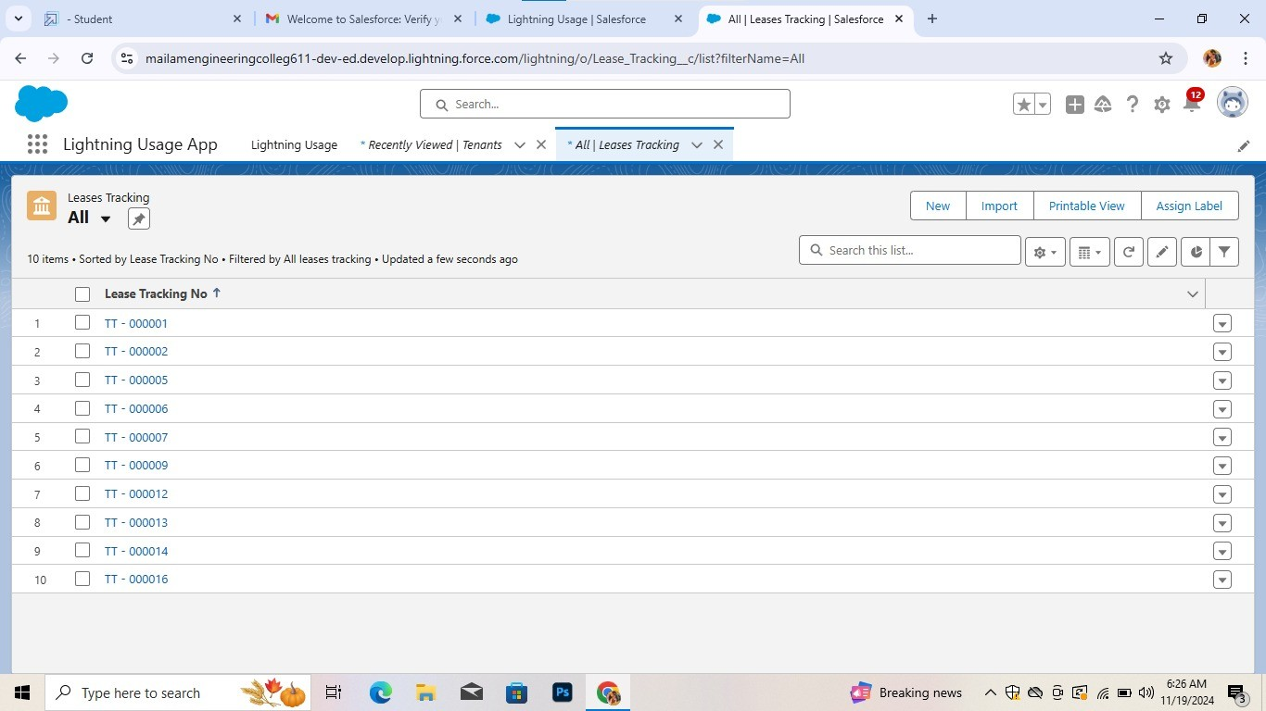

* **Inserting records in tenant issues object:**

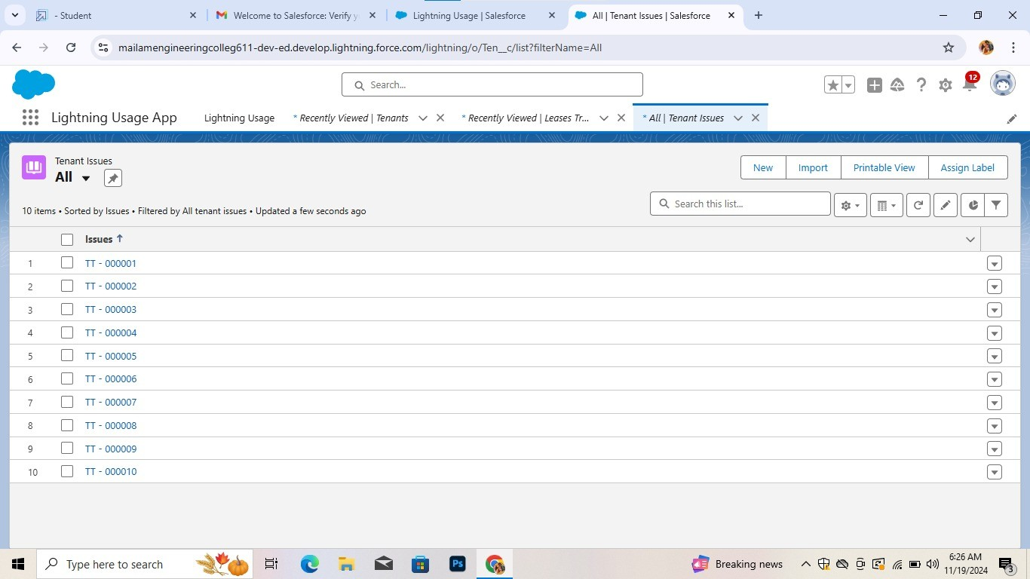

* **Create Flows:**

Designing a CRM (Customer Relationship Management) application for a mall involves creating a set of comprehensive, user-centric workflows to optimize operations, enhance customer experience, and provide valuable insights to stakeholders. Below are detailed flows tailored to the key user groups: Mall Administrators, Store Managers, and Customers.

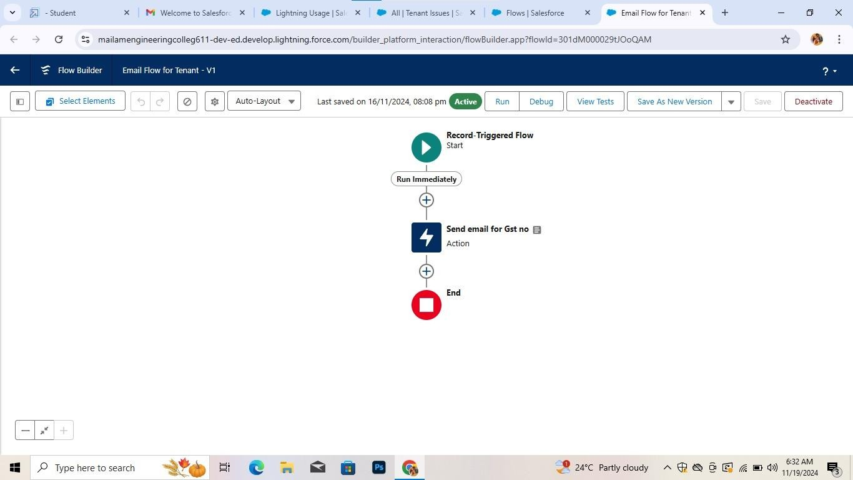

* **Create a schedule flow on lease management object:**

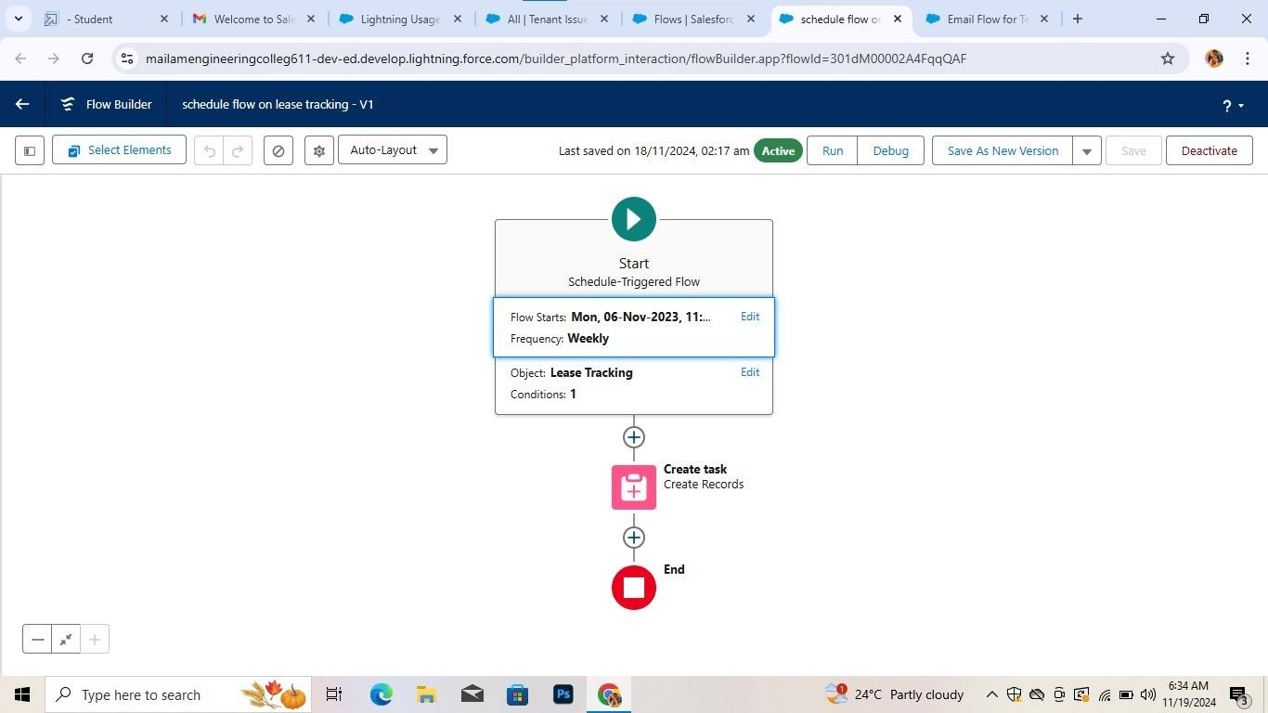

* **Apex Triggers:**

An Apex trigger is a set of instructions that execute when certain events occur on

a Salesforce object (like when a record is created, updated, deleted, or restored).

* **Lease tracking trigger:**

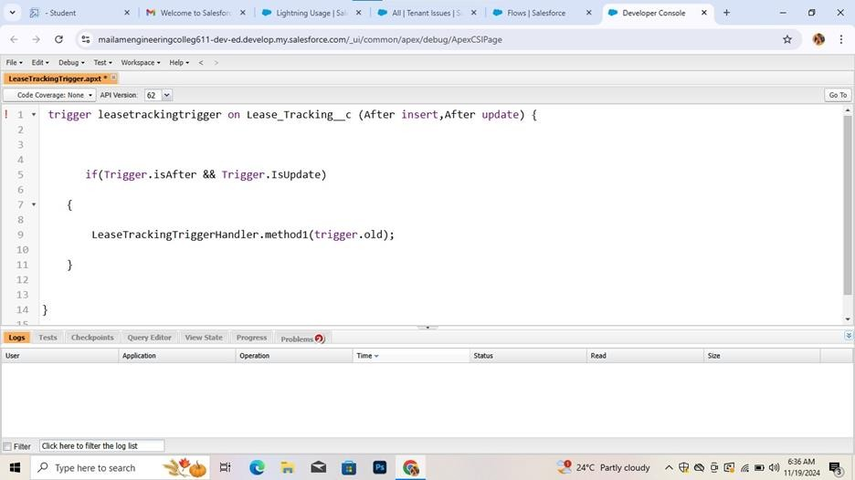

* **Lease tracking trigger handler:**

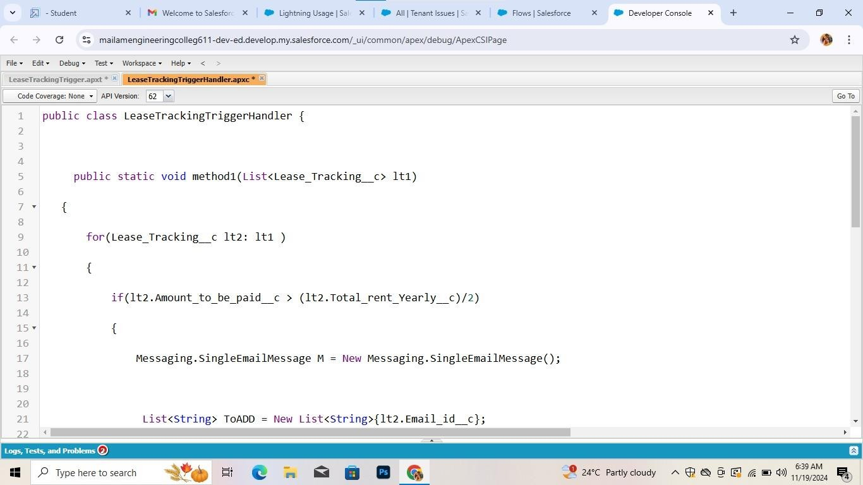

* **Asynchronous apex:**

Asynchronous Apex can be applied to CRM systems for a mall to handle operations that are long-running, resourceintensive, or time-dependent, such as sending notifications, processing tenant records, or updating analytics dashboards. Below are examples of Asynchronous Apex implementations, including Scheduled Apex for specific scenarios in a mall CRM application.

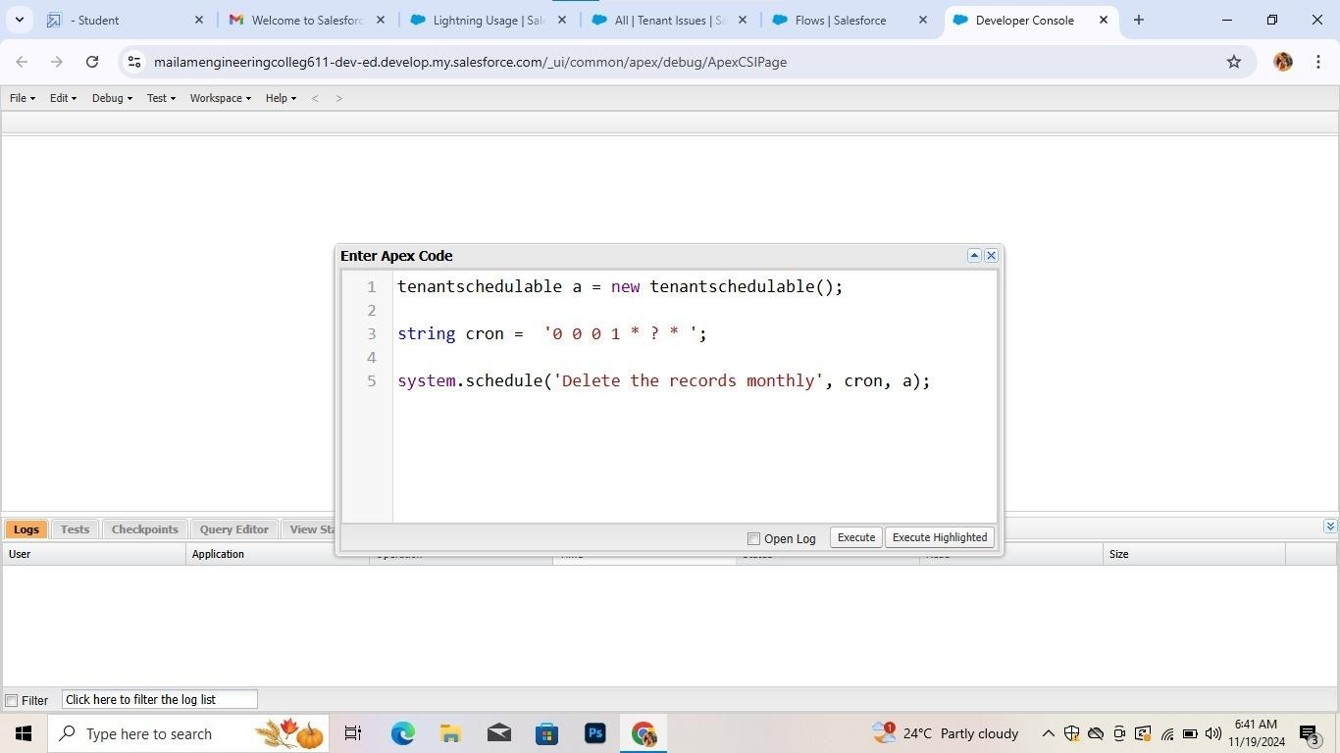

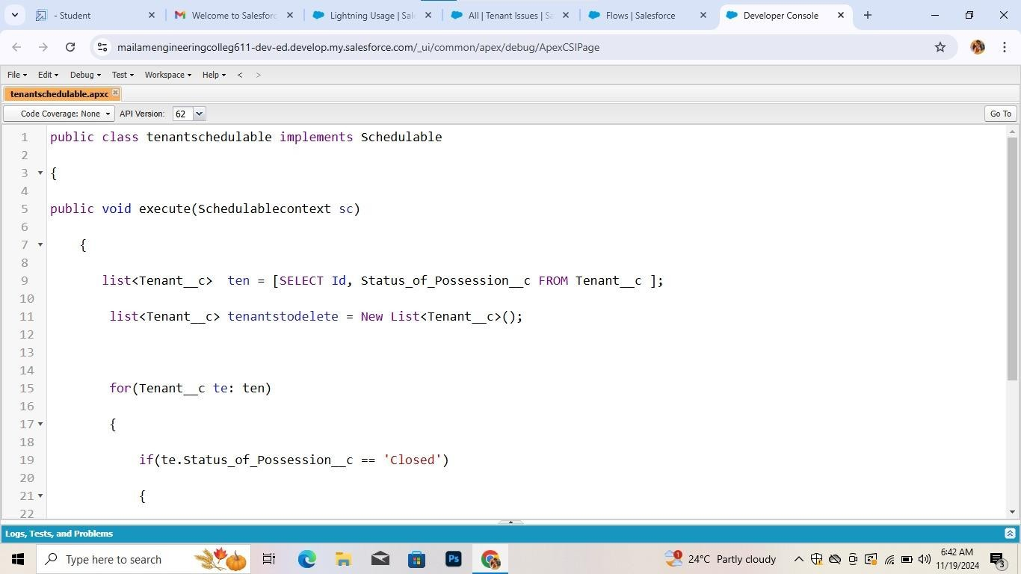

* **Reports:**

Reports give you access to your Salesforce data. You can examine your Salesforce data in almost infinite combinations, display it in easy-to-understand formats, and share the resulting insights with others. Before building, reading, and sharing reports, review these reporting basics.

* + **Create A Report of lease Management Records:**

Lease management records play a critical role in the administration of real estate properties, especially for commercial spaces like malls, office buildings, or residential complexes. A well-organized lease management system helps property managers track lease agreements, rental payments, terms, renewals, and compliance with lease conditions

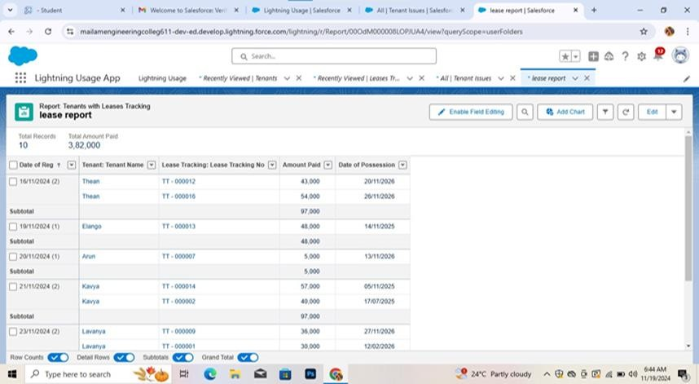

* + **Create a report of Tenant issue:**

This report will outline the key components of lease management records, including the structure, data, andkey performance indicators (KPIs) relevant to tracking lease agreements.

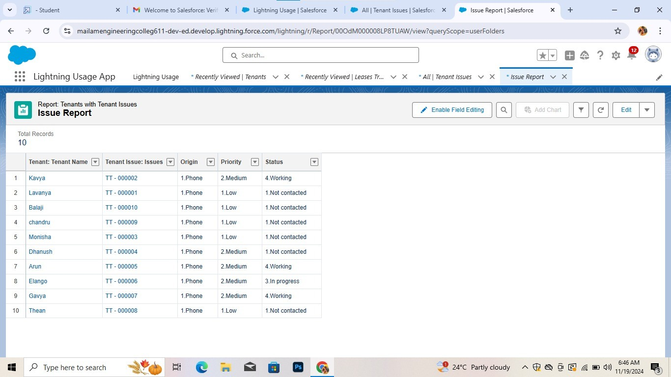

* + **Create A Report on Tenant Records:**

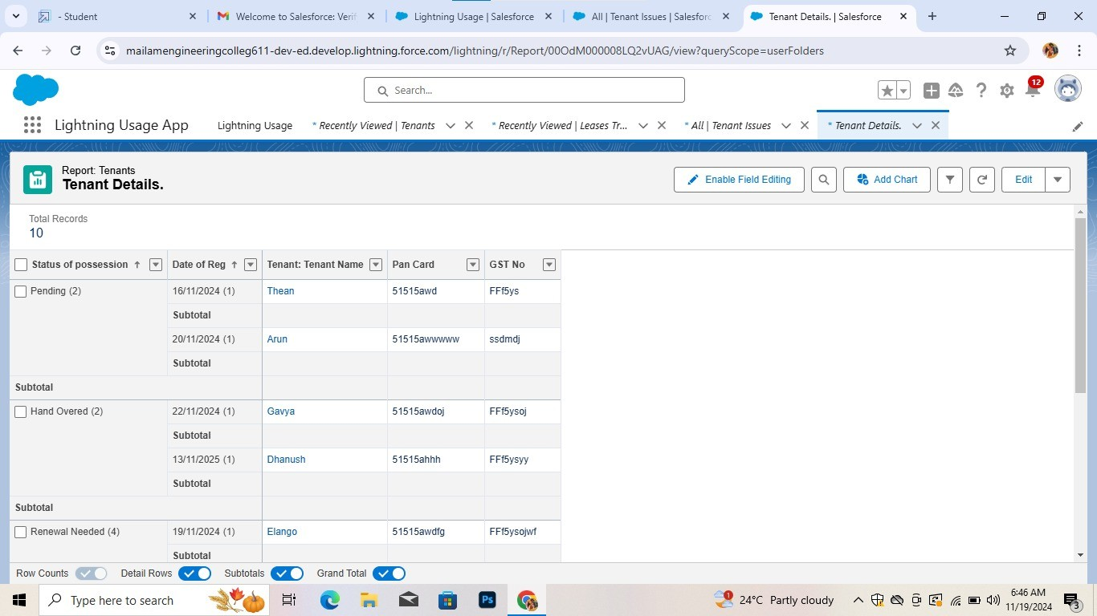

* **Dashboard:**

Dashboards help you visually understand changing business conditions so you can make decisions based on the real-time data you’ve gathered with reports. Use dashboards to help users identify trends, sort out quantities, and measure the impact of their activities.

A set of steps designed to review, validate, and authorize tasks or transactions related to workforce management. This process ensures that actions like employee onboarding, promotions, leave requests, and payroll changes comply with organizational policies and are properly documented.

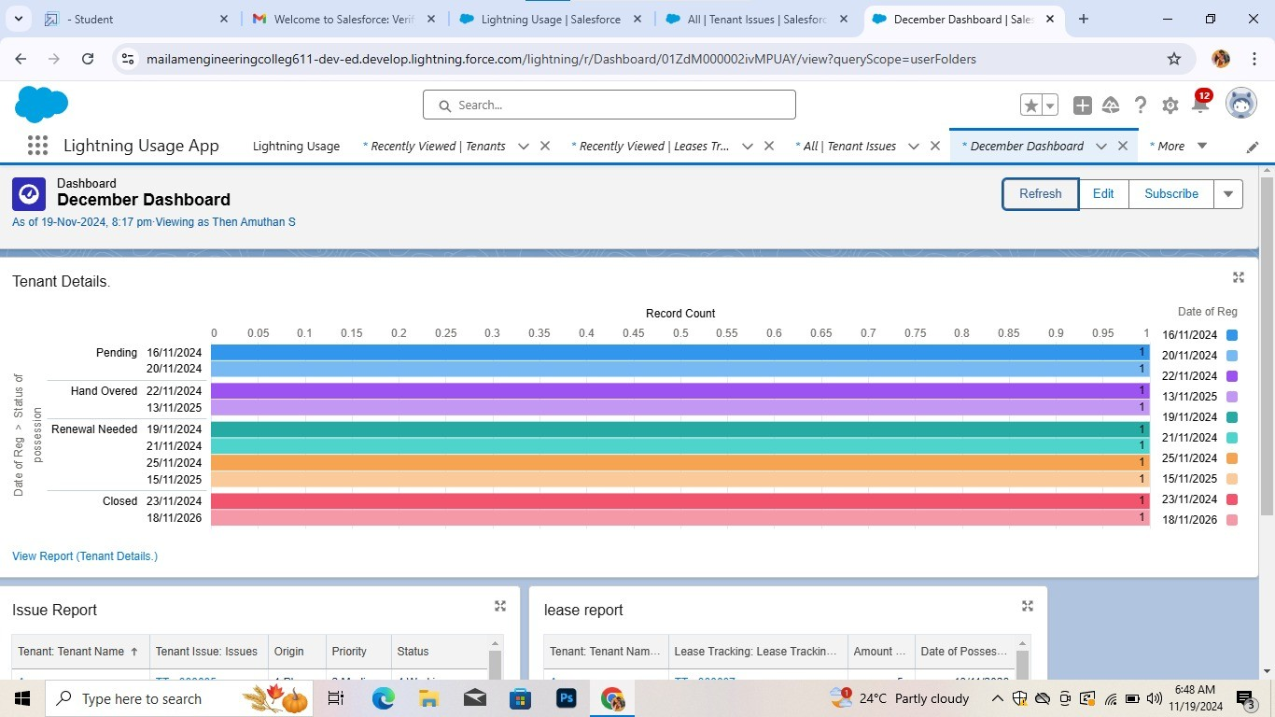

* **Data Model Design:**
* Incorporating tenants, leases, shops, and customer data.
* **User Interface Design:**
* Tenant portals for lease and communication management.
* Customer portals for event updates and feedback.
* **Business Logic:**
* Custom triggers for automated alerts and renewals.

1. **Testing and Vadlidation:**

* **Unit Testing:**
* Apex classes and triggers tested for functionality.
* **User Interface Testing:**
* Ensuring intuitive and responsive UI for all users.

1. **Key Scenarios Addressed by Salesforce in the Implementation Project:** 
   * **Customer Data Management:**

**Scenario:** Centralizing all customer data in one place to create a 360degree view of each customer.

**Implementation:** Salesforce integrates various customer touchpoints (e.g., website, email, call centers) to aggregate customer data, ensuring that all interactions and transactions are captured and easily accessible to sales, marketing, and service teams.

* + **Lead and Opportunity Management:**

**Scenario:** Managing and nurturing leads through the sales funnel to convert them into opportunities and eventually customers.

**Implementation:** Salesforce provides tools like Lead and Opportunity Management to track the lifecycle of potential customers, from initial interest to final sale. It allows for automatic lead assignment, status tracking, and personalized follow-up tasks.

* + **Sales Forecasting and Reporting:**

**Scenario:** Generating accurate sales forecasts and performance reports for management and sales teams.

**Implementation:** Salesforce offers customizable dashboards, realtime analytics, and reporting tools to track sales performance, revenue, and forecasting. Users can visualize data in real time and generate reports to understand trends, close rates, and pipeline health.

* + **Marketing Automation and Campaign Management:**

**Scenario:** Automating marketing tasks and creating personalized campaigns to engage customers and prospects.

**Implementation:** Salesforce Marketing Cloud enables the creation, automation, and tracking of marketing campaigns across multiple channels, including email, social media, and SMS. It allows businesses to send targeted messages based on customer behavior and preferences.

* **Automating tenant onboarding and lease renewal processes.**
* **Providing customers with tailored promotional offers based on their shopping patterns.**
* **Facilitating real-time maintenance and support request tracking**

**7.Conclusion:**

In conclusion, implementing a CRM application for a mall provides a strategic advantage by centralizing customer data, streamlining operations, and enhancing customer engagement. The CRM system allows for efficient management of customer relationships through personalized marketing, targeted promotions, loyalty programs, and responsive customer service. It empowers mall management with valuable insights into customer behavior, sales performance, and campaign effectiveness, enabling data-driven decision-making. Moreover, by integrating with other systems such as POS, tenant management, and inventory systems, the CRM application creates a seamless experience for both customers and mall operators. Ultimately, the CRM application not only boosts customer satisfaction and loyalty but also contributes to the mall’s overall growth and operational efficiency, making it an indispensable tool for modern retail management.

**Summary of Achievements:**

The CRM application enhances mall management by automating key processes, fostering better relationships with tenants and customers, and providing actionable insights for decision-making.