Exp No :3
REGRESSION AND OPTIMIZATION (MULTI LINEAR AND
POLYNOMIAL REGRESSION)

SCENARIO 1 : MULTILINEAR REGRESSION

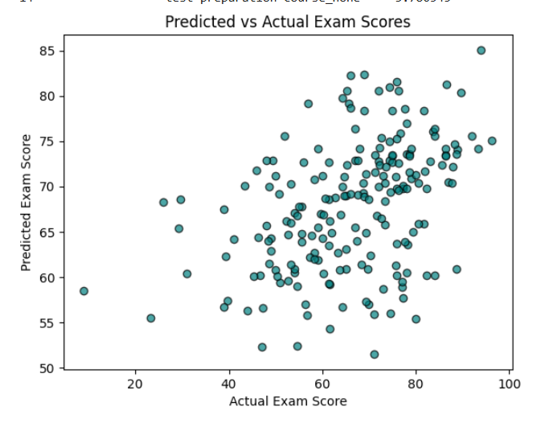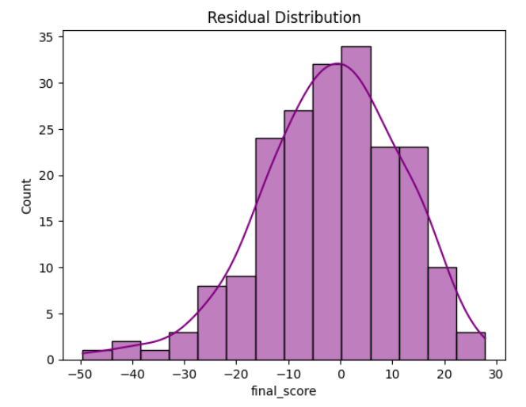

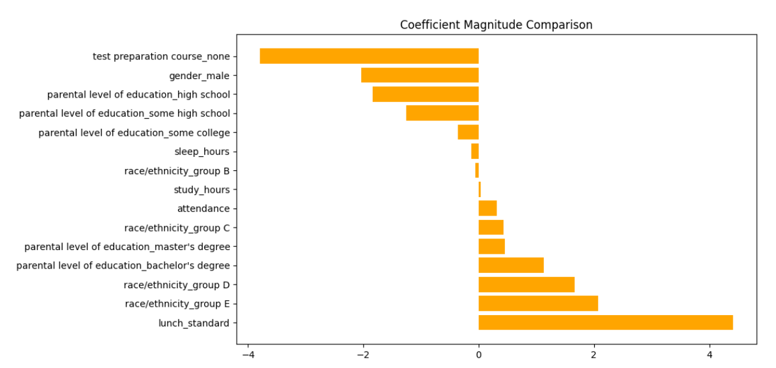

SCENARIO 2: POLYNOMIAL REGRESSION

