**CODE**

The code for the respective project is as under:-

**STEP 1**: LOADING MODULES

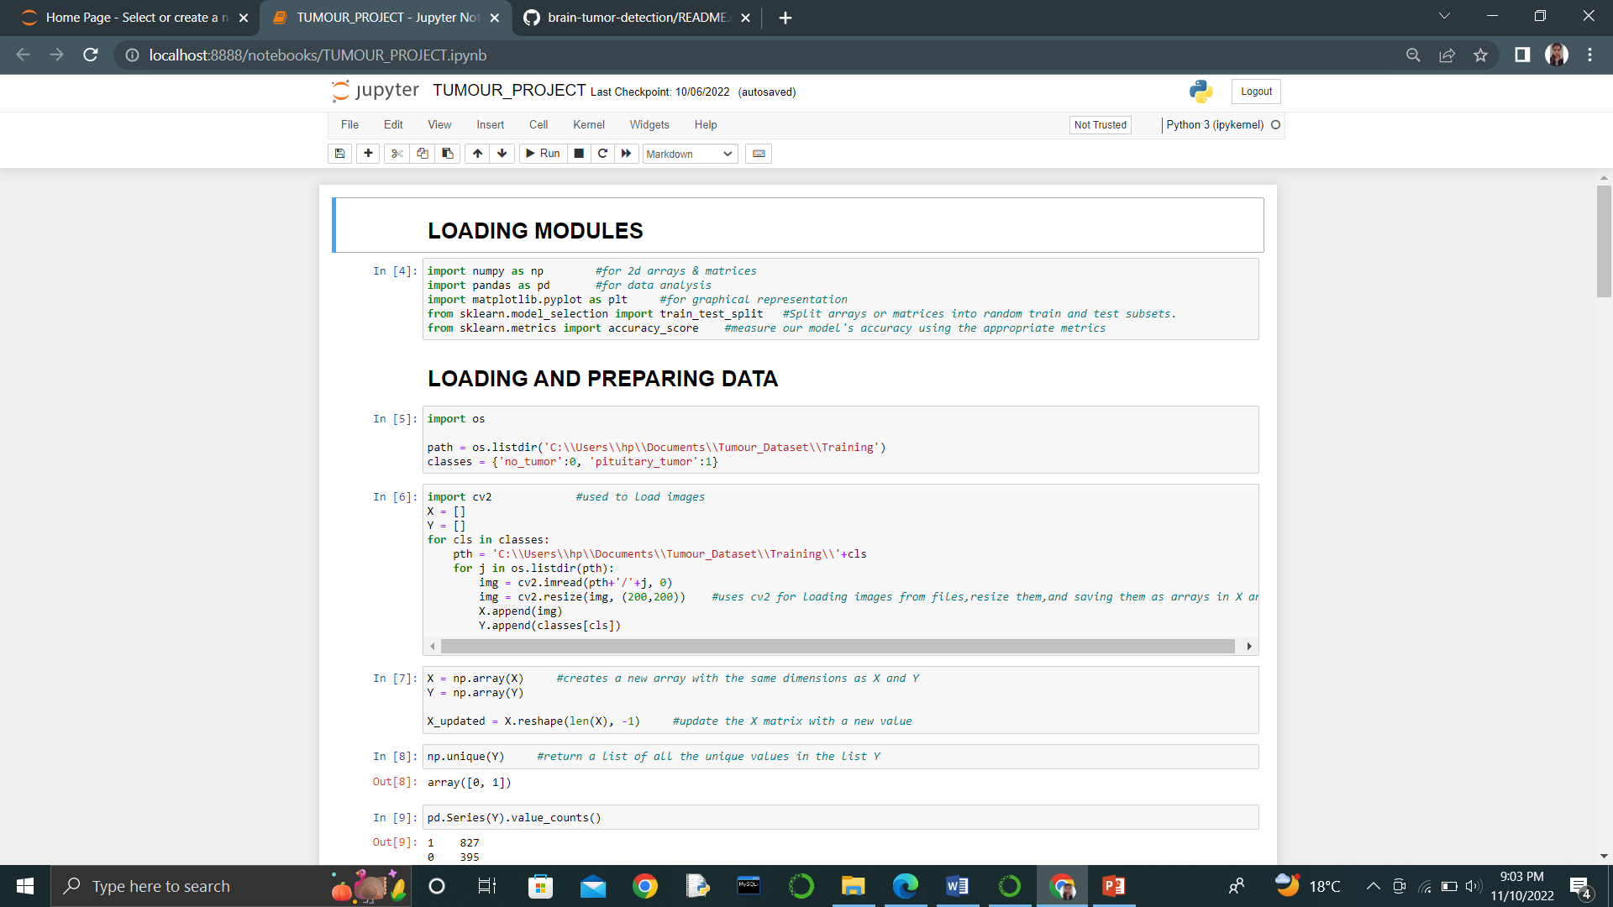

**STEP 2**: LOADING AND PREPARING DATA

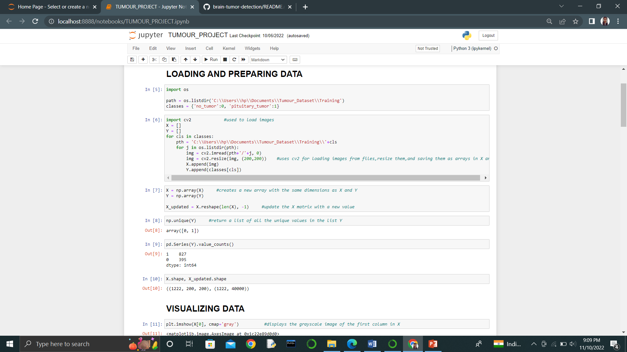

**STEP 3**: VISUALIZING DATA

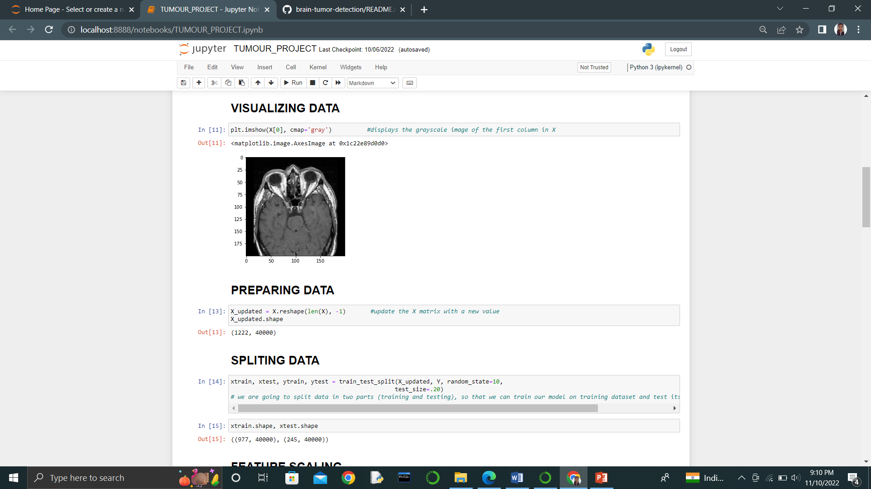

**STEP 4**: PREPARING DATA

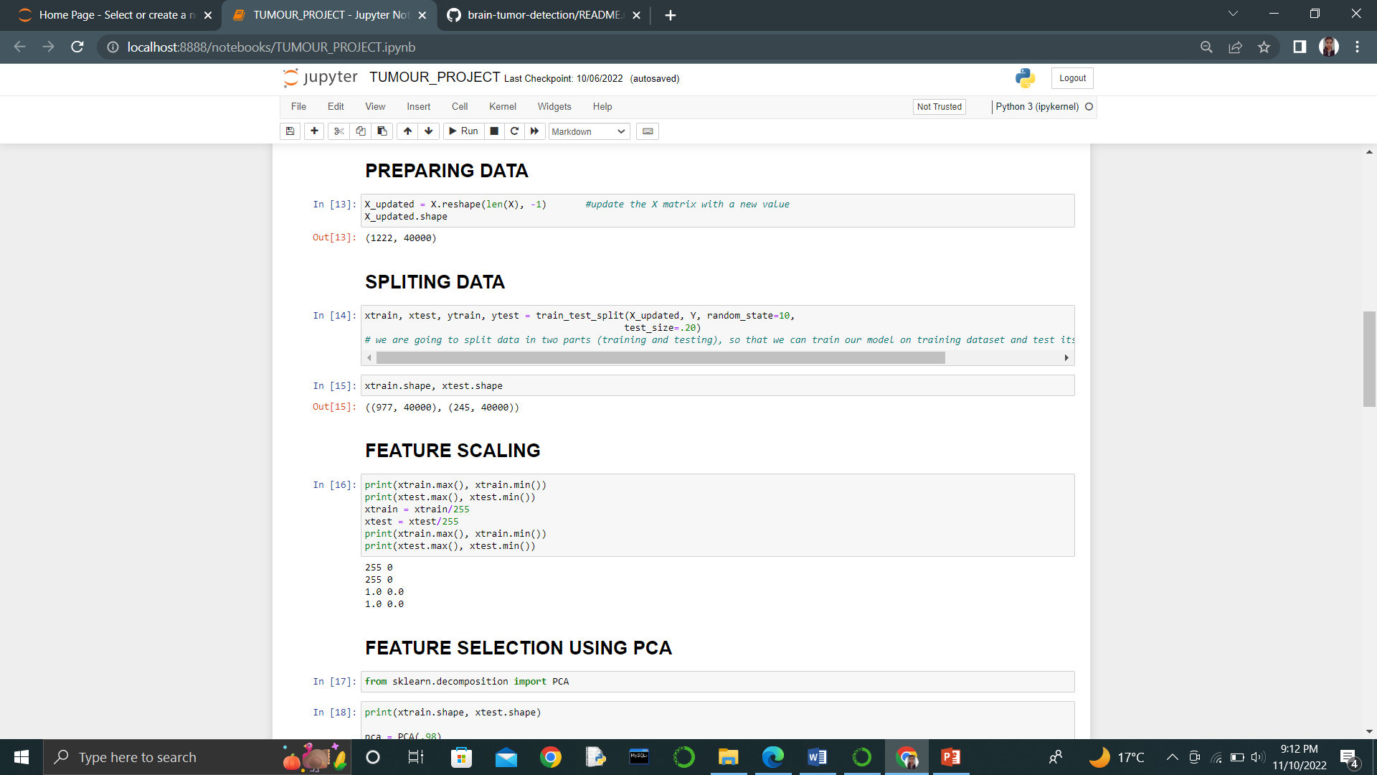

**STEP 5**: SPLITING DATA

Here we will be splitting our data in two parts:-

* Training
* Testing

The reason behind the splitting is to train our model on the dataset of training and then test its accuracy on the testing dataset.

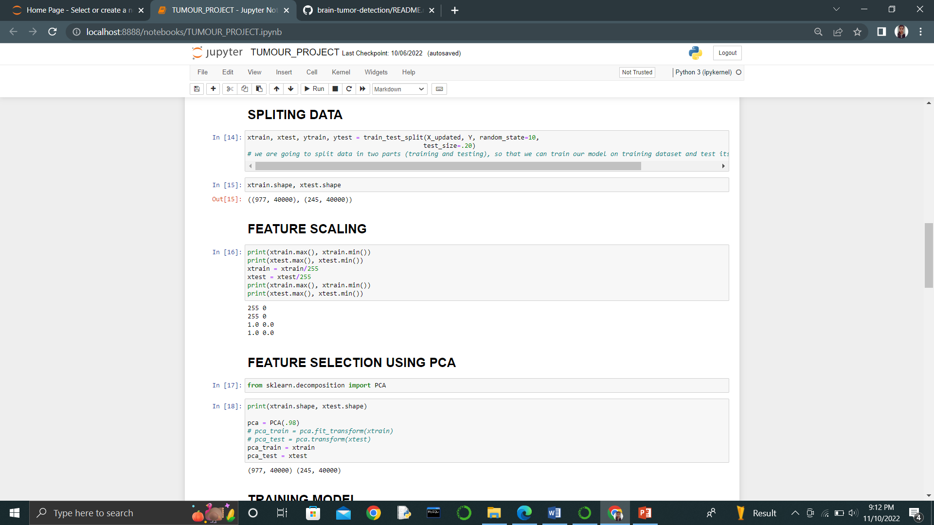

**STEP 6**: FEATURE SCALING

In this step of our code wee will be using minmax technique in order to

bring all the feature values that are less than or equal to one. Further, we are

dividing our training data bye the maximum value.

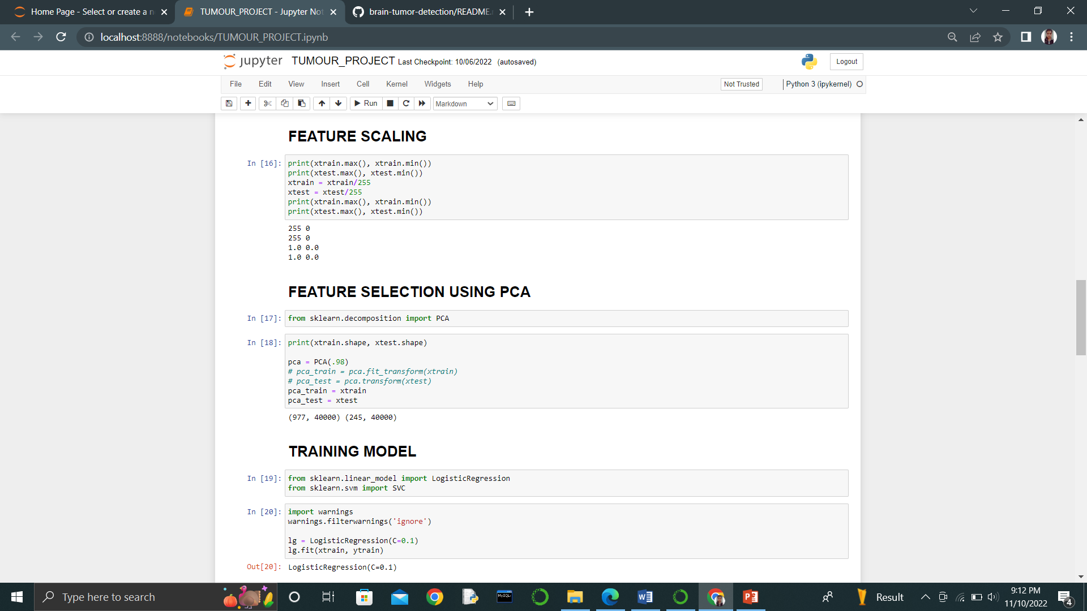

**STEP 7**: FEATURE SCALING USING PCA

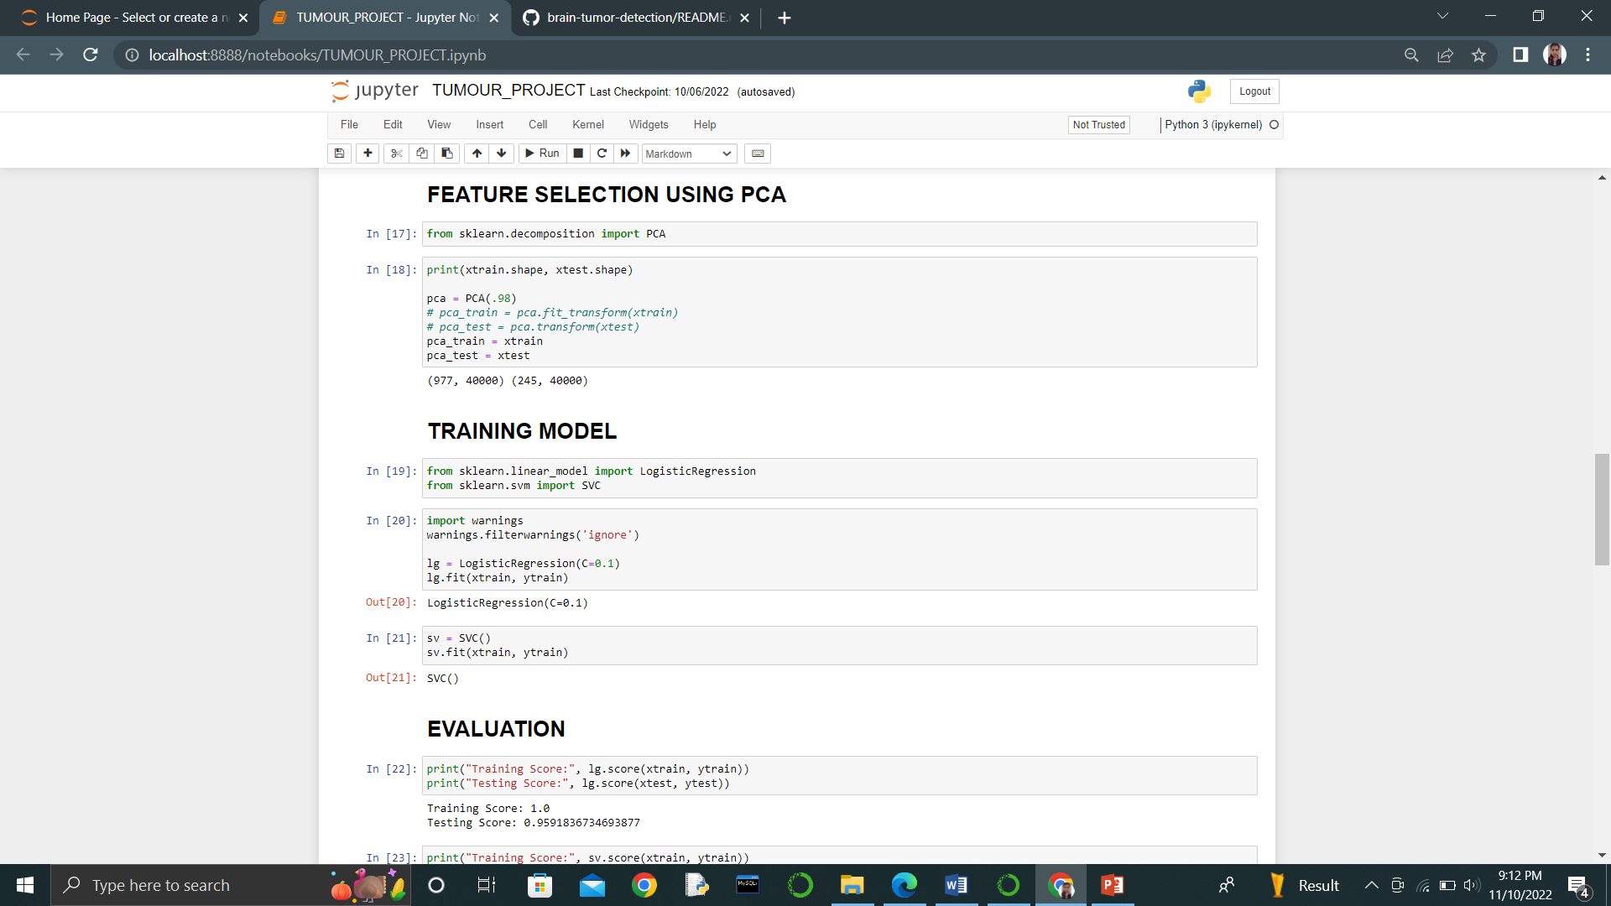

**STEP 8**: TRAINING MODEL

In this step of our project we will be training our model with the help of

SVM and logistic regression algorithms. After that we will be comparing the

performance of the two different models.

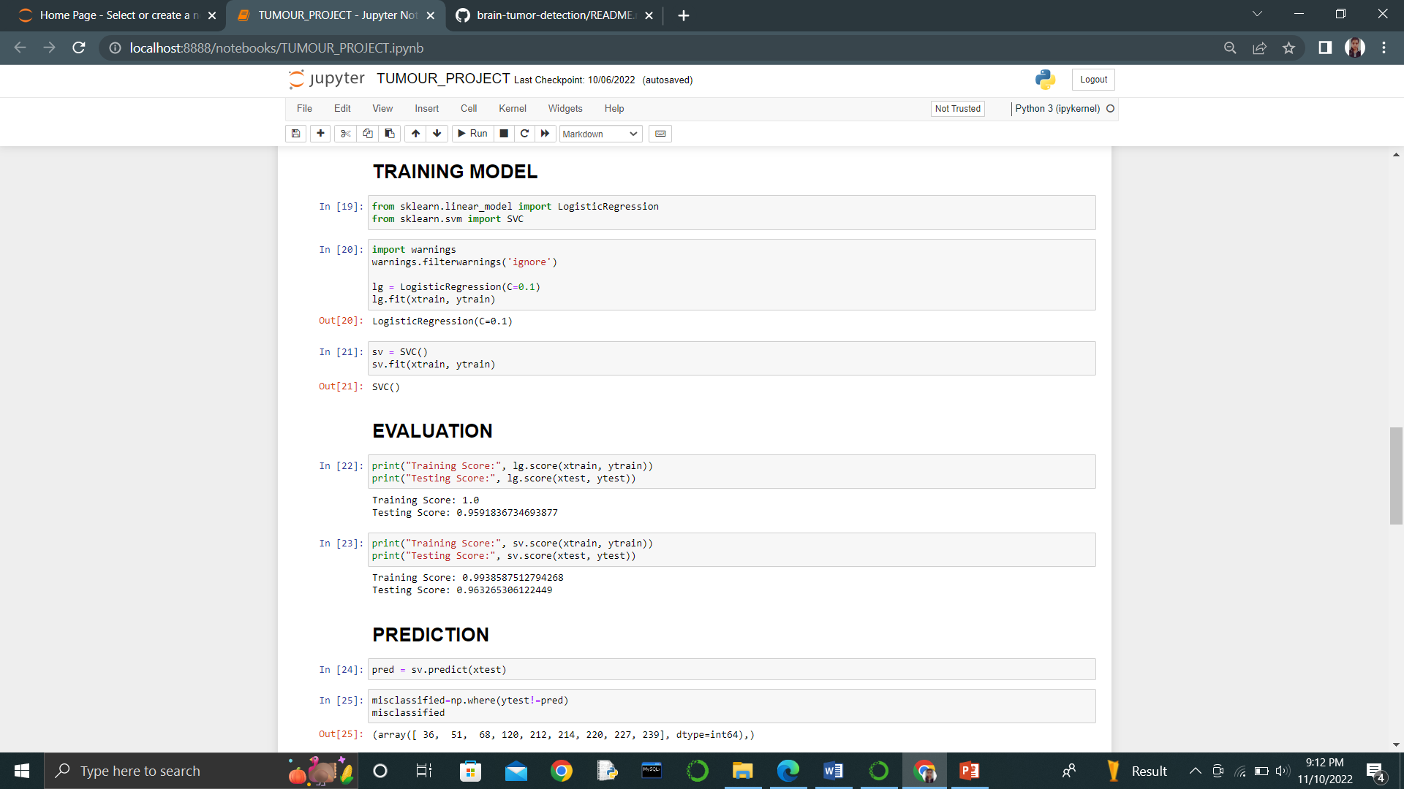

**STEP 9**: EVALUATION

From here we can have a clear view about the balance between the two.

SVM showed a great balance among training an testing score as compared to

Logistic Regression.

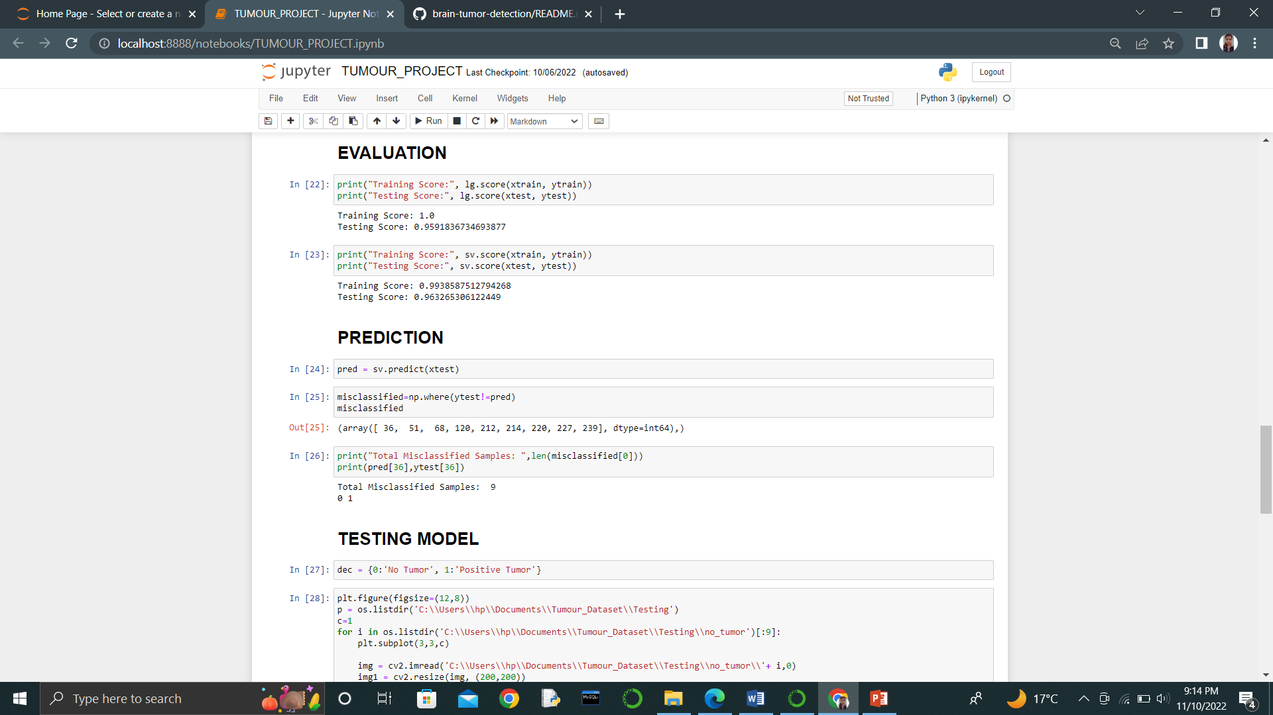

**STEP 10**: PREDICTION

In this step we are going to predict test dataset. Further, we are checking the total

number of misclassified samples out of total test samples.

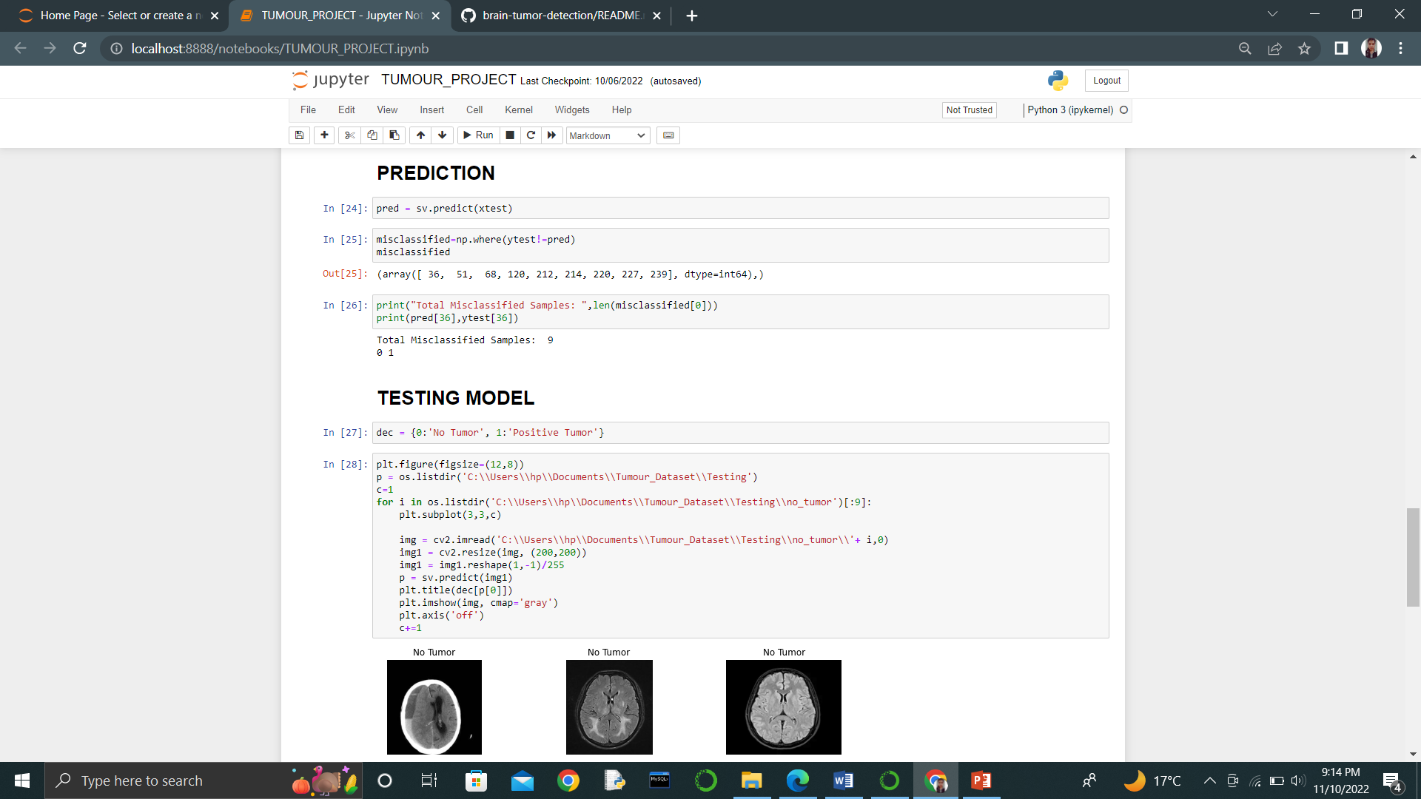

**STEP 11**: TESTING MODEL

Last but the least, we are testing the results out by the model.

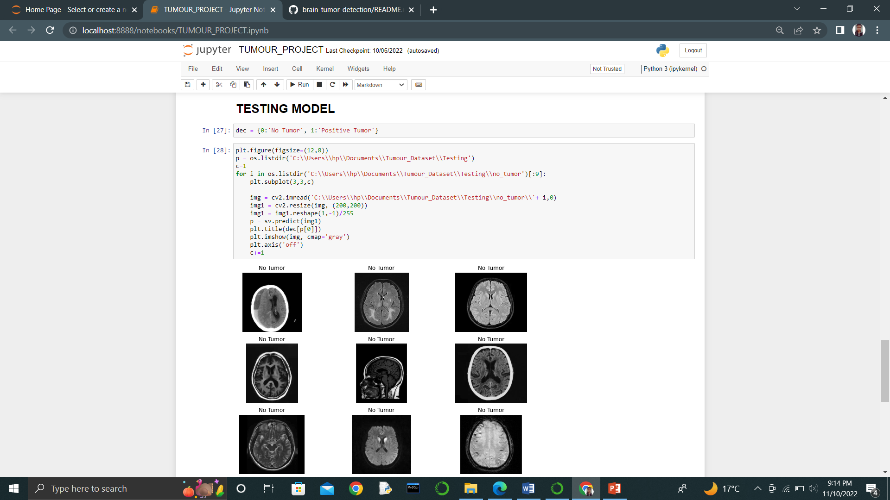

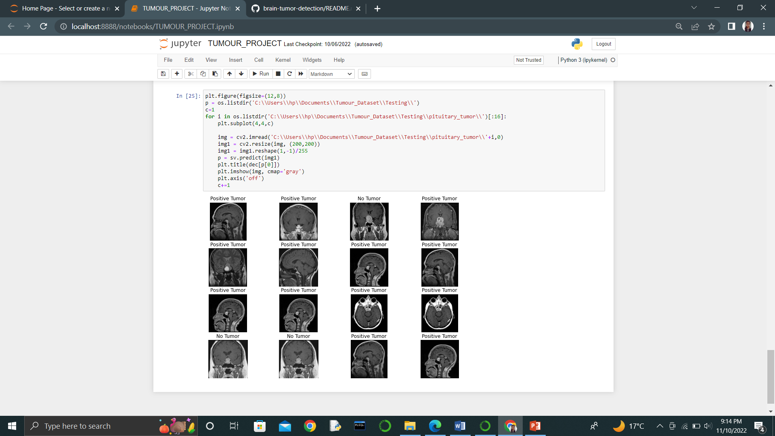

**REFERENCES**

1. [**https://www.python.org/**](https://www.python.org/)
2. [**https://docs.python.org/3/tutorial/**](https://docs.python.org/3/tutorial/)
3. [**https://www.w3schools.com/python/**](https://www.w3schools.com/python/)
4. [**https://www.tutorialsteacher.com/python/python-version-history**](https://www.tutorialsteacher.com/python/python-version-history)
5. [**https://www.javatpoint.com/python-oops-concepts**](https://www.javatpoint.com/python-oops-concepts)