**CODE: (HTML file)**

<!DOCTYPE html>

<html lang="en">

<head>

<meta charset="UTF-8">

<meta name="viewport" content="width=device-width, initial-scale=1.0">

<title>Document</title>

<link rel="stylesheet" href="style5.css">

</head>

<body>

<div class="container">

<form>

<div class="sub-container">

<h1>Please Sign-in</h1>

<label for="emailbox" class="block-labels">Email:</label>

<input type="text" placeholder="email in text..." id="emailbox">

<label for="password" class="block-labels">Password:</label>

<input type="password" placeholder="password...">

<div id="login-checkbox">

<input type="checkbox">

<label for="my-checkbox">Keep me signed in</label>

</div>

<button id="c">Sign In</button>

</div>

</form>

</div>

</body>

**CODE: (External CSS file)**

body{

margin: 0;

font-family: Cambria, Cochin, Georgia, Times, 'Times New Roman', serif;

}

.block-labels{

display: block;

font-weight: 1.2rem;

margin-top: 1rem;

margin-bottom: 1rem;

}

h1{

text-align: center;

}

form{

background-color: rgb(163, 219, 253);

border-radius: 5%;

}

.container{

background-image: linear-gradient(to right,#020024, #090979,#00d4ff);

height: 100vh;

display: flex;

flex-direction: column;

align-items: center;

justify-content: center;

}

input{

font-size: 1.2rem;

border-radius: 5px;

padding: 5px;

border: none;

}

#login-checkbox{

margin-top: 12px;

margin-bottom: 12px;

color: gray;

}

#sign-btn{

display: block;

padding: 10px;

width: 100%;

cursor: pointer;

color: white;

background-color: green;

border: none;

border-radius: 1px;

}

#sign-btn:hover{

background-color: rgb(31, 139, 31);

}

.sub-container{

border: 1px solid white;

padding: 20px;

border-radius: 5%;

box-shadow: 10px 10px 15px black;

background-color: #b4ebf6;

}

**OUTPUT**:

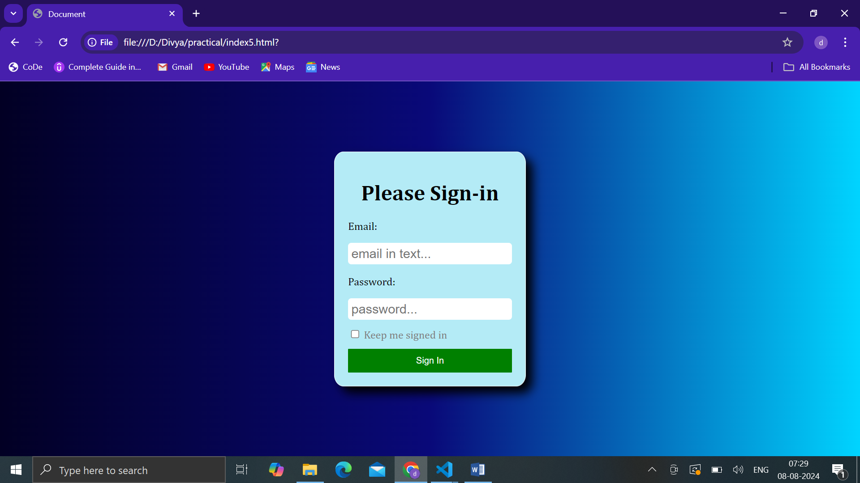

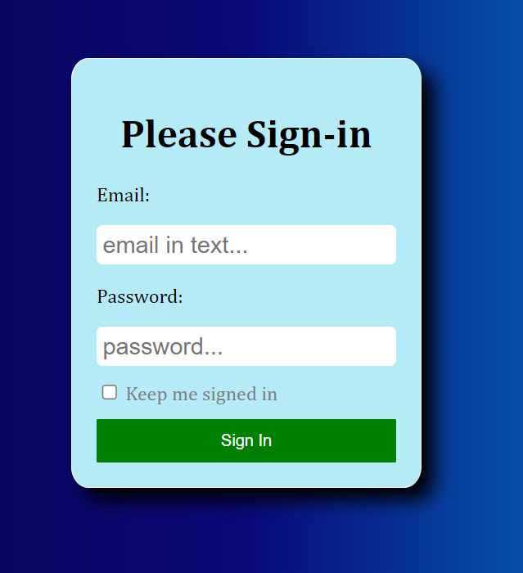

**CODE: (INTERNAL CSS )**

<!DOCTYPE html>

<html lang="en">

<head>

<meta charset="UTF-8">

<meta name="viewport" content="width=device-width, initial-scale=1.0">

<title>WP</title>

<style>

body{

background-color: rgb(192, 171, 171);

}

p {

color: red;

text-align: center;

font-size: 30px;

}

</style>

</head>

<body>

<p>Name: Divya Kesarkar</p>

<p>Roll No: 54</p> <p>Class: IT-A</p>

</body>

</html>

**OUTPUT**:

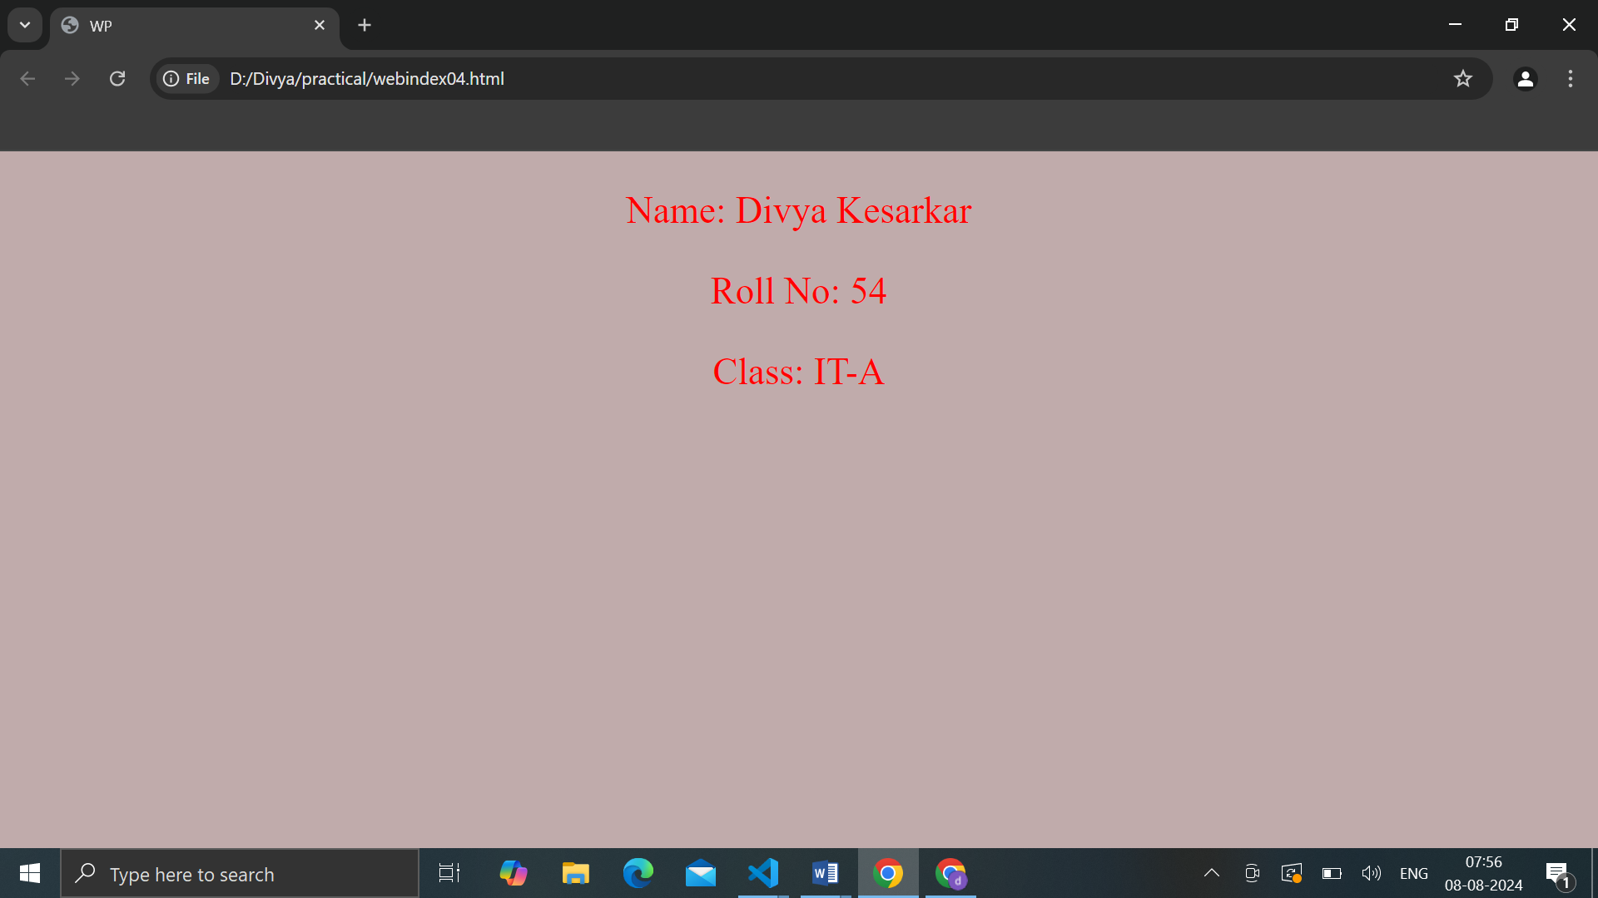

**CODE: (INLINE CSS )**

<!DOCTYPE html>

<html lang="en">

<head>

<meta charset="UTF-8">

<meta name="viewport" content="width=device-width, initial-scale=1.0">

<title>WP</title>

</head>

<body style="background-color: ivory;">

<p style="color: rgb(25, 98, 118); text-align:center; font-weight: bold; font-size: 35px;">Name: Divya Kesarkar</p>

<p style="color: rgb(21, 46, 54); text-align:center; font-weight: bold; font-size: 25px;">Roll No: 54</p>

<p style="text-align:center; font-style:italic;">Class: IT-A</p>

</body>

</html>

**OUTPUT**:

