<!DOCTYPE html>

<html lang="en">

<head>

<meta charset="UTF-8">

<meta name="viewport" content="width=device-width, initial-scale=1.0">

<title>WP Exp 1</title>

<h1>Personal Details</h1>

</head>

<body>

<p>Name: Divya Kesarkar</p>

<p>Roll No: 54</p> <p>Class: IT-A</p>

<p>College: Thakur College of Engineering & Technology</p>

<p>Achievements: 8.98 SGPI</p>

<p>Skills: Python, HTML, CSS, JS </p>

</body>

</html>

Output:

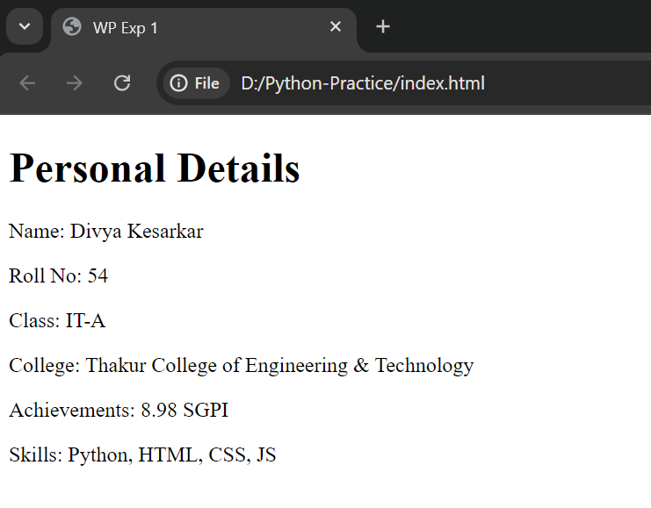

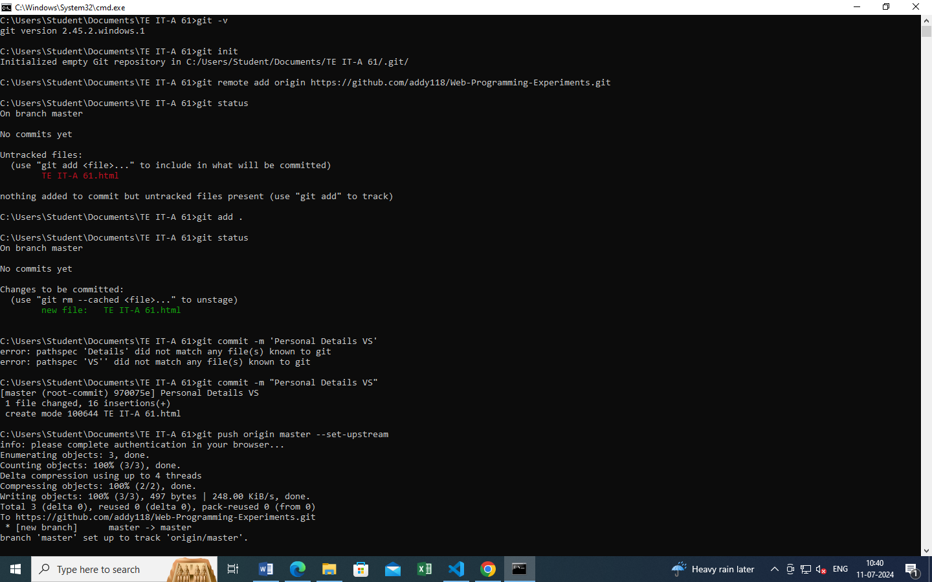Git Commands:

