Soil Moisture Sensor Probes

Our high frequency VH400 series soil moisture sensor probes enable precise low cost monitoring of soil water content. Because our probe measures the dielectric constant of the soil using transmission line techniques, it is insensitive to water salinity, and will not corrode over time as does conductivity based probes. Our probes are small, rugged, and low power.  Compared to other low cost sensor such as gypsum block sensors, our probes offer a rapid response time. They can be inserted and take an accurate reading in under 1 second.  The VH400 consumes more power than the VG400 series sensors because it operates at a much higher frequency, however, it is much more sensitive at higher VWC levels, and it's curves are more linear.  Probes come standard with a 2 meter cable.  Also see our extremely low power VG400 series soil moisture sensors.  See our Soil Moisture Sensor Selector, to figure out which probe is right for your application. | 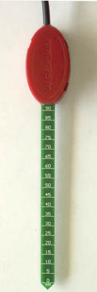  VH400 - Soil Moisture Sensor Probe

Soil Moisture Sensor Probe Applications
- Irrigation and sprinkler systems.
- Moisture monitoring of bulk foods.
- Rain and weather monitoring.
- Environmental monitoring.
- Water conservation applications.
- Fluid level measurements.

Soil Moisture Sensor Probe Features
- Extreme low cost with volume pricing.
- Not conductivity based.
- Insensitive to salinity.
- Probe does not corrode over time.
- Rugged design for long term use.
- Small size.
- Consumes less than 600uA for very low power operation.
- Precise measurement.
- Measures volumetric water content (VWC) or gravimetric water content (GWC).
- Patent pending technology.
- Output Voltage is proportional to moisture level.
- Wide supply voltage range.
- Can be buried and is water proof.
- Probe is long and slender for wider use, including smaller potted plants.

Other Vegetronix Products of Interest
- Soil Moisture Meter
- VG400 Series Soil Moisture Sensors
- Soil Moisture Sensor Relay Boards
- Soil Temerature Sensors
- Voltage to Current Loop Translators
- SDI-12 Protocol Translators
- Data Loggers
- Extension Cable for VH400 Probes

Soil Moisture Sensor Probe Pricing and Ordering Info
Contact us for pricing information.
ORDER INFO
Part Number | Description | Price | Purchase
VH400 | High Frequency Soil Moisture Sensor Probe | $36.95

Soil Moisture Sensor Relay Boards
The quickest way to evaluate if the VH400 series is right for you is to also order some of our sensor relay boards. The relay boards accept input from a single sensor and control a solid state or mechanical relay. The relay contacts can be configured to close when wet, or open when wet. The dry/wet threshold is easily set by an an on board variable resistor, which can be tuned with a small screwdriver. With our relay boards, within minutes you'll be using your VH400 soil moisture probe to control, valves, alarms or home automation systems.

Soil Moisture Sensor Probe Specifications
VH400 Sensor
Power consumption | < 7mA
Supply Voltage | 3.3V to 20 VDC.
Dimensions | See drawing below.
Power on to Output stable | 400 ms
Output Impedance | 100K ohms
Operational Temperature | -40ºC to 85ºC
Accuracy | 2%
Output | 0 to 3V related to moisture content
Shell Color | Red
Voltage Output Curves | Curves, Piecewise linear equations

Soil Moisture Sensor Probe Wiring Table
Bare | Ground
Red | POWER: 3.3V to 20 VDC.
Black | OUT: (0 to 3V related to moisture content.)

VH400 Soil Moisture Sensor Probe Drawing
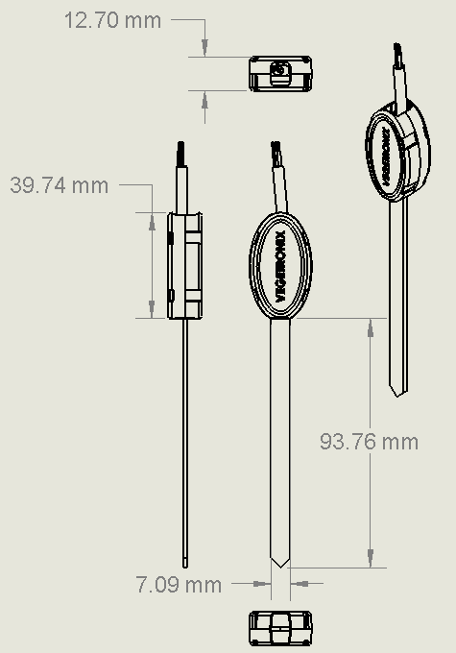
VH400 Soil Moisture sensor Drawing

Soil Moisture Sensor Probe Technical Literature
See our Soil Moisture Sensor Probe Application Notes for reference designs and information on how to use the soil moisture probe in larger systems.

How to Get Started with the Soil Moisture Sensor Probe
The best way to get started is to purchase a few low cost soil moisture sensor probes and try them out in your application.

Soil Moisture Sensor Instructional & Promotional Videos

How To Wire Up a Soil Moisture Sensor
The Techno Gardener shows you how to wire up a Vegetronix soil moisture sensor to a digital multimeter.

Soil Moisture Sensor as Water Level Sensor
The Techno Gardener demonstrates how a Vegetronix soil moisture sensor can be used as a water level sensor.

Soil Moisture Sensor Detects Clammy Hands
The Techno Gardener shows you how a Vegetronix soil moisture sensor can also be used to detect the moisture in your hands. It blows away gypsum block sensors with it's instantaneous moisture readings.

