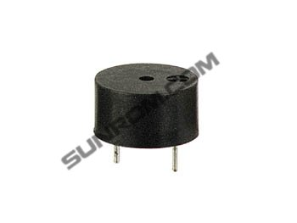

Details
Loud output buzzer for printed circuit board mounting.

Features
- Rated Frequency: 4KHz Continuous
- Operating Voltage: 1.5 - 27Vdc
- Current Consumption: 15mA @ 12Vdc
- Sound Pressure Level(30cm): 85dB @ 5Vdc

