## **Configuring default route to the Router**

* A topology was created using three Router-PT, two Switch-PT and two PC's connected to each switch using copper straight-through connections and serial DCE connections

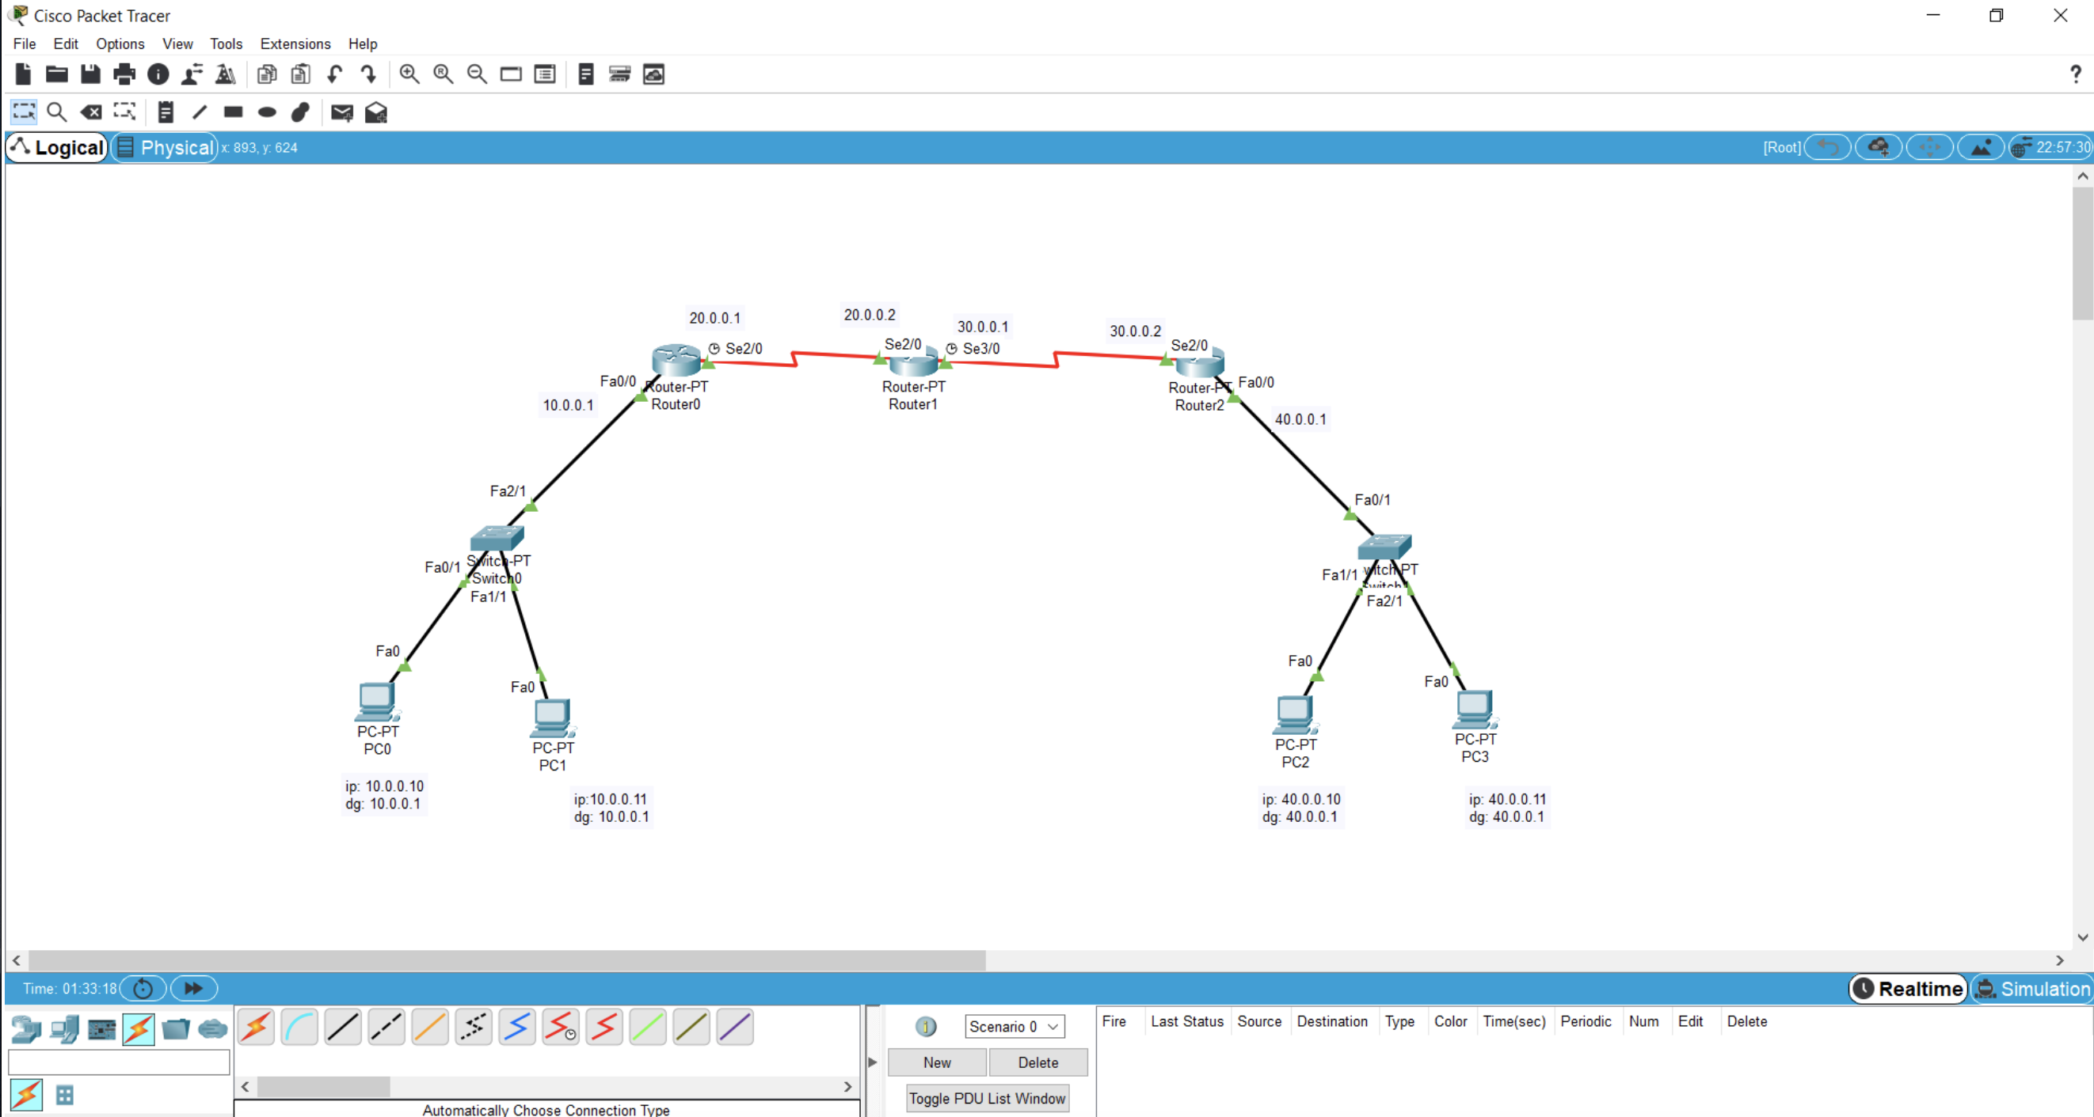

* Default gateways and unique ip addresses were configured for each PC .
* IP address was configured for each interface using CLI
* Pinging PC2 from PC0 gave destination host unreachable
* ip routes for each router was viewed using the command: show ip route
* Static ip route was configured for router 1 using CLI commands: ip route destination_network subnet_mask next_hop_address
* Default ip route was configured for router 0 and router 2 using CLI commands: ip 0.0.0.0 0.0.0.0 next_hop_address

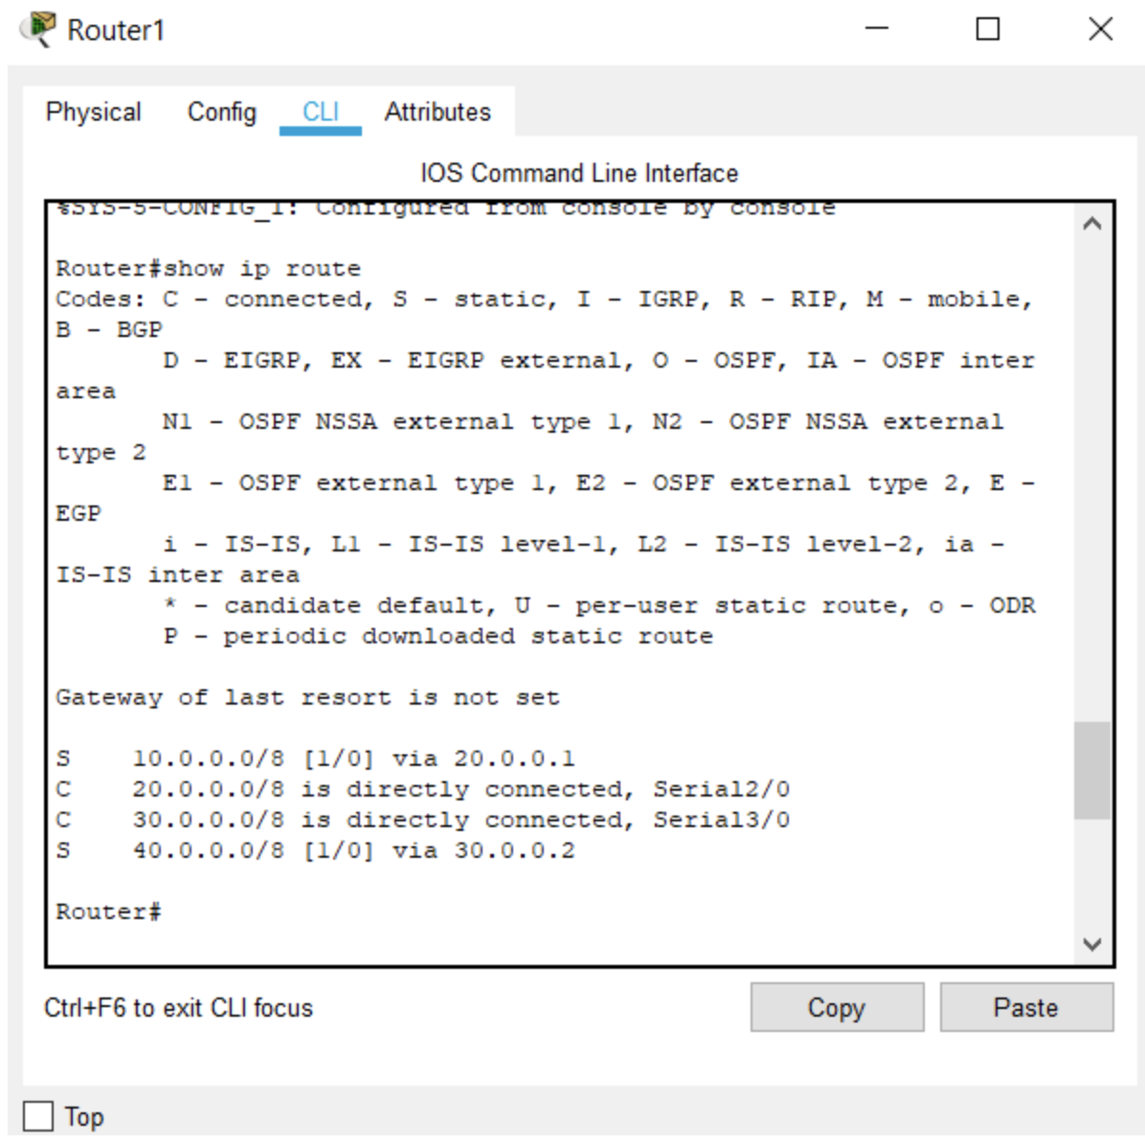

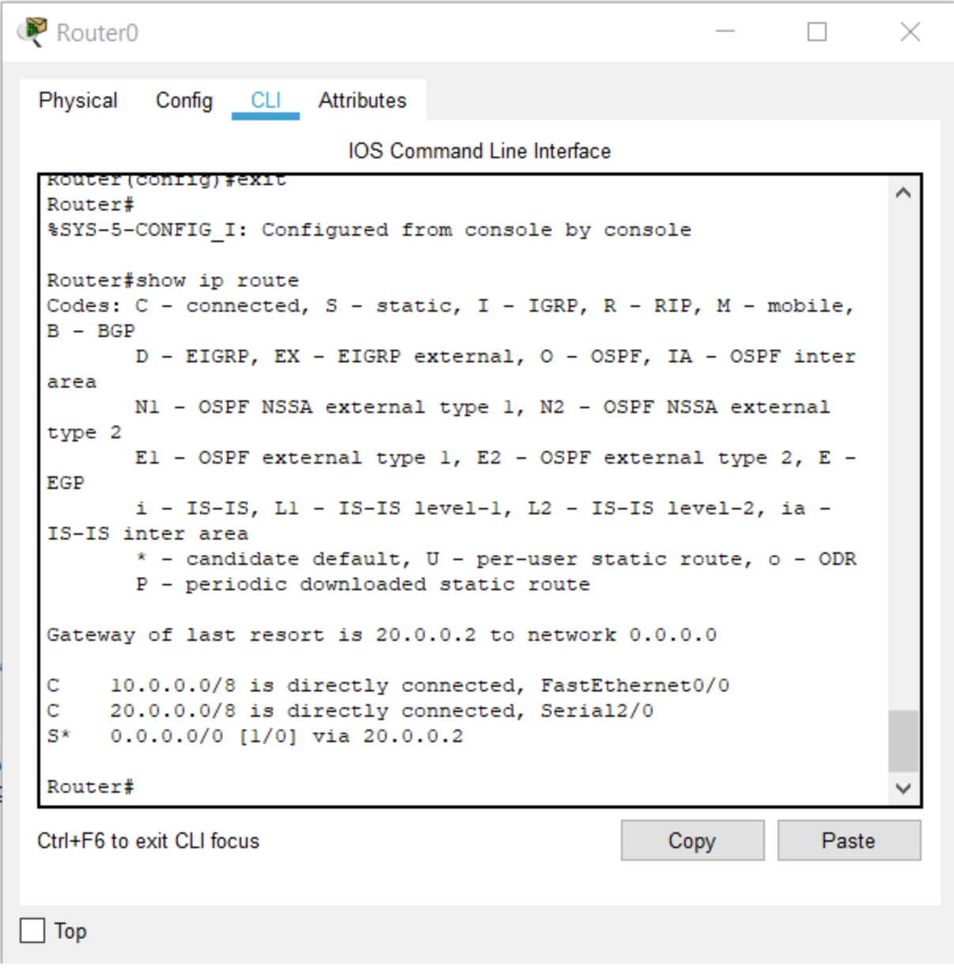

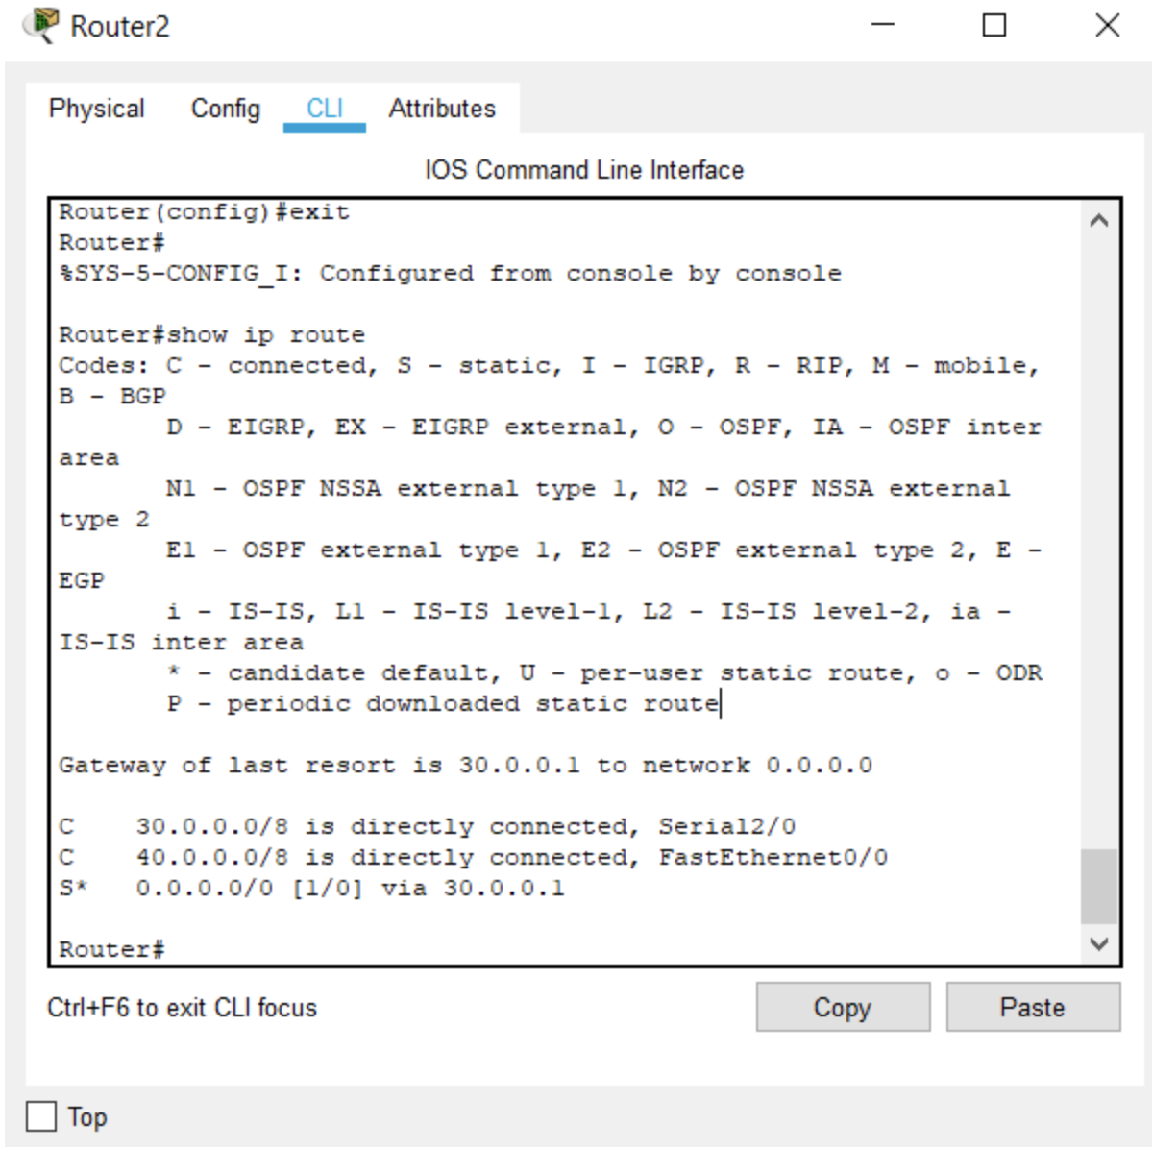

* Pinging PC2 from PC0 gave the required reply

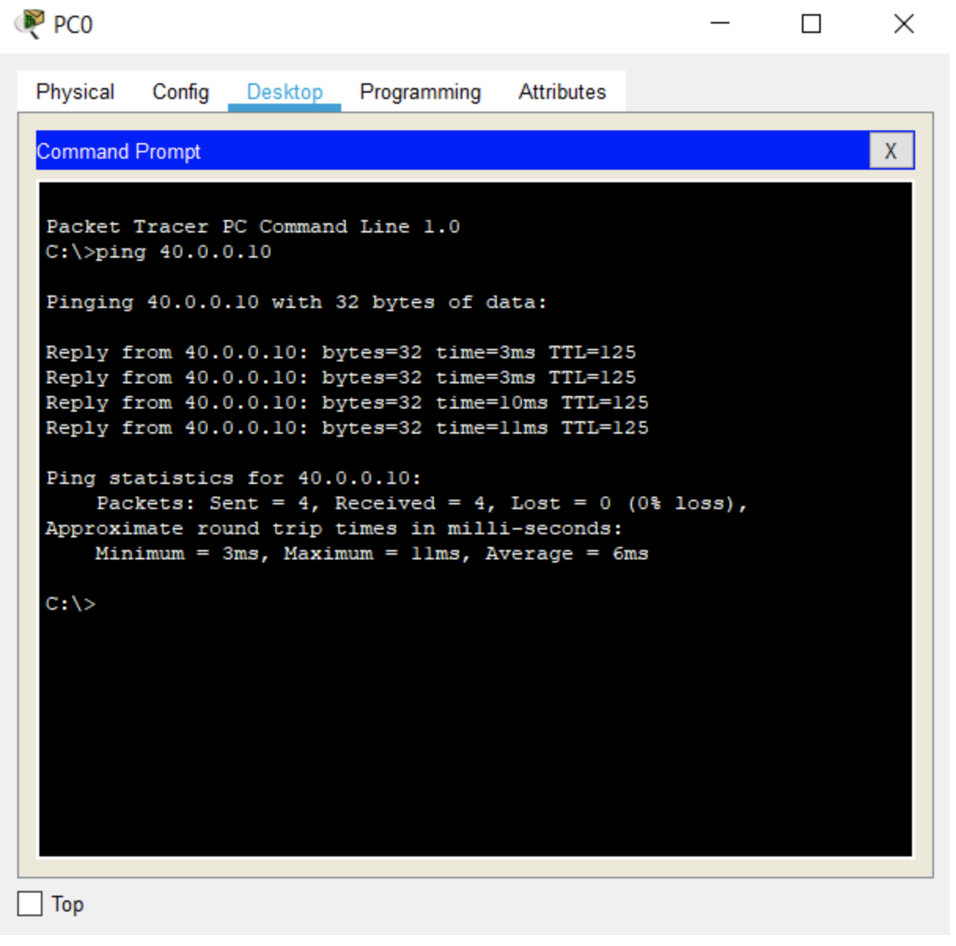

* Simulated sending of an ICMP packet from PC0 to PC2

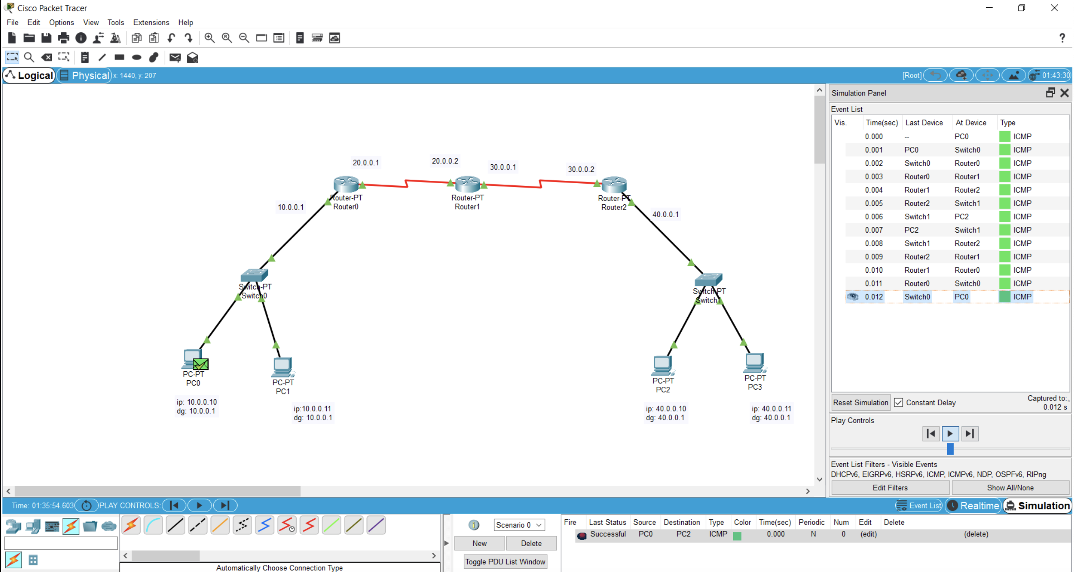

### Learning outcomes

* Creating a topology with multiple routers and switches.
* Configuring default gateway and ip address.
* Configuring ip address for the interfaces
* Pinging gives destination host unreachable if the device networks are not directly connected
* Configuring static ip route to a router
* Configuring default ip route to a router ensures that the packet passes through the default route when no other route is available for an IP destination address
* On configuring the default ip routes, pinging gives the required response
* The simulation of sending a simple PDU from source to destination shows the route taken by the ICMP packet