## **Configuring DHCP within a LAN**

### A topology was created using a Router, a Switch, a Server and four PC's connected as shown in the figure

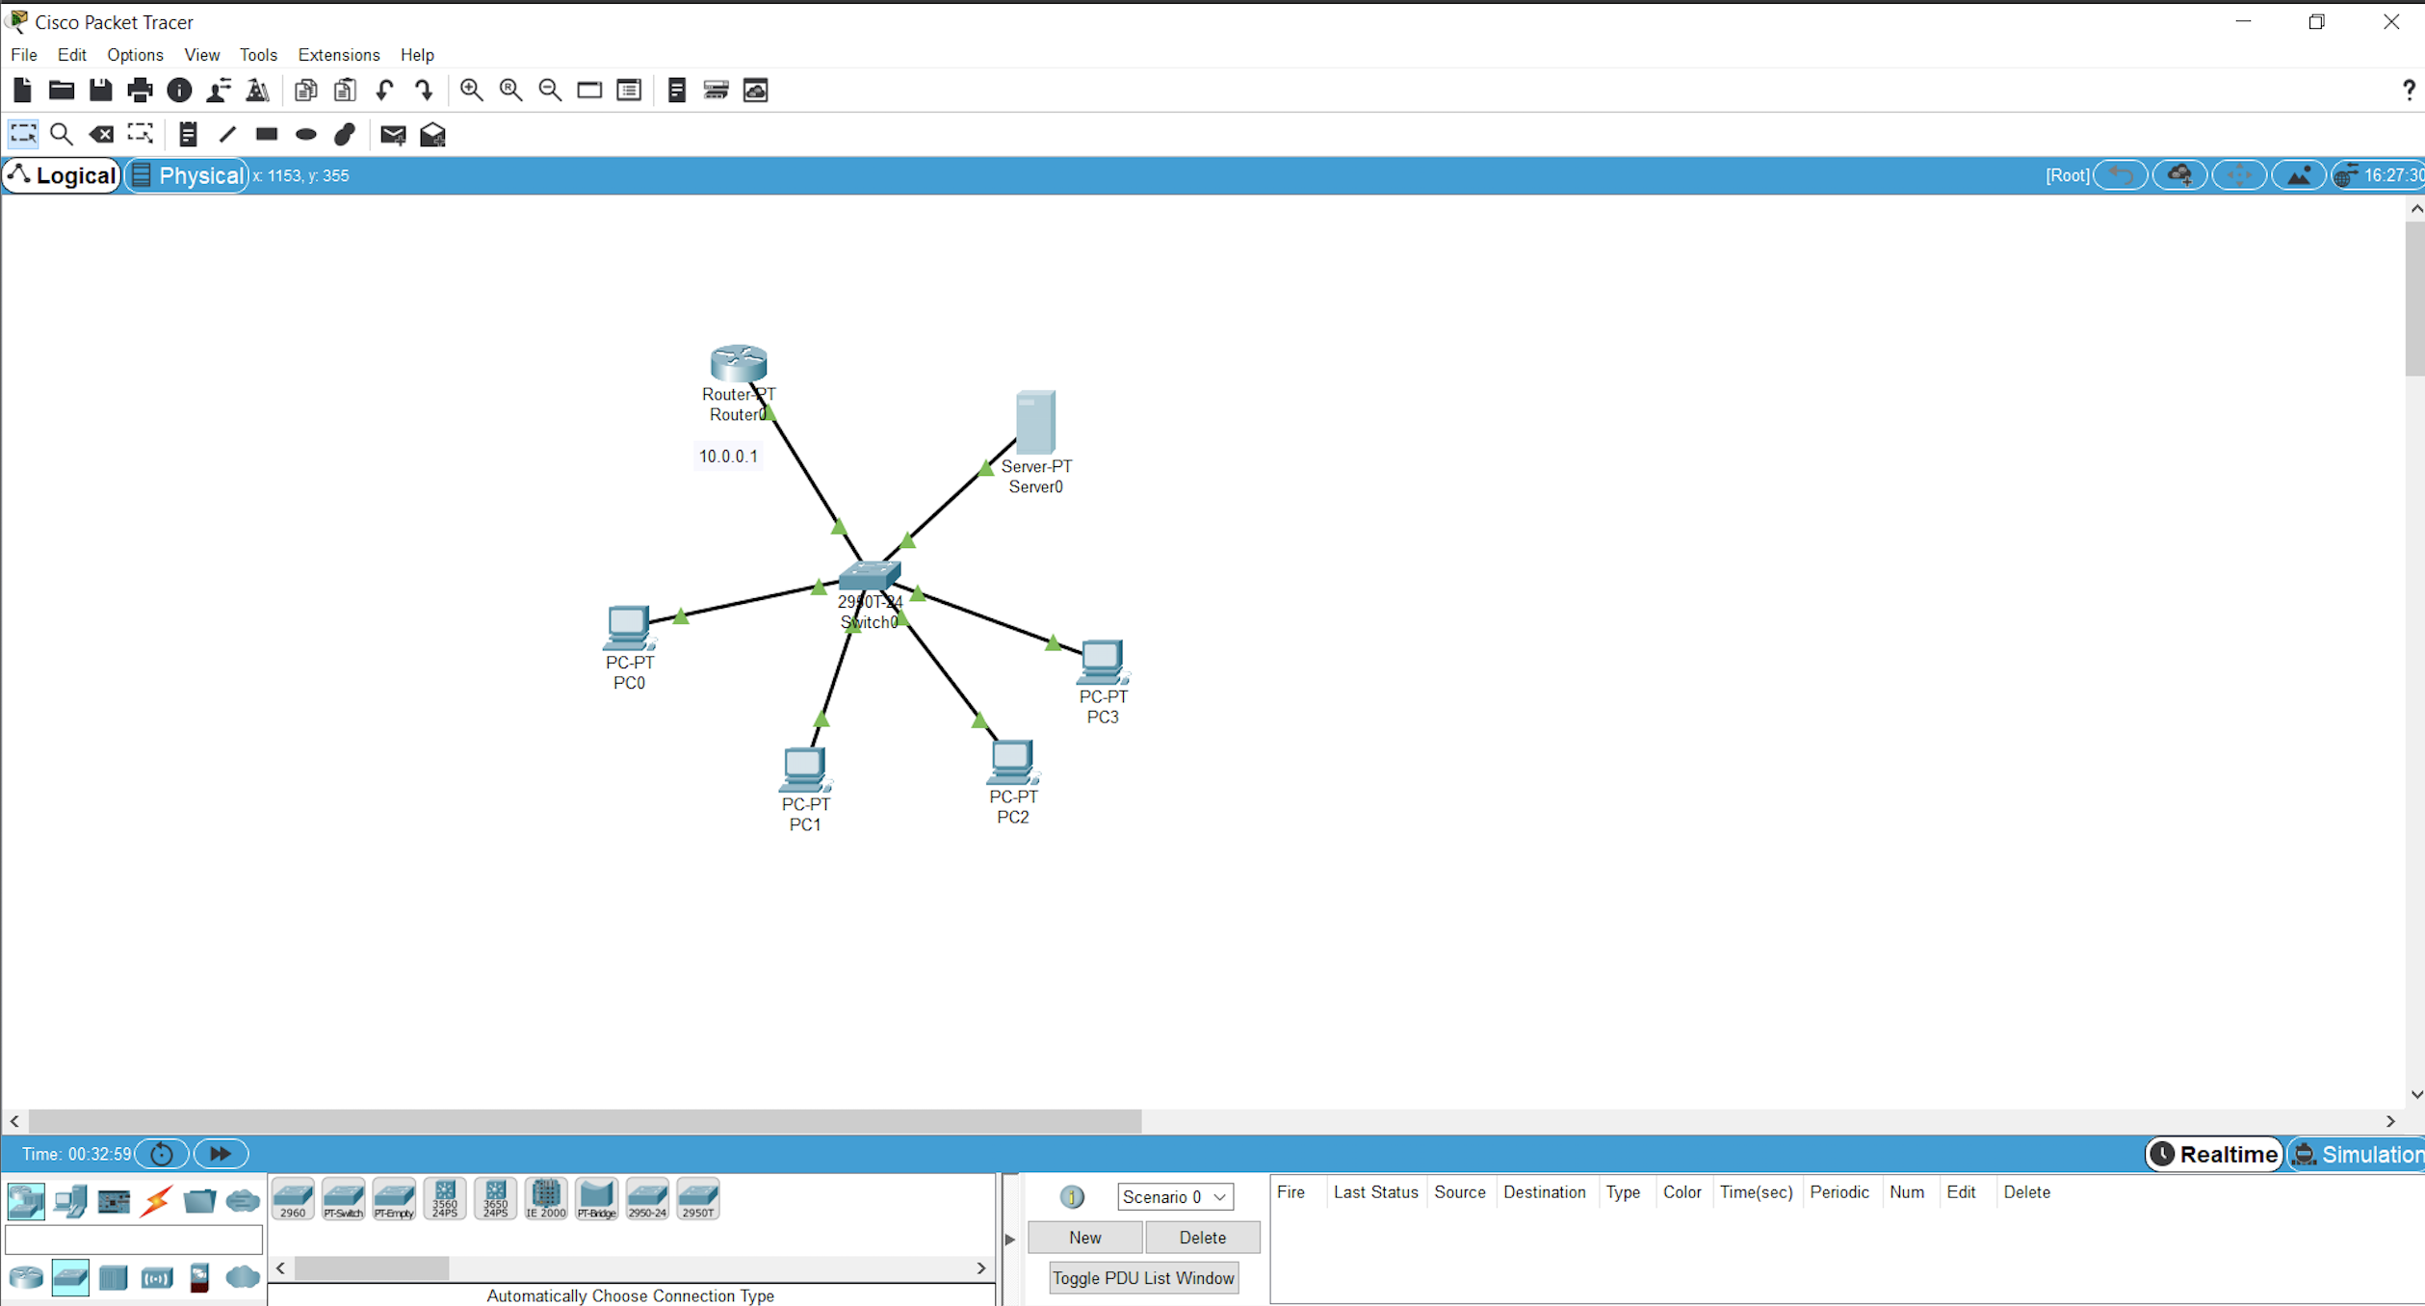

### The Router interface was configured using CLI

### The Server was configured specifying the default gateway, DNS server, TFTP server as shown below

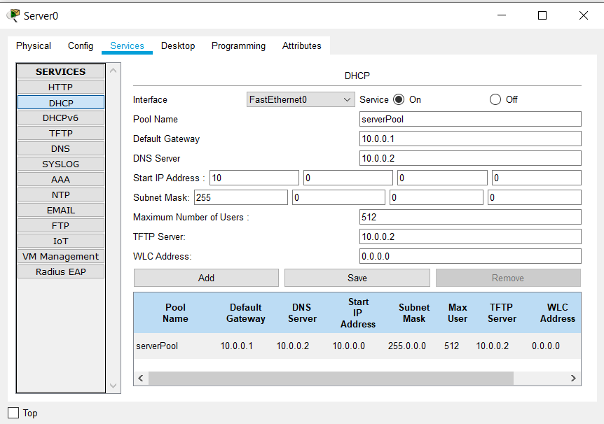

### The PCs request the Server for ip

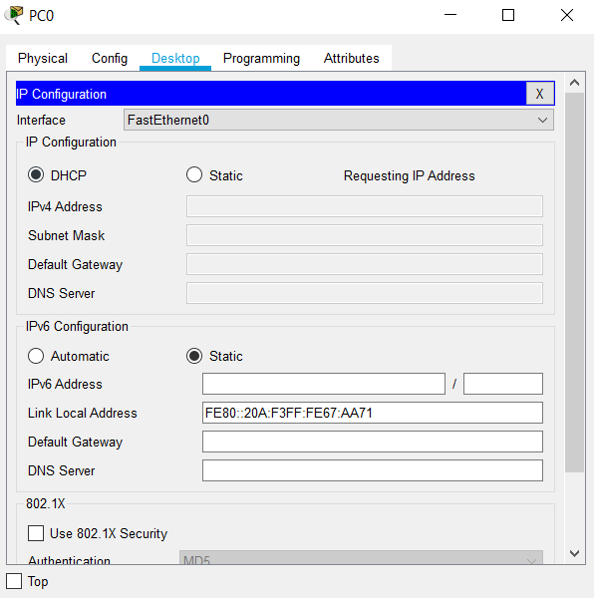

### Upon request, an ip address was successfully assigned to the PC

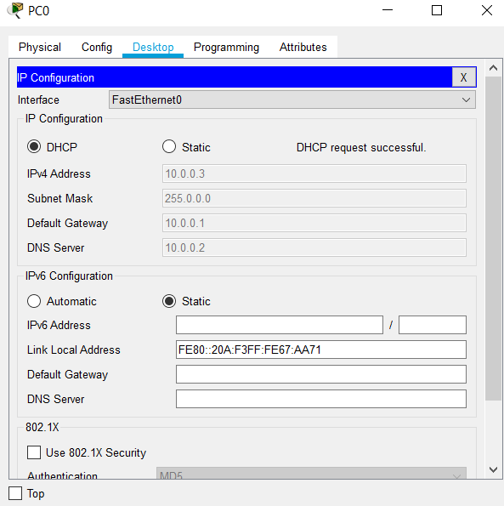

### **Learning Outcomes :**

* Creating a topology with router, switch, server and PCS.
* Configuring the server.
* 4 steps in DHCP
  + D - Discover the server
  + O - Offer the IP address
  + R - Request ip
  + A - Acknowledgement
* Individual PC request the Server for an ip address
* An ip address is assigned to the PC from a pool of IP addresses by the DHCP server