## **Configuring Web server and DNS**

### A topology was created using a Switch, a Server and a PC connected as shown in the figure

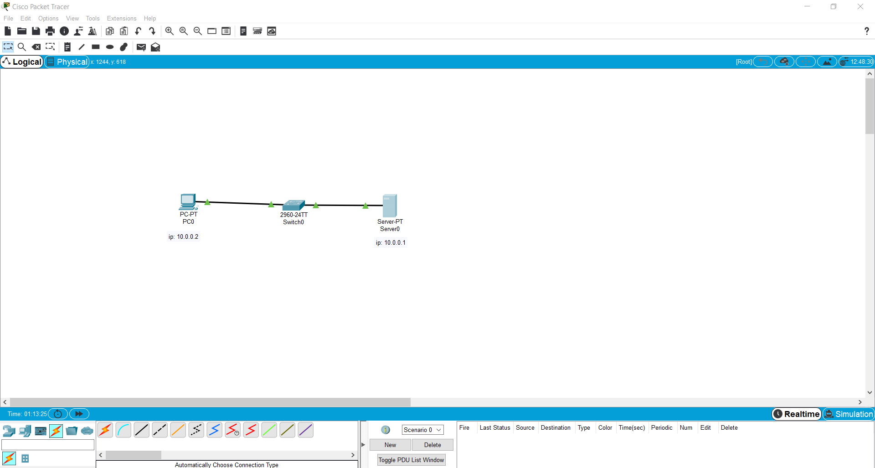

* HTTP services of the server was switched on

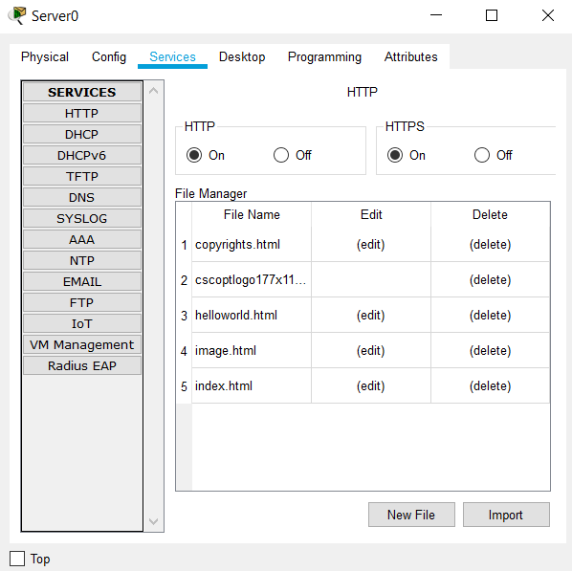

### DNS service of the Server was configured as shown in the figure

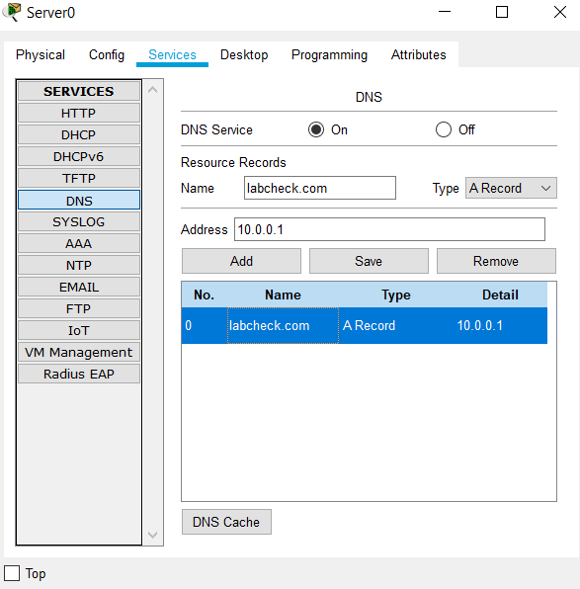

### Typing the defined url in the web browser of PC gives the required result

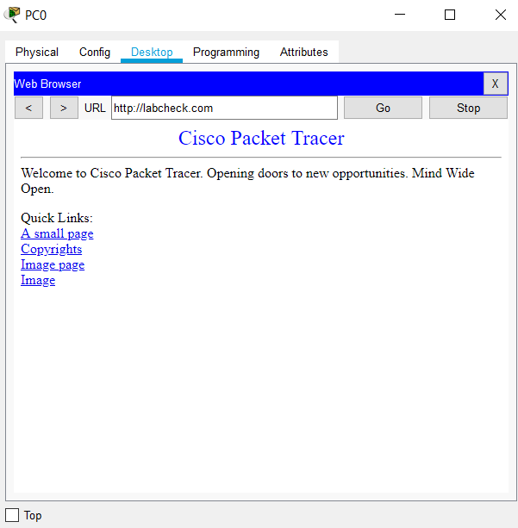

### **Learning Outcomes :**

* Creating a topology with switch, server and PC.
* Using HTTP services.
* Configuring the web server.
* Configuring DNS services so that we can use the name instead of ip address.
* Using the name or the ip address in the web browser of PC gives the required result.