**Program Title : Distance detector**

**Aim : Design a system to measure the distance between the objects.**

**Hardware Required :**

* Arduino Board
* Ultrasonic distance sensor

**Circuit Diagram :**

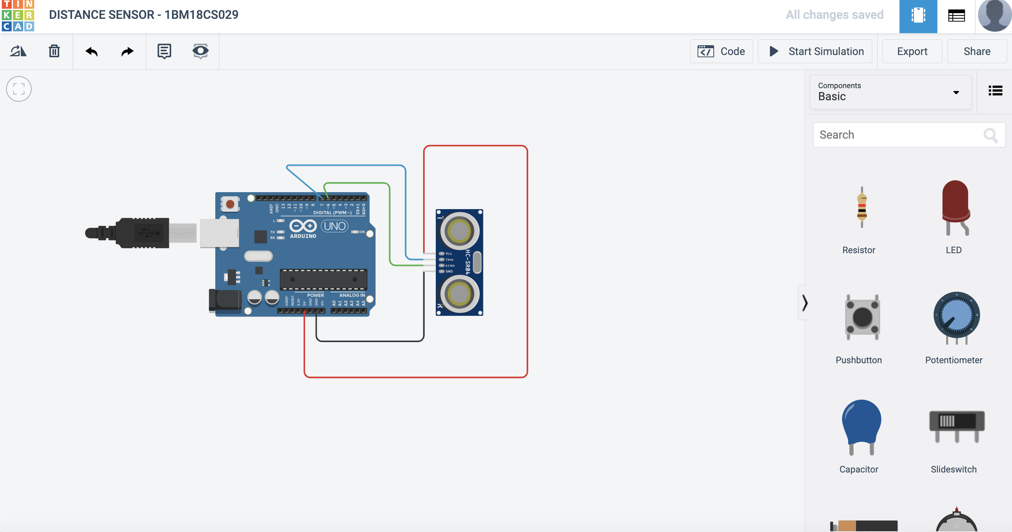

**Output/Working :**

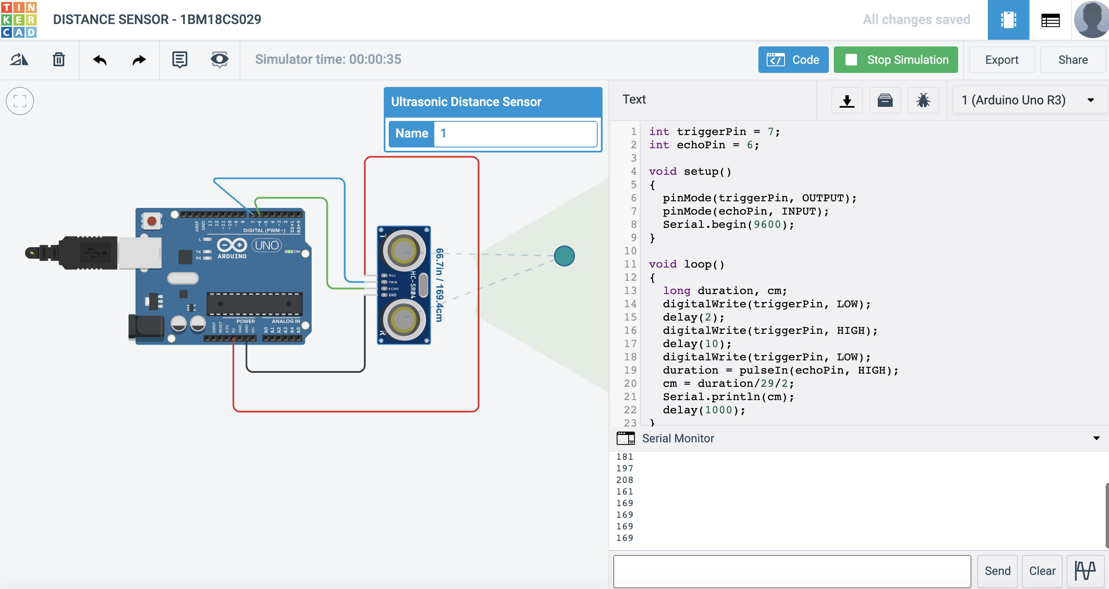

**Code:**

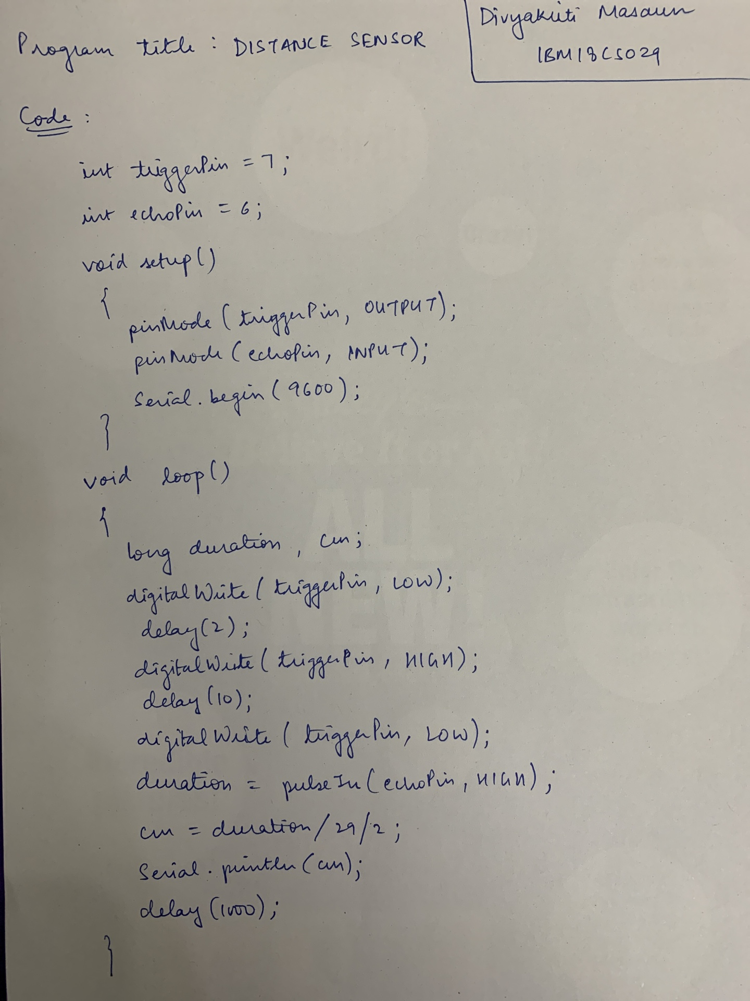

**Observation :**

It will tell the distance in cm. Distance changes as you move the object.