**Program Title : Flame sensor**

**Aim : Design an alert system using flame sensor.**

**Hardware Required :**

* Arduino Board
* Temperature sensor

**Circuit Diagram :**

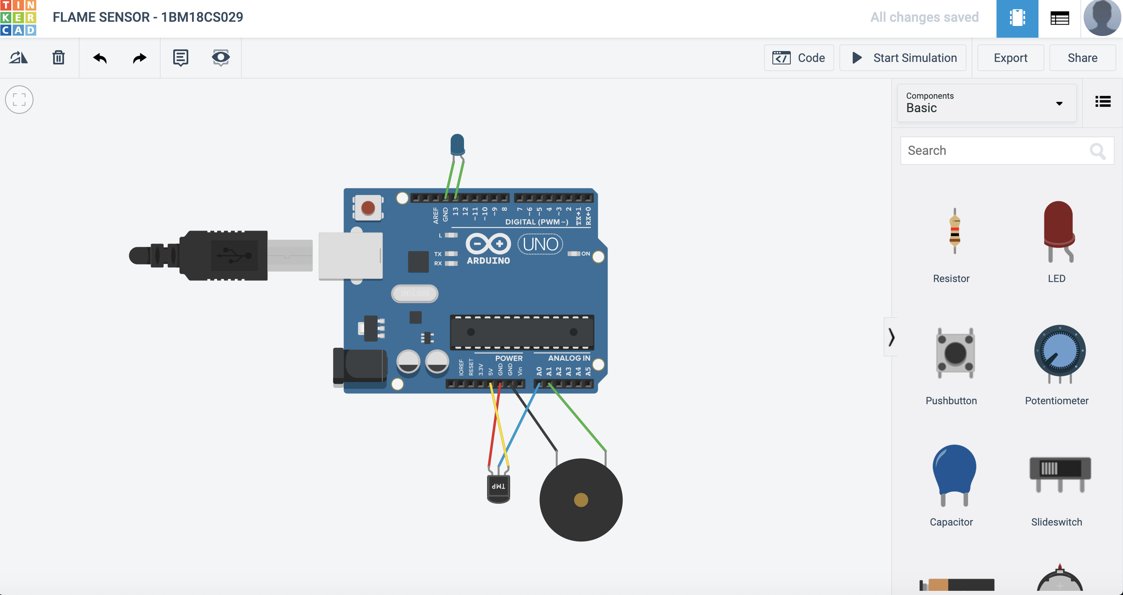

**Output/Working :**

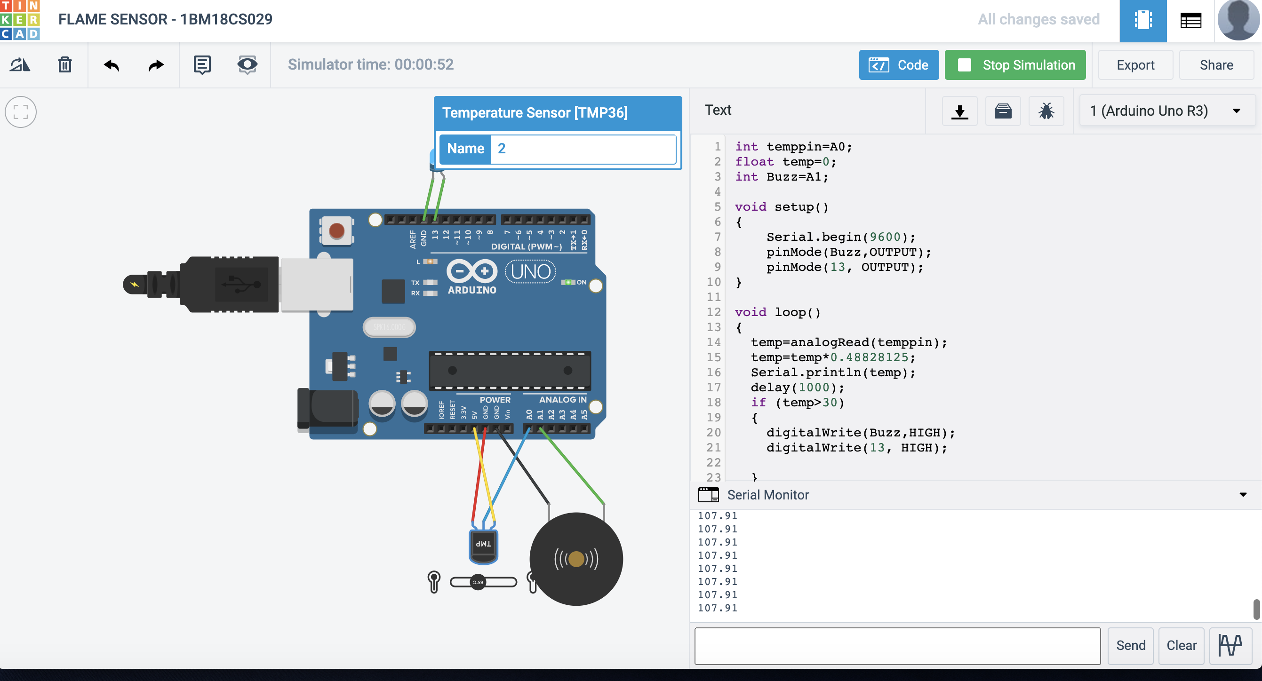

**Code:**



**Observation :**

If temperature exceeds the given value, temperature sensor triggers and buzz sound is produced and LED glows. If temperature is below the given value then there will be no buzz sound and LED wont glow.