**Program Title : Vibrator**

**Aim : Design an automated dat indicator system**

**Hardware Required :**

* Arduino Board
* Vibration Motor
* LDR

**Circuit Diagram :**

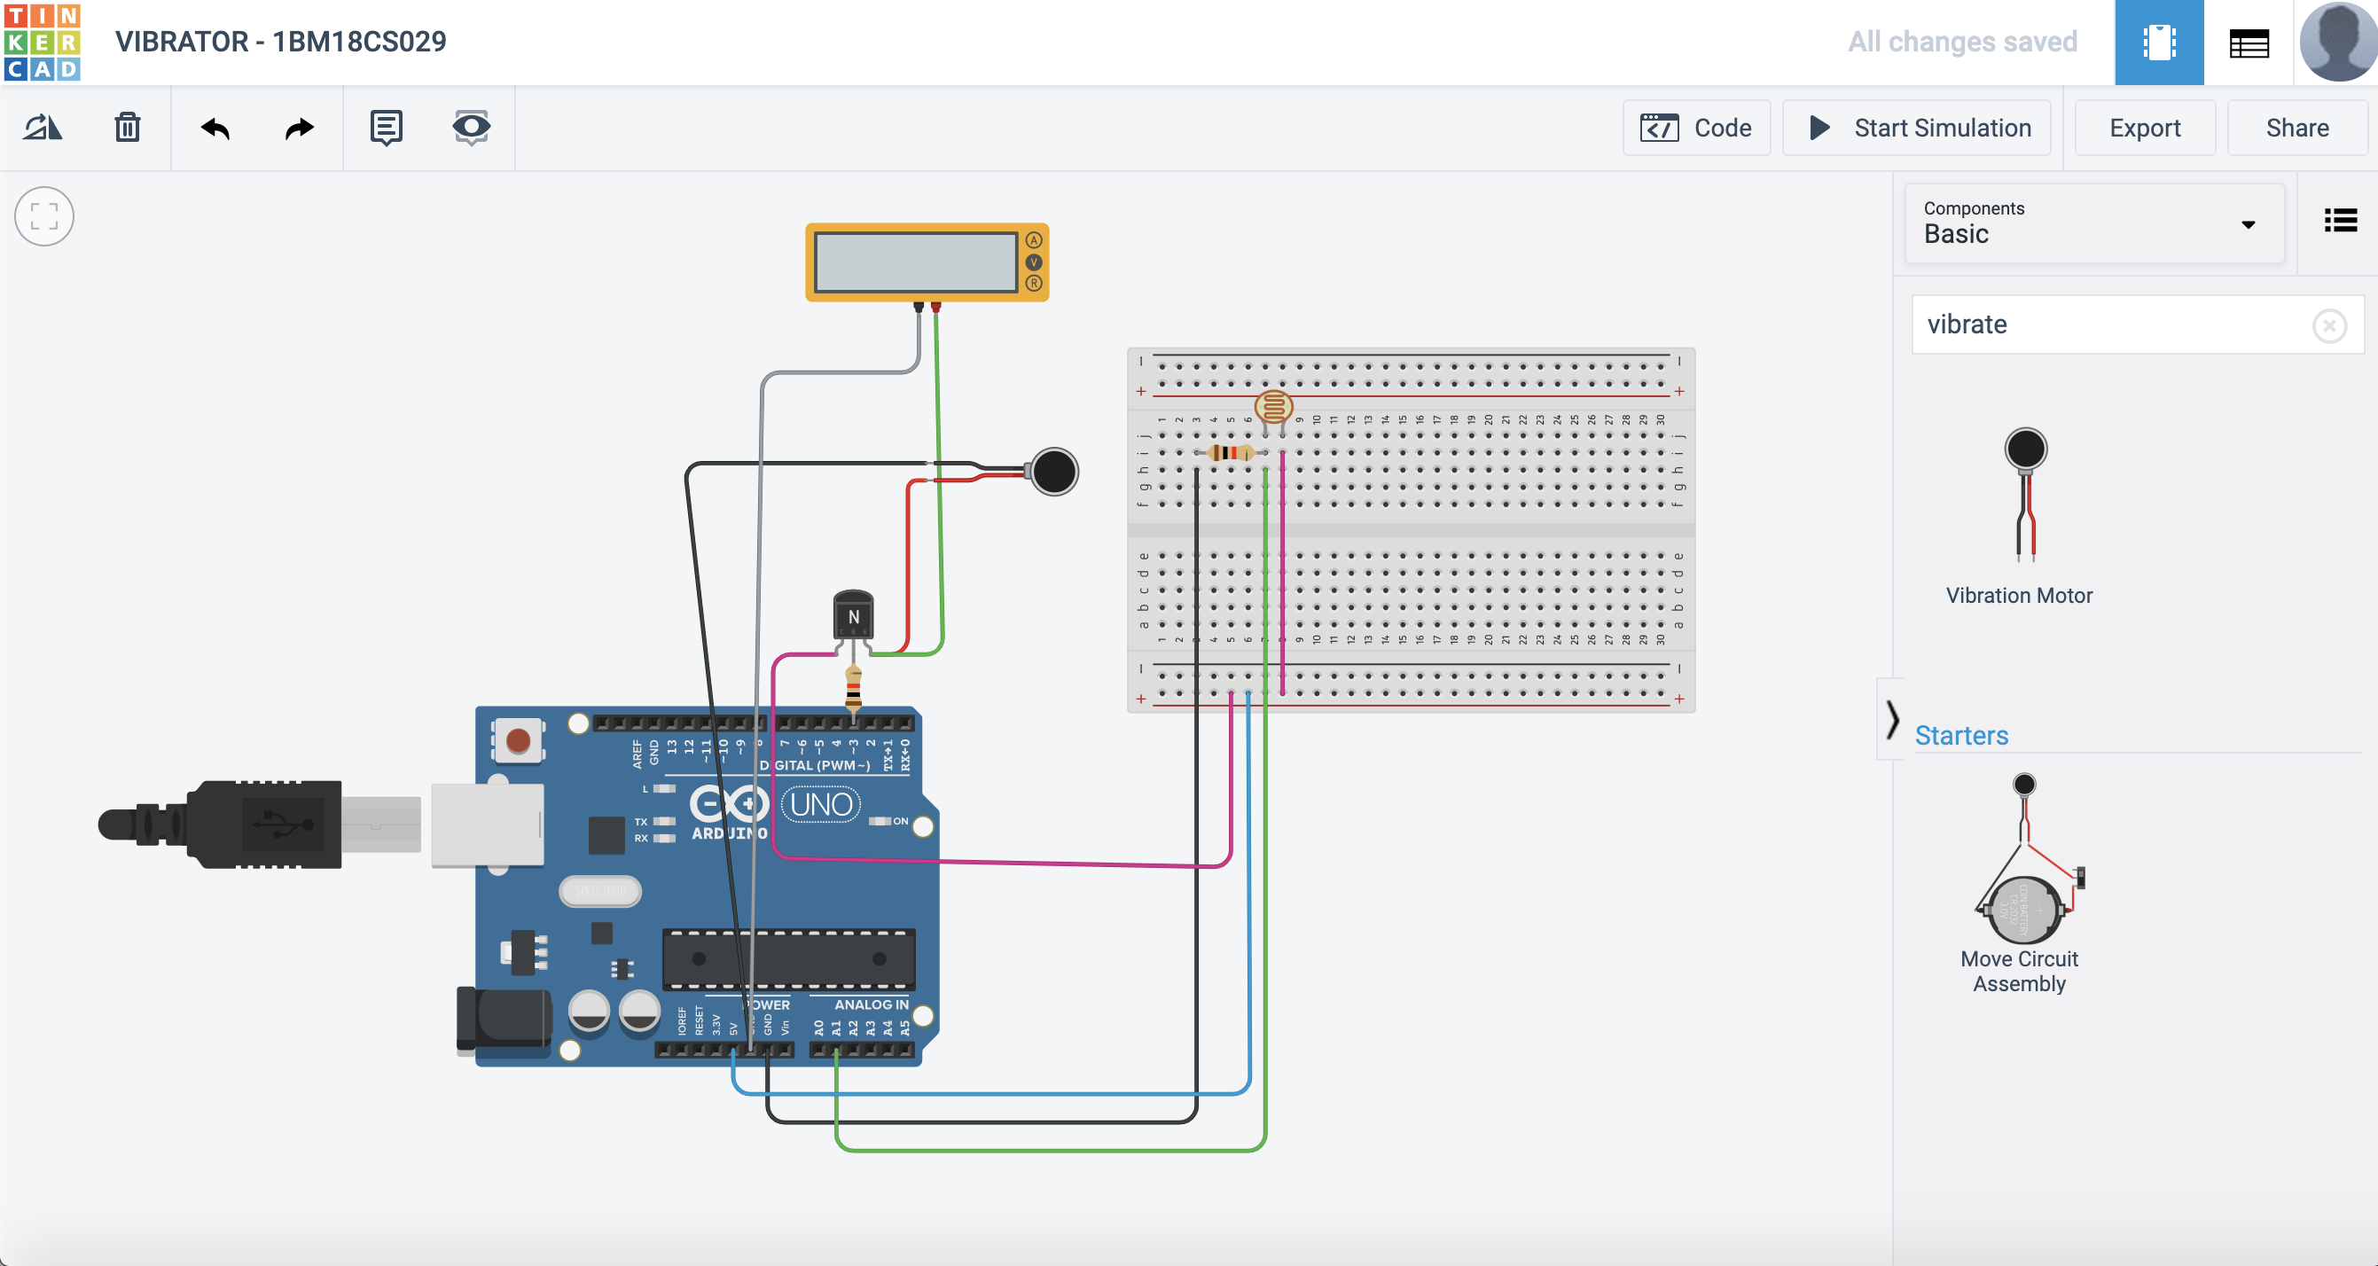

**Output/Working :**

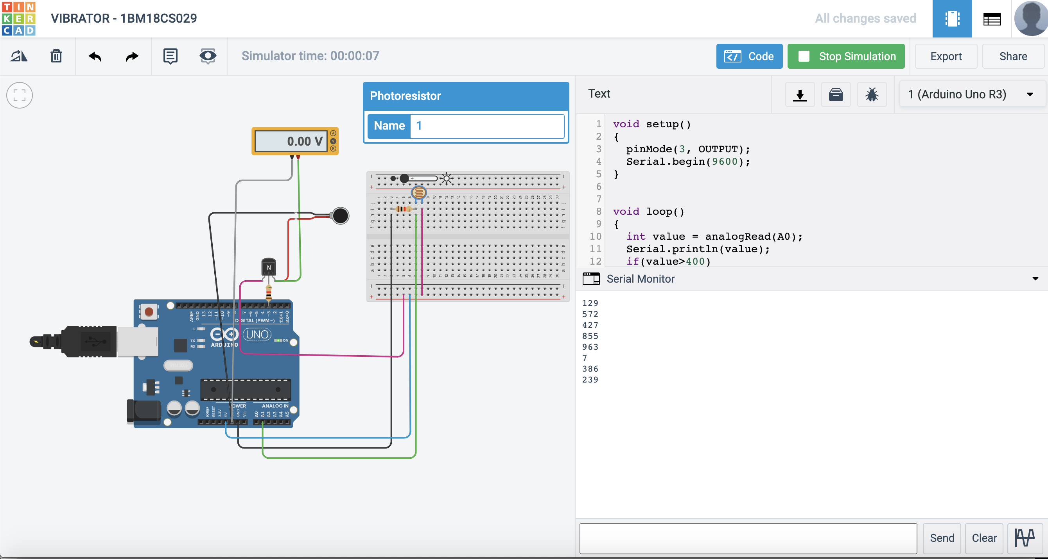

**Code:**

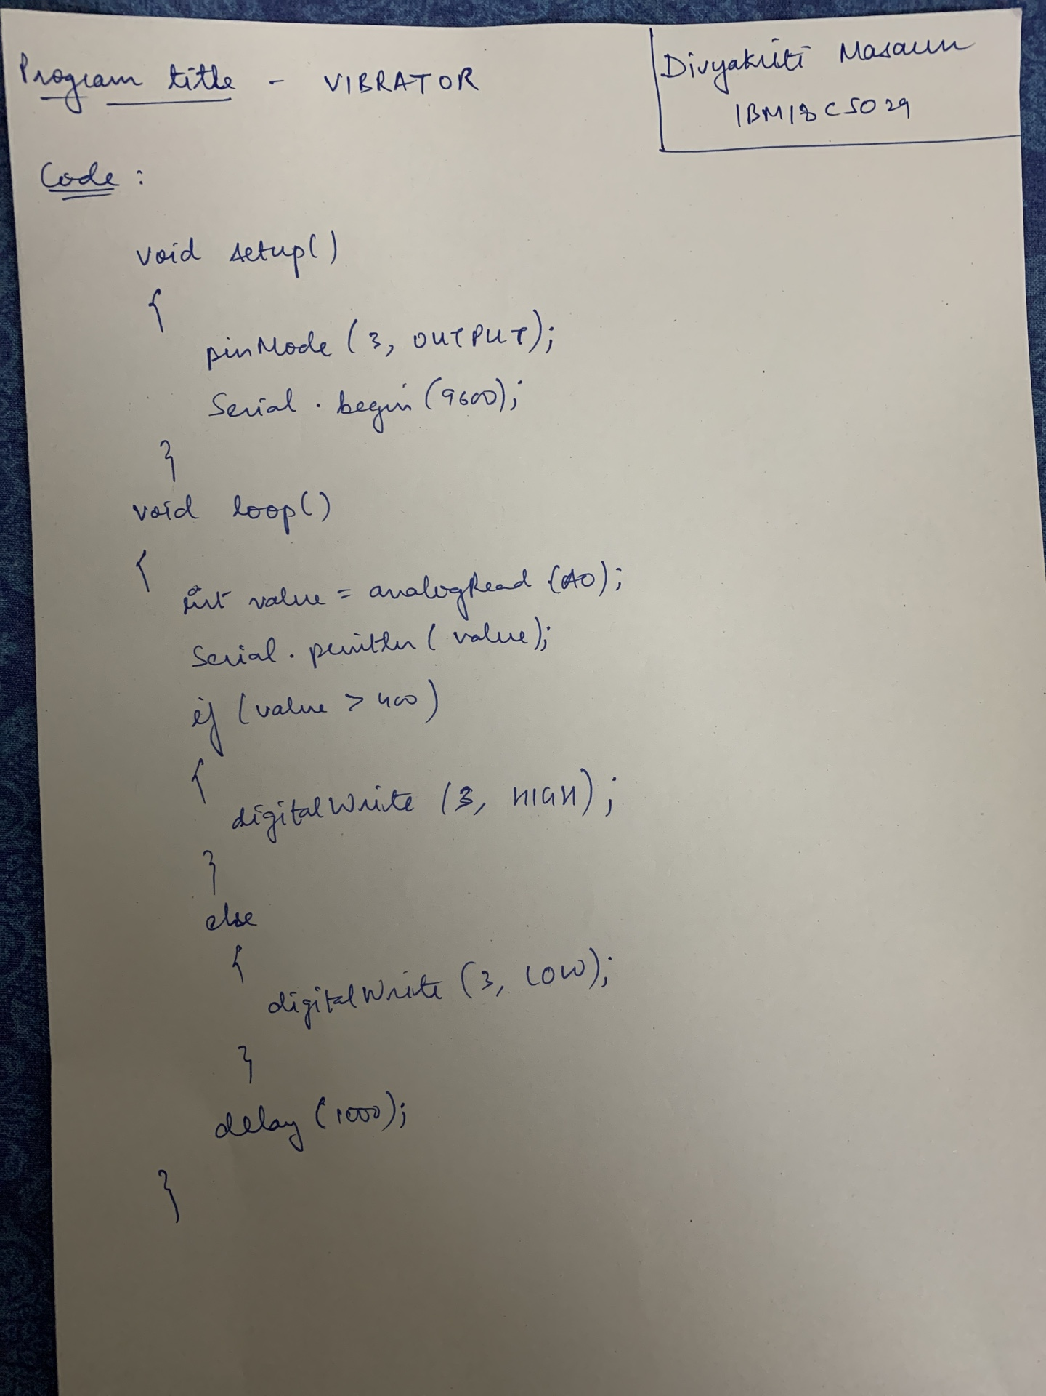

**Observation :**

If the temperature value increases 400, then the vibration motor vibrates. But if the temperature value is less than 400, then no change.