**Program Title :** RGB LED AND LCD

**Aim :** Design a display system to print the red, blue and green colours.

**Hardware Required:**

* Arduino Board
* Bread board
* Wires
* Resistor
* LED Display
* LED RGB

**Circuit Diagram :**

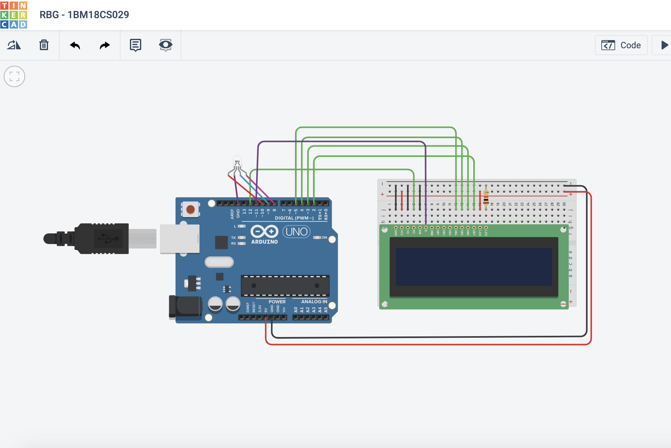

**Output/Working :**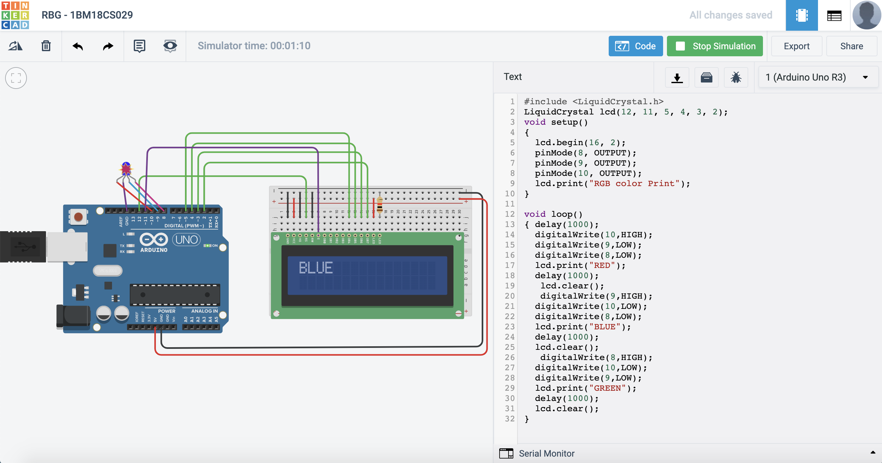

**Code:**

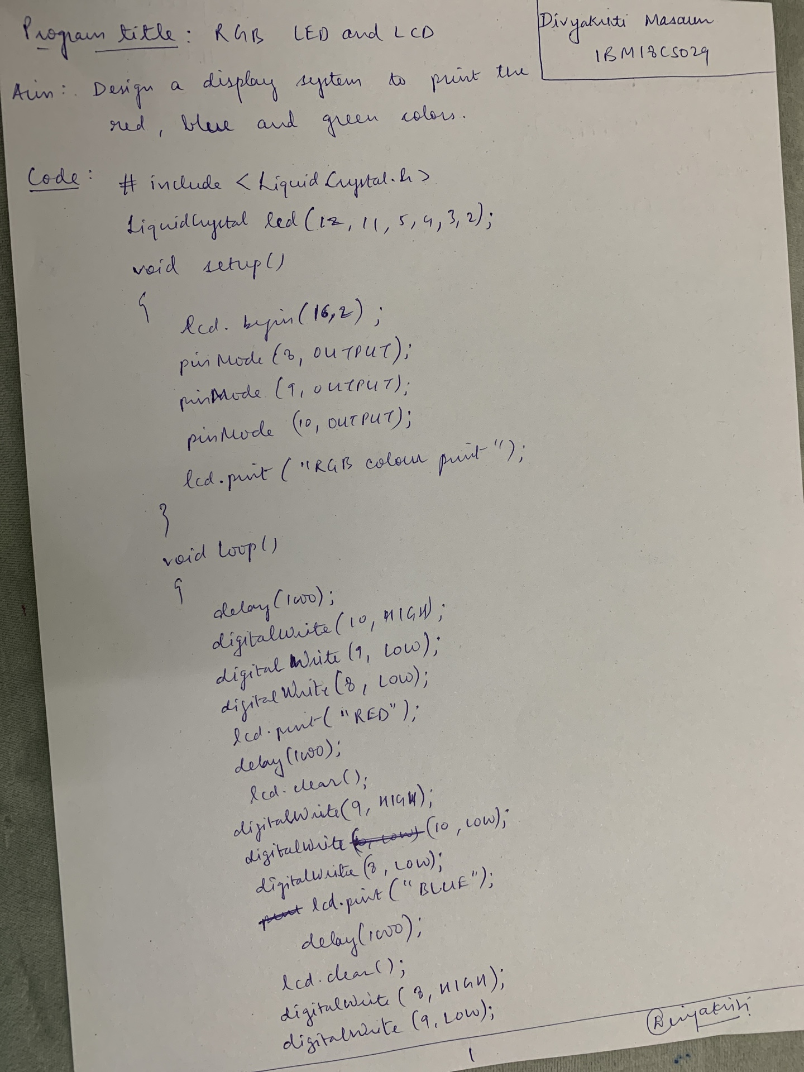

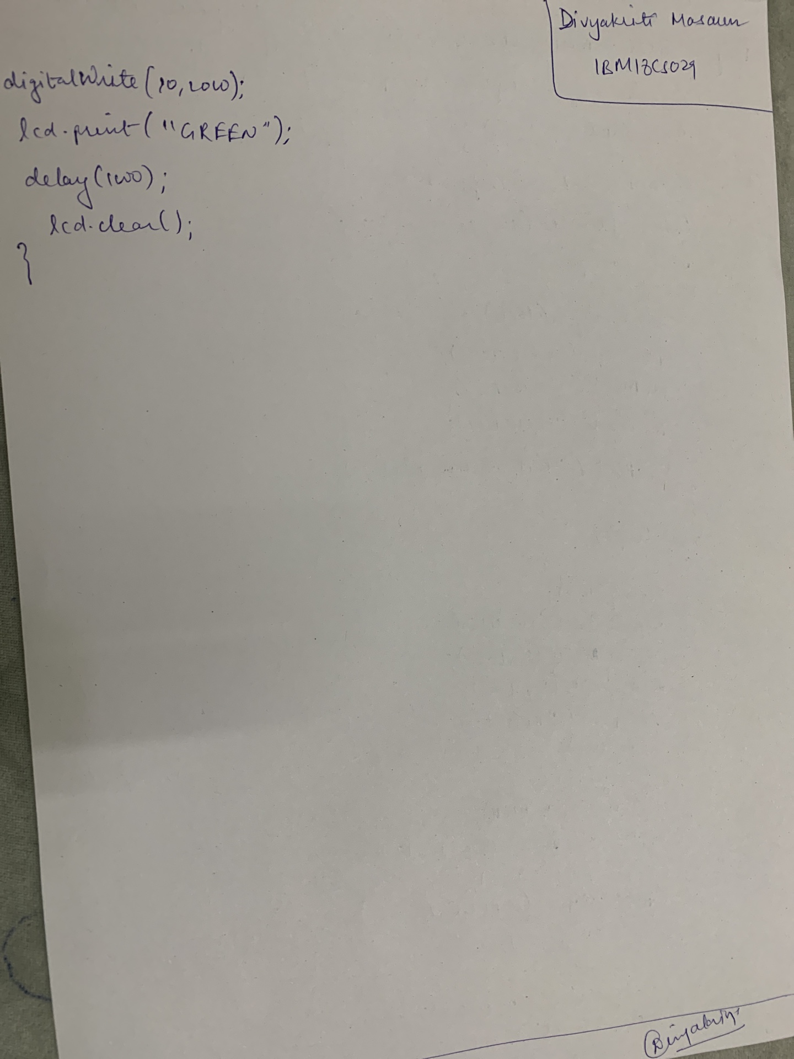

**Observation :**

The red, blue and green colors are lit on LED and displayed on the screen.