**IOT LAB**

**Program no - 5**

**Program Title - LDR PROGRAM**

**AIM – Demonstrate to show ON/OFF of a LED using LDR-Night Light simulation.**

**Hardware Required -**

* Arduino Board
* LED
* Breadboard
* Wires
* Photoresistor
* Resistor

**Circuit Diagram -**

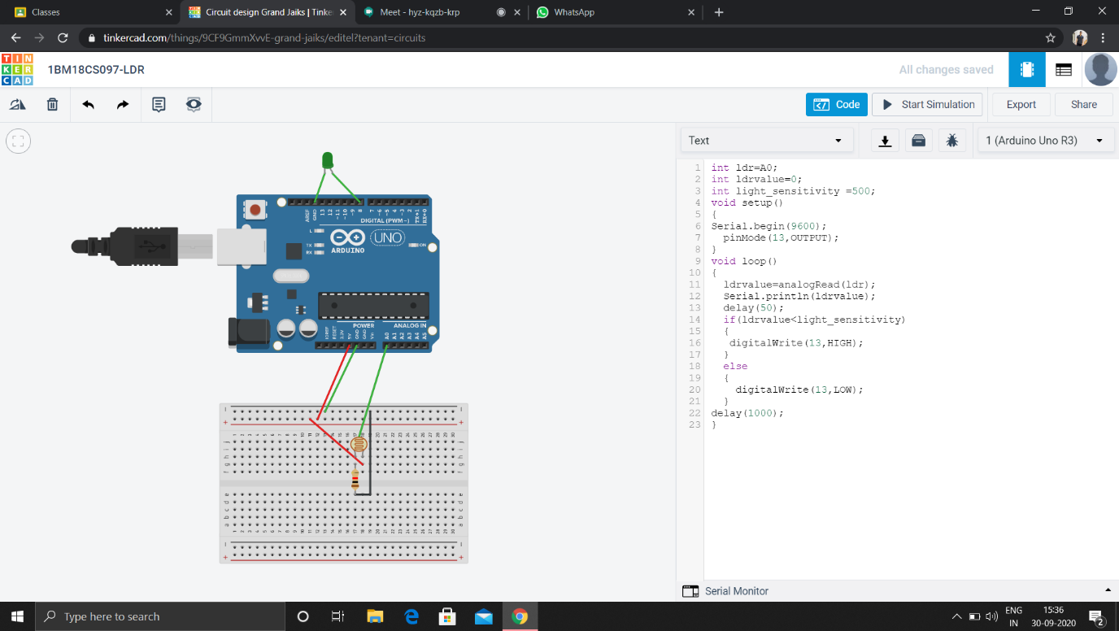

Code-

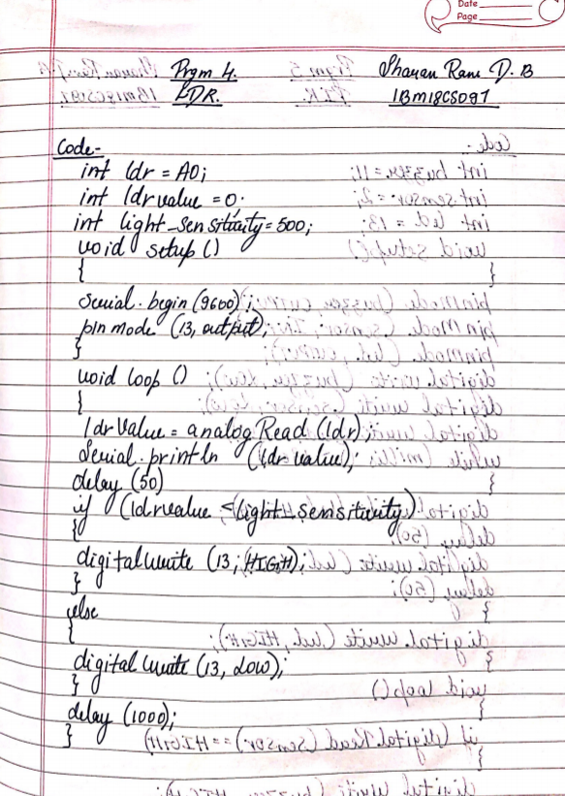

**Observation /Output -**

**The on and off of the LED can be observed and also the brightness can be read according to the tuning.**