**IOT LAB**

**Program No - 13**

**Program Title – RGB LED AND LCD.**

**Aim – Design a display system to print the red, blue and green colours.**

**Hardware Required -**

* Arduino Board
* Bread board
* Wires
* Resistor
* LED Display
* LED RGB

**Circuit Diagram –**

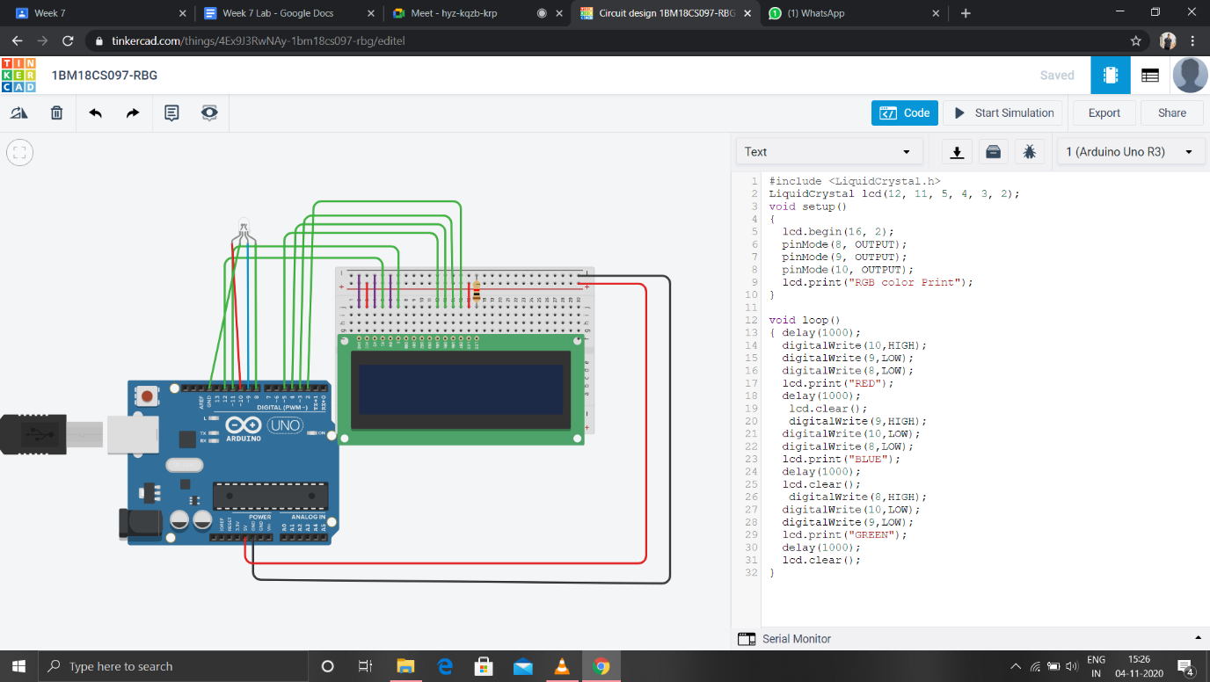

**Code -**

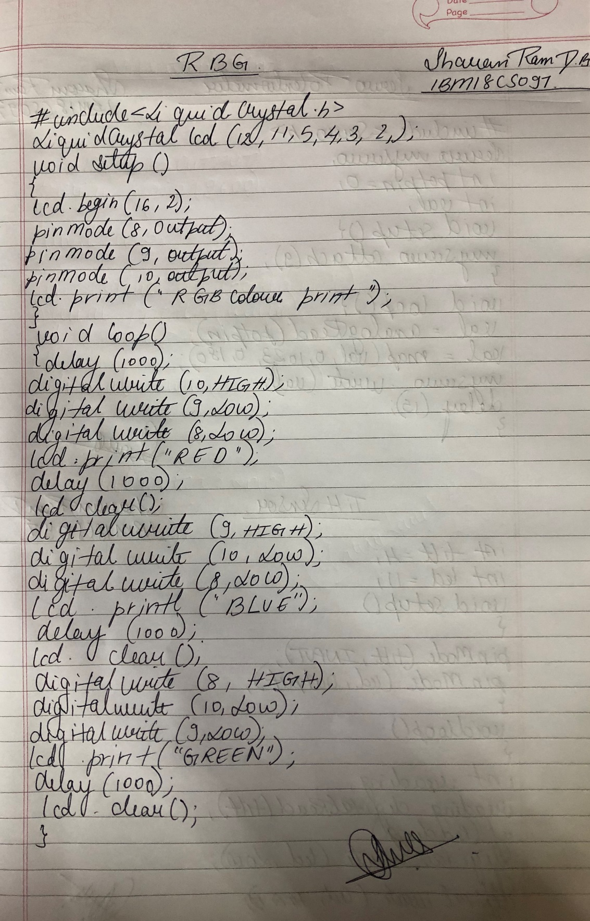

**Observation /Output –**

**The red, blue and green colours are lit on LED and displayed on the screen.**