आstha — E-commerce Website
Website Rendered Interface & Visual Proof Document
―――――――――――――――――――――――――――――――――――――――――――――
Student name: | [ENTER STUDENT NAME]
Roll number: | [ENTER ROLL NUMBER]
Course/subject: | [ENTER COURSE NAME]
Institution: | [ENTER INSTITUTION]
Submission date: | [ENTER DATE]

Website Rendered Visual Proof
This document contains high-fidelity screen captures of the running आstha sacred apparel storefront. Every capture was recorded from the production build operating at http://localhost:3000 across desktop (1280x840) and mobile (390x844) viewports. The captures verify complete visual coherence, typography, product details, interactive galleries, and transactional flows.

Figure 1: Homepage — Hero Campaign & Global Navigation

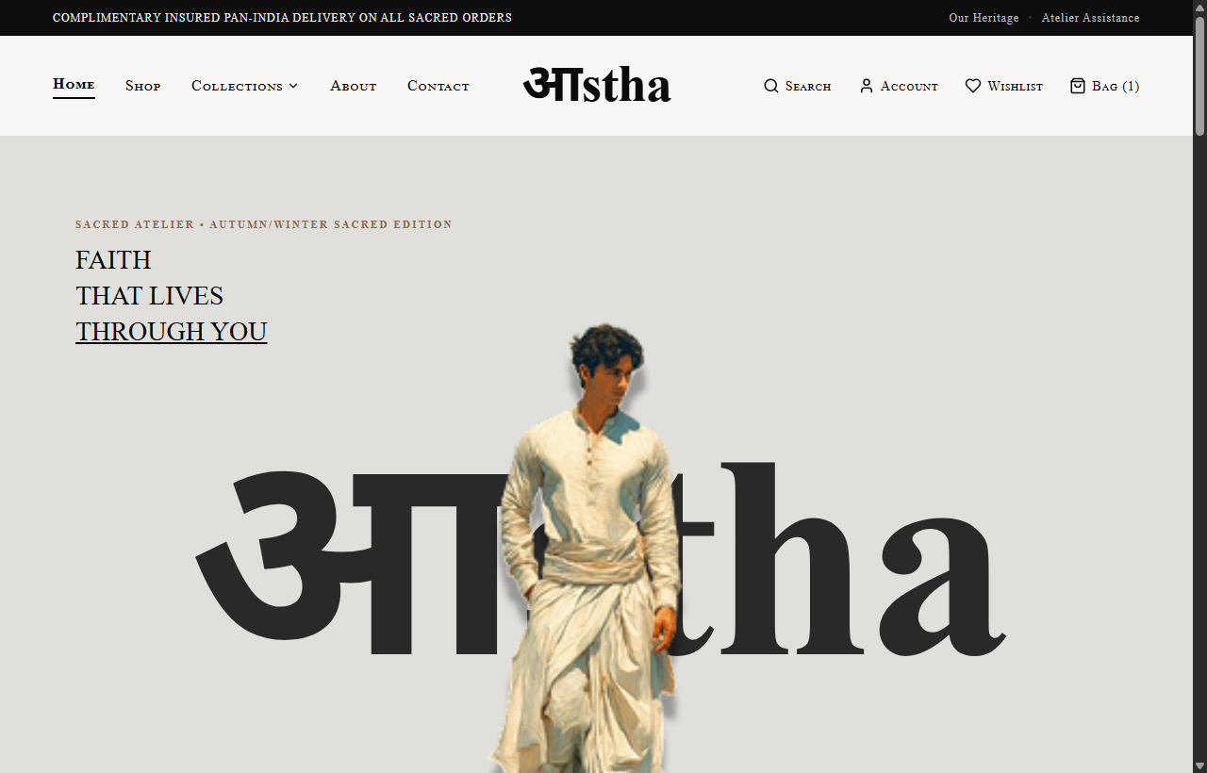
Route: / | Viewport: Desktop (1280px)
Demonstrates the refined editorial luxury hero banner, announcement bar with rotating delivery guarantees, desktop navigation links with Collections dropdown, and high-contrast campaign typography.

Figure 2: Shop Catalogue — Tradition Filters & Product Grid

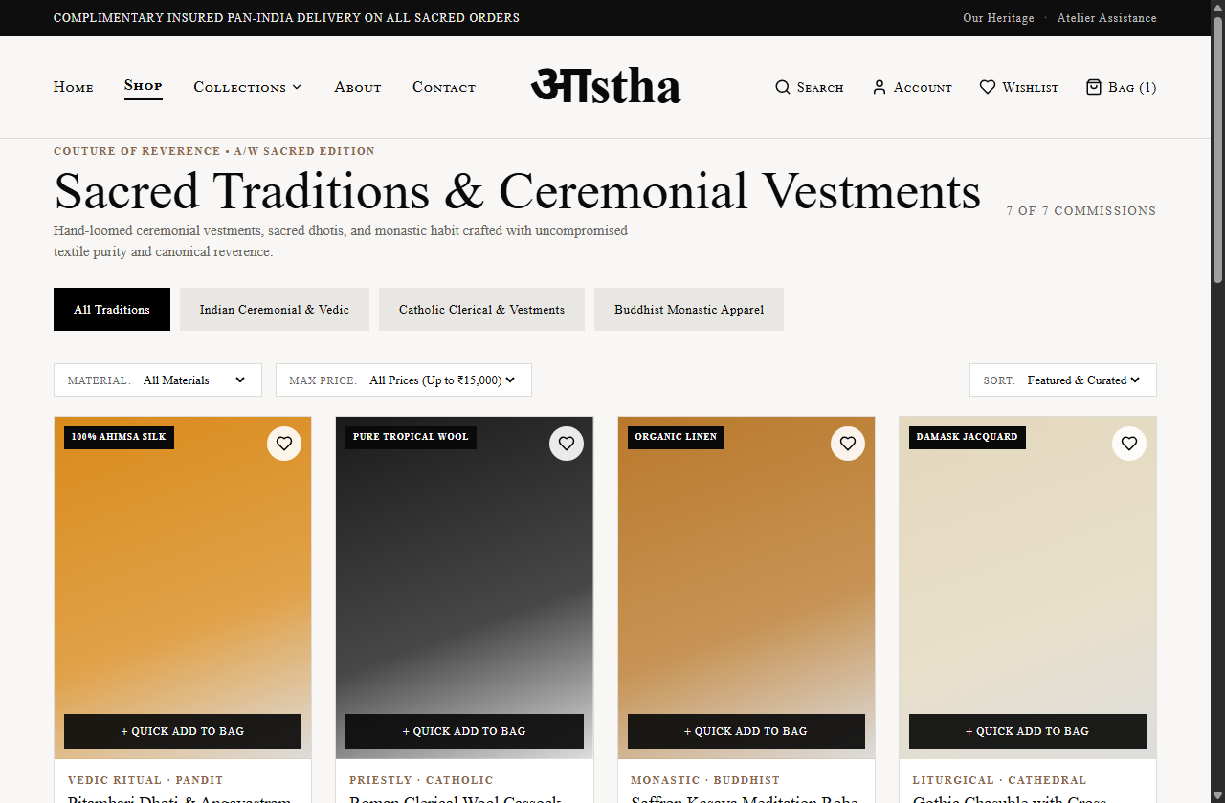
Route: /shop | Viewport: Desktop (1280px)
Demonstrates the complete catalogue browsing experience, tradition filter chips (Vedic, Priests, Monks), material and price select filters, sorting control, and consistent 3:4 portrait product cards.

Figure 3: Product Detail — Pitambari Dhoti & Angavastram

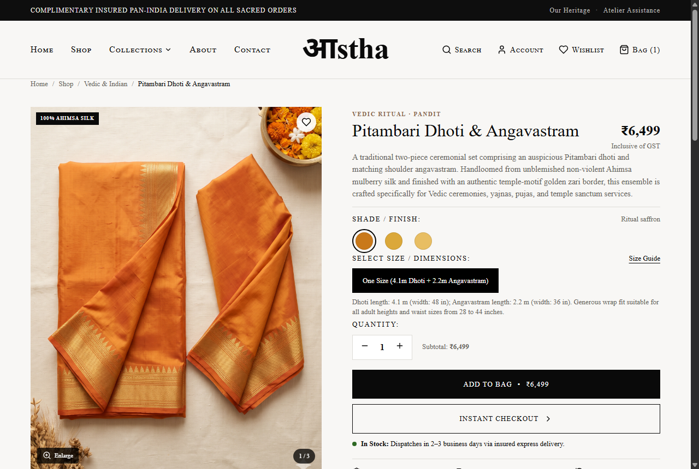
Route: /product/pitambari-dhoti-angavastram | Viewport: Desktop (1280px)
Demonstrates the multi-image gallery with thumbnail selection, zoom capability, size selection, package inclusions breakdown, and technical tabs for verified Ahimsa mulberry silk composition and pure zari border specifications.

Figure 4: Product Detail — Roman Clerical Wool Cassock

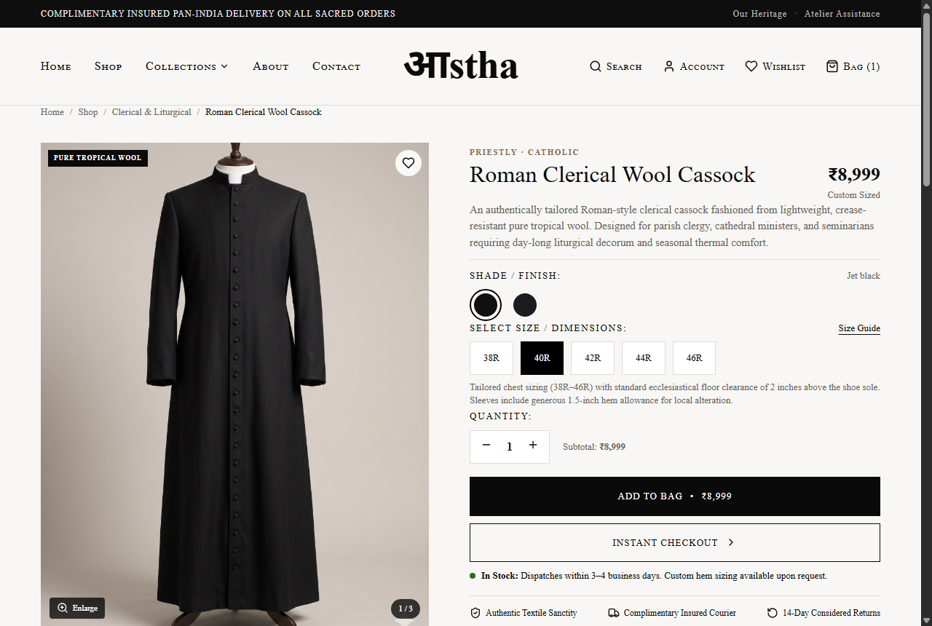
Route: /product/roman-clerical-wool-cassock | Viewport: Desktop (1280px)
Demonstrates the ecclesiastical clerical cassock detail page featuring 33 hand-stitched cloth buttons, pure tropical worsted wool specifications, tailored chest sizing (38R-46R), and direct consultation CTA.

Figure 5: Shopping Bag & Considered Order Breakdown

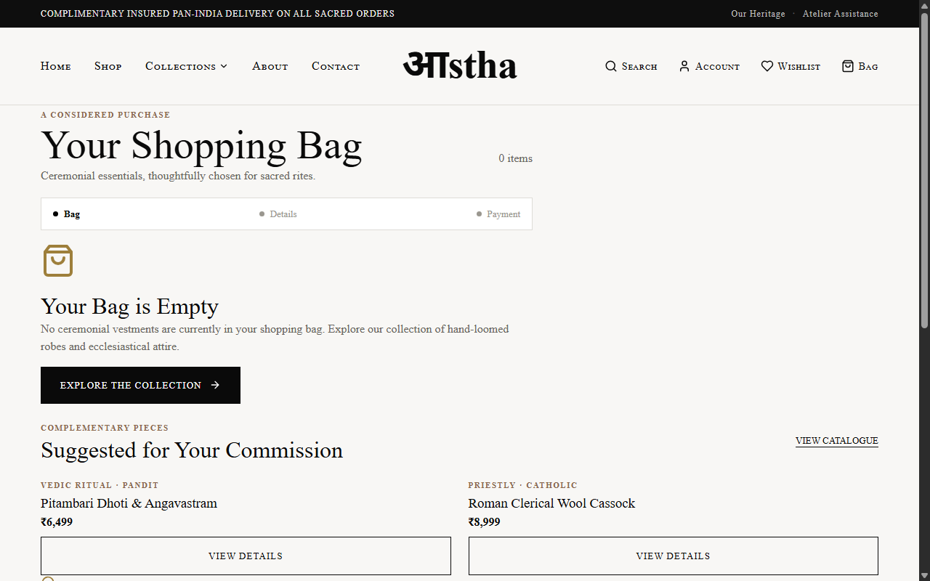
Route: /cart | Viewport: Desktop (1280px)
Demonstrates the shopping bag with live line item details, quantity adjustment controls, item removal, active voucher code application (ASTHA10 / ATELIER500), and subtotal calculation.

Figure 6: Checkout — Indian Delivery Address & Payment Methods

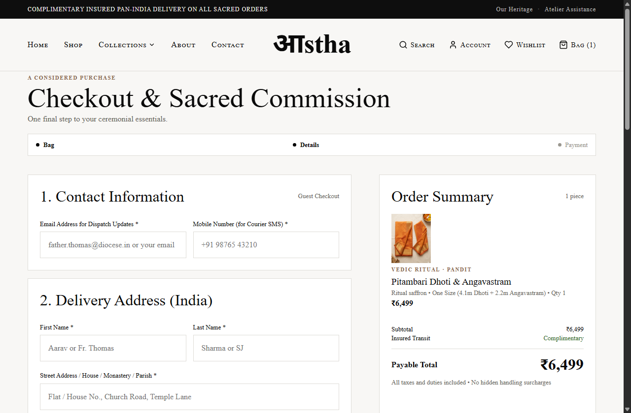
Route: /checkout | Viewport: Desktop (1280px)
Demonstrates the guest checkout workflow with full Indian delivery fields (PIN code, state dropdown, street address), complimentary insured courier selection, and payment options (UPI, Credit/Debit Card, Net Banking).

Figure 7: About Us — Sacred Textile Craftsmanship Manifesto

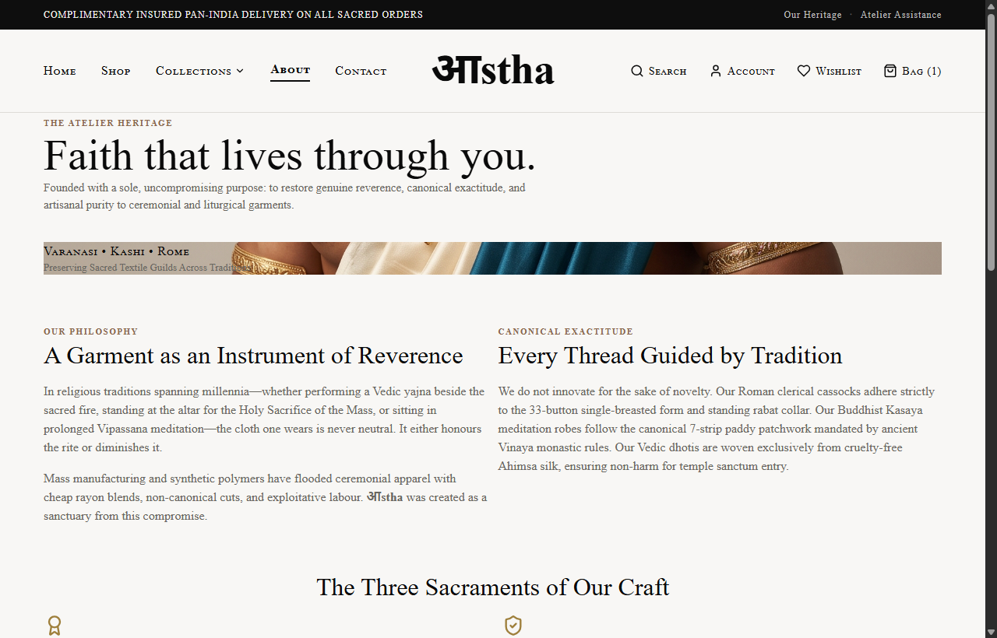
Route: /about | Viewport: Desktop (1280px)
Demonstrates the atelier manifesto detailing sacred textile sanctity, multi-generational Varanasi pit-loom guilds, and canonical exactitude across Vedic, Buddhist, and Roman liturgical traditions.

Figure 8: Contact Atelier — Sizing & Consultation Desk

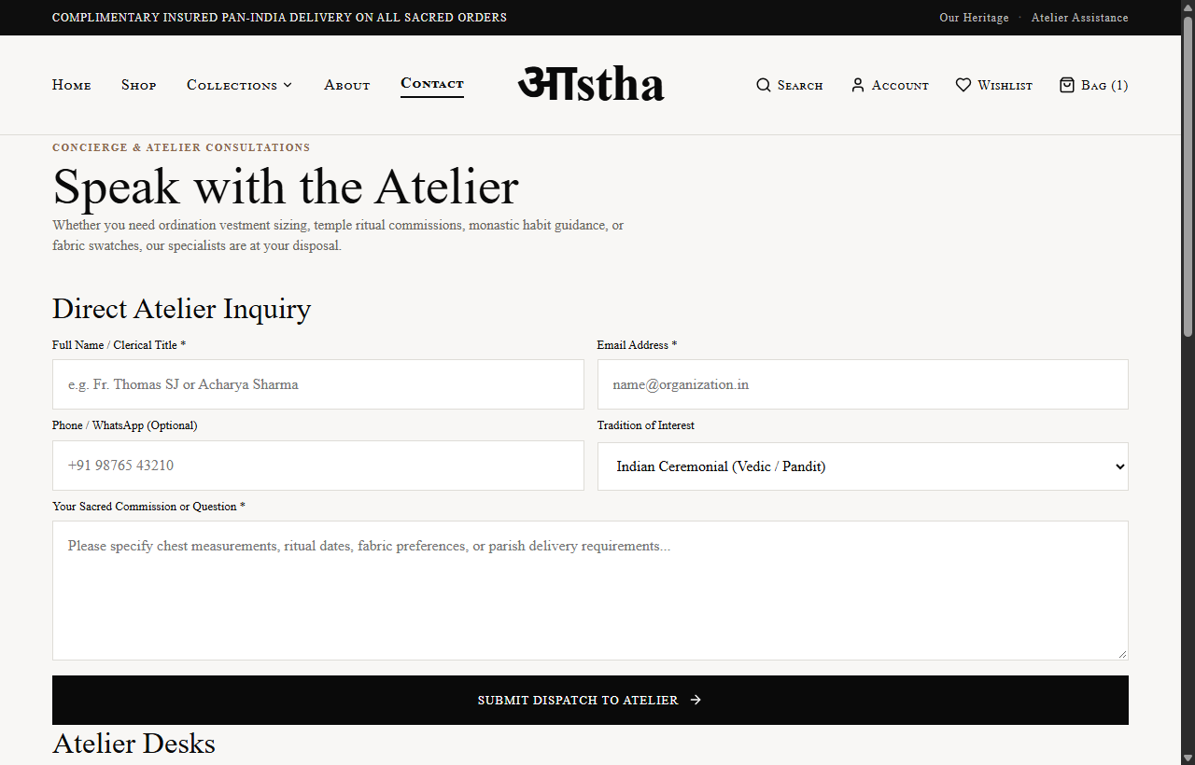
Route: /contact | Viewport: Desktop (1280px)
Demonstrates the interactive consultation form for custom ordination vestment measurements, parish commissions, direct atelier email, telephone, and physical weaving guild addresses.

Figure 9: Frequently Asked Questions — Canonical Guidance

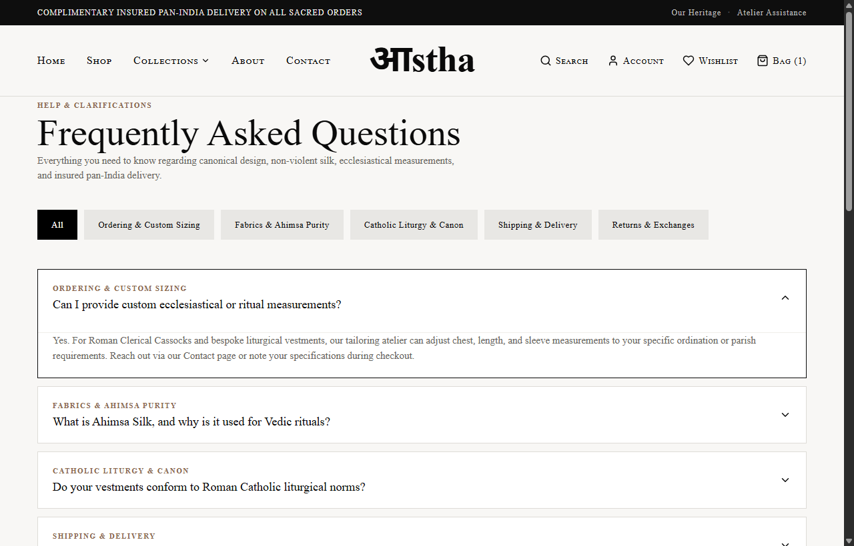
Route: /faq | Viewport: Desktop (1280px)
Demonstrates the interactive categorized FAQ accordion covering Ahimsa silk purity, Roman clerical sizing, diocesan feast day commissions, and insured pan-India delivery.

Figure 10: Mobile Responsive View — Homepage Hero & Navigation

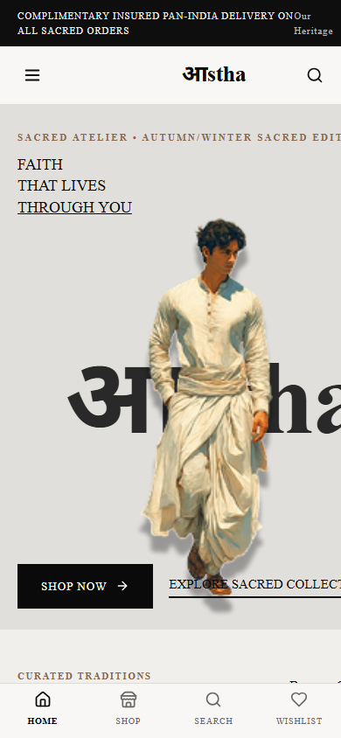
Route: / | Viewport: Mobile (390x844 iPhone Viewport)
Demonstrates responsive mobile scaling, accessible top bar, hamburger navigation drawer trigger, and touch-friendly bottom TabBar.

Figure 11: Mobile Responsive View — Shop Catalogue

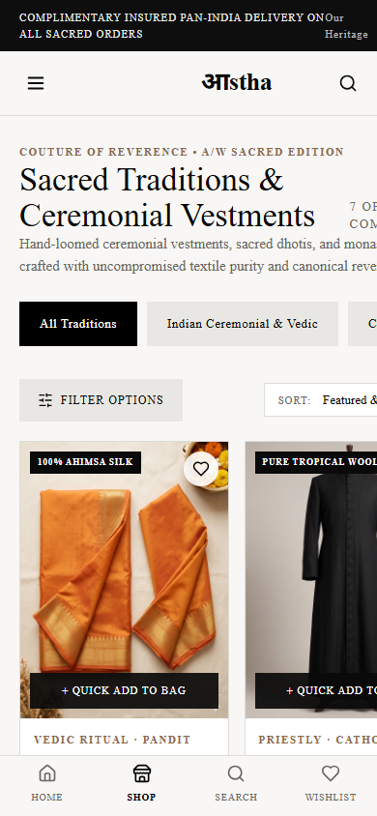
Route: /shop | Viewport: Mobile (390x844 iPhone Viewport)
Demonstrates mobile product catalogue grid with responsive card scaling, horizontally scrollable tradition chips, and mobile filter drawer trigger.

Figure 12: Dynamic XML Sitemap — Canonical URL Index

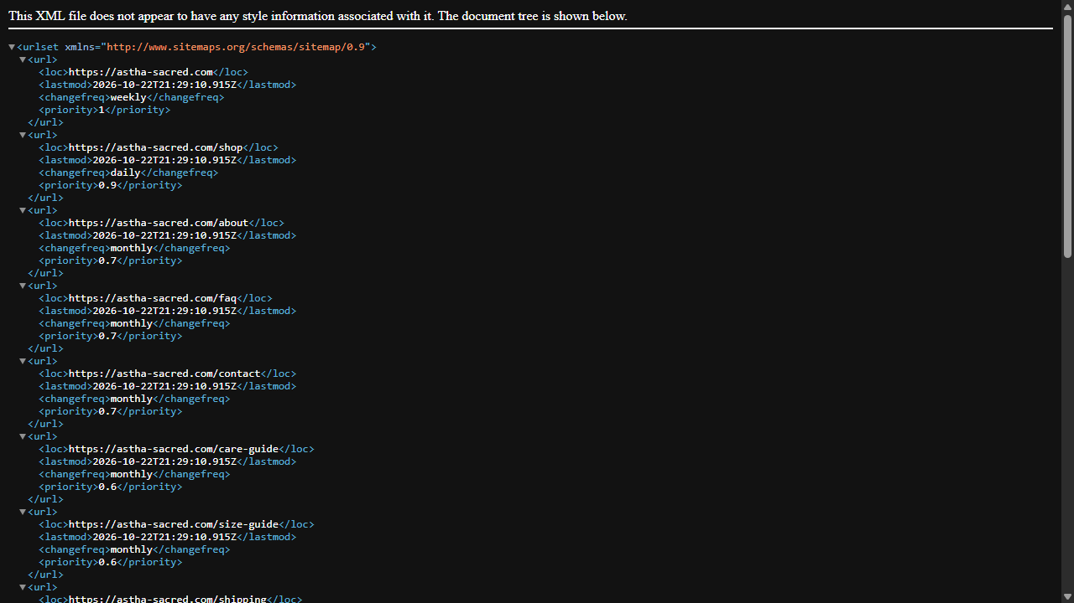
Route: /sitemap.xml | Viewport: Desktop (1280px)
Demonstrates the rendered XML sitemap containing all 18 canonical static and dynamic product URLs, calibrated priority ratings, and update frequencies.

Figure 13: Search Crawler Directives — Robots Configuration


Route: /robots.txt | Viewport: Desktop (1280px)
Demonstrates the live robots.txt directives properly shielding private utility routes (/cart, /checkout, /account, /wishlist) while referencing the production XML sitemap.

