IU2541230082 – CPP54 – PROJECT REPORT
Online Course Management
Enrollment No.: IU2541230082
Student Name: [Enter your full name]
Semester: 3
Subject: C++ Guided Project
Submission Date: [Enter actual date]
GitHub Repository: [Paste your public repository URL here]

1. Introduction
This report documents Online Course Management, a beginner-level console-based C++ application prepared for the C++ Guided Project. It focuses on core programming concepts and a simple file-based workflow.
2. Problem Statement
Educational institutes need a straightforward way to maintain student and course records, enroll students, and track learning progress. This console application demonstrates these operations using introductory C++ and object-oriented programming.
3. Objectives
• Maintain student and course details using classes and objects.
• Enroll an existing student into an existing course and track progress.
• Support add, display, search, update, and delete operations.
• Demonstrate encapsulation, inheritance, constructors, virtual functions, dynamic memory, and file handling.
• Store records in text files so they can be loaded after restarting the application.
4. Functional Requirements
• Add student records
• Add course records
• Display, search, update, and delete records
• Enroll students and update progress
• Generate a summary report
• Persist records using text files
5. System / Project Flow
User selects a menu option → the system validates input → the relevant class creates or updates a record → FileManager saves data → the program displays a confirmation or report.
6. Class Descriptions
Class | Responsibility
Person | Base class with common ID/name fields and virtual display().
Student | Stores student name and email; inherits common identity fields.
Course | Stores course title and fee.
Instructor | Demonstrates another Person-derived type with a specialization.
Enrollment | Connects a student to a course and stores progress percentage.
FileManager | Reads and writes student, course, and enrollment records.
CourseSystem | Coordinates menus, validation, record operations, and dynamic arrays.
7. OOP Concepts Used
• Encapsulation groups data and operations inside classes.
• Constructors initialize objects with safe starting values.
• Inheritance reuses common fields through the Person base class.
• Runtime polymorphism uses virtual display() functions.
• Dynamic memory uses new[] and delete[] for record arrays.
• File handling reads and writes delimiter-separated text records.
8. File Handling and Data Persistence
Data is stored in the Data folder. The program loads existing records when it starts and writes changes to the corresponding text files.
• Data/students.txt
• Data/courses.txt
• Data/enrollments.txt
9. UML Diagrams
The project includes a use-case diagram, class diagram, and two sequence diagrams. Source files are provided in UML/ alongside rendered images.
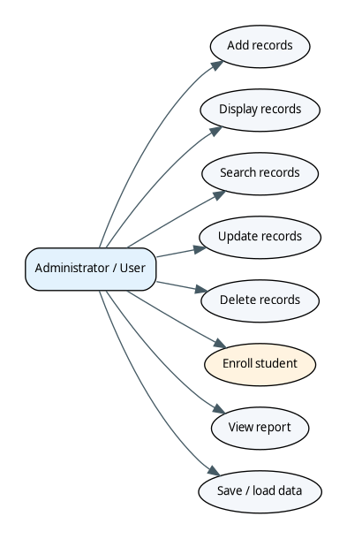
Figure 1. Use-case diagram
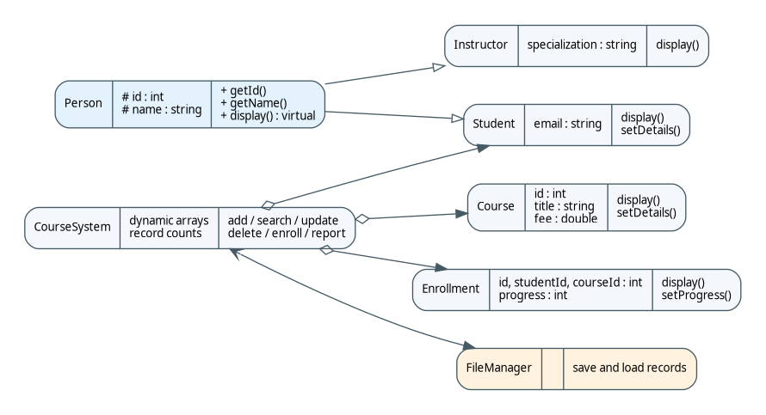
Figure 2. Class diagram
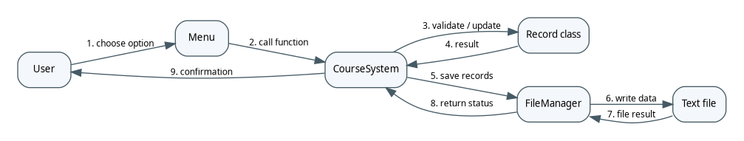
Figure 3. Main transaction sequence
Figure 4. Search/update sequence
10. Implementation Details
The source is organized into separate class headers and companion C++ files under Source_Code/. main.cpp starts the application. The code uses straightforward loops, classes, and text-file operations to remain approachable for a second-year student.
11. Testing and Results
The following test cases describe expected checks. Execute them on your computer and record actual results in Tests/TEST_RESULTS.txt and Tests/TEST_LOGS.txt. Pending tests must not be marked as passed.
Test | Action / Input | Expected result
Add student | Enter name and email | Student added
Add course | Enter title and non-negative fee | Course added
Display records | Choose display | Record lists shown
Search existing ID | Enter stored ID | Matching record shown
Search missing ID | Enter 9999 | Not-found message
Update student | Change details | Updated record displayed
Update course | Change title/fee | Updated course displayed
Reject negative fee | Enter -10 | Validation message
Delete record | Delete existing ID | Record removed
Enroll student | Use valid IDs | Enrollment saved
Reject invalid enrollment | Use unknown ID | Validation message
Update progress | Enter 0–100 | Progress updated
View report | Choose report | Counts and fee summary
Persistence | Restart program | Saved records load
Invalid menu choice | Enter 77 | Invalid-choice message
12. Sample Screens / Output
The images below are illustrative console captures. Replace them with genuine screenshots from your own run if required by faculty.
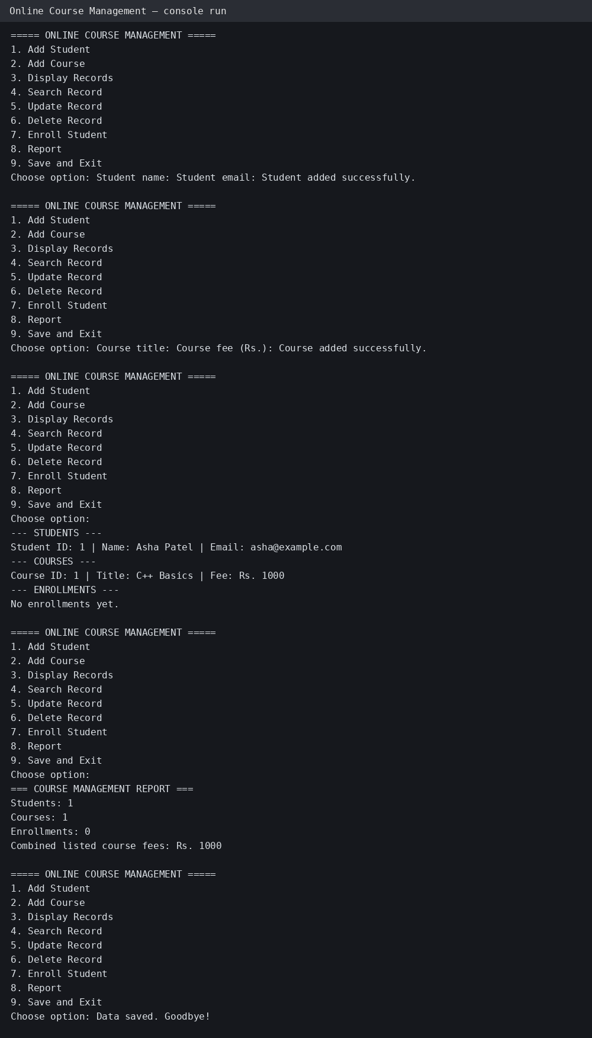
Figure 5. Main menu
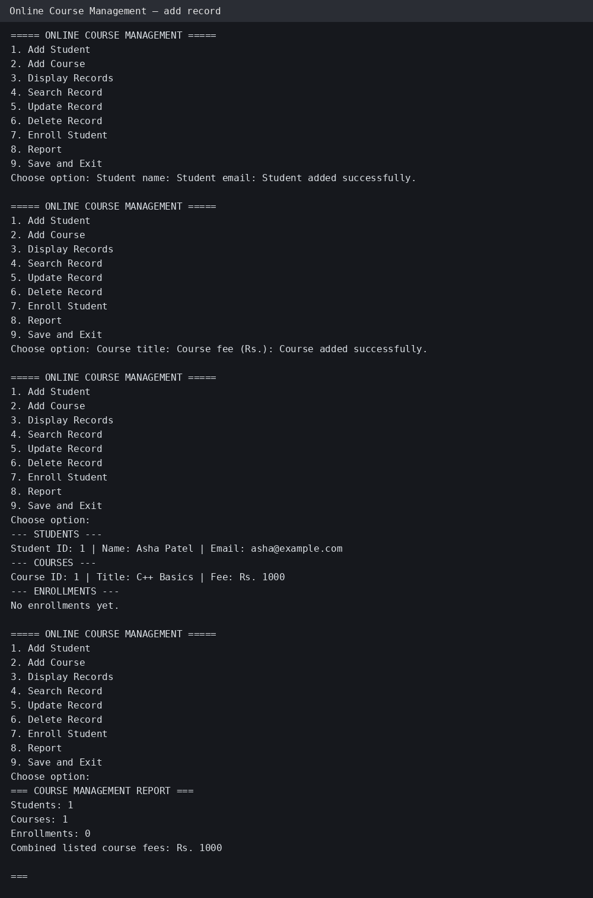
Figure 6. Add record
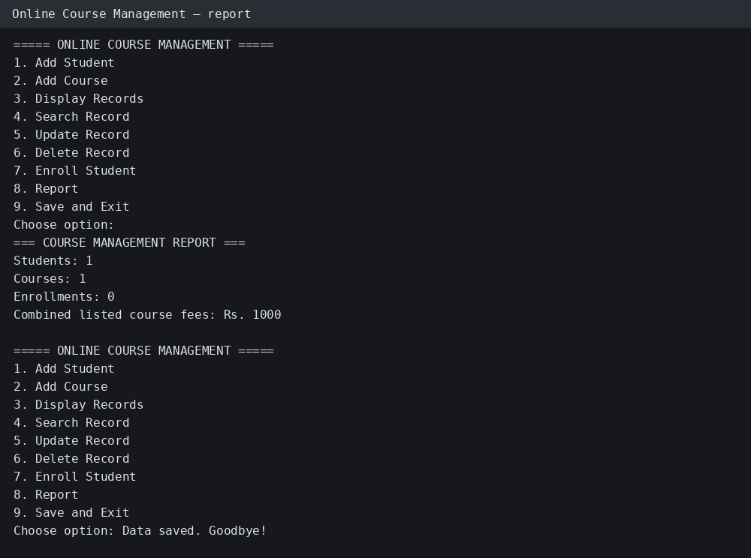
Figure 7. Summary report
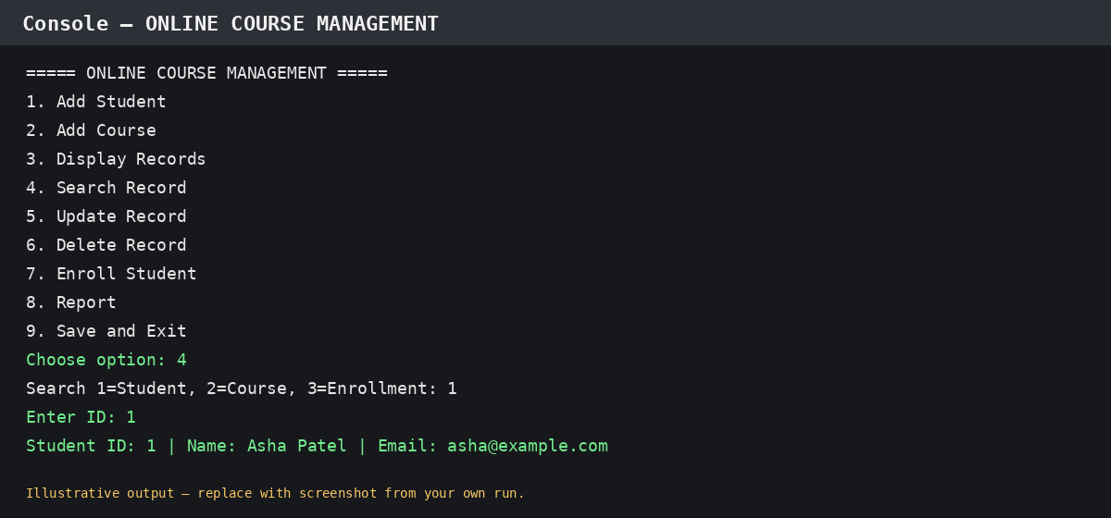
Figure 8. Search record
13. Limitations
Local single-user console program using fixed-capacity dynamic arrays and text files rather than a database.
14. Future Scope
Possible extensions include database integration, authentication, sorting and filtering, and a graphical user interface.
15. Conclusion
Online Course Management demonstrates C++ object-oriented programming, record management, and text-file persistence. The student should compile, test, personalize, and understand each source file before submission.
Appendix A. Compilation
Use build_windows.bat on Windows with GCC/MinGW installed, or compile the listed Source_Code/*.cpp files with g++ -std=c++11 -Wall -Wextra.

