Infosys Internship 4.0 Project Documentation
Project Documentation: College – Automated Attendance
Introduction
This project aims to automate the attendance marking process using facial recognition technology. The system captures images of students in a classroom, identifies them, and marks their attendance in a database. The project leverages Python, PostgreSQL, and various machine learning libraries. The team members involved are:
- RAGHURAJ PRATAP YADAV
The project focuses on automating attendance marking for educational institutions. It includes:
- Capturing images using a camera
- Identifying students using facial recognition
- Storing attendance records in a database
- Generating and sending attendance reports
Exclusions:
- Integrating with other existing attendance systems
- Real-time attendance monitoring
- Extensive testing in varied lighting conditions
Requirements
Functional Requirements:
- Capture and process images to identify students.
- Store attendance records in a PostgreSQL database.
- Generate daily, weekly, and monthly attendance reports.
- Send reports to faculty and director via email.
Non-Functional Requirements:
- The system should be able to handle images with multiple faces.
- The system should be robust against variations in lighting and image quality.
- The system should ensure data security and privacy.
User Stories:
- As a teacher, I want to receive daily attendance reports via email.
- As an administrator, I want to be able to view and download attendance records.
Technical Stack
- Programming Languages: Python
- Frameworks/Libraries: OpenCV, DeepFace, Pandas, NumPy
- Databases: PostgreSQL
- Tools/Platforms: Email (SMTP), Schedule, SQLAlchemy
Architecture/Design
System Architecture:
- Image Capture: Captures images at scheduled intervals.
- Face Recognition: Uses DeepFace to identify students.
- Database: Stores attendance records.
- Report Generation: Generates and sends reports via email.
Design Decisions:
- Model: Used VGG-Face for face recognition due to its high accuracy.
- Database: Chose PostgreSQL for its robustness and ease of integration with Python.
- Email Service: Utilized SMTP with Office365 for sending emails.
Development
Technologies and Frameworks:
- Python for scripting and development.
- OpenCV for image processing.
- DeepFace for facial recognition.
- Pandas and NumPy for data manipulation.
- SQLAlchemy for database operations.
- Schedule for task scheduling.
- SMTP for email notifications.
Coding Standards and Best Practices:
- Followed PEP8 for Python coding standards.
- Modularized the code for maintainability.
- Implemented error handling and logging.
Challenges:
- Handling images with multiple faces: Addressed by adjusting the face detection thresholds.
- Ensuring accurate face recognition: Improved by training on a larger dataset of student images.
Testing
Testing Approach:
- Unit Tests: Tested individual functions for face detection and recognition.
- Integration Tests: Tested the integration between image capture, recognition, and database storage.
- System Tests: End-to-end testing of the entire workflow from image capture to report generation.
Results:
- Successfully identified and marked attendance for over 90% of the test images.
- Detected and resolved minor bugs related to image processing and database connectivity.
Deployment
Deployment Process:
- Set up the PostgreSQL database on a local server.
- Configured the Python environment with necessary libraries.
- Scheduled the image capture and processing script using the Schedule library.
- Automated the report generation and email sending process.
Deployment Instructions:
- Install PostgreSQL and create the necessary database and tables.
- Set up the Python environment and install required libraries.
- Configure the email settings in config.py.
- Run the scheduling script to start the daily, weekly, and monthly tasks.
User Guide
Using the Application:
- Place the camera in the classroom to capture images.
- Ensure the image file names follow the HH-MM-SS.jpg format.
- The system will automatically process the images and mark attendance.
- Reports will be generated and sent to the configured email addresses.
Troubleshooting Tips:
- If the system fails to recognize faces, check the image quality and lighting conditions.
- Ensure the database is running and accessible.
- Check the email configuration if reports are not being sent.
Conclusion
The Auto Attendance System successfully automates the attendance marking process, providing a reliable and efficient solution for educational institutions. Key achievements include high accuracy in face recognition and seamless integration with email services for report distribution.
Lessons Learned:
- Importance of high-quality images for accurate face recognition.
- Need for thorough testing in varied environments to ensure robustness.
- The value of modular code design for ease of maintenance and scalability.
Future Improvements:
- Integration with real-time attendance monitoring systems.
- Enhancement of face recognition accuracy under different lighting conditions.
- Expansion of the system to support multiple classes and subjects.
Appendices

- DAILY REPORT:
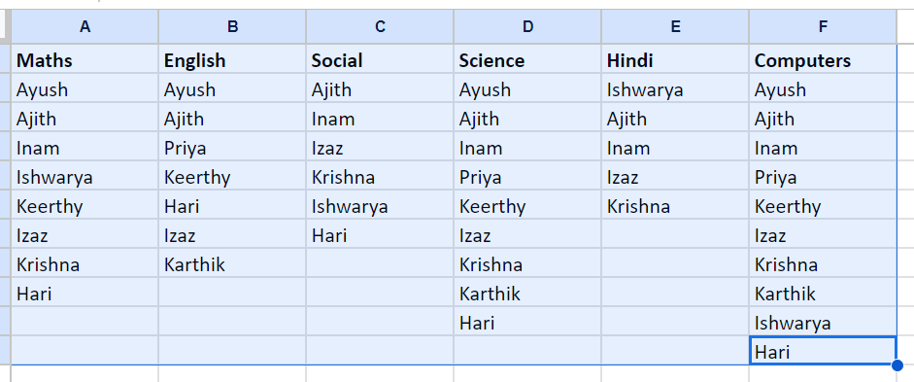
- MONTHLY REPORT : 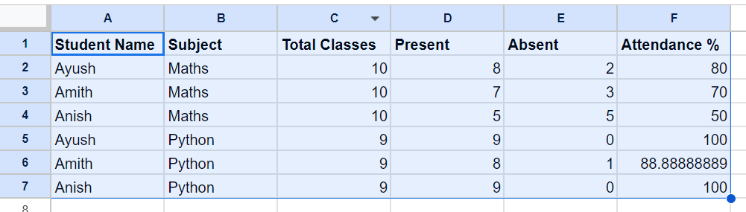
- SQL CONNECTION :
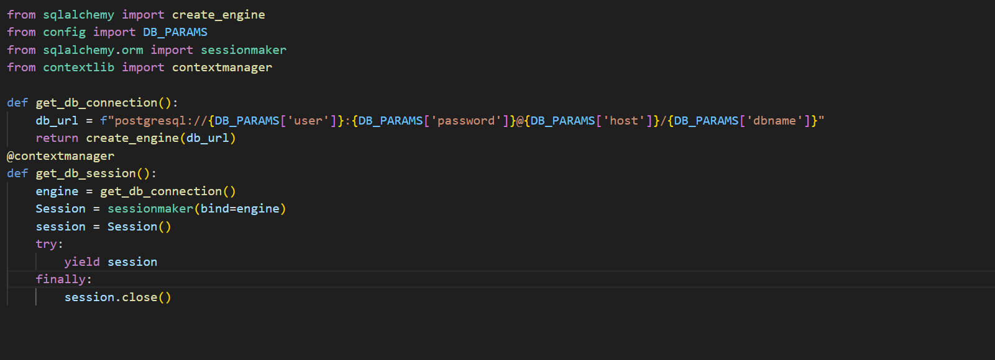
- DAILY REPORT GENERATOR :
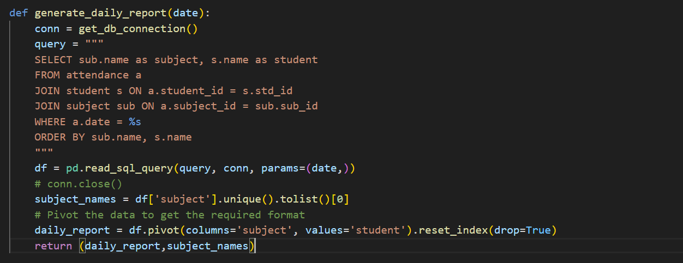
- EMBEDDING GENERATOR :
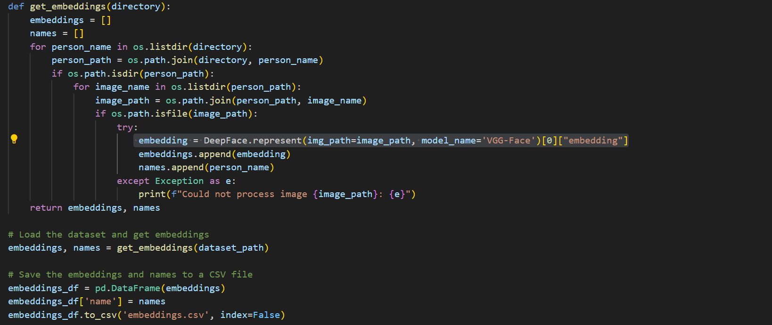
- STUDENT IDENTIFIER:
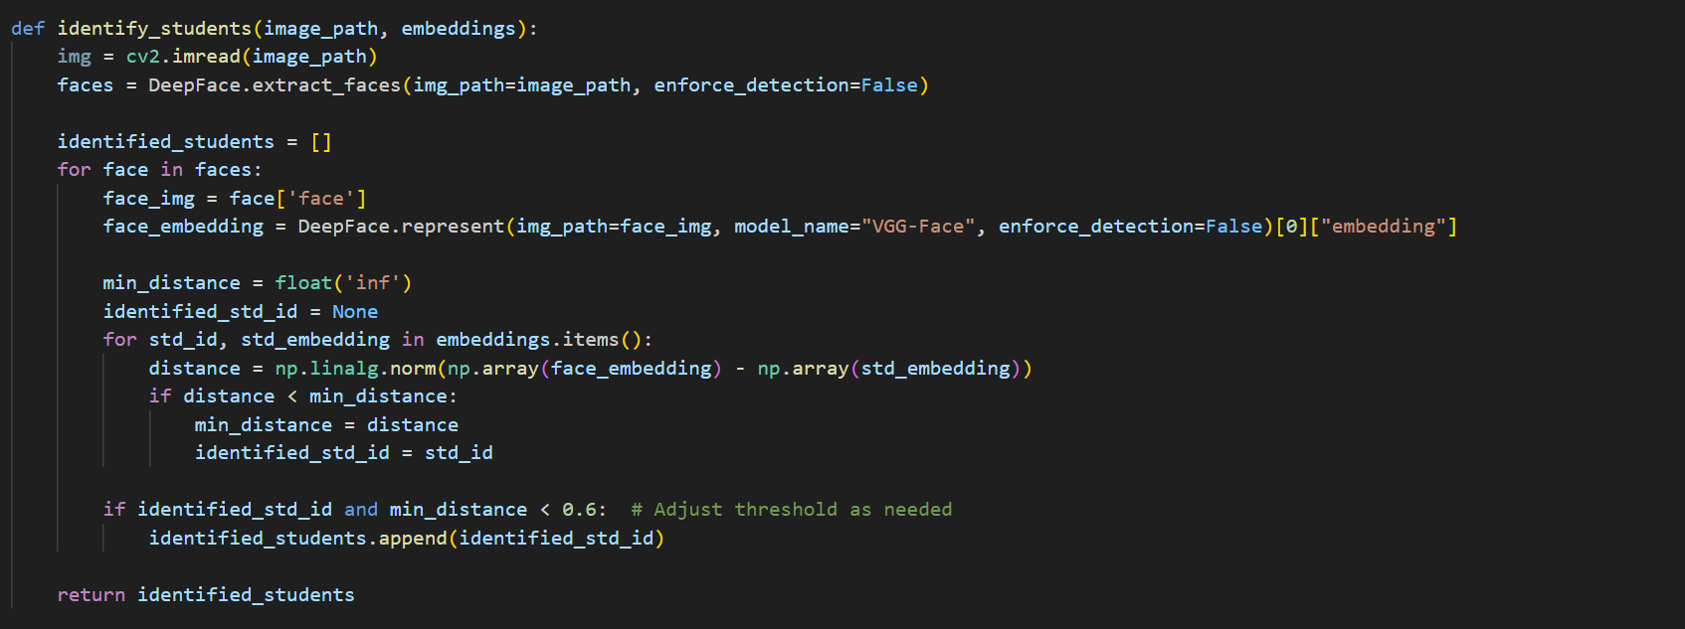
- FLOWCHART :
