**Paste the command that you require to achieve steps mentioned below and paste the screenshot whenever needed.**

**(You can save a copy of this file and modify it directly!)**

1. See currently active services on your system.

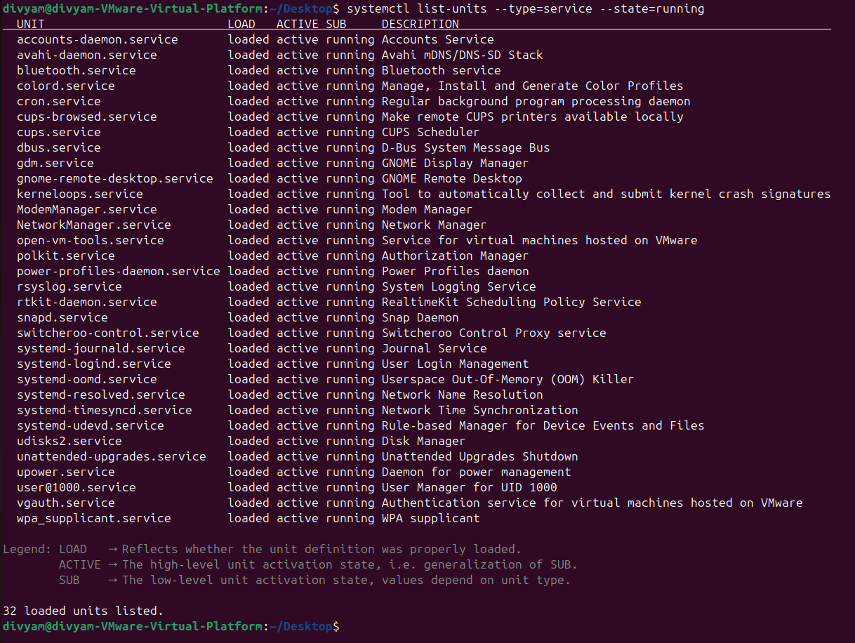

1. See currently active interfaces on your device.

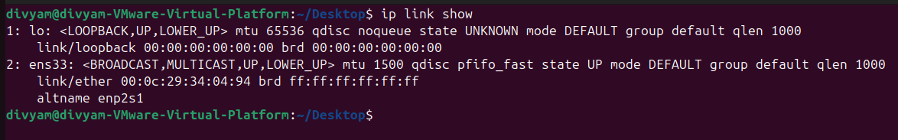

1. See currently active connections on your device.

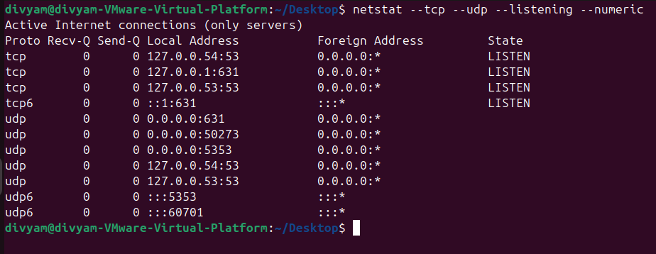

1. See currently available devices.

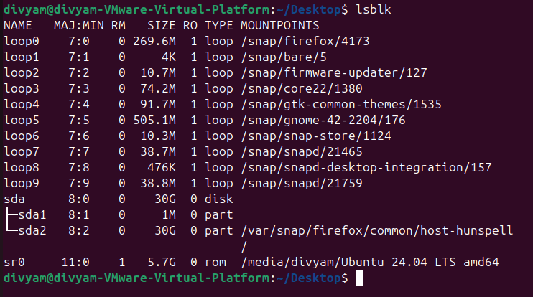

1. Print the ip addresses of current active connection.

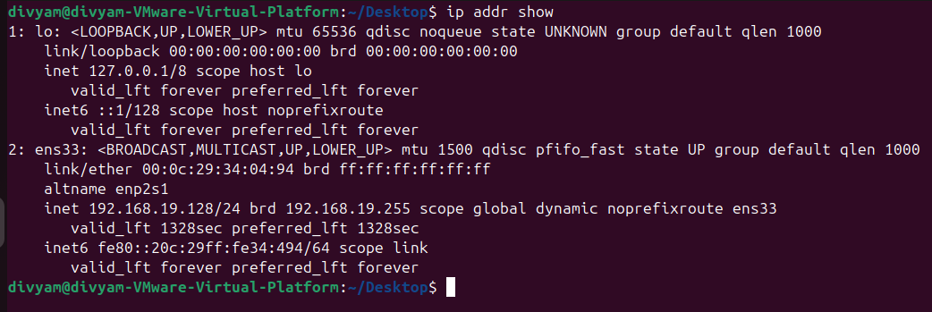

1. Ping to “youtube.com” with 6 packets.

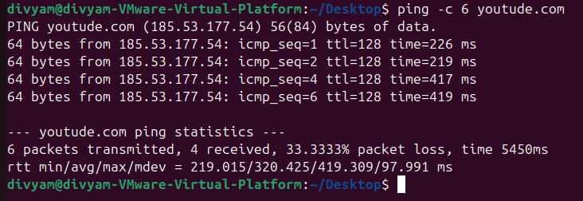

1. Trace the route to “youtube.com”.

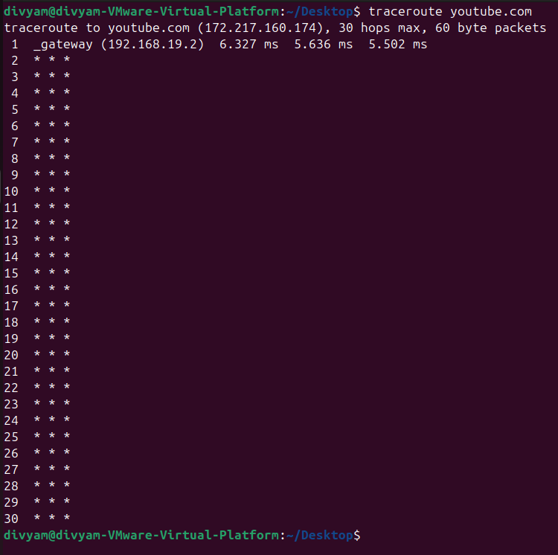

1. See currently mounted files.

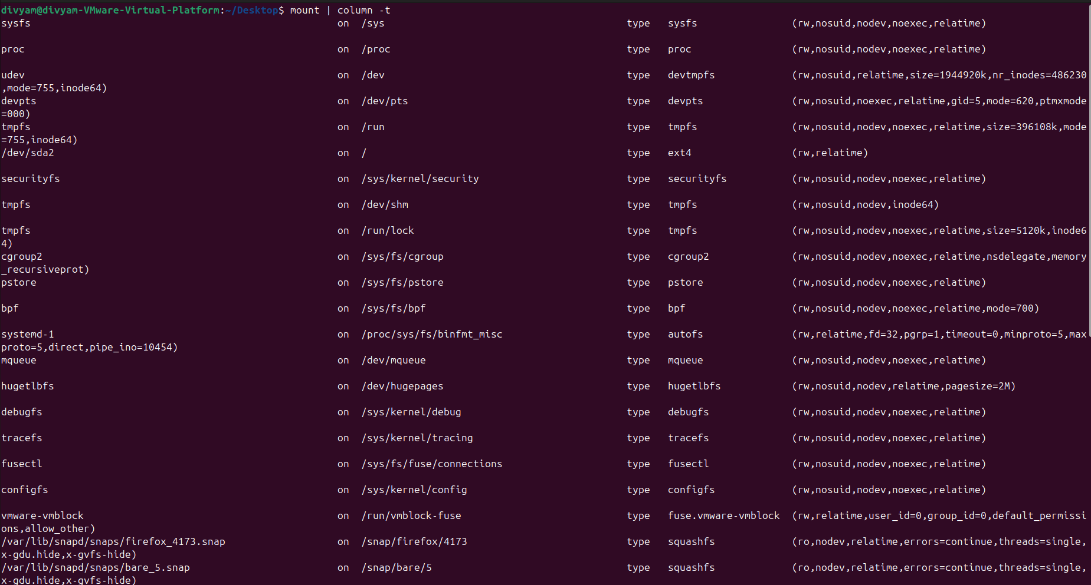

1. See what’s the active partition for your system and what’s it’s size.

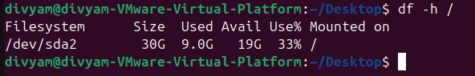

1. Create one folder on Desktop named “masterDrive”

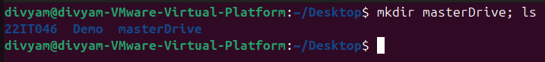

1. Create one folder inside “/dev” named “mainDrive”



1. Create ten files named test1, test2, …, test10 inside “mainDrive”.



1. Now create mount point in “masterDrive” with “mainDrive”



1. Now change directory to “masterDrive”.



1. Use “ls -lah” command and see the output.

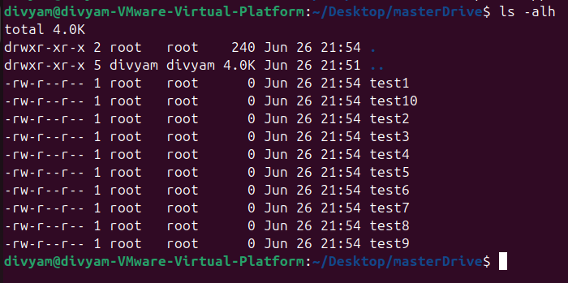

1. What’s the observation, describe it in one paragraph.

The ls -alh command in Linux lists all files and directories in the current directory in long format, including hidden files (those starting with a dot). The output provides detailed information such as file permissions, number of links, owner, group, file size (in human-readable format), and timestamp of the last modification.

1. Remove the mount point.



1. Remove “mainDrive” and “masterDrive”

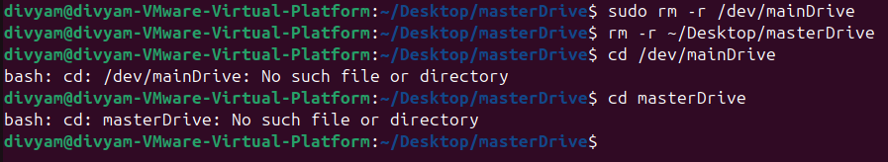

**Paste your cheat sheet here:**

**1. top (Can See process in linux)**

**2. ps (Can see snapshot of current process)**

**3. sleep (Provides Delay)**

**4. if we apply '&' in last line of command, it creates background process.**

**5. ps j (Gives info about jobs)**

**6. KiLL (kill all processes you can kill)**

**7. For manual page**

**man usermod**

**man LS**

**To exit that**

**Press q**

**8. LS (long listing of files in particular directory)**

**9. cd (directory name)**

**10. To print on screen**

**echo (text)**

**11. To see history**

**history**

**12. To see date**

**date**

**13. wc**

**14. To create empty file**

**touch filename**

**15. To see content**

**cat filename**

**16.**

**apt is a package manager in Linux**

**To update all packages**

**sudo apt update**

**To install vim**

**sudo apt install vim**

**17. man 7 signal (Listing of signals)**

**18. man kill (Info about kill command)**

**19. fg (It resumes the Latest stopped process)**

**press ctrl+z to stop the process.**

**20. lscpu (gives info about cpu).**

**21. Daemon (Process that run in background)**

**22. systemctl (List of daemons)**

**23. mount**

**24. findmnt**

**25. findmnt -t ext4**

**26. lsblk**

**27. du (file space usage)**

**28. sudo mount /dev/sdb1**

**29. sudo umount /dev/sdb1**

**------------ Shell Script --------------**

**(Bunch of Commands)**

**1. echo $PATH**

**(Location of path)**

**2. printenv**

**(Can see all environment variables)**

**3. export _NAME="Divyam"**

**(variable name)**

**4. unset**

**5. $0(can See filename)**

**6.**

**Write conclusion in few lines for above activity and today’s session:**

By performing above activity I learnt about hardware management in linux. Got to know some linux commands as well.