**Paste the command that you require to achieve steps mentioned below and paste the screenshot whenever needed.**

**(You can save a copy of this file and modify it directly!)**

1. Make a directory on desktop named “Demo”.

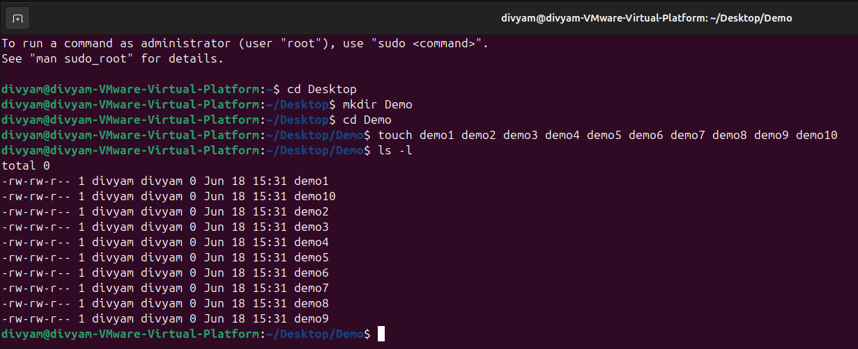

1. Make 10 files demo1,demo2,demo3,…,demo10 inside Demo directory.



1. Add new user named “testuser”

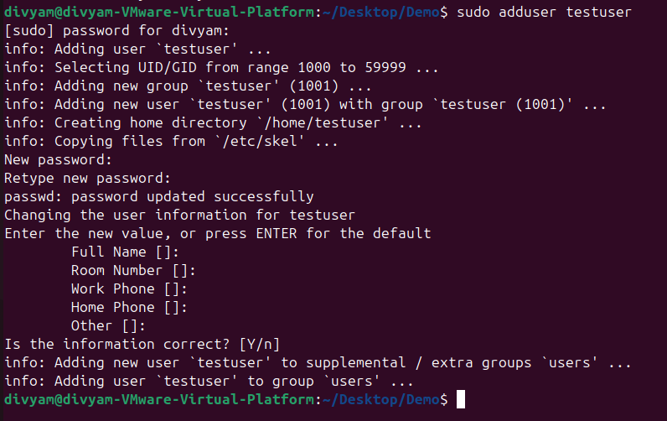

1. Verify that user has been added or not? Mention the steps that you have followed to verify!



1. Login as testuser

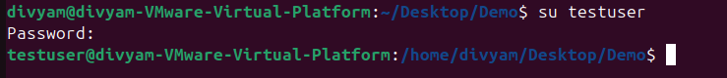

1. Create new file named “testuserfile” inside Demo directory.





1. Exit from testuser

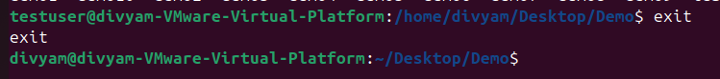

1. Change ownership of first 5 files (demo1, demo2, … demo5) to testuser

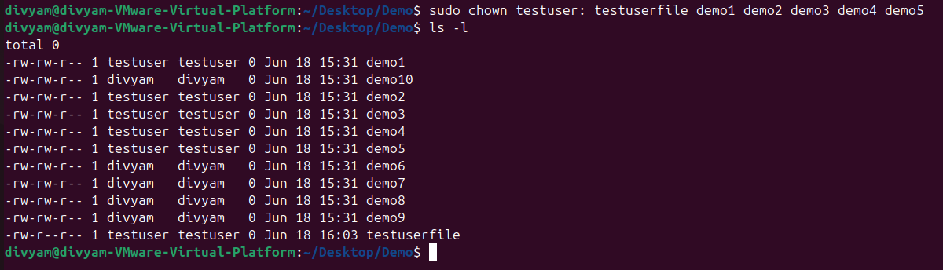

1. Create group named “HR”

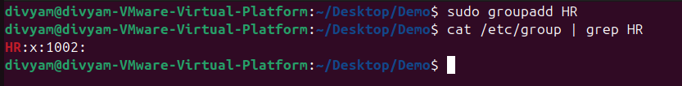

1. Add testuser and your current user to this group (“HR”)

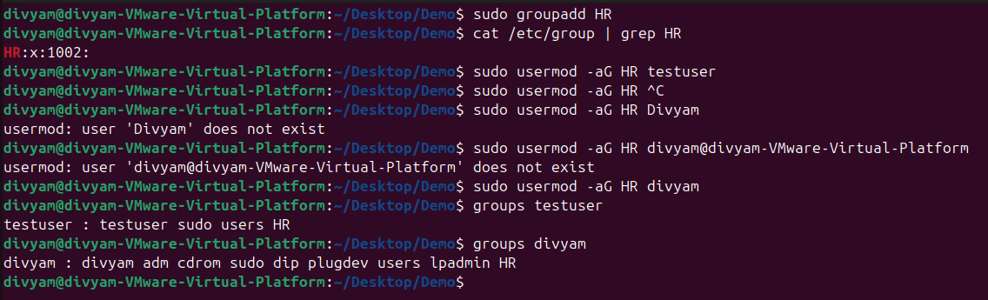

1. Remove read permission from all groups for last five files inside Demo directory (demo6, demo7, … , demo10)

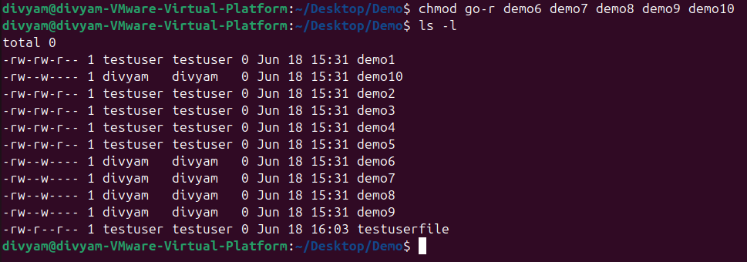

1. Delete first 5 files from demo directory with minimal number of commands.

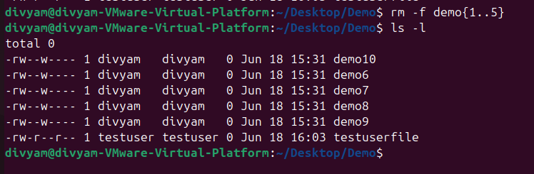

1. Remove group “HR” and verify it.



1. Remove “testuser”

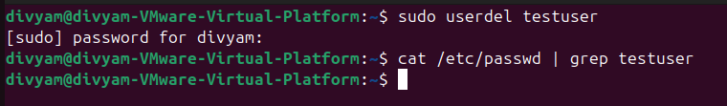

1. Remove Demo directory.

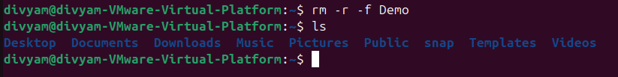

**Paste your cheat sheet here:**

**1. top (Can See process in linux)**

**2. ps (Can see snapshot of current process)**

**3. sleep (Provides Delay)**

**4. if we apply '&' in last line of command, it creates background process.**

**5. ps j (Gives info about jobs)**

**6. KiLL (kill all processes you can kill)**

**7. For manual page**

**man usermod**

**man LS**

**To exit that**

**Press q**

**8. LS (long listing of files in particular directory)**

**9. cd (directory name)**

**10. To print on screen**

**echo (text)**

**11. To see history**

**history**

**12. To see date**

**date**

**13. wc**

**14. To create empty file**

**touch filename**

**15. To see content**

**cat filename**

**16.**

**apt is a package manager in Linux**

**To update all packages**

**sudo apt update**

**To install vim**

**sudo apt install vim**

**17. man 7 signal (Listing of signals)**

**18. man kill (Info about kill command)**

**19. fg (It resumes the Latest stopped process)**

**press ctrl+z to stop the process.**

**20. lscpu (gives info about cpu).**

**21. Daemon (Process that run in background)**

**22. systemctl (List of daemons)**

**23. mount**

**24. findmnt**

**25. findmnt -t ext4**

**26. lsblk**

**27. du (file space usage)**

**28. sudo mount /dev/sdb1**

**29. sudo umount /dev/sdb1**

**Write conclusion in few lines for above activity and today’s session:**

Through above activity I got to know about user management in Linux, I learnt various commands and theory related to it through session.