**Paste the command that you require to achieve steps mentioned below and paste the screenshot whenever needed.**

**(You can save a copy of this file and modify it directly!)**

1. See currently started processes in your system.

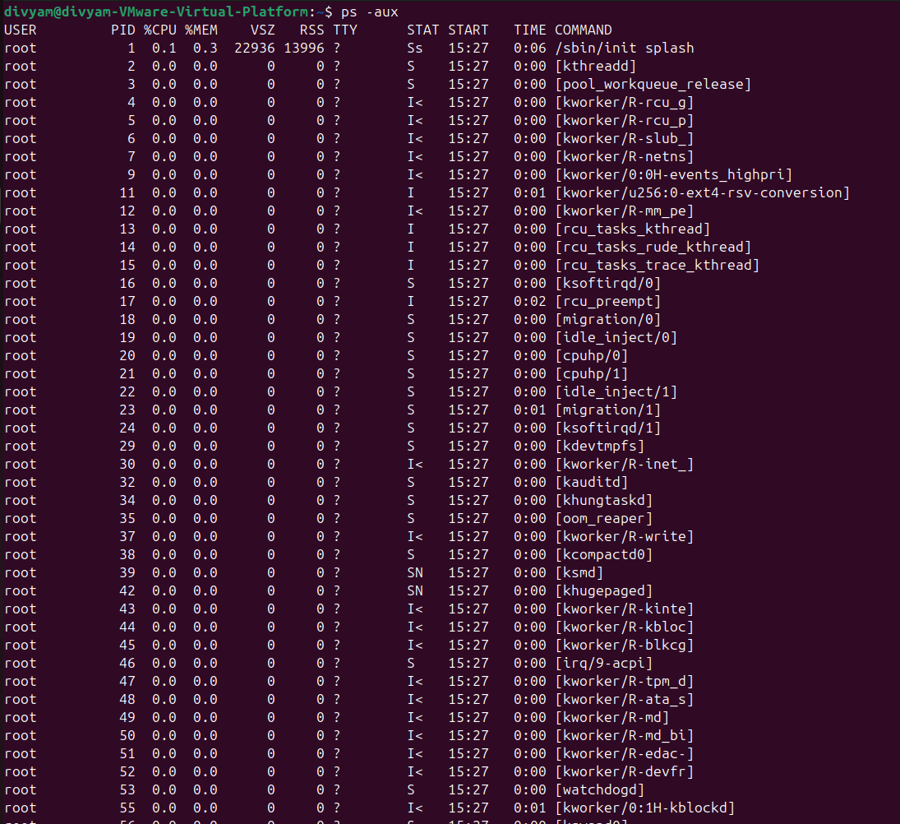

1. Get the snapshot of active processes in your system.

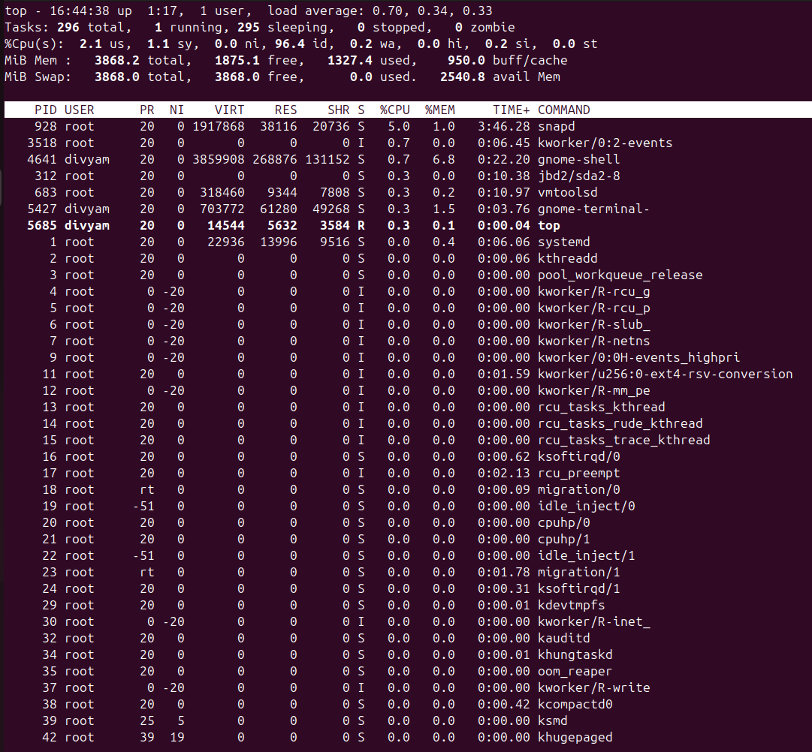

1. Log in as some another user (Maybe you can log in as user, which you have created for previous activity)

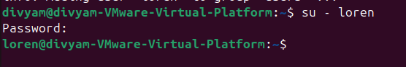

1. Now create background process. (e.g. sleep 50 &)

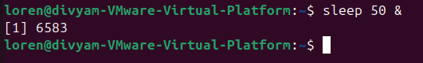

1. Now observe currently active jobs and note their user id. Can you see some change, if so, describe it with screenshot.



1. Create one background process “sleep 500 &”

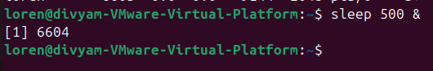

1. Switch back to your regular user

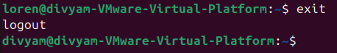

1. Now send “SIGKILL” signal to the process, created in step-6.

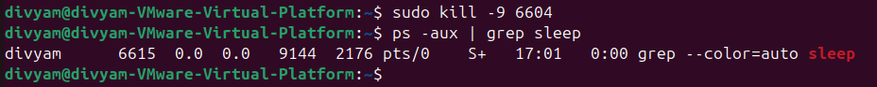

1. Create one background process “sleep 100 &”

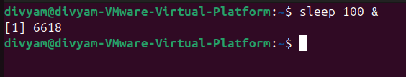

1. Stop that process, created in above step-9.

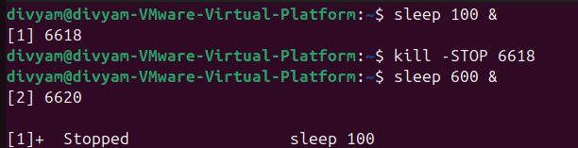

1. Resume that process, stopped in above step – 10.

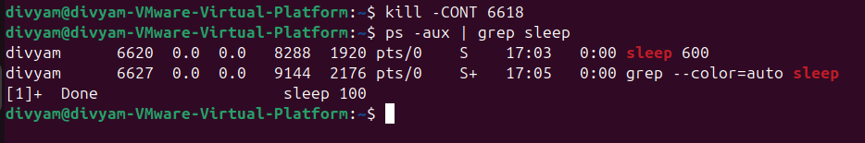

1. Create same process (from step-9), stop that process (followed by step-10) then switch user to some other user and resume that process.

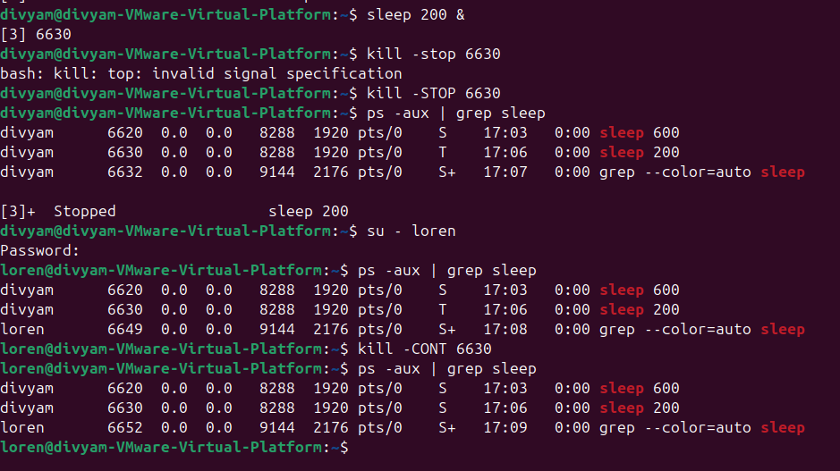

1. Switch back to your regular user and kill that process.

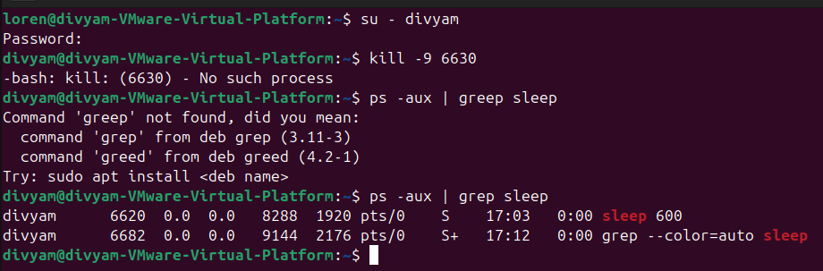

**Paste your cheat sheet here:**

**1. top (Can See process in linux)**

**2. ps (Can see snapshot of current process)**

**3. sleep (Provides Delay)**

**4. if we apply '&' in last line of command, it creates background process.**

**5. ps j (Gives info about jobs)**

**6. KiLL (kill all processes you can kill)**

**7. For manual page**

**man usermod**

**man LS**

**To exit that**

**Press q**

**8. LS (long listing of files in particular directory)**

**9. cd (directory name)**

**10. To print on screen**

**echo (text)**

**11. To see history**

**history**

**12. To see date**

**date**

**13. wc**

**14. To create empty file**

**touch filename**

**15. To see content**

**cat filename**

**16.**

**apt is a package manager in Linux**

**To update all packages**

**sudo apt update**

**To install vim**

**sudo apt install vim**

**17. man 7 signal (Listing of signals)**

**18. man kill (Info about kill command)**

**19. fg (It resumes the Latest stopped process)**

**press ctrl+z to stop the process.**

**20. lscpu (gives info about cpu).**

**21. Daemon (Process that run in background)**

**22. systemctl (List of daemons)**

**23. mount**

**24. findmnt**

**25. findmnt -t ext4**

**26. lsblk**

**27. du (file space usage)**

**28. sudo mount /dev/sdb1**

**29. sudo umount /dev/sdb1**

**Write conclusion in few lines for above activity and today’s session:**

In the above activity I learnt about “Process Management” in Linux, learnt commands for it.