**Programming Assignment #1**

**CS 6375.005 – Machine Learning**

**Team:**

**Divya Machenahalli Lokesh, DXM190018**

**Nidhin Anisham, NXA190000**

Objective: Implementation of a fixed-depth ID3 decision tree algorithm.

Requirements: Python 3.7

Libraries: numpy, sklearn, matplotlib, graphviz

Input datasets:









Notes:

1. The attribute-value pairs of each feature are the splitting criteria and the decision tree created is binary.
2. The values in the feature which correspond to the attribute-value pair is a positive example and all other attribute-value is a negative example. Ex: if the pair is (x1,1) values in x1 where x1=1 is positive and x1!=1 is negative.
3. The best attribute value pair is chosen based on the maximum information gain.
4. The tree is stored as a dictionary.
5. For the training set with continuous values, the data is discretized as follows: if x>mean, x=1 else x=0
6. The graphviz output pdf file needs to be closed before the program is re-run.

Output:

1. ID-3 algorithm on monks-1, monks-2 and monks-3

Error curves for depth = 1 to 10 on all three datasets

1. ID-3 Algorithm on monks-1 for depth 1 and depth 2. Tree is visualized.

1. Using sklearn Decision Tree Classifier on the monks-1 dataset and visualizing using graphviz

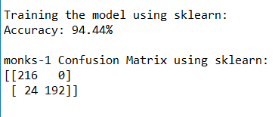

1. ID-3 algorithm on the Banknote Authentication dataset

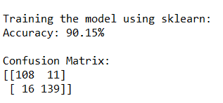

Visualizing the learned decision tree using graphviz

