DQ-2 Porter Data Transformations
Codebase audit of data transformations, utilities and reference tools

1. Executive summary
Area | Scripts / versions identified | What they do
Influencer | influencer_processor/main.py; main(2).py | Category-based influencer processing, city allocation, fact-ready output.
Coupon | influencer_processor/coupon_main.py; src/coupon_city_split.py; src/coupon_classify.py | City row splitting, integer allocation, coupon classification.
Affiliate | affiliate_cumulater.py; affiliate_channel_others.py; affiliate_city_split.py | Aggregate metrics, route unknown channels to Others, split metrics to city rows.
Reactivation | reactivation_crosstab.py | Unpivot day columns and build date/bucket crosstab output.
OOH | ooh/step1_summarize.py; step2_calculate.py; main.py; ooh_spend_negative.py | Monthly spend summarization and next-month negative-return treatment; an additional/older OOH processor also exists.
DAP | dap.py | Append newer DAP period to historical base and add City using only supplied Geo ID mappings.
Revenue | revenue_generator_aov.py | Aggregate completed orders and calculate revenue_amount from AOV lookup.
Other data utilities | date_sorter.py; name_replace.py; replace_head_office.py; dollar_remove.py; apple_usd_to_inr.py; two_sheet_merge.py | Date sorting, name formatting, text replacement, currency cleanup/conversion, data stacking.
Mapping / discovery | platform_finder.py; product_type_finder.py; extract_source_metadata.py | Find platform/channel mappings, list product types, extract file/sheet/column metadata.
Google Ads | Excel Mapping Engine: main.py (entry point); mapper.py (pipeline); matcher.py (column, text and join-key matching); schema.py (mapping vs raw file detection); config.py; utils.py; analytics.py (reports); test_engine.py (tests). | Uses a supplied mapping/reference file to append additional columns to the raw rows. It finds the best join key (e.g. campaign + date + platform), joins on a normalized key, recovers unmatched rows with fuzzy campaign-name matching, and writes <raw>_mapped.xlsx, <raw>_unmapped.xlsx, summary_report.xlsx and mapping_quality.xlsx. Additional Google Ads columns: the campaign type and vehicle type columns in the mapping file were generated manually by giving the Campaign Name values to Claude, asking it to produce campaign-type and vehicle-type columns, and pasting the result directly into the sheet (not done by a script; date not confirmed).
Meta Ads | Excel Mapping Engine: main.py (entry point); mapper.py (pipeline); matcher.py (column, text and join-key matching); schema.py (mapping vs raw file detection); config.py; utils.py; analytics.py (reports); test_engine.py (tests). | Uses a supplied mapping/reference file to append additional columns to the raw rows. It finds the best join key (e.g. campaign + date + platform), joins on a normalized key, recovers unmatched rows with fuzzy campaign-name matching, and writes <raw>_mapped.xlsx, <raw>_unmapped.xlsx, summary_report.xlsx and mapping_quality.xlsx.

2. Core business data transformations

2.1 Influencer processor — category-based processing and city allocation
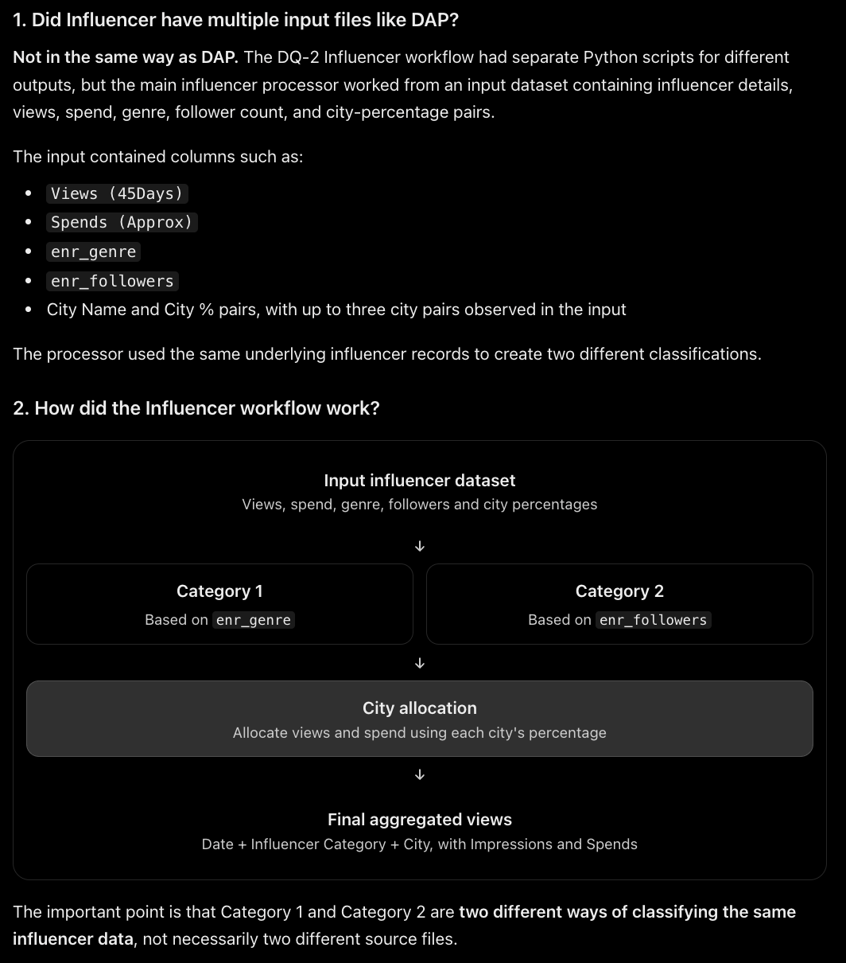
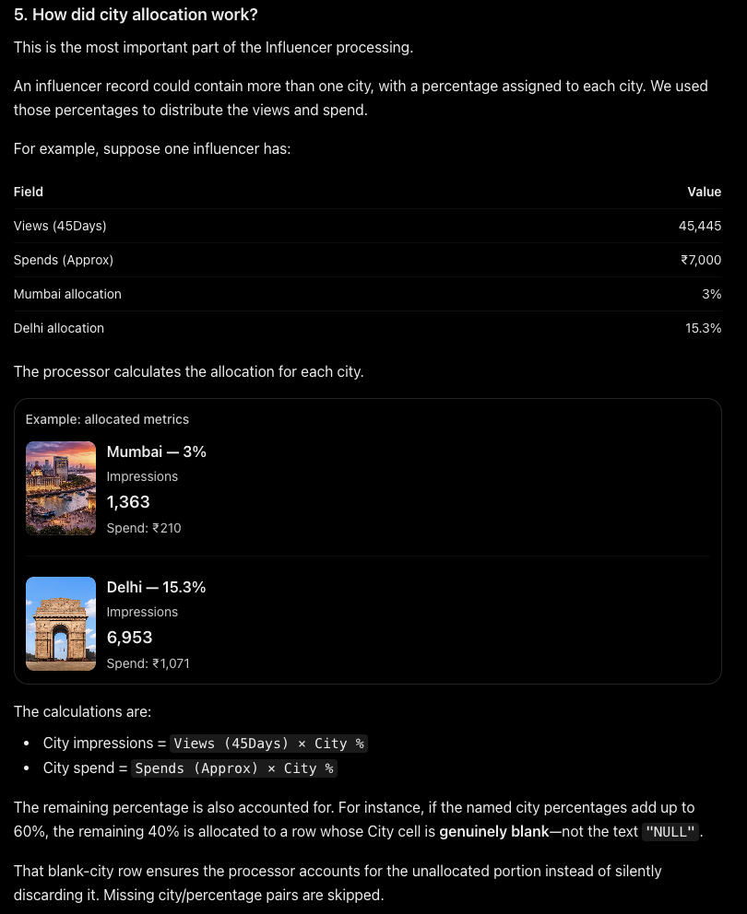
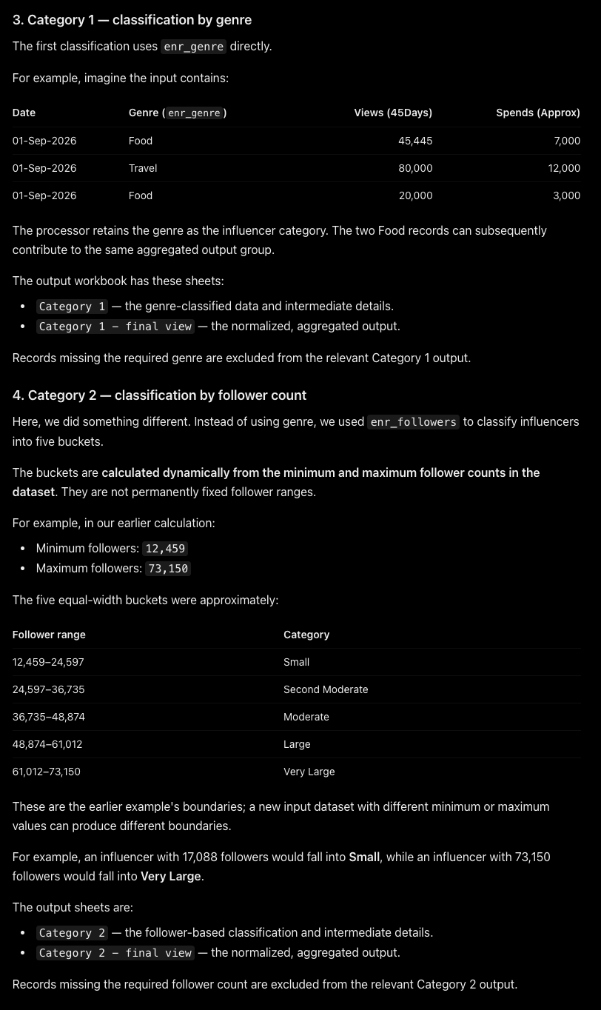
Scripts:
- influencer_processor/main.py — broader category-oriented processor.
- influencer_processor/main(2).py — fact-ready city-level processor; final grain documented in code is Date × Campaign × Genre × City.
Input: Excel workbook selected interactively from the project's data area. The uploaded scripts select the input at runtime, so the exact filename for each historical run cannot be established from code alone.
Treatment in main.py:
- Normalizes column names and source fields, cleans numeric values, and prepares dates.
- Creates Category 1 using the genre-based classification (enr_genre).
- Creates Category 2 using follower count and dynamically divides followers into five buckets.
- Filters invalid rows from the relevant category output without modifying the original input dataframe.
- Builds category-level views and final views by Date + Influencer Category + City.
- Allocates impressions and spend using weighted city percentages.
Treatment in main(2).py:
- Prepares source columns, normalizes percentages and metrics, and constructs a city allocation.
- For each city, allocates each available metric using its city audience percentage: city metric = source metric × city percentage.
- Outputs date_key, campaign_name, genre_name, city_name, spend, reach, views, likes and comments.
- The code comments specify that any unallocated percentage is represented by a blank-City allocation row.
Example: a campaign with Spend = 10,000 and a Mumbai percentage of 60% gives Mumbai Spend = 6,000. The same percentage-based allocation rule is applied to Reach, Views, Likes and Comments where available.
Outputs: workbook(s) under influencer_processor/outputs/, named from the input stem with suffixes such as _influencer_processed.xlsx or _influencer_fact_ready.xlsx.
Date evidence: influencer processing was discussed in August 2026. Exact file creation date is not confirmed.

2.2 Coupon/promotional data — influencer_processor coupon city split
Script: influencer_processor/coupon_main.py
Purpose: split coupon/promotional rows into city-level rows.
- Keeps the original columns and writes a new workbook rather than modifying the source.
- Splits multi-city cells into one output row per city; supports comma-separated and space-separated city text.
- Divides coupon usage equally among cities when a numeric coupon usage value is present.
- Leaves NULL coupon usage as NULL, but does not let a NULL usage value prevent city splitting.
- Keeps single-city rows as one row and explicitly preserves “Delhi NCR” as one city.
- Output is written under influencer_processor/outputs/ with a city-split suffix.
Example: a row with Mumbai, Pune and coupon usage 9 becomes three city rows with usage allocated as 3, 3 and 3 (subject to the script's integer allocation logic).
Date evidence: coupon/influencer processing discussions occurred around September 2026; exact implementation date is not confirmed.

2.3 Coupon city split — Sheet1 Column A / Column G integer allocation
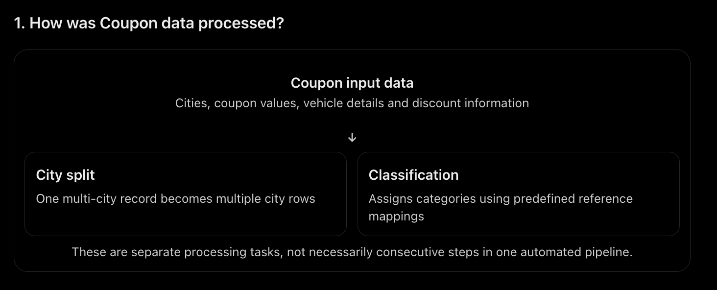
Script: src/coupon_city_split.py
- Requires a Sheet1 worksheet in the input workbook.
- Splits comma-separated cities from Column A into separate rows.
- Splits the integer value in Column G across the resulting city rows using quotient and remainder allocation, preserving the exact total.
- If Column G is blank, the blank is copied to each city row; if it is non-numeric, the original value is copied unchanged.
- All other columns are copied unchanged, with cell formatting retained.
- Creates/replaces a Data_City_Split worksheet and saves a new file with _city_split suffix.
Example: Column G = 10 split across 3 cities becomes 4, 3, 3, preserving the total of 10. Which city receives the remainder follows the row order in the city list.
Note: this is a separate implementation from influencer_processor/coupon_main.py; do not assume they are interchangeable.

2.4 Coupon classification
Script: src/coupon_classify.py
- Reads the first worksheet of a coupon workbook.
- Uses Promo Name/Tag as the primary lookup key for Vehicle Segment, Discount Type, Discount Band and Order Condition.
- When the primary promo lookup is unavailable, uses reference dictionaries/fallbacks based on vehicle model/category plus promo description, description-only mappings, and promo-name-plus-description mappings.
- Writes the four classifications into columns G,H,I,J.
- Counts fully classified rows and reports rows/fields needing review.
- Saves a separate output named <input>_classified with the original extension.
The classification rules are encoded as large hardcoded reference dictionaries. The exact coverage depends on the mapping entries present in the script; unmatched fields remain blank and are reported for review.
Date: not confirmed from the available conversation.

2.5 Affiliate data cumulater
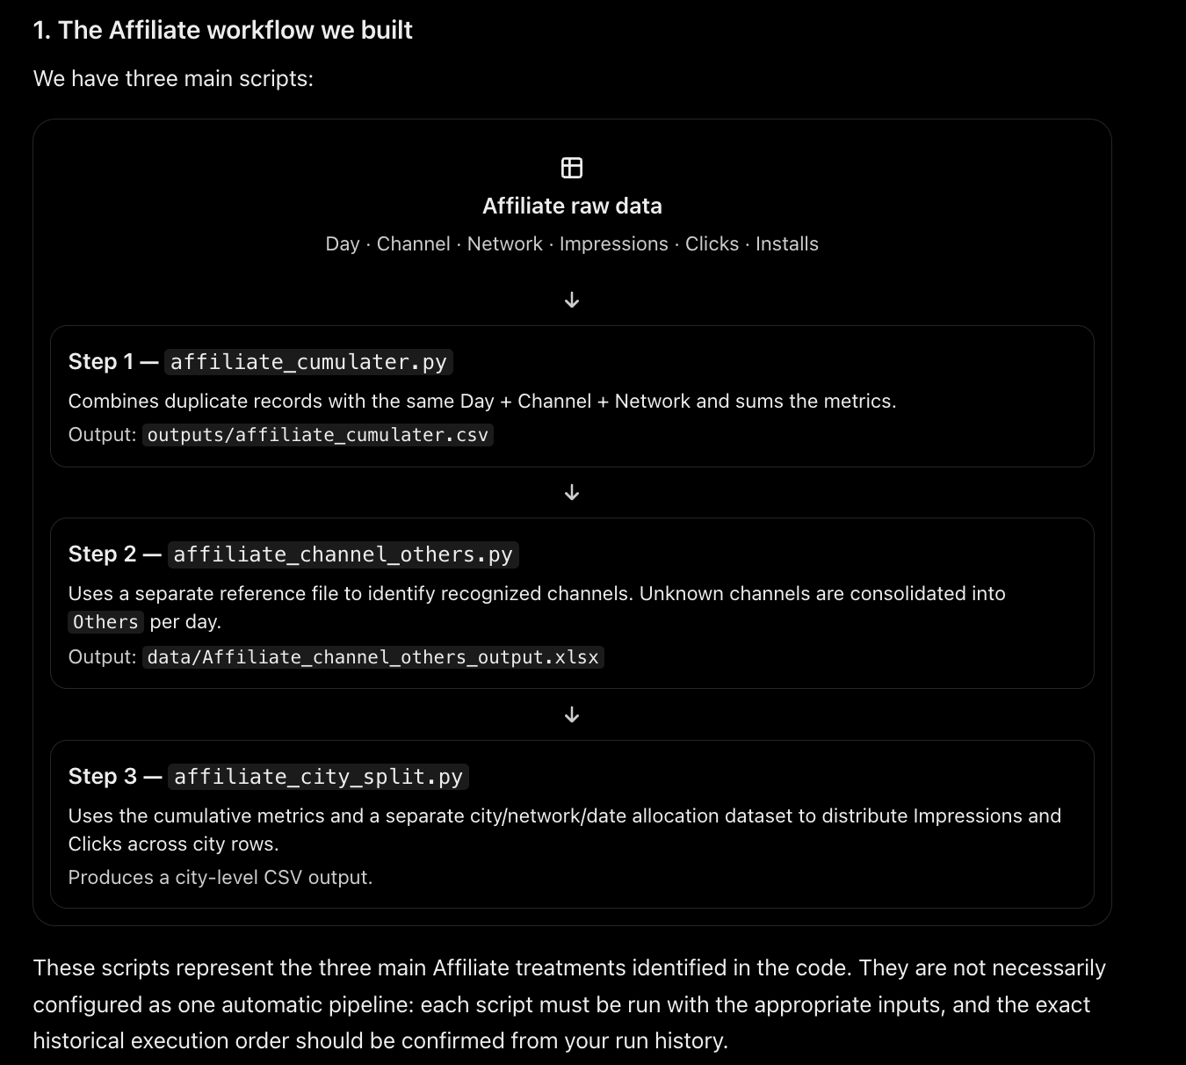
Script: src/affiliate_cumulater.py
Input columns required: day, channel, network, impressions, clicks, installs.
- Converts impressions, clicks and installs to numeric values; invalid/missing metric values become zero.
- Groups by day + channel + network.
- Sums impressions, clicks and installs for each unique combination.
- Writes outputs/affiliate_cumulater.csv.
Example: two rows for the same day/channel/network with 100 and 50 impressions become one row with 150 impressions; clicks and installs are summed in the same group.

2.6 Affiliate channel Others aggregation
Script: src/affiliate_channel_others.py
- Reads the allowed/recognized channel list from an affiliate reference file.
- Keeps cumulative rows whose channel exists in the reference list unchanged.
- For channels not found in the reference, groups by day and sums impressions, clicks and installs.
- Labels those grouped rows channel = Others and network = Others.
- Writes data/Affiliate_channel_others_output.xlsx.
Example: on one date, unrecognized channel rows with 10 and 20 clicks are consolidated into one Others row with 30 clicks. Recognized channel rows remain separate and unchanged.

2.7 Affiliate city split
Script: src/affiliate_city_split.py
Inputs: city split data (DATE, NETWORK_NAME, CITY, IMPRESSION_BASED) and cumulative data (day, channel, network, impressions, clicks, installs).
- Matches city-split records and cumulative records by date/day + network.
- Uses all city-split rows for the matching date/network as allocation rows.
- Splits cumulative impressions and clicks across those city rows and adds the cumulative channel.
- Does not require the number of city rows to equal cumulative installs; IMPRESSION_BASED is retained and is not used as a validation condition.
- If a city-split date/network has no cumulative match, retains the city rows with impressions = 0, clicks = 0 and blank channel.
- Copies cumulative rows where channel = Others and network = Others directly into the output, without re-aggregating, splitting or renaming them; CITY becomes Others and IMPRESSION_BASED is blank.
- Writes one CSV output so that the result is not limited by Excel worksheet row limits.
Example from the code documentation: 49 city-split rows and 47 installs are still processed; the 49 city rows are used for impressions/clicks allocation. The exact integer allocation method should be confirmed from the implementation before relying on a worked numerical split.
Date evidence: affiliate city split was discussed in September 2026; exact script creation date is not confirmed.

2.8 Reactivation crosstab
Script: src/reactivation_crosstab.py
Input: Reactivation - MMM.csv; columns include Month, Inactivity Bucket, Vehicle Category, City, Accumulated Base and Day 1 … Day 31.
- Detects Day N columns and converts their wide day-column structure into row-level daily records.
- Uses Month plus day number to produce the actual calendar date.
- Turns the inactivity bucket categories into separate output columns.
- Preserves Accumulated Base at the Month + Inactivity Bucket + Vehicle Category + City grouping level across days.
- Validates that inactivity bucket values match the expected categories: 121-365 days, 31-120 days and 365+ days.
- Writes reactivation_crosstab.xlsx by default; the script accepts input/output paths as command-line arguments.
Recorded run: input 6,120 × 36; output 68,319 × 10. The user confirmed the output looked correct. Discussion date: September 2026.
Example: a January source row with Day 1 and Day 2 values becomes records dated 1 January and 2 January, with bucket values represented in the crosstab columns.

2.9 OOH monthly spend and negative-return processing
Current pipeline scripts: src/ooh/step1_summarize.py, src/ooh/step2_calculate.py, src/ooh/main.py
Input: 20260909/OOH Data (3).xlsx; sheets OOH Vehicle branding and OOH Other.
Step 1 — monthly summarization:
- Converts date/month fields to the first day of the month for month-level grouping.
- OOH Vehicle branding groups by National/Region/Local + Month + Vehicle Type.
- OOH Other groups by Month + Location/Site Name + Format Type; the year is derived from the date rather than grouping by month name alone.
- Separates positive Spend allocations from negative Spend returns into separate rows/types.
- Adds a readable Month (M/Y) label such as Oct-24 while retaining the actual Month date.
- Uses integer cents/Decimal helpers to reduce floating-point discrepancies.
Step 2 — return calculation:
- For mixed-sign combinations, a negative value in the immediately following calendar month is treated as the return of the current month's positive allocation.
- Final Spend = current month's positive allocation + immediately next month's negative return.
- If no negative return exists in the next month, the positive allocation remains unchanged.
- A negative-only month in a mixed-sign combination is a return month and receives Final Spend = 0.
- Combinations containing only positive values retain the positive spend; combinations containing only negative values retain the negative value under the agreed rule.
- The lookup is for the exact next calendar month only; it does not skip a missing month. December-to-January is handled chronologically.
Step 2 outputs include Allocation, Next Month Return and Final Spend. The main runner creates a unique timestamped run folder and saves step1_output.xlsx and final_output.xlsx without overwriting previous run folders.
Recorded example: Oct-24 Ahmedabad Autohoods allocation 801,220 matched a Nov-24 return of -801,220, producing Final Spend 0; the Nov-24 positive allocation of 2,506,320 had no December return and remained 2,506,320.
An additional script, src/ooh_spend_negative.py, also processes negative OOH spend for both OOH sheet types and writes ooh_spend_processed.xlsx. It appears to be a separate/earlier OOH implementation; whether it is still in active use is not established by the ZIP alone.
Discussion date: September 2026; user confirmed the current pipeline worked.

2.10 DAP historical consolidation
Script: src/dap.py
Inputs:
- 20260909/Business Metrics Data/DAP with Old Data.csv — historical base.
- 20260909/Business Metrics Data/DAP (Daily active partners) - MMM.csv — newer source.
Final rules agreed:
- Keep the historical base data through 8 September 2025.
- Append only newer-source records dated 9 September 2025 onward (the reported available end date was 23 July 2026).
- Add City immediately after Geo Region ID in the output structure.
- For existing base rows, map only the 15 supplied Geo IDs to cities; other existing Geo IDs receive City = unspecified.
- For appended rows, preserve CITY_NAME directly as City and leave Geo Region ID blank/null because a complete city-to-Geo-ID map was not supplied.
- Map DATE to Date, VEHICLE_CATEGORY to Level 0 Mapping, and DAP to DAP.
- Do not attempt to match new rows to base rows and do not sort the combined dataframe.
- Preserve base rows in their original order, followed by qualifying new rows in their original source order.
Geo Region ID | City
1 | Mumbai
2 | Delhi
3 | Bangalore
4 | Hyderabad
5 | Chennai
6 | Ahmedabad
7 | Jaipur
8 | Pune
9 | Kolkata
10 | Surat
11 | Lucknow
12 | Coimbatore
13 | Indore
14 | Nagpur
15 | Chandigarh

Observed run counts before the final mapping-policy revision: base 74,487 rows; new source 55,548 rows; 29,468 rows qualified after the date cutoff. These counts came from the console log. The final revised script's successful run should be verified separately.
Output path configured in code: 20260909/Business Metrics Data/DAP_final.csv. Discussion dates: September and October 2026.

2.11 Completed Orders revenue generation using AOV
Script: src/revenue_generator_aov.py
Inputs: an AOV workbook and a Completed Orders workbook selected/provided to the script. Exact historical filenames should be verified for each run.
- Finds an AOV worksheet containing ORDER_DATE, CITY_NAME, VEHICLE_CATEGORY, USER_SEGMENT and CURRENT_AOV.
- Normalizes date, city, vehicle and user segment for matching.
- Groups duplicate AOV records by Date + City + Vehicle + User Segment and averages CURRENT_AOV for duplicate keys.
- Finds the Completed Orders sheet using required headers.
- Aggregates completed order counts by ORDER_DATE_FORMATED + ORDER_CITY + FREQUENCY_SME_RETAILS + USED_VEHICLE_TYPE_ON_ORDERS.
- Intentionally excludes ACQUISITION_CITY from the aggregation key.
- Matches aggregated completed orders to AOV by Date + City + Vehicle + Frequency/User Segment.
- Calculates revenue_amount = aggregated completed-order count × matched CURRENT_AOV.
- Leaves revenue_amount blank where no AOV match is found and produces match summary statistics.
- Replaces the output worksheet's row data with the aggregated structure and saves a new workbook with _with_revenue.xlsx suffix.
Example: 100 completed orders × matching CURRENT_AOV of ₹250 = revenue_amount ₹25,000. Duplicate AOV values for the same key are averaged before this calculation.
This script is present in the uploaded src folder. Exact historical execution date is not confirmed in the available conversation.

3. Additional data-cleaning and utility transformations
Script | Treatment / logic | Output / caveat
src/replace_head_office.py | Interactive CSV/Excel replacement: exact “Head Office” values become “Bangalore” in selected column(s). Can process one Excel sheet or selected columns across all sheets; other values/sheets are intended to remain untouched. | data/Head_Office_Replaced.xlsx. Input files are discovered under data/.
src/name_replace.py | Finds City or Geography columns in every worksheet; trims and title-cases each comma-separated city component. | Defaults to <input>_formatted<extension>.
src/date_sorter.py | Detects date columns, parses mixed date formats and sorts CSV or each Excel worksheet by date; outputs a new sorted file. | Suffix _sorted.csv or _sorted.xlsx. It is a sorting utility, not a business metric formula.
src/dollar_remove.py | Removes dollar-sign formatting from data values in the selected file (the code is a small standalone cleanup utility). | Exact historical input/output file not established from code inventory; inspect run arguments before use.
src/apple_usd_to_inr.py | Converts Apple Search Ads Spend from USD to INR using hardcoded quarterly exchange rates for 2022–2026; date column expected as Date (DD-MM-YYYY), metric column Spend. | Accepts input CSV and optional output path; default output is an XLSX with the same base filename.
src/two_sheet_merge.py | Stacks a 2022 weather workbook and a 2023–2025 workbook, aligns to common columns if column lists differ, parses Period and sorts by Period + Geography. | Output path is supplied as a command-line argument.
src/ooh_spend_negative.py | Separate OOH processor for vehicle branding and OOH other that handles negative spend and writes a processed workbook. | Output default: ooh_spend_processed.xlsx. Treat as separate/possibly legacy relative to src/ooh/ pipeline.
src/extract_source_metadata.py | Scans data/loading data/ recursively and records source filename, sheet name and column header only; it does not copy source data values. | source_metadata.xlsx.

4. Source discovery, mapping and reference utilities
Script | Purpose | How to interpret it
src/platform_finder.py | Reads a reference workbook's source-file/sheet/source-column/target mappings, searches matching source files recursively, samples the first 10 rows to determine platform and fills Platform, Sub-platform, Channel and Sub-channel attributes based on the reference mapping. | Mapping-population utility; exact output file configured by script as platform_finder_output.xlsx.
src/product_type_finder.py | Scans CSV/Excel files recursively in a supplied folder, detects common Product Type headers (e.g. VEHICLE_CATEGORY, VEHICLE_TYPE, Segment), and extracts distinct non-empty values case-insensitively while preserving the first original spelling. | Reference/discovery tool; writes product_type_finder_output.xlsx.
src/analyzers/populate_competitor_search.py | Uses source file/sheet/column mapping and a MySQL connection to look up or create mapping keys and month keys for competitor-search data. | Database population utility; confirm DB/table settings before treating it as an active transformation.

5. Full Python file manifest
The 25 Python files that transform, clean, map or reshape data are listed below. “Core” means a direct business-data treatment; “Utility” means data cleanup, reshaping, reference discovery or conversion. The analysis, comparison and reporting scripts belong to data quality and are no longer listed here; data quality is described sheet by sheet in section 6.
Relative path | Classification
influencer_processor/main.py | Core transformation
influencer_processor/main(2).py | Core transformation
influencer_processor/coupon_main.py | Core transformation
src/affiliate_channel_others.py | Core transformation
src/affiliate_city_split.py | Core transformation
src/affiliate_cumulater.py | Core transformation
src/coupon_city_split.py | Core transformation
src/coupon_classify.py | Core transformation
src/reactivation_crosstab.py | Core transformation
src/dap.py | Core transformation
src/ooh/main.py | Core transformation runner
src/ooh/step1_summarize.py | Core transformation step
src/ooh/step2_calculate.py | Core transformation step
src/ooh_spend_negative.py | Separate/possibly older OOH processor
src/revenue_generator_aov.py | Core transformation
src/replace_head_office.py | Utility transformation
src/name_replace.py | Utility transformation
src/date_sorter.py | Utility transformation
src/dollar_remove.py | Utility transformation
src/apple_usd_to_inr.py | Utility transformation
src/two_sheet_merge.py | Utility transformation
src/platform_finder.py | Reference mapping utility
src/product_type_finder.py | Reference discovery utility
src/extract_source_metadata.py | Metadata utility
src/analyzers/populate_competitor_search.py | Reference/database utility

6. Data quality: sheet-wise issues and how they are fixed
Sections 2 to 5 describe data transformation: scripts that change, reshape, merge or reformat source data. Data quality is a separate step. It checks the data and flags issues for the client to answer; it does not extract or reshape data. This section lists the issues sheet by sheet, what the data quality step does and does not do for each, and how each one is handled now.

6.1 Influencer
Dos:
- Check the city percentage against the total views.
- Check the influencer size.
Don’t:
- Extracting.
How it is handled now:
- City percentage against total views: not built yet (to do).
- Influencer size: not built yet (to do).

6.2 Coupon
Dos:
- One cell has many cities: create multiple rows and divide the facts.
Don’t:
- Extracting.
How it is fixed now:
- Several cities in one cell are flagged by data quality rule D-29 (more than one value in a cell). The item shows the cell as written and the separator found, and the cell is left unchanged until it is answered.
- The answer Split creates one row per city. Each new row keeps a link to its source row (the Excel row stays the same).
- Dividing the facts: the transformation scripts (coupon_main.py and coupon_city_split.py) already divide the coupon usage across the cities. The data quality Split currently repeats the other values on every new row instead of dividing them, so dividing the facts inside the data quality step is still to do.

6.3 Affiliate
Dos:
- The data comes in two files (the cumulative file and the city-split file); merge them before checking.
How it is handled now:
- The merge is done by the transformation script affiliate_city_split.py, which writes one CSV. The data quality step runs on that merged file.

6.4 Reactivation
Dos:
- The sheet is a cross tab (Day 1 to Day 31 as columns); flatten it before checking.
How it is handled now:
- The transformation script reactivation_crosstab.py flattens it (recorded run: 6,120 × 36 in, 68,319 × 10 out). The data quality step runs on the flattened output.
- Still to do: warn when a cross tab is uploaded without being flattened first.

6.5 All files
Fixed now:
- Multiple cities in one cell: flagged by rule D-29 (see 6.2). Text cells with a list (for example “Mumbai; Pune”), cells with two numbers, and a comma that could be a decimal, a thousands mark or two numbers are flagged and never changed without an answer.
- Negative values: flagged by rule D-15. Every numeric column that has at least one negative value gets one flag for the column (how many, the first few values and their Excel rows). Nothing is changed.
To do:
- Ask the user which columns to check in every file, and include this in the UI.
Noted for DAP:
- Data is received today and, two days later, something changes in between in the pipeline. The data quality step needs a rule for new data that overlaps or revises data already received. Not built yet.

6.6 Total issues
# | Sheet | Issue | How we handle it now | Status
1 | Influencer | City percentage against total views | Not built yet | To do
2 | Influencer | Influencer size | Not built yet | To do
3 | Coupon | Several cities in one cell | Flagged by D-29; the answer Split makes one row per city | Fixed now
4 | Coupon | Divide the facts across the city rows | Done in the transformation scripts; the data quality Split repeats the values | To do
5 | Affiliate | Two files must be merged before checking | Merged by affiliate_city_split.py; data quality runs on the merged file | Handled by transformation
6 | Reactivation | Cross tab layout | Flattened by reactivation_crosstab.py; warning for an unflattened upload not built | Handled by transformation
7 | All files | Choose which columns to check in each file | Not built; to be asked in the UI | To do
8 | All files | Negative values | Flagged by D-15, one flag per numeric column, nothing changed | Fixed now
9 | DAP | Data changes in between the pipeline after it is received | Noted; a rule for overlapping or revised data is not built | To do
Total issues: 9. Fixed now in data quality: 2. Handled by the transformation step: 2. To do: 5.

