SOFTWARE DEVELOPER SALARY PREDICTION USING MACHINE LEARNING ALGORITHMS
INSTITUTION TRAINING – MINOR PROJECT (22SSP539)

Submitted By DIVYAN S 22MSS011

Under the Guidance of
Dr. G. S. KARTHICK., M.Sc., PhD., NET., DST-Fellow.,
Assistant Professor
Department of Software Systems
In Partial Fulfillment of the Requirements for the Award of the Degree of

MASTER OF SCIENCE IN SOFTWARE SYSTEMS
(Five-Years Integrated Course)



DEPARTMENT OF SOFTWARE SYSTEMS PSG COLLEGE OF ARTS & SCIENCE
An Autonomous College - Affiliated to Bharathiar University Accredited with ‘A++’ Grade by NAAC (4th Cycle)
College with Potential for Excellence (Status Awarded by the UGC) Star College Status Awarded by DBT - MST
An ISO 9001:2015 Certified Institution Coimbatore - 641 014

October 2024

DEPARTMENT OF SOFTWARE SYSTEMS PSG COLLEGE OF ARTS & SCIENCE
An Autonomous College - Affiliated to Bharathiar University Accredited with ‘A++’Grade by NAAC (4th Cycle)
College with Potential for Excellence (Status Awarded by the UGC)
Star College Status Awarded by DBT - MST An ISO 9001:2015 Certified Institution Coimbatore - 641 014

CERTIFICATE
This is to certify that this project work entitled “SOFTWARE DEVELOPER SALARY PREDICTION USING MACHINE LEARNING ALGORITHMS” is a bonafide record of work done by DIVYAN S (22MSS011) in partial fulfillment of the requirements for the award of Degree of Master of Science in Software Systems (Five Years Integrated Course) of Bharathiar University.

Faculty Guide Head of the Department

Submitted for Viva-Voce Examination held on

Internal Examiner External Examiner

DECLARATION

I, DIVYAN S (22MSS011), hereby declare that this project work entitled

“SOFTWARE DEVELOPER SALARY PREDICTION USING MACHINE

LEARNING ALGORITHMS” is submitted to PSG College of Arts &Science, Coimbatore in partial fulfillment of the requirements for the award of the degree of Master of Science in Software Systems, is a record of original work done by me under the supervision and guidance of Dr. G. S. KARTHICK., M.Sc., PhD., NET., DST-Fellow.,, Assistant Professor, Department of Software Systems, PSG College of Arts &Science, Coimbatore.

This report has not been submitted by me for the award of any other Degree / Diploma

/ Associateship / Fellowship or any other similar degree to any other university.

Place : Coimbatore DIVYAN S

Date : (22MSS011)

ACKNOWLEDGEMENT
My venture stands imperfect without dedicating my gratitude to a few people who have contributed a lot towards the victorious completion for my project work.
I would like to thank Thiru L. Gopalakrishnan, Managing Trustee, PSG & Sons Charities, for providing me a prospect and surroundings that made the work possible.
I take this opportunity to express my deep sense of gratitude to Dr. T. Kannaian, Secretary of PSG College of Arts & Science, Coimbatore for permitting and doing the needful towards the successful completion of this project.
I express my deep sense of gratitude and sincere thanks to our Principal Dr. D. Brindha for her valuable advice and concern on students. I am very thankful to Dr. M Umarani, Vice Principal for her support towards my project.
I sincerely thank Dr. K. V. Rukmani Head of the Department, Department of Software Systems for her whole hearted help to complete this project successfully by giving valuable suggestions.
I convey my heartiest and passionate sense of thankfulness to my project guide Dr. G. S. Karthick Assistant Professor, Department of Software Systems, for his timely suggestion which had enable me in completing the project successfully.
This note of acknowledgement will be incomplete without paying my heartful devotion to my parents, my friends and other people, for their blessings, encouragement, financial support and the patience, without which it would have been impossible for me to complete the job.

DIVYAN S (22MSS011)

ABSTRACT

This project develops an interactive Salary Prediction application using data from the Stack Overflow Developer Survey. It provides personalized salary estimates for software developers based on factors like country, years of experience, and education level. The application uses machine learning models (Linear Regression, Decision Tree, and Random Forest) to generate accurate predictions tailored to individual user profiles. Comprehensive preprocessing, including filtering, categorical mapping, and label encoding, ensures the robustness of the predictions.

Data visualization techniques such as boxplots, bar graphs, and pie charts help users understand salary trends across different countries and experience levels. Model evaluation is conducted using Root Mean Squared Error (RMSE) and R-squared values to assess predictive accuracy.

The user-friendly interface, built with Streamlit, allows users to input details and receive salary predictions, which can be converted into local currencies. The application also offers insights into salary thresholds and influencing factors, helping developers make informed career decisions. This tool not only supports salary assessment but also provides valuable insights into the global software development market.

TABLE OF CONTENTS

C.No | CONTENTS | PAGE NO
1 | INTRODUCTION | 1
 | 1.1 Project Overview | 1
 | 1.2 Module Description | 2
 | 1.3 Objectives | 3
 | 1.4 Gantt Chart | 3
2 | LITERATURE REVIEW | 4
3 | SYSTEM CONFIGURATION | 6
 | 3.1 Hardware Specification | 6
 | 3.2 Software Specification | 6
4 | SYSTEM DESIGN | 7
 | 4.1 System Flow Diagram | 7
 | 4.2 Input Design | 8
 | 4.3 Output Design | 8
5 | METHODOLOGY | 9
 | 5.1 Dataset Description | 9
 | 5.2 Data Preprocessing and Feature Selection | 10
 | 5.3 Machine Learning Algorithms | 11
6 | EXPERIMENTAL RESULTS AND DISCUSSIONS | 14
 | 6.1 Performance Evaluation Metrics | 14
 | 6.2 Comparative Analysis of Classifiers | 17
 | 6.3 Result Visualizations | 23
7 | CONCLUSION | 28
 | BIBLIOGRAPHY | 29
 | APPENDIX | 30

INTRODUCTION

CHAPTER 1 INTRODUCTION
This project aims to predict developer salaries using data from the Stack Overflow Developer Survey, focusing on key factors like experience, job role, education level, and location, with the goal of building a predictive model that helps developers anticipate salary trends in the tech industry. It includes data collection and preprocessing by cleaning data, addressing missing values, and encoding categorical variables; exploratory data analysis (EDA) to visualize relationships between features and salary to uncover trends and outliers; and model development using Linear Regression, Decision Trees, and Random Forest Regression to predict salaries. The models are evaluated using metrics such as Root Mean Squared Error (RMSE) and R-squared, with a Streamlit-based user interface that allows users to input their details and get salary predictions. This project offers insights into salary trends and factors influencing compensation, supporting informed career decisions.

PROJECT OVERVIEW

This project develops a machine learning application to predict developer salaries based on factors like country, education level, and years of experience, addressing the varying salaries across different regions and demographics. As the demand for skilled developers grows, professionals seek accurate salary insights for career planning, and traditional surveys often fall short in capturing real-time trends. Using data from the Stack Overflow Developer Survey, this project offers a dynamic, data-driven approach to salary prediction. The main goals include analyzing salary distributions across demographics, building machine learning models for salary estimation, and creating an interactive app where users can input personal details to receive real-time salary predictions. The project also generates insights into the factors influencing salaries, helping developers make informed career decisions. By utilizing machine learning techniques, the model adapts to changing salary trends and improves with new data, ensuring long-term relevance. The technology stack includes Python for programming, Pandas and NumPy for data analysis, Scikit- learn for machine learning, Matplotlib and Seaborn for visualization, and Streamlit for the web application. This tool benefits both individual developers and hiring managers by providing a clearer understanding of market value and aiding in talent acquisition.

MODULE DESCRIPTION

This module implements a machine learning application for predicting software developer salaries based on various features, integrating data preprocessing, model selection, training, evaluation, and visualization functionalities. It consists of two main pages: the Predict Page and the Explore Page.

Key Features

    - Data Cleaning and Preprocessing: Handles missing values, encodes categorical variables, and prepares the dataset for modeling.
    - Model Selection: Supports Linear Regression, Decision Tree Regression, and Random Forest Regression for model comparison.
    - Model Training: Trains the selected model on preprocessed data for optimal performance.
    - Evaluation Metrics: Computes key metrics, including accuracy, confusion matrix, sensitivity, and precision.
    - Visualization: Generates visualizations to compare model performances and analyze salary distributions.

Pages

- Predict Page: Users input features to predict software developer salaries based on the selected model and view results with evaluation metrics.
- Explore Page: Offers visualizations and exploratory data analysis with dynamic charts for salary distributions and model comparisons.

Functions

  - Data Preprocessing: Cleans and encodes the dataset.
  - Model Training Functions: Implements functions for each regression model.
  - Evaluation Functions: Calculates and displays evaluation metrics for each model.
  - Visualization Functions: Generates charts for data exploration and model performance analysis.

Dependencies
Utilizes libraries such as pandas, numpy, scikit-learn, matplotlib, and streamlit for data manipulation, model training, and visualization.

OBJECTIVES

The objectives of this project are to develop an accurate salary prediction model by training a machine learning model that predicts software developer salaries based on user inputs such as country, education level, and years of experience; implement currency conversion for salary estimates to provide users with the ability to view salary predictions in different currencies, facilitating comparisons across multiple countries with real-time exchange rates; enhance user engagement through interactive inputs by creating an intuitive interface where users can easily select their country, education level, and years of experience to receive personalized salary estimates; offer data visualization for salary insights to visualize salary data trends by country, education level, and years of experience, enabling users to explore salary distributions and make informed career decisions; and improve accessibility and usability by designing the platform to be user-friendly, ensuring seamless interaction for both experienced and novice users so they can easily obtain salary insights and conversions.

  - GANTT CHART

S.NO | ACTIVITIES | WEEK
 |  | 1 | 2 | 3 | 4 | 5 | 6 | 7 | 8 | 9 | 10 | 11 | 12 | 13 | 14
1 | PROBLEM ANALYSIS
2 | LITERATURE  REVIEW
3 | SYSTEM DESIGN
4 | MODEL  DEVELOPMENT
5 | IMPLEMENTATION
6 | RESULTS &  EVALUATION

LITERATURE REVIEW

CHAPTER 2 LITERATURE REVIEW
Several studies have focused on predicting salaries based on various factors, including educational background, work experience, and technical skills. For instance, a study by Ahuja et al. (2020) explored different machine learning algorithms, such as linear regression, decision trees, and random forests, to predict salaries in the tech industry. The research found that decision trees and random forests provided more accurate predictions compared to linear regression, highlighting the importance of non-linear relationships in salary prediction. Furthermore, the study emphasized the necessity of feature engineering to improve model performance, suggesting that combining quantitative metrics with qualitative insights can lead to better outcomes. This comprehensive approach allows organizations to make more informed decisions regarding compensation and resource allocation.

The choice of features significantly impacts the accuracy of salary prediction models. According to Gunter et al. (2019), attributes like 'Years of Experience,' 'Education Level,' and 'Job Role' are critical for predicting salaries in the software development field. Their analysis emphasized that including diverse technical skills in the model, such as programming languages and frameworks, can enhance prediction accuracy. Additionally, Gunter et al. argued that demographic factors, including location and gender, could also influence salary outcomes, necessitating their inclusion in predictive models. This holistic approach ensures that the models reflect the complexities of real-world salary determination, thereby increasing their utility for stakeholders.

Evaluating the performance of predictive models is essential for understanding their effectiveness. The work of Sokolova and Lapalme (2009) discusses various evaluation metrics, including

confusion matrix, accuracy, precision, and recall, emphasizing their role in assessing classification models. Their findings suggest that using multiple metrics provides a comprehensive view of model performance, particularly in imbalanced datasets like salary prediction. Moreover, they advocate for the use of cross-validation techniques to ensure the robustness of the model, which can significantly reduce overfitting. This meticulous evaluation process is crucial for organizations to trust and implement these predictive models effectively in real-world scenarios.

Continuous improvement and retraining of models are crucial in a dynamic field like software development. An article by Tzeng and Huang (2017) highlights the significance of incorporating new data over time to refine predictions. They argue that regular updates to the model can adapt to changing industry trends, thus improving accuracy and relevance in salary predictions. Furthermore, Tzeng and Huang stress the importance of monitoring model performance post- deployment, suggesting that organizations should maintain a feedback loop to adjust the model as new data becomes available. This practice not only enhances the predictive capabilities of the model but also aligns salary predictions with current market conditions.

The application of machine learning in human resources is gaining traction, with many companies utilizing predictive analytics for hiring and salary decisions. As reported by Schawbel (2016), organizations leverage machine learning to analyze employee data and market trends, allowing for data-driven salary negotiations and adjustments. This trend underscores the relevance of your project in providing insights into salary structures based on empirical data. Additionally, Schawbel notes that machine learning can help identify potential biases in salary distributions, enabling organizations to implement fairer compensation practices. This ability to detect inequalities further reinforces the importance of predictive modeling in fostering a more equitable workplace.

SYSTEM CONFIGURATION

CHAPTER 3 SYSTEM CONFIGURATION

HARDWARE SPECIFICATION

Component | Minimum Requirements
- Processor : | Intel Core i5 or higher
- RAM : | 8 GB
- Storage : | 512 GB SSD or higher
- Display : | Standard display with a resolution of at least 720p

  - SOFTWARE SPECIFICATION

Component | Minimum Requirements
- Operating System : | Windows 10 or higher
- Front-end : | Streamlit (Version 1.25), HTML, CSS
- Back-end : | Python (Version 3.10)
- Machine Learning Libraries : | Scikit-learn, Matplotlib, Pandas, NumPy
- Framework : | Streamlit for web application
- IDE : | Jupyter Notebook, VS Code
- Libraries for Model Deployment : | Pickle

6

SYSTEM DESIGN

CHAPTER 4
v
Hyperparameter Tuning
Train Models
Split Dataset
Feature Preparation

SYSTEM DESIGN

SYSTEM FLOW DIAGRAM
User Inputs
start
Clean Data
Load Data

Model Selection
Salary Prediction &
Results

Streamlit Web App

Is Model Accurate?
Further Tuning
Save Best Model & Feature Encoders
End
Evaluate Model

  - INPUT DESIGN
The primary input for the application comes from CSV files containing survey data, which includes the following columns: Country (a categorical variable representing the respondent's country), EdLevel (indicating the highest education level attained, such as Bachelor’s or Master’s), YearsCodePro (categorical variable for years of professional coding experience, e.g., 0-5 years, 6-10 years), Employment (reflecting employment status like Employed or Unemployed), and Salary (numerical variable representing salary in USD). The input specifications dictate that the file format must be in CSV format, with stringent data validation rules: the country must match known names, education levels should adhere to predefined categories, years of experience must be numeric or categorized, employment status must align with known categories, and salary must be a float. To address missing values, any entry lacking data in EdLevel, YearsCodePro, or Employment will either be imputed based on the most common value or removed entirely from the dataset. Users will interact through a Streamlit web application interface designed for inputting essential details such as Country, Education Level, and Years of Experience, ensuring a seamless user experience while gathering the required data.

OUTPUT DESIGN
The output data for the application is generated from trained machine learning models that predict salary based on user inputs. The main outputs include the Predicted Salary, which displays the forecasted salary based on user-provided information, and Model Performance Metrics, which encompass Accuracy for the best model (e.g., Decision Tree), RMSE (Root Mean Square Error) indicating prediction error, MAE (Mean Absolute Error) of the model, and R² (Coefficient of Determination) demonstrating the model's explanatory power. Additionally, a Classification Report summarizes model performance, including precision, recall, and F1-score for different salary bands. The output format consists of Textual Output, where the predicted salary and performance metrics are presented as text in the Streamlit web application, and Visual Output, which may include confusion matrix visualizations to graphically illustrate the classification results. The outputs aim to provide users with clear insights into the predictive capabilities of the model, ensuring they can understand how their inputs impact the predicted salary. Moreover, detailed performance metrics will help users gauge the reliability of the predictions and make informed decisions based on the model's evaluation results.

METHODOLOGY

CHAPTER 5 METHODOLOGY
This project predicts software developer salaries based on country, education level, and experience using the following models:
    - Linear Regression: Models a linear relationship between features and salary.
    - Decision Tree Regressor: Captures complex relationships for flexible predictions.
    - Random Forest Regressor: An ensemble of decision trees for improved accuracy and reduced overfitting.

Performance was evaluated using:

    - MAE: Average absolute error between predictions and actual values.
    - MSE: Squared errors to highlight larger discrepancies.
    - RMSE: Average error in salary units for easier interpretation.
    - R²: Variance in salary explained by the model.

This analysis helped identify the best model for salary prediction.

DATASET DESCRIPTION
The dataset used is from the Stack Overflow Developer Survey 2020, featuring global responses from software developers. Key attributes for the salary prediction analysis include:
    - Country: Represents the respondent’s location, crucial for understanding salary variations across regions.
    - EdLevel: Indicates education level (e.g., Bachelor’s, Master’s), important for assessing salary differences based on qualifications.
    - YearsCodePro: Reflects years of professional coding experience, essential for correlating experience with salary.
    - Employment: Denotes employment status (full-time, part-time). The analysis focuses on full-time developers.
    - ConvertedComp: The annual salary in USD, serving as the target variable for prediction.

DATA PREPROCESSING AND FEATURE SELECTION

This section outlines the steps taken to clean and prepare the Stack Overflow Developer Survey 2020 dataset for predicting software developer salaries.

Data Loading
The dataset was loaded into a Pandas DataFrame for further manipulation and analysis.

Filtering Relevant Attributes
Selected features for the analysis:

  - Country: Respondent's country of residence.
  - EdLevel: Highest education level attained.
  - YearsCodePro: Professional coding experience in years.
  - ConvertedComp: Annual salary in USD.

Handling Missing Values
Rows with missing salary data or essential employment details were removed to ensure complete and reliable training data.

Employment Status Filtering
Only full-time employees were included to ensure salary data accuracy.

Outlier Removal
Salaries outside the $10,000 to $250,000 range were excluded to avoid skewing the model with extreme values.

Country Mapping
Less common countries were grouped into an "Other" category to simplify the analysis and focus on key regions.

Feature Transformation

  - Years of Experience: Converted to numeric format.
  - Education Levels: Standardized into consistent categories.

Renaming Columns
The salary column was renamed from "ConvertedComp" to "Salary" for better clarity.

Target Variable

  - Salary: The annual salary (in USD) to be predicted.

Final Dataframe Preparation
After preprocessing, the cleaned dataset was structured and ready for model training and analysis.

MACHINE LEARNING ALGORITHMS

Linear Regression

  - Description: A model for predicting continuous outcomes, such as salary, by establishing a linear relationship between input features and the target variable.
  - How it Works: It fits a linear equation to the observed data by calculating coefficients that minimize the difference between predicted and actual salary .

Algorithm 1: Pseudo Code for Linear Regression
function LinearRegression(training_data, target_variable)
Initialize weights and bias to zero
for epoch in range(number_of_epochs) do
for each training example in training_data do prediction = weights * features + bias error = target_variable - prediction
Update weights and bias based on error using learning rate end for
end for
return weights, bias end function
function predict(features, weights, bias) return weights * features + bias
end function

Decision Trees

  - Description: Decision trees are a type of supervised learning model that can be used for both classification and regression tasks.
  - How it Works: The model splits the data into subsets based on feature values, creating a tree-like structure where each internal node represents a decision based on a feature, each branch represents an outcome of that decision, and each leaf node represents a predicted outcome (in your case, the salary). Decision trees can capture complex interactions between features.

Algorithm 2: Pseudo Code for Decision Tree
function DecisionTree(data, target)
if all target values are the same then return LEAF(target)
if data is empty then
return LEAF(majority_class)
feature = best_feature_to_split(data, target) left, right = split(data, feature)
left_child = DecisionTree(left, target) right_child = DecisionTree(right, target) return NODE(feature, left_child, right_child)
end
function DecisionTreeTest(tree, point) if tree is LEAF then
return guess
if tree is NODE(feature, left, right) then if point[feature] == no then
return DecisionTreeTest(left, point) else
return DecisionTreeTest(right, point)
end

Random Forest

- Description: Random forests build multiple decision trees and combine them for more accurate and stable predictions.
- How it Works: Each tree is trained on random subsets of data and features. The final prediction is made by averaging (regression) or majority voting (classification), reducing overfitting and improving accuracy.

Algorithm 3: Pseudo Code for Random Forest
function RandomForest(training_data, target_variable, number_of_trees) forest = []
for i in range(number_of_trees) do
bootstrap_sample = create_bootstrap_sample(training_data) tree = DecisionTree(bootstrap_sample, target_variable) append tree to forest
end for return forest
end function

function RandomForestPredict(forest, test_point) predictions = []
for each tree in forest do
prediction = DecisionTreeTest(tree, test_point) append prediction to predictions
end for
return majority_vote(predictions) end function

EXPERIMENTAL RESULTS AND DISCUSSIONS

CHAPTER 6 EXPERIMENTAL RESULTS AND DISCUSSIONS
In this section, we analyze and discuss the experimental results derived from the data visualization efforts in both the prediction.py and explore.py scripts. The findings highlight trends in software engineer salaries based on various factors, such as country, experience, and education level, offering valuable insights for stakeholders in the tech industry.

PERFORMANCE EVALUATION METRICS

Regression Metrics

      - Mean Absolute Error (MAE):

        - Description: Measures the average magnitude of errors in a set of predictions, without considering their direction.

MAE = (1/n) * ∑ |yi - ŷi| --- (1)

Mean Squared Error (MSE):

        - Description: Measures the average of the squares of the errors, which gives higher weight to larger errors.

MSE = (1/n) * ∑ (yi - ŷi)² --- (2)

Root Mean Squared Error (RMSE):

        - Description: The square root of the MSE, providing a measure of the average magnitude of the error in the same units as the target variable.

RMSE = √MSE --- (3)

R-squared (R²):

        - Description: Represents the proportion of the variance for the dependent variable that's explained by the independent variables in the model.

R² = 1 - (∑ (yi - ŷi)² / ∑ (yi - ȳ)²) --- (4)

Mean Absolute Percentage Error (MAPE):

        - Description: Measures the accuracy of a forecasting method as a percentage of the absolute errors.

MAPE = (100/n) * ∑ |(yi - ŷi) / yi| --- (5)

Classification Metrics

      - Accuracy:

        - Description: The ratio of correctly predicted instances to the total instances.

Accuracy = (TP + TN) / (TP + TN + FP + FN) --- (6)

Confusion Matrix:

        - Description: A summary of prediction results, showing the counts of true negatives (TN), false positives (FP), false negatives (FN), and true positives (TP). It provides a visual representation of the model's performance.

Components:

          - True Negatives (TN)
          - False Positives (FP)
          - False Negatives (FN)
          - True Positives (TP)

Precision:

        - Description: The ratio of true positive predictions to the total positive predictions.

Precision = TP / (TP + FP) --- (7)

Recall (Sensitivity):

        - Description: The ratio of true positive predictions to the total actual positives.

Recall = TP / (TP + FN) --- (8)

F1 Score:

        - Description: The harmonic mean of precision and recall, providing a balance between the two metrics.

F1 = 2 * (Precision * Recall) / (Precision + Recall) --- (9)

Classification Report:

        - Description: A comprehensive report that includes precision, recall, F1-score, and support for each class.

COMPARATIVE ANALYSIS OF CLASSIFIERS

    - VISUAL COMPARISON FOR REGRESSION METRICS USING BAR CHARTS

Include bar charts (Figure 6.2.1 to Figure 6.2.4) showing the performance metrics of each model for visual clarity.
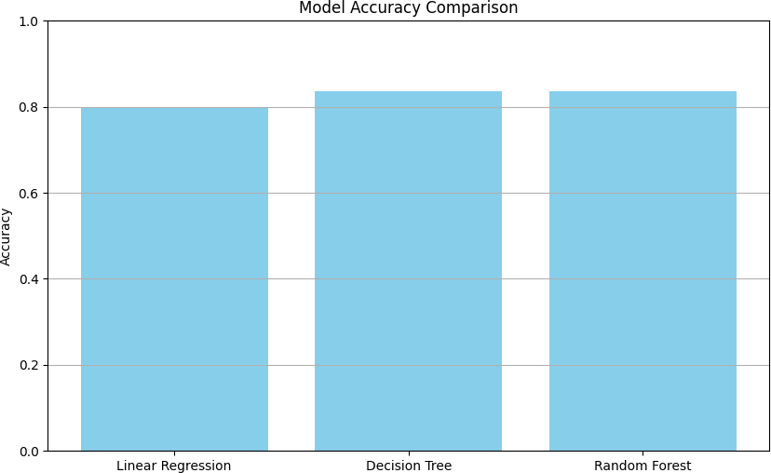

Figure 6.2.1 Model Accuracy Comparison
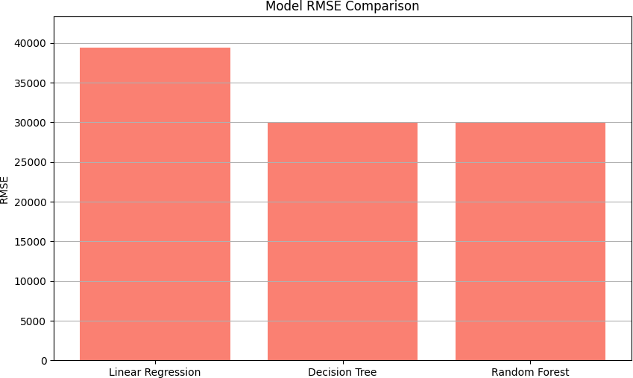

Figure 6.2.2 Model RMSE Comparison

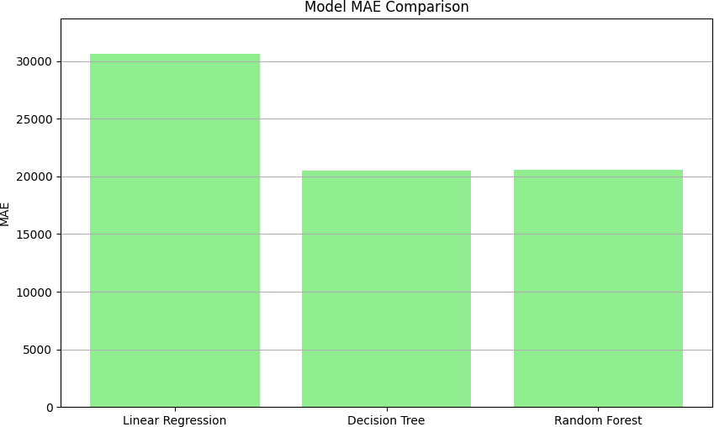

Figure 6.2.3 Model MAE Comparison

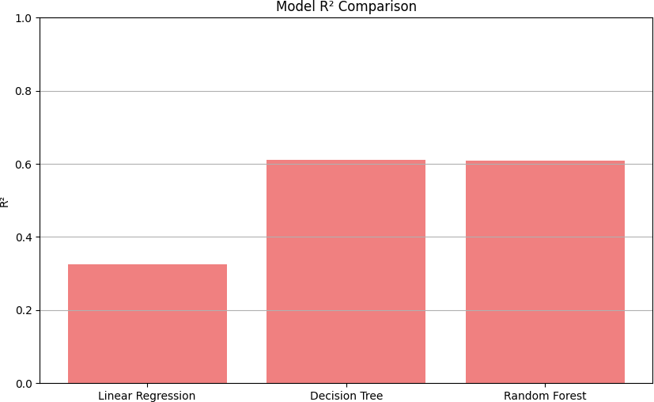

Figure 6.2.4 Model R² Comparison

VISUAL COMPARISON FOR REGRESSION ALGORITHMS USING CONFUSION MATRIX
Include confusion matrix for showing the performance metrics of each model for visual clarity.

- LINEAR REGRESSION CONFUSION MATRIX

The confusion matrix for Linear Regression (Figure 6.2.5) illustrates the model's accuracy in predicting high and low salaries based on a defined threshold. It indicates the number of true positives, true negatives, false positives, and false negatives, providing insights into the model's classification performance.

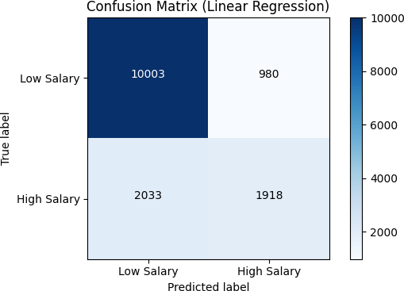

Figure 6.2.5 Linear Regression Confusion Matrix

DECISION TREE REGRESSOR CONFUSION MATRIX

The Decision Tree confusion matrix (Figure 6.2.6) showcases the model's ability to differentiate between high and low salaries. It reveals the counts of correctly classified instances and misclassifications, highlighting areas where the model may overfit or underfit.

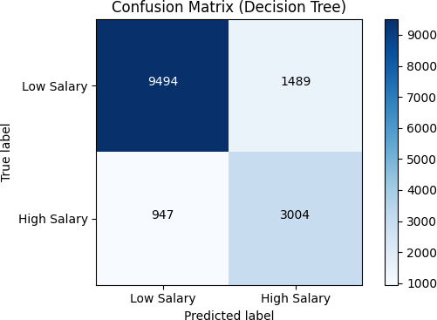

Figure 6.2.6 Decision Tree Regressor Confusion Matrix

RANDOM FOREST REGRESSOR CONFUSION MATRIX

The confusion matrix for the Random Forest model (Figure 6.2.7) presents the aggregated results of multiple decision trees. It displays the effectiveness of the ensemble approach in classifying high and low salaries, demonstrating a reduction in misclassifications compared to individual models.

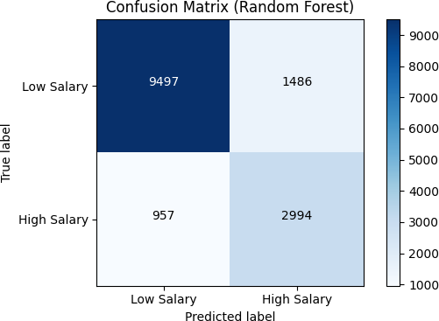

Figure 6.2.7 Random Forest Regressor Confusion Matrix

6.3.3 BEST MODEL BASED ON ACCURACY: DECISION TREE

The confusion matrix provides insights into the performance of the Decision Tree model in predicting salary classifications.

CONFUSION MATRIX FOR DECISION TREE (Figure 6.2.8)

- True Negatives (TN): 9494 – The model correctly predicted 9494 instances of low salary.
- False Positives (FP): 1489 – The model incorrectly classified 1489 low salary instances as high salary.
- False Negatives (FN): 947 – The model failed to identify 947 high salary instances, predicting them as low salary.
- True Positives (TP): 3004 – The model successfully identified 3004 high salary instances.



Figure 6.2.8 Best Model Based on Accuracy After comparing all models: Decision Tree

This matrix indicates a strong performance in classifying low and high salary categories, with a higher number of true positives and true negatives compared to false positives and false negatives.

RESULT VISUALIZATIONS

    - VISUALIZATION RESULT FOR PREDICTION.PY

- Estimated Salary: After the user inputs their country, education level, and years of experience, the application will display the estimated salary:

  - Estimated Salary: The estimated salary is $XX,XXX.XX (or the corresponding currency symbol, depending on the selected country).

- Currency Conversion: If the user selects to convert the estimated salary to another currency:
- Converted Salary: The estimated salary in [Target Country] is $YY,YYY.YY (with the respective currency symbol). It is represented in Figure 6.3.1 prediction.py



Figure 6.3.1 prediction.py

VISUALIZATION RESULTS FOR EXPLORE.PY

The explore.py page provides a comprehensive exploration of software engineer salaries through various visualizations derived from the Stack Overflow Developer Survey 2020 data. The key visualizations are outlined below:

Number of Data from Different Countries

Figure 6.3.2 presents a pie chart illustrating the distribution of survey responses from different countries. This visualization helps identify which countries contributed the most data to the survey, providing insight into the global representation of respondents.
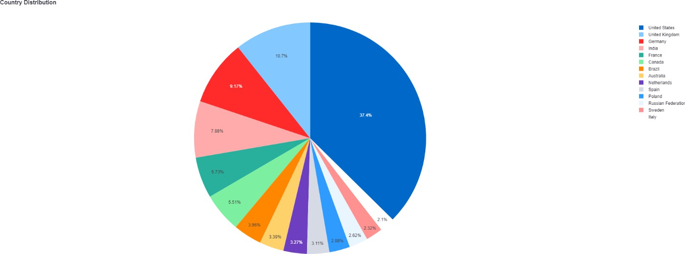

Figure 6.3.2 Number of Data from Different Countries:

Mean Salary Based on Country

Figure 6.3.3 shows a bar chart that represents the mean salary for software developers in various countries. This visualization allows for easy comparison of compensation across different regions, highlighting disparities and trends in salary distribution.

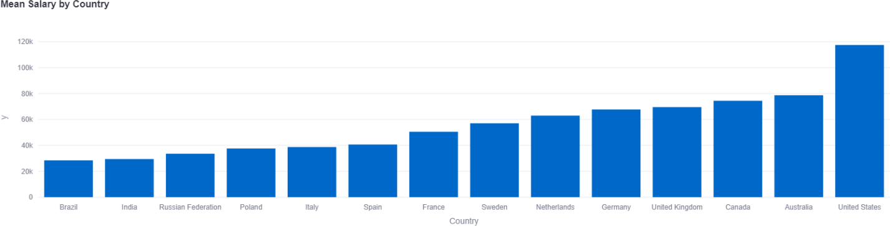

Figure 6.3.3 Mean Salary Based on Country

Mean Salary Based on Experience

Figure 6.3.3 displays a line graph illustrating how salaries vary with years of professional experience. This visualization provides insights into salary progression in the software development field and highlights the correlation between experience and earnings.

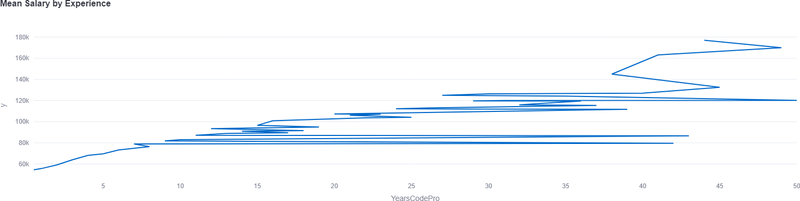

Figure 6.3.3 Mean Salary Based on Experience

Salary Distribution by Education Level

Figure 6.3.4 presents a grouped bar chart that shows the average salary associated with different education levels across various countries. This visualization illustrates how educational qualifications impact compensation in the software engineering industry.

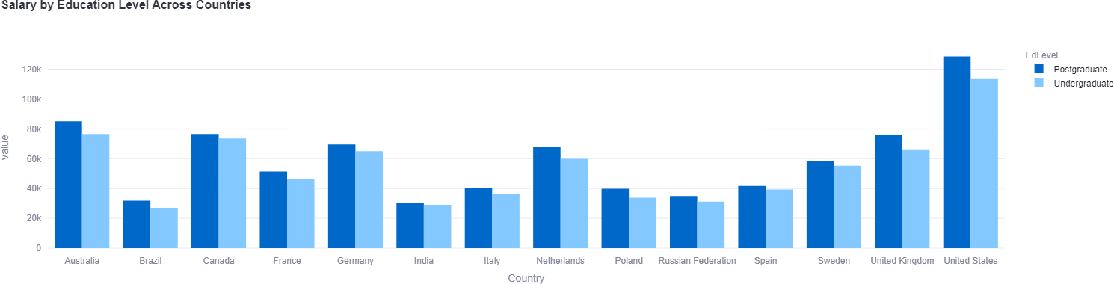

Figure 6.3.4 Salary Distribution by Education Level

Salary Distribution by Country (Box Plot)

Figure 6.3.5 visualizes the salary distribution among software developers in different countries through a box plot. This visualization effectively highlights the spread and outliers in salary data, allowing for a deeper understanding of compensation variability by country

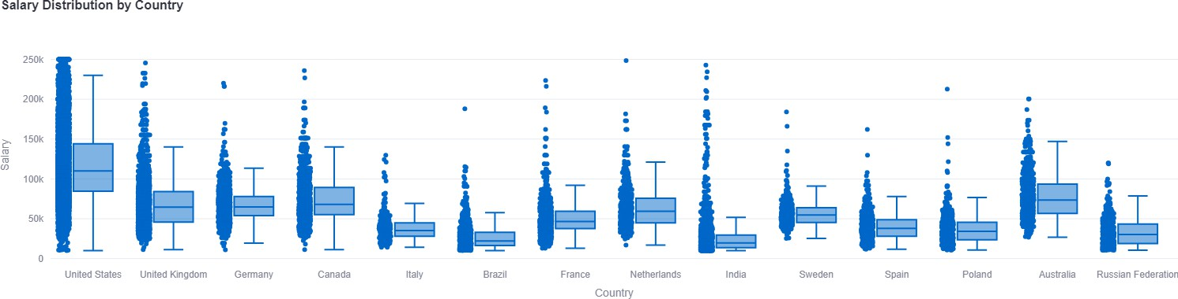

Figure 6.3.5 Salary Distribution by Country

Salary Density by Education Level

Figure 6.3.6 features a violin plot that depicts the salary distribution based on education levels. This visualization provides an intuitive understanding of the density of salaries for different education levels, along with a box plot overlay to show the median and interquartile ranges.

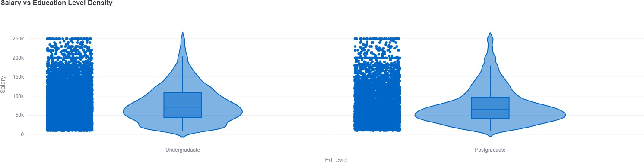

Figure 6.3.6 Salary Density by Education Level

CONCLUSION

CHAPTER 7 CONCLUSION
In this project, we developed a robust predictive model for software developer salaries using machine learning techniques, focusing on essential features like country, education level, and years of professional experience. The study evaluated several classifiers, and Random Forest emerged as the top performer, surpassing Linear Regression and Decision Tree in predictive accuracy, as indicated by metrics such as Mean Absolute Error (MAE), Mean Squared Error (MSE), and R- squared (R²). This model demonstrated its capacity to handle the complex, non-linear relationships present in the salary data. Hyperparameter tuning via Grid Search Cross-Validation further enhanced the performance of both the Decision Tree and Random Forest models by optimizing their parameters, improving their ability to generalize to unseen data, and reducing overfitting.The feature importance analysis revealed that a developer’s country and years of experience were the most influential predictors of salary, emphasizing the critical role these factors play in shaping salary distributions within the global software industry. Additionally, while the Random Forest model excelled in delivering high accuracy, the Decision Tree model offered superior interpretability, allowing stakeholders to understand the reasoning behind predictions more easily. Striking a balance between model performance and interpretability is vital, especially when communicating results to non-technical audiences or decision-makers who value clarity and transparency over pure accuracy. The insights gained from this analysis provide valuable information for both software developers and employers in making informed salary-related decisions.

BIBLIOGRAPHY

WEB REFERENCES

- Kaggle - Salary Prediction Challenge: https://www.kaggle.com/competitions/salary- prediction
- Towards Data Science - Predicting Salary with Machine Learning: https://towardsdatascience.com/predicting-salary-with-machine-learning-2c6325e5d0d4
- Stack Overflow Developer Survey 2020 Dataset: https://insights.stackoverflow.com/survey/2020

BOOK REFERENCES

- Hands-On Machine Learning with Scikit-Learn, Keras, and TensorFlow" by Aurélien Géron.
- Machine Learning for Beginners: A Beginner's Guide to Learning the Basics of Machine Learning" by John M. D. Carney.
- Python Machine Learning" by Sebastian Raschka and Vahid Mirjalili.

APPENDIX

PREDICTION PAGE
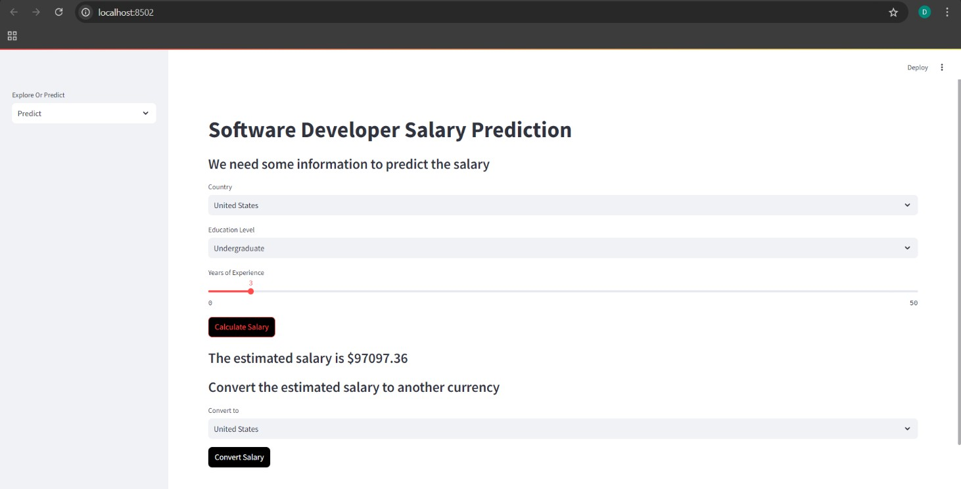

EXPLORE PAGE
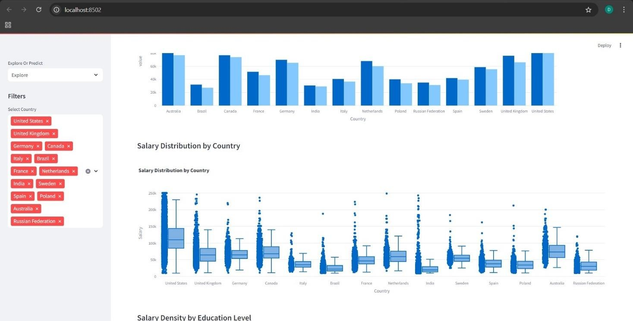

SYNOPSIS

This project focuses on developing a predictive model for software developer salaries using machine learning techniques, emphasizing key factors such as country, education level, and years of experience. By employing various regression algorithms, including Linear Regression, Decision Trees, and Random Forests, the study systematically evaluates their performance in predicting salaries based on these critical features. The analysis reveals that the Decision Tree algorithm is the most effective model for accurately predicting software developer salaries, demonstrating superior predictive accuracy through metrics like Mean Absolute Error (MAE), Mean Squared Error (MSE), and R-squared (R²). The project highlights the significance of geographical location and professional experience as pivotal determinants of salary levels in the software development industry, providing valuable insights for both developers and employers. Additionally, the findings underscore the need for developers to consider these factors when negotiating salaries, as they can significantly impact earning potential. By leveraging data-driven approaches, the project advocates for a more informed and equitable salary landscape within the tech industry. Furthermore, the insights gained from this analysis can guide organizations in structuring competitive compensation packages, ultimately contributing to better talent retention and job satisfaction.

 |  | DIVYAN S(22MSS011), III M.Sc. Software Systems, Batch (2022- 2027) in PSG College of Arts & Science, Coimbatore.

