Name : Divyanandh.A.S
Reg. no. : 722824148022
Title : 28. Data Center Migration
Amazon S3 Storage creation :
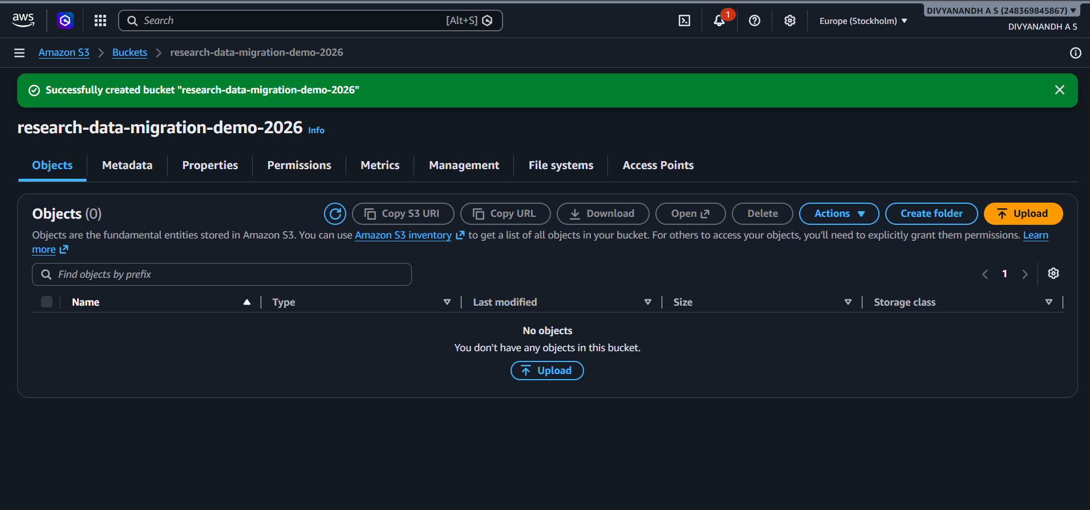

Creating Folders in S3 :
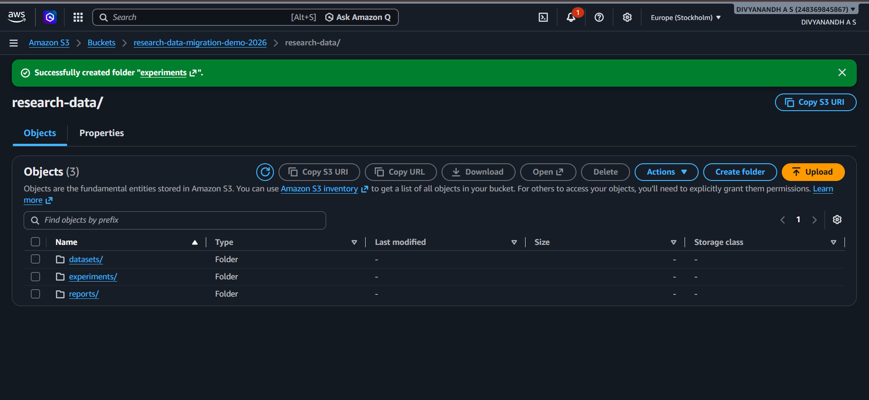

Adding Files with contents in S3 folders
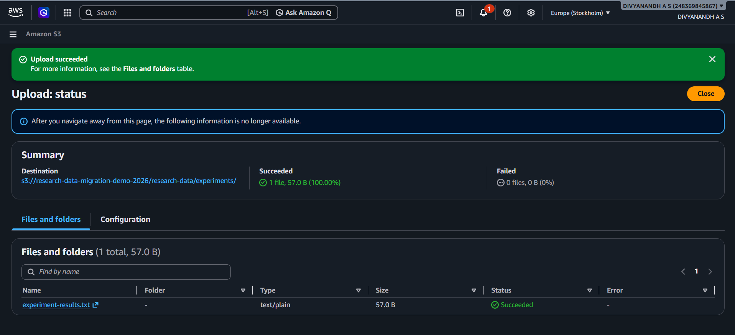

Creating AWS IAM role :
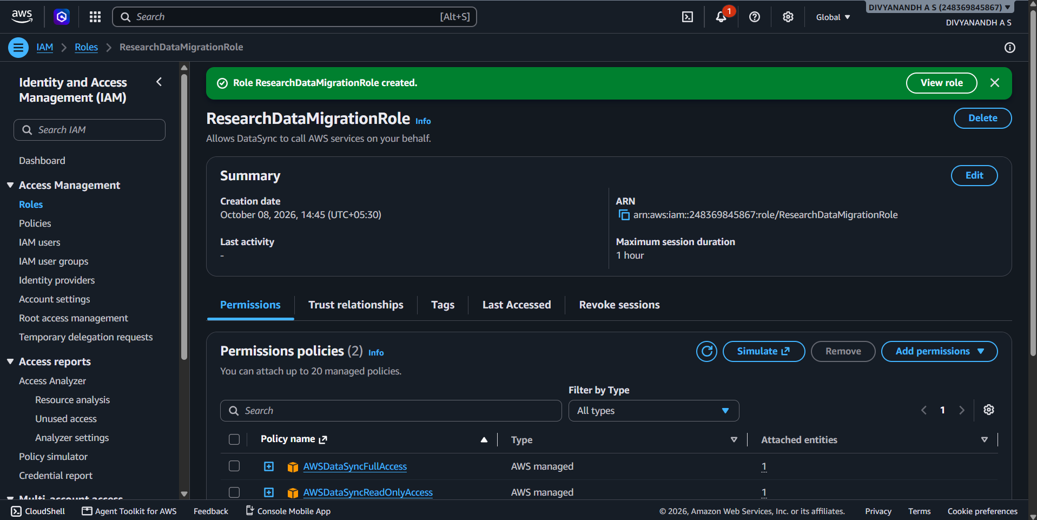

Pushing index.html file to Github for Deployment :
