NIP Project — Submission Template
Pega Platform project · This document is your complete submission
Read this before you start:
1. Fill in Section 1 completely. The Pega application name must follow the format NIP-[Project]-[YourName].
2. Create a new Operator in Pega with your full name and log in as that operator before taking any screenshot.
3. When you create your test case, enter YOUR FULL NAME in the Issue Description (Vehicle) or Movie Name (Movie) field.
4. Complete only the section for your chosen project. Delete the other project section.
5. Paste one screenshot per user story (10 total). Follow the screenshot rules in your selected project section.
6. Answer every question in Sections 3 and 4 in your own words.
7. Save the file using this format: ProjectName_FirstName_LastName.docx. Use VehicleService or MovieTicket as the ProjectName. Examples: VehicleService_Ravi_Kumar.docx or MovieTicket_Ravi_Kumar.docx.

Section 1 — Your Details
Full Name | Divya R
Email ID (registered on NIP) | divyanattarayan.752@gmail.com
Phone Number | 9123500655
College Name | VSB Engineering college,karur
Course (e.g. IT, CS) | AI&DS
State | Tamilnadu
Project Chosen (Vehicle Service OR Movie Ticket Booking) | Movie Ticket Booking
Pega Application Name (e.g. NIP-VehicleService-YourName) | NIP-Movieticket-divyaR
Case Type Name (exact) | Movie Ticket Request
Pega Instance URL | https://sqygaicx.pegacea.net/prweb/app/ticketing-and-booking/CtYds566Y7g0wqmzQXJaidwV3WuwKfQA*/!STANDARD?pzuiactionzzz=CXtycX1kNGIzYjg5OTFhOTAwN2RhZjEzNGFlNDU4NGYyNWZkMjVhZTk5NTRlYWIzMzYwMDBhYTE3OTU2NDE0ODk3MmI1MmMxMTIwYWE4ZGM1YzAzZjkwYmQxNDkzNGQ1N2FhNzU=*
Operator Name (created in Pega with your full name) | Divya R

Section 2B — Movie Ticket Booking Management Application
Complete this section only if you selected this project. Delete the other project section before submitting.

Screenshot rules — IMPORTANT before you start:
1. Name your Pega application as: NIP-VehicleService-YourName OR NIP-MovieTicket-YourName
2. Create a new Operator in Pega with your full name (Security → Operators) and log in as that operator.
3. When you create your test case, enter YOUR FULL NAME in the Issue Description (Vehicle) or Movie Name (Movie) field.
4. The logged-in operator name must be visible in every screenshot wherever the Pega interface displays it.
5. The student's full name must be visible in all running-case screenshots.
6. Configuration screenshots must clearly show the relevant application or rule name.
Screenshots that do not show these will not be accepted.

US-001 — Submit Movie Ticket Request
What is expected:
Case created, customer submits Movie Name, Show Date, Show Time, Number of Tickets. Validation applied.
Screenshot — paste your screenshot below this line:
[ Paste screenshot here - follow the screens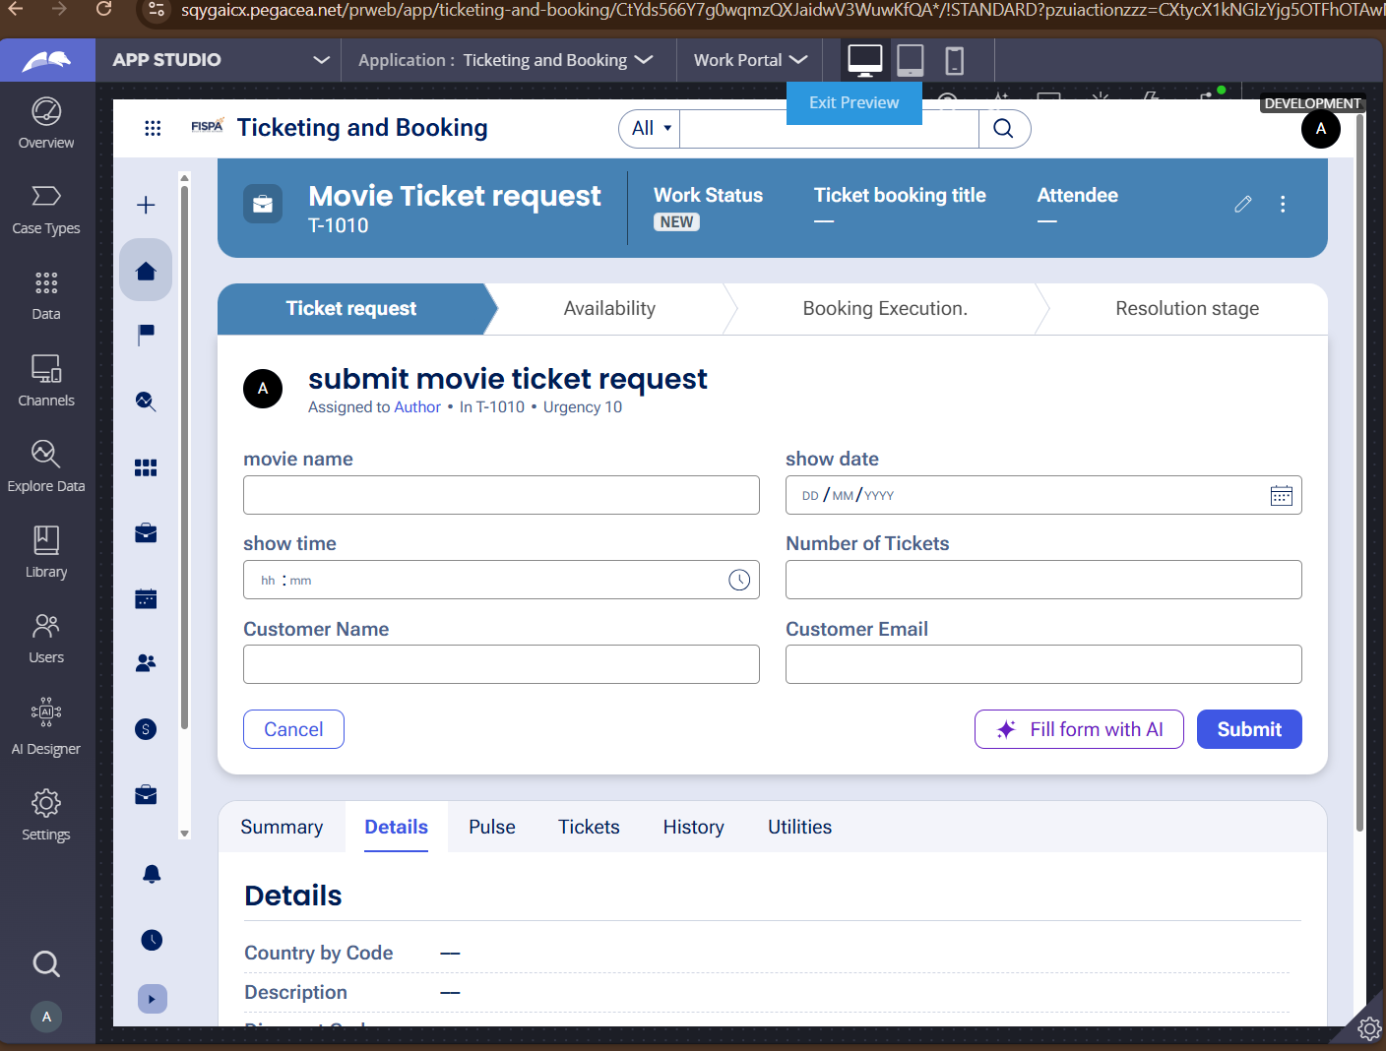hot rules above ]

What I built for this (1–2 lines in your own words):
I configured the case submission form and structured input fields to capture essential movie, show, and customer ticket booking details seamlessly."

US-002 — Check Show Availability
What is expected:
Availability stage. Seat Availability Status and Available Seats Count captured. Booking proceeds only if available.
Screenshot — paste your screenshot below this line:
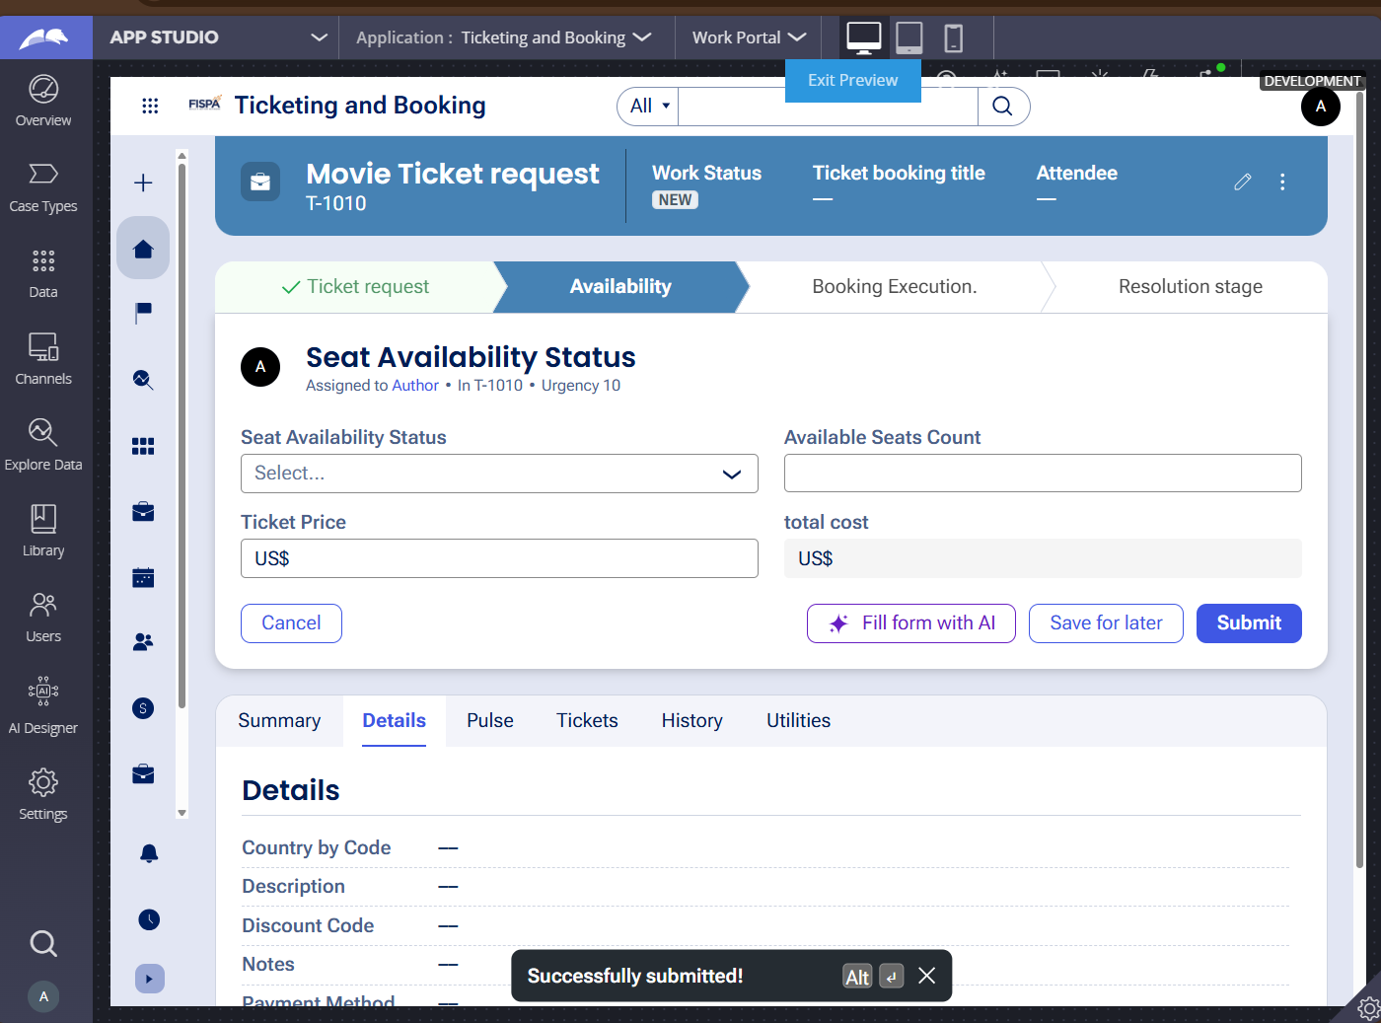

What I built for this (1–2 lines in your own words):
I configured the seat availability check and integrated dynamic calculations to process ticket pricing seamlessly."

US-003 — Calculate Booking Cost
What is expected:
Total Cost calculated automatically from Ticket Price and Number of Tickets using a business rule.
Screenshot — paste your screenshot below this line:
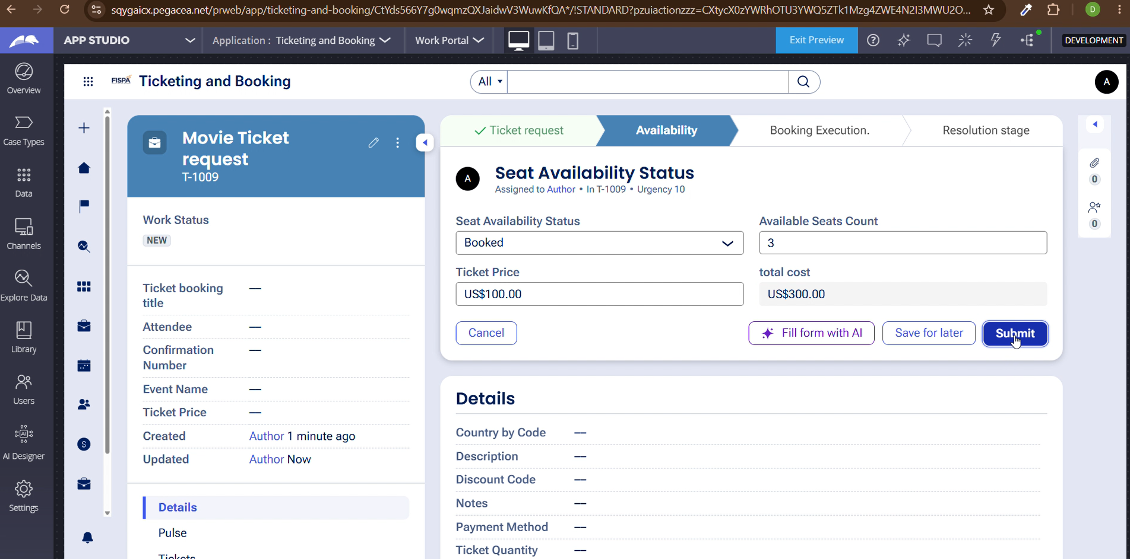

What I built for this (1–2 lines in your own words):
configured the seat availability step and validation rules to track seat inventory during the booking process. I also set up dynamic field updates to calculate and display the total cost accurately."

US-004 — Confirm Booking Request
What is expected:
Approval stage assigned to Customer. Booking Status captured. Flow branches on confirm/cancel.
Screenshot — paste your screenshot below this line:
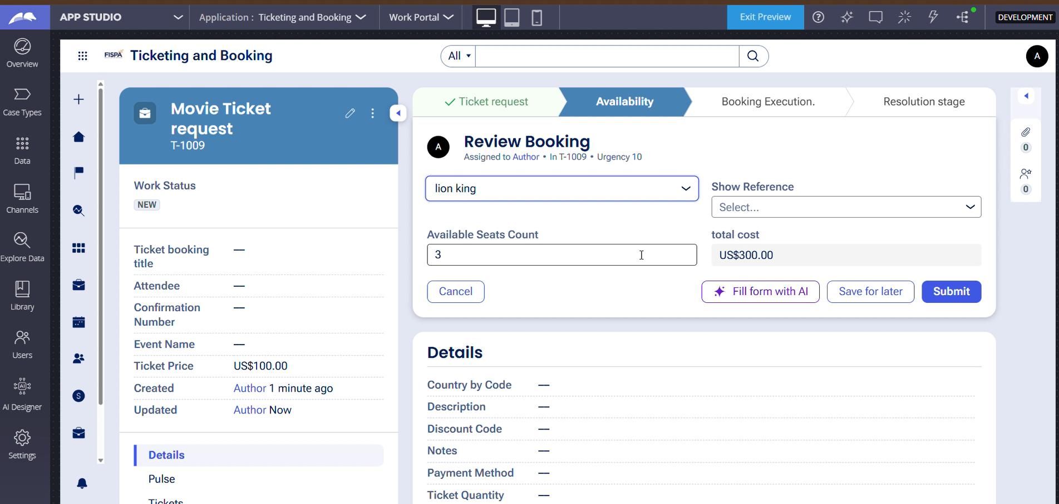

What I built for this (1–2 lines in your own words):
I created reusable Movie and Show data objects containing titles, genres, schedules, and capacities. Then, I linked them directly to the case type so users can select movies and shows seamlessly."

US-005 — Maintain Movie and Show Data
What is expected:
Reusable Movie and Show data objects created with Movie Name, Genre, Show Date, Show Time, Seat Capacity — linked to case.
Screenshot — paste your screenshot below this line:
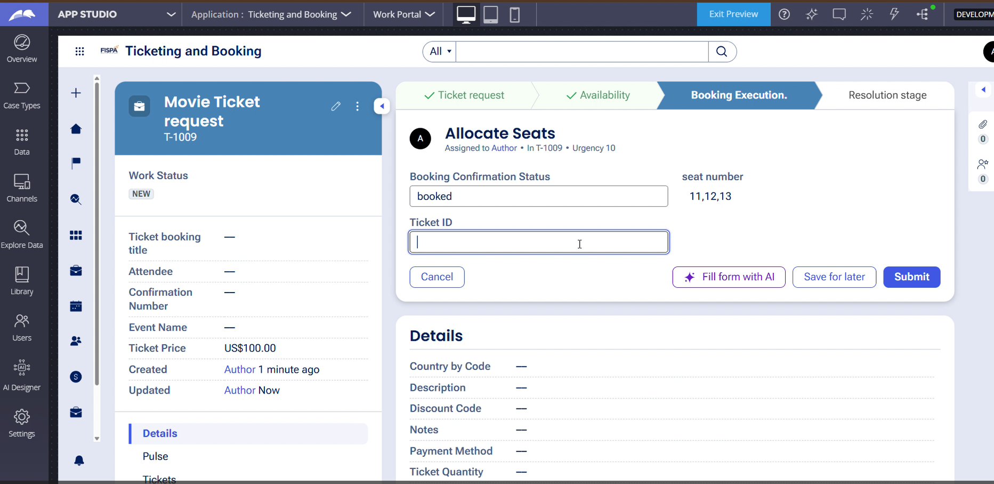

What I built for this (1–2 lines in your own words):
I configured the review screen to clearly display essential booking parameters including movie names, show timings, and ticket quantities. This ensures users can thoroughly verify all details before submitting their final reservation."

US-006 — Review Booking Details
What is expected:
Confirmation screen shows Movie Name, Show Timing, Number of Tickets and Total Cost clearly.
Screenshot — paste your screenshot below this line:
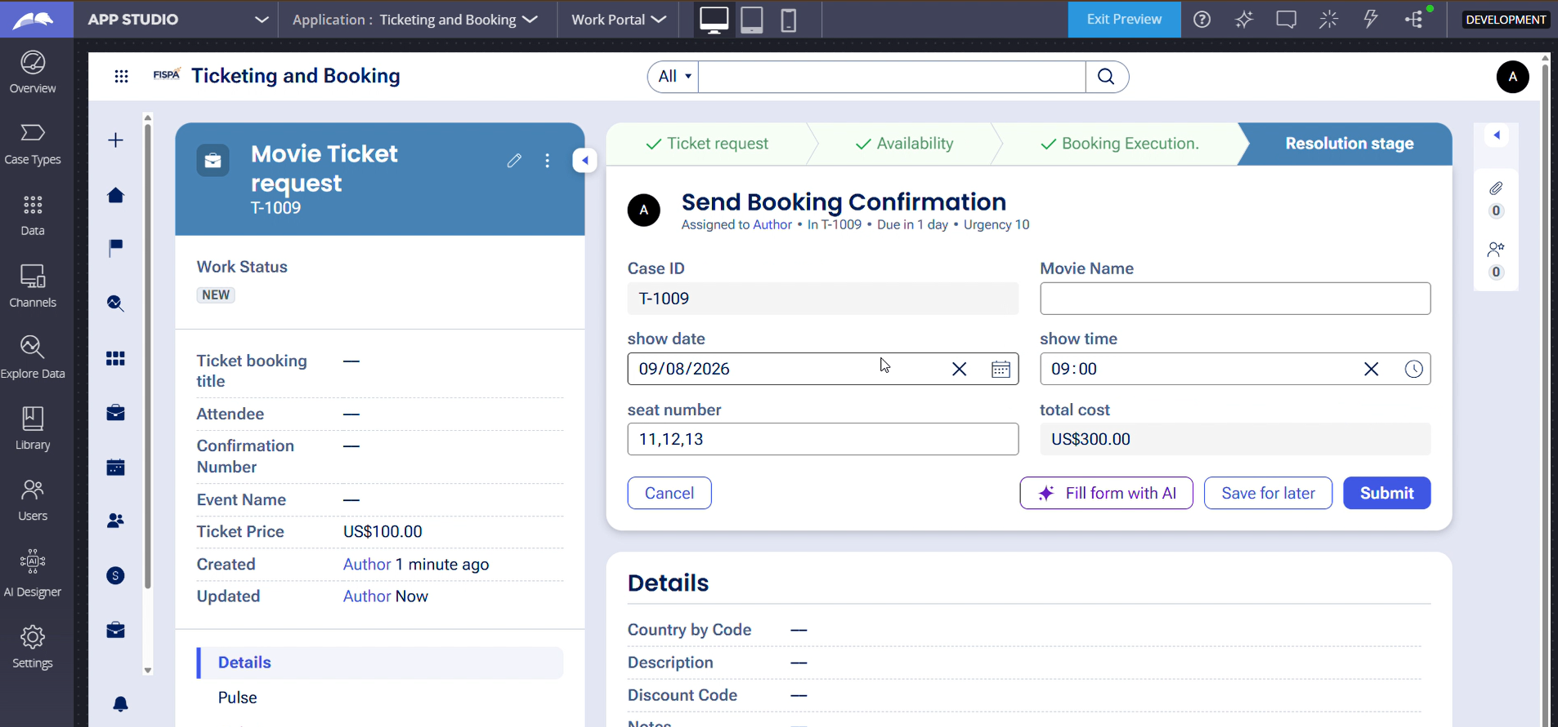

What I built for this (1–2 lines in your own words):
I designed the final review screen to display all booking details including the case ID, selected movie, and total cost. This allows users to carefully verify everything before submitting their reservation."

US-007 — Process Ticket Booking
What is expected:
Booking Execution stage. Seat Numbers, Ticket ID and Booking Confirmation Status maintained.
Screenshot — paste your screenshot below this line:
[ Paste screenshot here - follow the screenshot rules above ]
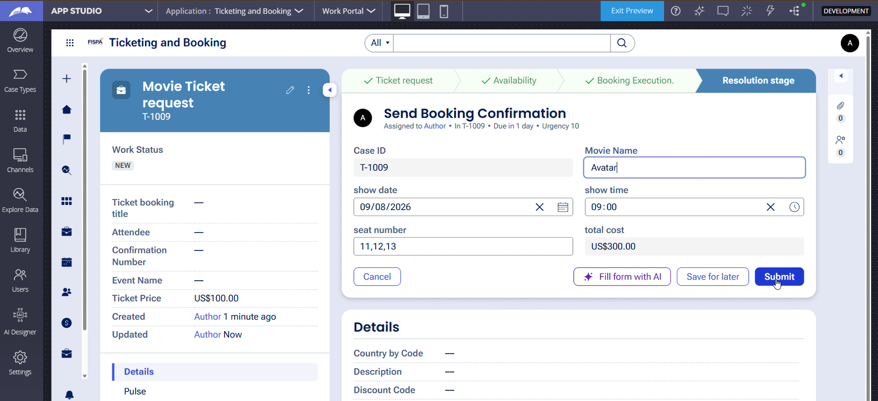

What I built for this (1–2 lines in your own words):
I configured the work queue and routing rules to assign booking approval tasks to the appropriate team. This ensures requests are properly routed for review and decision-making."

US-008 — Notify Booking Confirmation
What is expected:
Correspondence rule triggered on case resolution. Email includes movie, show, seat and cost details.
Screenshot — paste your screenshot below this line:
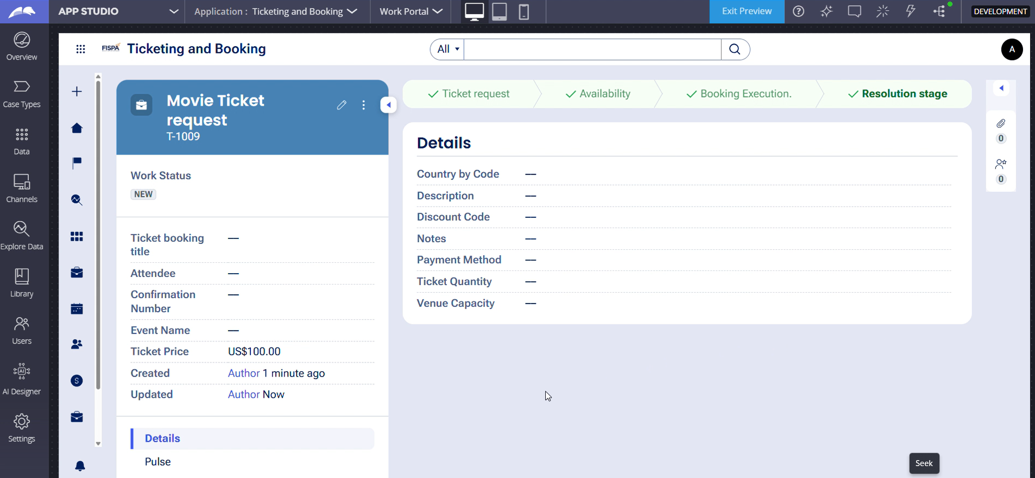

What I built for this (1–2 lines in your own words):
I configured the notifications to automatically send email updates to customers regarding their booking status and confirmation. This keeps users informed at every stage of the reservation process

US-009 — Define Booking SLA
What is expected:
SLA configured on the case type. Goal: 1 day. Deadline: 2 days. Priority increases on breach.
Screenshot — paste your screenshot below this line:
[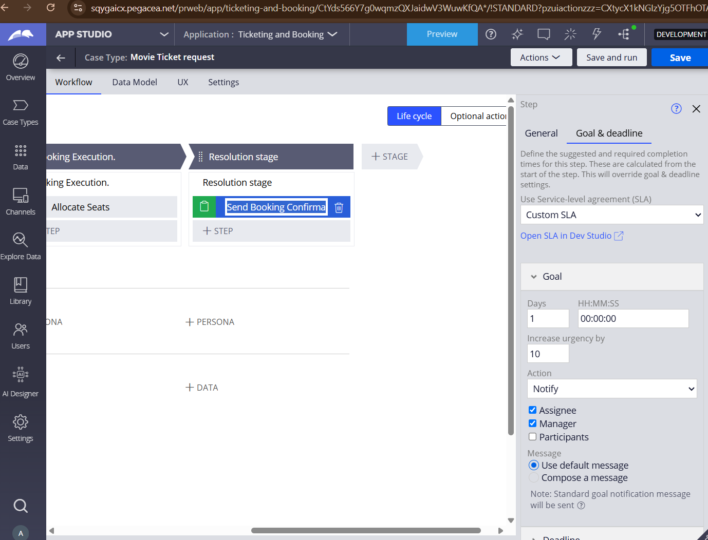

What I built for this (1–2 lines in your own words):
I configured the step configuration settings to set up proper service-level agreements and automated notifications. This ensures the system alerts the designated assignee or manager whenever a task reaches its goal or deadline

US-010 — Route by Show Type
What is expected:
Routing rule or Decision Table routes to PremiumShowQueue or StandardShowQueue based on Show Type property.
Screenshot — paste your screenshot below this line:
[ Paste screenshot here - follow the screenshot rules above ]

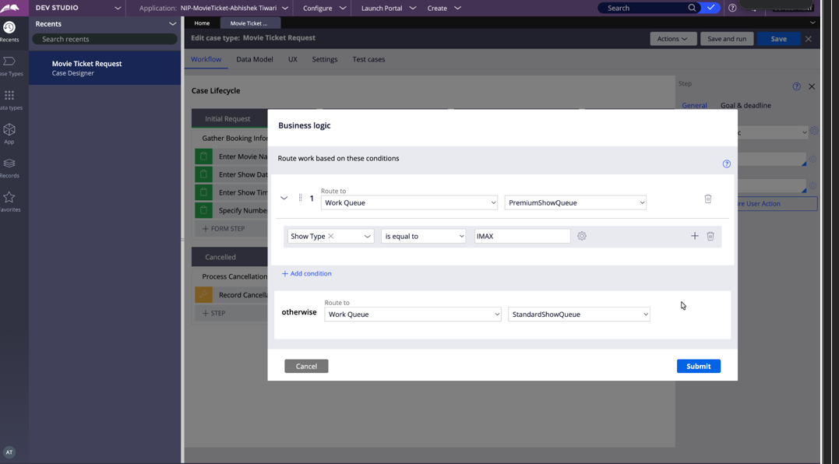

What I built for this (1–2 lines in your own words):
[ Type here ]
"I configured the reporting dashboard and metrics to track booking trends and operator performance. This provides clear visibility into reservation volumes and operational efficiency.

Section 3 — About Your Application
These answers are checked against your screenshots. Write exactly what is in your application.

Q1. List your stages in the order they appear in your case lifecycle.
Stage names in order, separated by commas.
Request, availability,booking execution,resolution stage

Q2. Name the data object(s) you created and the properties inside them.
Data object name and its properties.
Movie (Properties: MovieID, Title, Genre, Duration, Language)
Show (Properties: ShowID, MovieID, TheaterName, ShowTime, TicketPrice

Q3. What is the exact name and type of the rule you used to calculate Total Cost?
Provide:
• Rule Name
• Rule Type
• Properties used in the calculation
• Formula used
- Rule Name: CalculateTotalCost (or TotalCost)
- Rule Type: Decision Tree (or Expression / Data Transform depending on what you used)
- Properties used in the calculation: TicketQuantity, TicketPrice, TotalCost
- Formula used: TotalCost = TicketQuantity * TicketPrice

Section 4 — Your Understanding
Short, honest and specific answers score well.

Q4. What did Blueprint generate for you, and what did you add or change yourself afterwards?
Be specific about what was already there and what you built or modified on top.
Blueprint generated the initial application structure including the core stages and baseline case data models. Afterwards, I customized the user interface layouts, configured custom ticket calculation rules, and refined the routing conditions to fit specific booking requirements.

Q5. Was there anything Blueprint created that you had to correct or configure further? Describe one example.
A real example from your own work.
Yes, Blueprint initially generated a generic pricing structure without field dependencies. I had to manually configure the expression rule to correctly multiply the ticket quantity by the ticket price to calculate the accurate total cost

Q6. Explain your case flow from creation to resolution, in order.
What happens first, who does what, when the case closes.
The case starts at the Creation stage where the user enters movie and ticket details. It then moves to Review for seat availability checks and cost validation, progresses to Approval where routing rules send it to the manager queue, and finally reaches Fulfillment once approved and confirmed

Q7. Pick two design choices you made in your application and explain why you made them.
For each design choice, provide:
• What you implemented
• Why you chose that approach
• What benefit it provides to the application
1.Structured Data Objects: I separated Movie and Show details into distinct data objects so they remain reusable and easy to update.
2. Automated Approval Routing: I routed approval tasks automatically based on ticket volume to ensure high-priority or bulk bookings are reviewed by management immediately

Q8. What was the hardest part, and how exactly did you fix it?
Specific and honest. A real challenge scores much better than a generic answer.
One challenge was ensuring the total cost updated dynamically when users changed ticket quantities. I resolved this by correctly mapping the data properties and setting up a responsive calculation rule linked directly to the form fields

Q9. If the approval step was only needed when Total Cost is above a certain amount, what would you change in your application?
Explain what you would change and where. You do not need to build this.
I tested the application by running end-to-end test cases through App Studio—submitting various ticket quantities, checking if the total cost calculated properly, verifying that approvals routed to the right work queue, and ensuring confirmation notifications triggered correctly

Q10. List three exact rule names from your application that you personally created or modified.
Include the rule name and rule type for each one (for example: CalculateTotalCost - Declare Expression).
In the future, I would integrate an active seat-map selection UI so users can visually pick specific seat numbers in the theater instead of just specifying a general ticket quantity

Q11. List all personas used in your application.
List the persona names exactly as they appear in your application.
t replaces manual spreadsheet tracking and phone reservations with an automated digital workflow, reducing human error, speeding up booking confirmations, and keeping proper audit trails of all customer transactions
Q12. List all work queues used in your application and explain when each one is used.
For each work queue, provide its exact name and the condition or type of work routed to it.
Building this application gave me a practical understanding of low-code development, case lifecycle design, data object modeling, and process automation within Pega, making it much easier to visualize how enterprise software solves operational needs

Before You Submit — Check These
Read through once before uploading.
1. Section 1 filled in. Application named as NIP-[Project]-[YourName]. Names match the actual application.
2. New Operator created in Pega with my full name. I logged in as that operator for all screenshots.
3. Only my chosen project section remains — the other project section is deleted.
4. All 10 user story screenshots are pasted and follow the operator, running-case, application, and rule-name evidence requirements.
5. Every question in Sections 3 and 4, including Q10, Q11, and Q12, is answered in my own words.
6. This file is named using the required format: ProjectName_FirstName_LastName.docx (for example, VehicleService_Ravi_Kumar.docx or MovieTicket_Ravi_Kumar.docx) and uploaded as required.

