LIBRARY MANAGEMENT SYSTEM

Harshil Shah

Hxs155030

INTRODUCTION:

This document is used to present the system at design level. The application is called Library Management System where the users are the library staff. This application can be used to get information relating to current books in the library, add a borrower in the system, check-in/check-out books as well as calculating the fines.

SYSTEM ARCHITECHTURE:

The application interacts with the user using GUI. Here the users are the library staff involved in the borrower interaction with the library. The application in the back end maintains a database where information is stored in different tables. SQL queries are fired to get the required results.

DESIGN DECISIONS AND ASSUMPTIONS:

The menu has options button doing the respective work. The search results in books along with the inventory and current availability. For the same one more column is added called inventory in the BOOK_COPIES table in the database schema. So if any book is checkout the no-of-copies column has the availability number and inventory column will have the total number of books the branch has including both available and checked-out.

Whenever a borrower is added in the system, a card-no is generated which is done using a variable which is initialized to the max card no already present in the system and incremented as a borrower is added.

From all other table entries auto-incremental was used to generate different primary key for insert queries.

For Fines the payment is done collectively for a borrower and not for individual loan-ids. The table displayed on clicking fines is only displaying unpaid loan-ids.

When a payment is made fines is only collected for the books that are checked-in.

Database Schema:

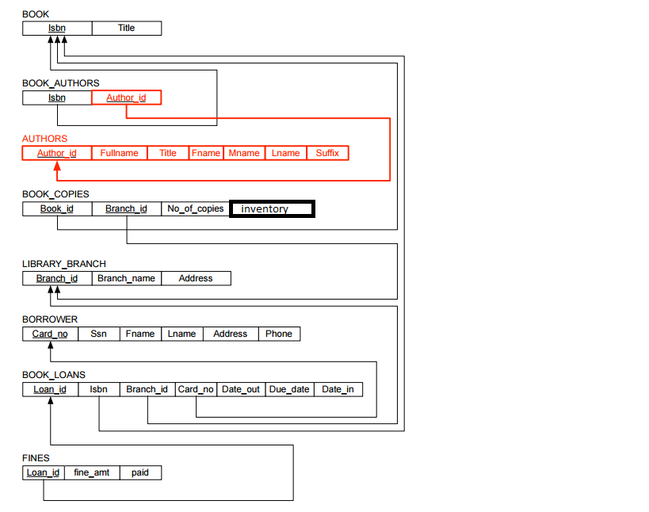

ARCHITECHTURE:

END USER

LIBRARY STAFF

Database

MySQL

GUI  
TKINTER

PYTHON