**A CRM APPLICATION TO MANAGE THE SERVICES OFFERED BY AN INSTITUTION**

**By**

**N. Divya Sree**

**21131a4436@gvpce.ac.in**

**Abstract**

The EduConsultPro Institute stands as a premier educational institution, annually offering an expanding array of courses and programs to accommodate the growing number of prospective students. To maintain high service standards and effectively manage admissions, student inquiries, and consulting services, the institute aims to implement a robust CRM solution using Salesforce. This project will focus on designing and deploying a comprehensive CRM application that enhances the experiences of students and admissions staff alike.

The solution will encompass key features including Admission Application Management, Consulting Services Management, and Immigration Case Management. Through the Admission Application Management module, prospective students can submit applications online, and admissions staff can efficiently track and review these applications with automated notifications streamlining the process. The Consulting Services Management feature will enable students to request expert advice, allowing consultants to effortlessly schedule and manage appointments. Additionally, the Immigration Case Management module will provide up-to-date information on immigration-related queries and cases.

Key functionalities such as automated workflows, email notifications, comprehensive dashboards, and collaboration tools will be integrated to ensure a smooth and transparent experience for both prospective students and staff. With revamped, user-friendly pages made possible through Salesforce CRM, EduConsultPro Institute can boost operational efficiencies, resulting in a higher throughput in admissions and consulting services. This project aligns the institute’s present needs with a future-ready platform, supporting scalable growth and a more efficient admissions process.

**INDEX PAGE**

**Topic** **Page no**

1. Title 1
2. Abstract 2
3. Introduction 4
4. Create Objects from Spreadsheet 5
5. Create a ScreenFlow for Student Admission Application process 8
6. Create Users 10
7. Create an Approval Process for Property Object 11
8. Create a Record Triggered Flow 13
9. Create a ScreenFlow for Existing Student to Book an Appointment 14
10. Create a ScreenFlow to Combine all the flows at one place 16
11. Create a lightning app page 18
12. Execution Screenshots 19

**INTRODUCTION**

EduConsultPro Institute, a prestigious educational institution, is dedicated to advancing the management of its admissions, consulting services, and immigration case handling to meet the growing demands of student applications and service requests. Recognizing the need for a more streamlined and integrated approach, the institute is implementing a comprehensive CRM solution using Salesforce.

To drive operational efficiency and provide a seamless experience for both prospective students and admissions staff, the institute's new Salesforce CRM initiative will unify processes related to admission applications, consulting services, and immigration case management in a single, cohesive platform.

This project will include:

* Development of an Intuitive Admission Application System: Prospective students can easily submit applications online, with automated notifications and detailed reporting capabilities for admissions staff, enhancing both tracking and response efficiency.
* Consulting Request Approval Workflow: By implementing an efficient workflow for consulting requests, the solution will automate email alerts and streamline the submission and approval process, improving response times and clarity.
* Comprehensive Consulting Services Management: Students will be able to request consultations, schedule appointments, and track service statuses directly within Salesforce, simplifying the consulting experience.
* Streamlined Immigration Case Handling: Students can initiate cases through multiple channels, manage required documents, and monitor case progress with integrated tracking tools, ensuring transparency and ease in the immigration process.

To achieve these outcomes, the project will include the setup of custom Salesforce objects, development of tailored flows, and the design of unified app pages in Salesforce Lightning. Each enhancement will contribute to a more streamlined and intuitive experience for users navigating the admissions and consultation processes, positioning EduConsultPro for scalable growth and elevated service standards.

**Task 1: Create Objects from Spreadsheet**

* **Enhanced Service Management Setup**:  
  Salesforce was utilized to seamlessly integrate EduConsultPro's existing data from spreadsheets, enabling efficient data handling and management across the institution’s departments.
* **Object Creation and Design**:  
  Custom objects—**Course**, **Consultant**, **Student**, and **Appointment**—were created in Salesforce to represent the primary components of EduConsultPro's operations. Lookup relationships were established between **Appointment and Student** and **Appointment and Consultant**, ensuring data integrity and easy navigation for users.
* **Registration Object Setup**:  
  A **Registration** object was created to store critical information about **Student** and **Course** details. Additionally, a lookup relationship between **Student** and **Case** was added to streamline the management of immigration or visa applications arising from student inquiries.
* **Tab Creation**:  
  Custom tabs were set up for each new object, allowing users to navigate the system efficiently and access relevant data without hassle.
* **Case Object Customization**:  
  The **Case** object was customized with specific field values for seamless immigration-related management:
  + **Type** field values: "Immigration" and "Visa Application."
  + **Status** field values: "Open" and "In Progress."
* **Lightning Application Development**:  
  A new Lightning app, **EduConsultPro**, was developed to provide a streamlined, user-friendly experience. The app includes tabs for **Home**, **Students**, **Courses**, **Consultants**, **Appointments**, **Registrations**, and **Cases**, offering a comprehensive and optimized interface for effective service management. This design supports the institution’s administrators and staff in managing services efficiently, with enhanced visibility and transparency.

**Screenshots:**

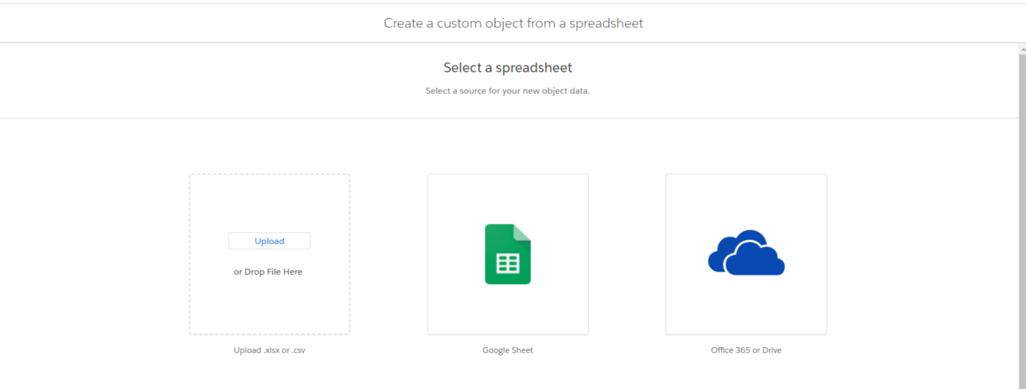

Create object from spreadsheet

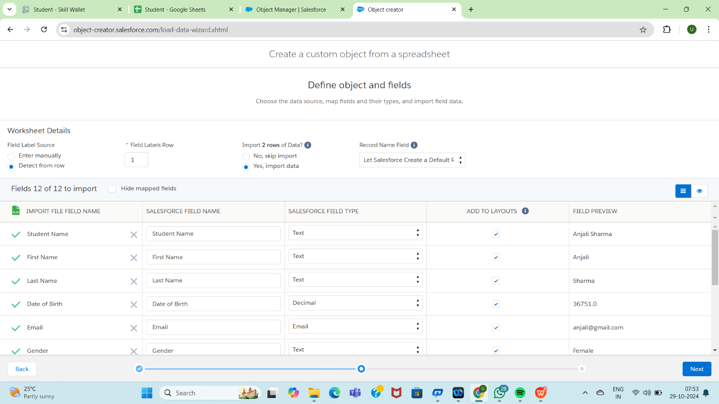

Defining Object properties

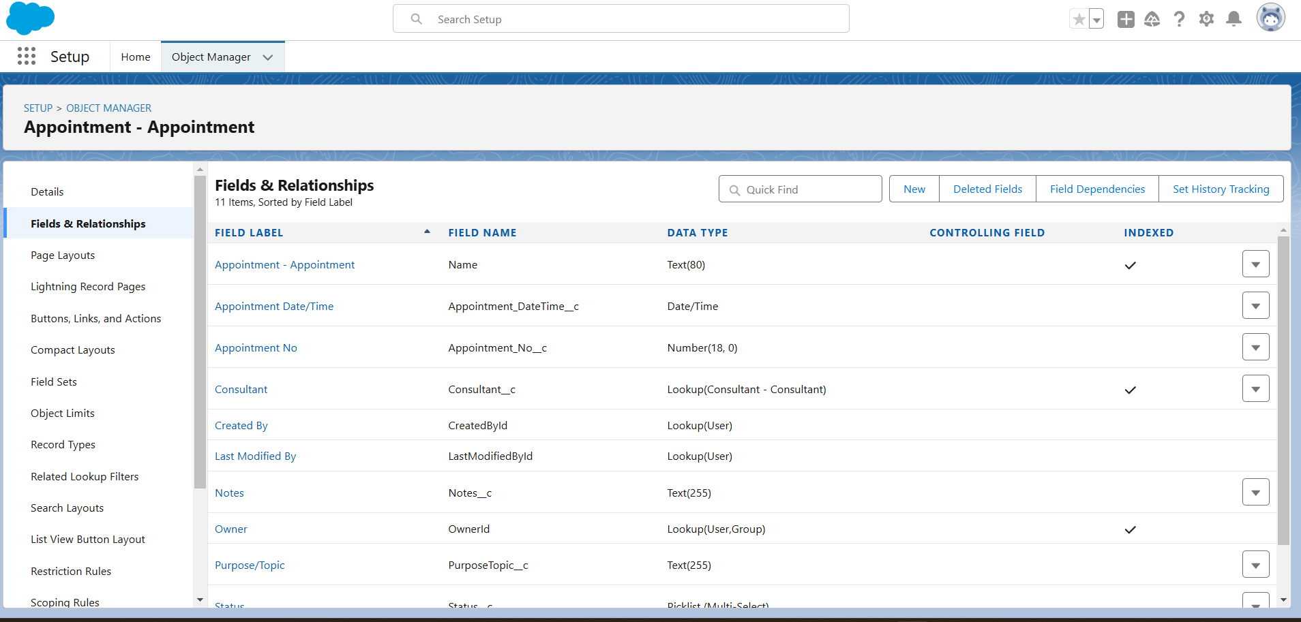

Appointment Object Fields and Relationships

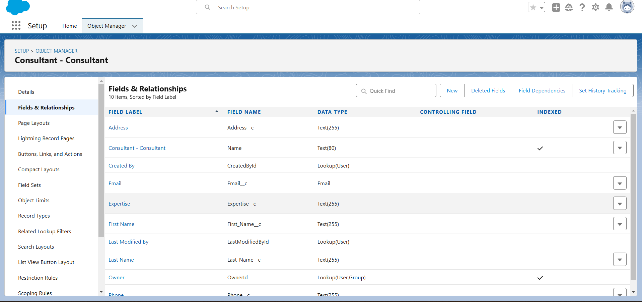

Consultant Object Fields and Relationships

**Task 2: Create a Screen Flow for Student Admission Application Process**

The **EduConsultPro Student Flow** simplifies and enhances the registration experience for students by guiding them through an intuitive application process. Here is a detailed breakdown of the flow setup:

1. **Student Information Screen**:  
   A **Screen** element named "Student Info" was created to collect all necessary student details. A **record variable** named **StudentRecordRes** was also established to display fields from the **Student** object, allowing students to enter their information smoothly.
2. **Create Student Record**:  
   A **Create Records** element titled "Create Student Record" was added to save the student's input into the **Student** object in the Salesforce database, ensuring that student information is accurately captured and stored.
3. **Course Selection Screen**:  
   A second **Screen** element named "Course Screen" was added, featuring a **picklist** titled "Select Course" to let students choose their course. Options include IELTS, GRE, GMAT, Duolingo, and TOEFL, providing a straightforward selection experience.
4. **Course Selection Decision**:  
   A **Decision** element named "Selecting Course" was configured to manage the flow based on the course choice. This decision point checks the selected course and directs the next action accordingly. When a course is chosen, a **Get Records** element retrieves the corresponding course data from the **Course** object to ensure proper association during registration.
5. **Create Registration Record**:  
   Using a **Create Records** element, a record in the **Registration** object was created, linking the selected course with the student’s provided information. This step ensures that each student’s registration is complete and properly recorded.
6. **Email Notification Setup**:
   * **Text Template Resources** were created for the **email body** and **subject**, crafting a confirmation message for students.
   * An **Action** element, titled "Send Email to Student," was added to automatically send this email, including relevant student details, to confirm successful registration.
7. **Success Screen**:  
   A final **Screen** element, titled "Success Screen," was added to display a completion message: "Registration has been completed successfully." Students are advised to check their email for further details.

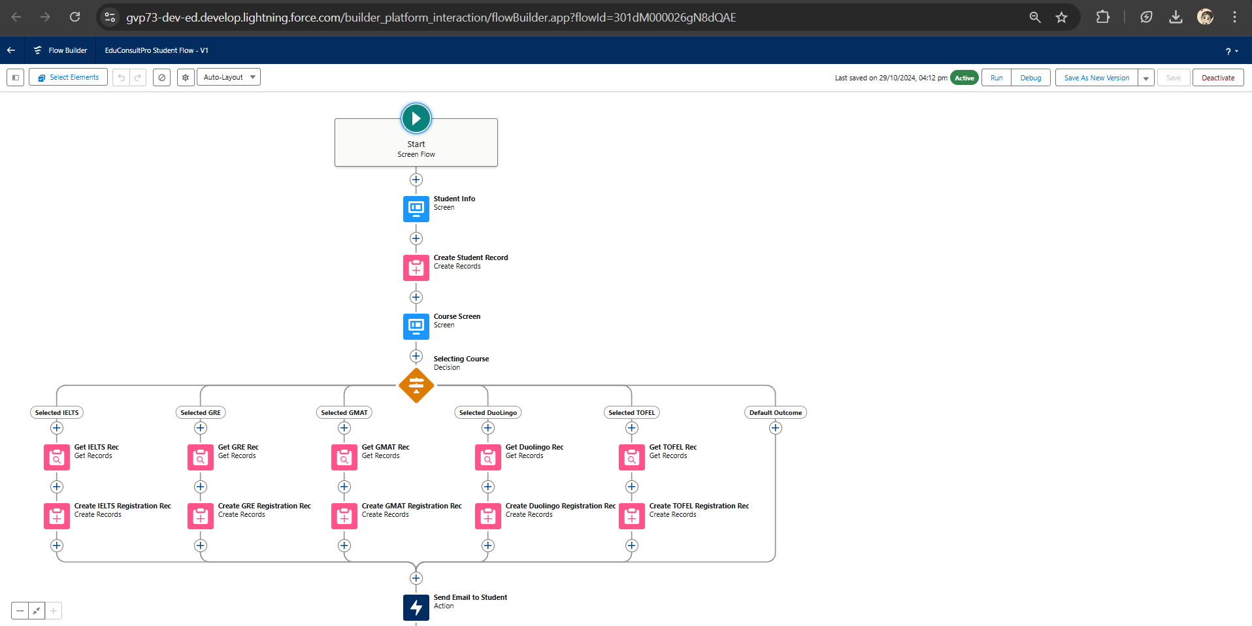

**Task 3: Create Users**

1. **User Creation**:  
   A new user was created in Salesforce by navigating to **Setup → Administration → Users → New User**. The following information was entered:
   * **Last Name**: "Consultant"
   * **License Type**: "Salesforce Platform"
   * **Profile**: "Standard Platform User"
2. All necessary fields were filled out, and the record was saved to create the new user.
3. **User Configuration**:  
   To configure additional settings for this user:
   * Navigated to **Setup → Administration → Users** and selected **Edit** on the newly created user profile.
   * In the **Approver Settings** section, selected "Consultant" for the **Manager** field.
   * Scrolled to the bottom and clicked **Save** to apply these settings.

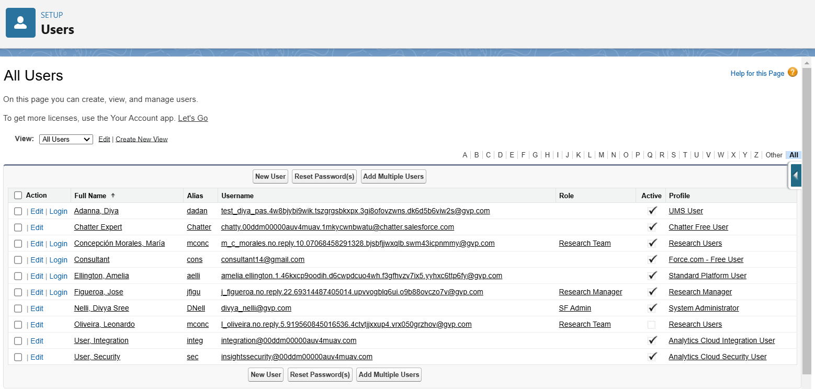

**Task 4: Create an Approval Process for the Property Object**

* **Email Template Setup**:  
  To create email templates, I navigated to **Setup**, entered **"Templates"** in the Quick Find box, and enabled **Lightning Email Templates**.
  + Opened the **App Launcher** and searched for **Email Templates**.
  + Created a new folder for organizing templates and saved it.
  + Added a new email template, choosing the created folder and entering specific content in the **HTML Value**. Named this template **"Submission Template"** to confirm submission.
  + Created two additional templates for approval and rejection messages, following the same process for consistency.
* **Approval Process Setup**:  
  I accessed **Approval Processes** by going to **Setup** and entering **"Approval"** in the Quick Find box.
  + Selected to manage approval processes for the **Appointment** object and created a new approval process using the **Jump Start Wizard**.
  + Named the process **"Appointment Approval"** and configured it to automatically assign approvers by using the **Manager** hierarchy.
  + Set **"Next Automated Approver Determined By"** to **"Manager"**.
* **Record Editability Properties**:
  + Adjusted record editability by setting it to **"Administrator OR the currently assigned approver."**
  + Saved the approval process configuration and reviewed the form for accuracy.
* **Field Update for Initial Submission**:
  + Created a **Field Update** action under **Initial Submission Actions**, named **"Submitted."**
  + Configured this to update the **Appointment: Status** field to **"Pending"** upon submission.
* **Email Alerts for Approval Process Stages**:
  + Created a new **Email Alert** called **"Submission Email Alert"**, selecting the **"Submission Template"**.
  + Set the **Recipient Type** to the **user's Name** to notify them upon submission.
  + Configured additional email alerts for **Final Approval** and **Final Rejection** actions, linking them to the respective templates.

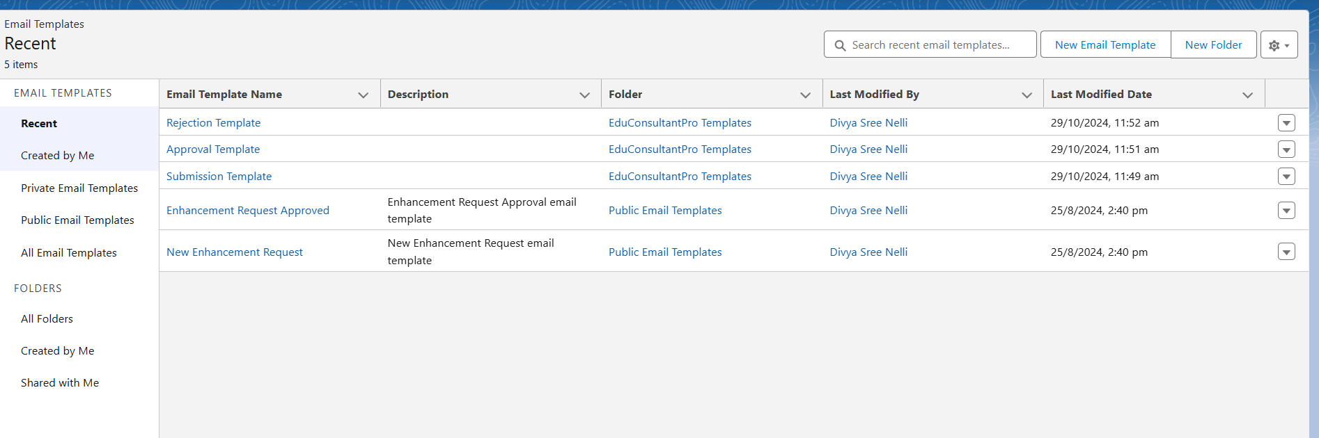

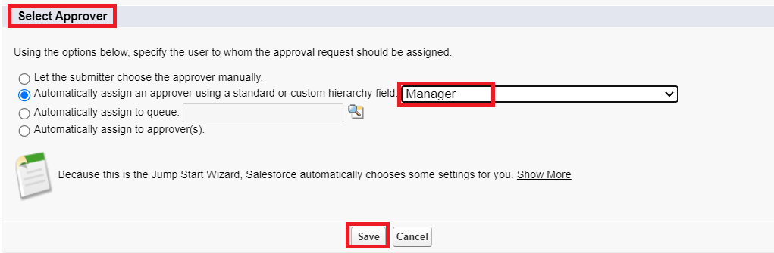

**Task 5: Create a Record-Triggered Flow**

1. **Flow Setup**:  
   Created a **Record-Triggered Flow** in Salesforce, designed to initiate automatically when a new **Appointment** record is created.
2. **Trigger Configuration**:  
   Set the trigger criteria to **"When a record is created"** to ensure that the flow starts immediately upon the creation of an appointment record.
3. **Approval Action**:  
   Added an **Action** element within the flow, labeling it **"Approval SubFlow"**. This action is configured to submit the record for approval.
   * Set **RecordId** to **"{!$Record.Id}"** to ensure that the flow targets the specific appointment record that triggered the flow.
4. **Flow Finalization**:  
   Saved the flow with the label **"EduConsultPro Approval Flow"** and activated it.

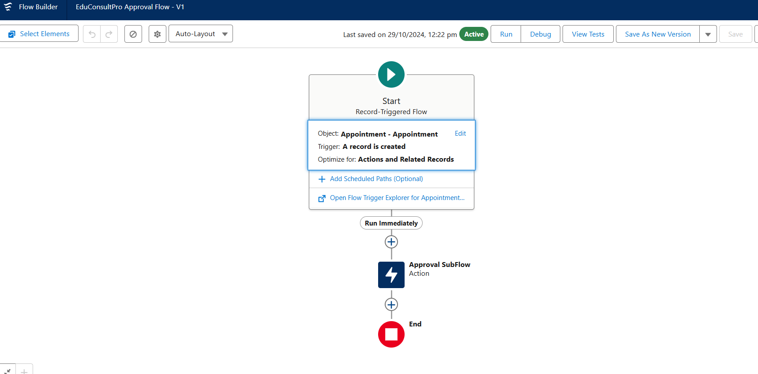

**Task 6: Create a ScreenFlow for Existing Student to Book an Appointment**

1. **Student Information Collection**:  
   Added a **Screen** element labeled **"Get Student Info"** to gather the student's name and email.
   * Inserted a **Get Records** element to fetch existing student details using the provided name and email for accurate data retrieval.
2. **Decision Routing**:  
   Included a **Decision** element to direct the flow based on the student’s request—either **"Appointment"** or **"Case"**.
   * This allows students to choose between booking an appointment or creating a case.
3. **Appointment Booking**:
   * Added a **Screen** element named **"Appointment Booking Screen"** for students selecting an appointment, which collects relevant booking details.
   * Included another **Get Records** element to retrieve **Consultant** details based on the selected consultant’s name.
   * Added a **Create Records** element to generate a new appointment record with the gathered information.
4. **Confirmation Screen**:  
   Added a **Screen** element titled **"Confirmation Screen"** to display appointment confirmation details, providing students with verification of their booking.
5. **Case Creation (Subflow)**:
   * Incorporated a **Subflow** element called **"Create Student Case"** for students who choose to initiate a case.
   * Configured the subflow to create a new case and link it to the student’s profile.
6. **Flow Finalization**:  
   Saved the flow as **"EduConsultPro Existing Student Flow"** and prepared it for deployment.

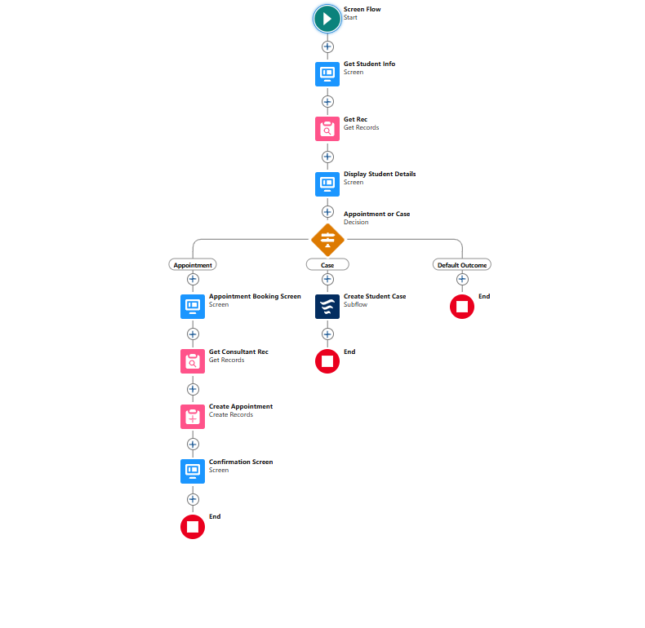

**Task 7 :Creating a Combined ScreenFlow for EduConsultPro**

1. **Welcome Screen**:
   * Created a **Screen** element labeled **"Welcome Screen"**.
   * Inside this screen, added a **Display Text** component labeled **"SuccessMessage"** to present a welcoming message that introduces EduConsultPro’s services and support for students.
2. **Existing or New Student Confirmation**:
   * Added another **Screen** element following the Welcome Screen, labeled **"Existing or New Student Confirmation Screen"**.
   * Inside this screen, added a **Radio Button** component labeled **"Are you an Existing Student?"** with two choices: **"Yes"** and **"No"** to allow students to indicate their status.
3. **Decision Element for Student Status**:
   * Added a **Decision** element named **"Decision 1"** to route the flow based on the student’s choice.
   * Set the decision criteria as follows:
     + **Outcome 1 - If Existing Student**: When the **{!Are_you_a_Existing_Student}** resource equals **"Yes"**.
     + **Outcome 2 - If New Student**: When the **{!Are_you_a_Existing_Student}** resource equals **"No"**.
4. **Subflow for Existing Students**:
   * Inserted a **Subflow** element in the **"If Existing Student"** path, selecting **"EduConsultantPro Existing Student Flow"** and labeled it as **"Existing Student Flow"**.
5. **Subflow for New Students**:
   * Inserted another **Subflow** element in the **"If New Student"** path, selecting **"EduConsultantPro Student Flow"** and labeled it as **"New Student Flow"**.
6. **Finalization**:
   * Saved the entire flow under the name **"EduConsultPro Flow"**.

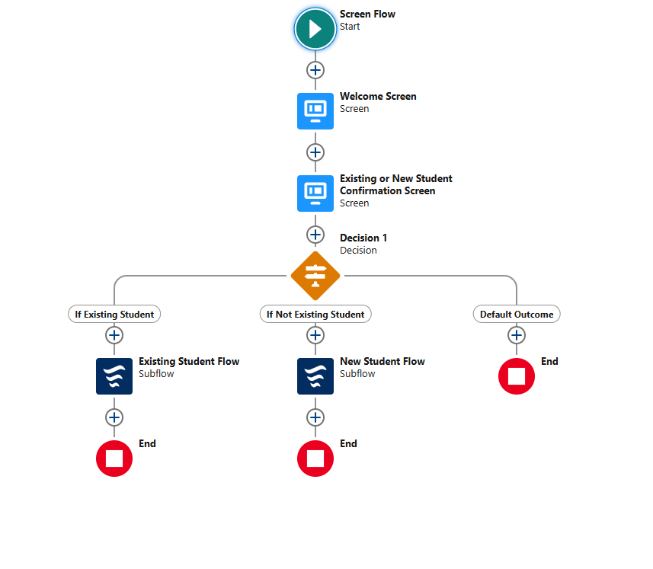

**Task 8 :Creating a Lightning App Page: EduConsultPro Home Page**

1. **Page Setup**:
   * Created a **Lightning App Page** and named it **"EduConsultPro Home Page"** using the **Standard Home Page** template.
   * This template was chosen to optimize navigation and provide easy access to the primary flow for both students and staff.
2. **Flow Component Integration**:
   * Added the **Flow** component to the **top-right region** of the page layout.
   * Configured this component to incorporate the **"EduConsultPro Flow"** created earlier, ensuring that users can initiate student processes directly from the home page.
3. **Page Activation and Assignment**:
   * Activated the page and assigned it specifically to the **Sales app** for context within the admissions workflow.
   * Assigned it to the **System Administrator** profile, enabling access for designated users responsible for managing admissions and consulting services.
4. **Finalization**:
   * Ensured the page was tested and deployed as **"EduConsultPro Home Page"** to provide a centralized, user-friendly interface for streamlined student management within Salesforce.

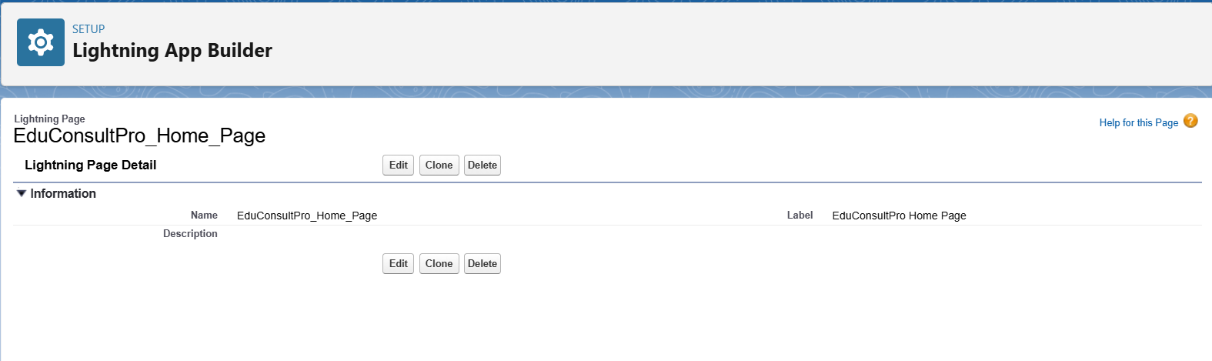

**Execution of the Application:**

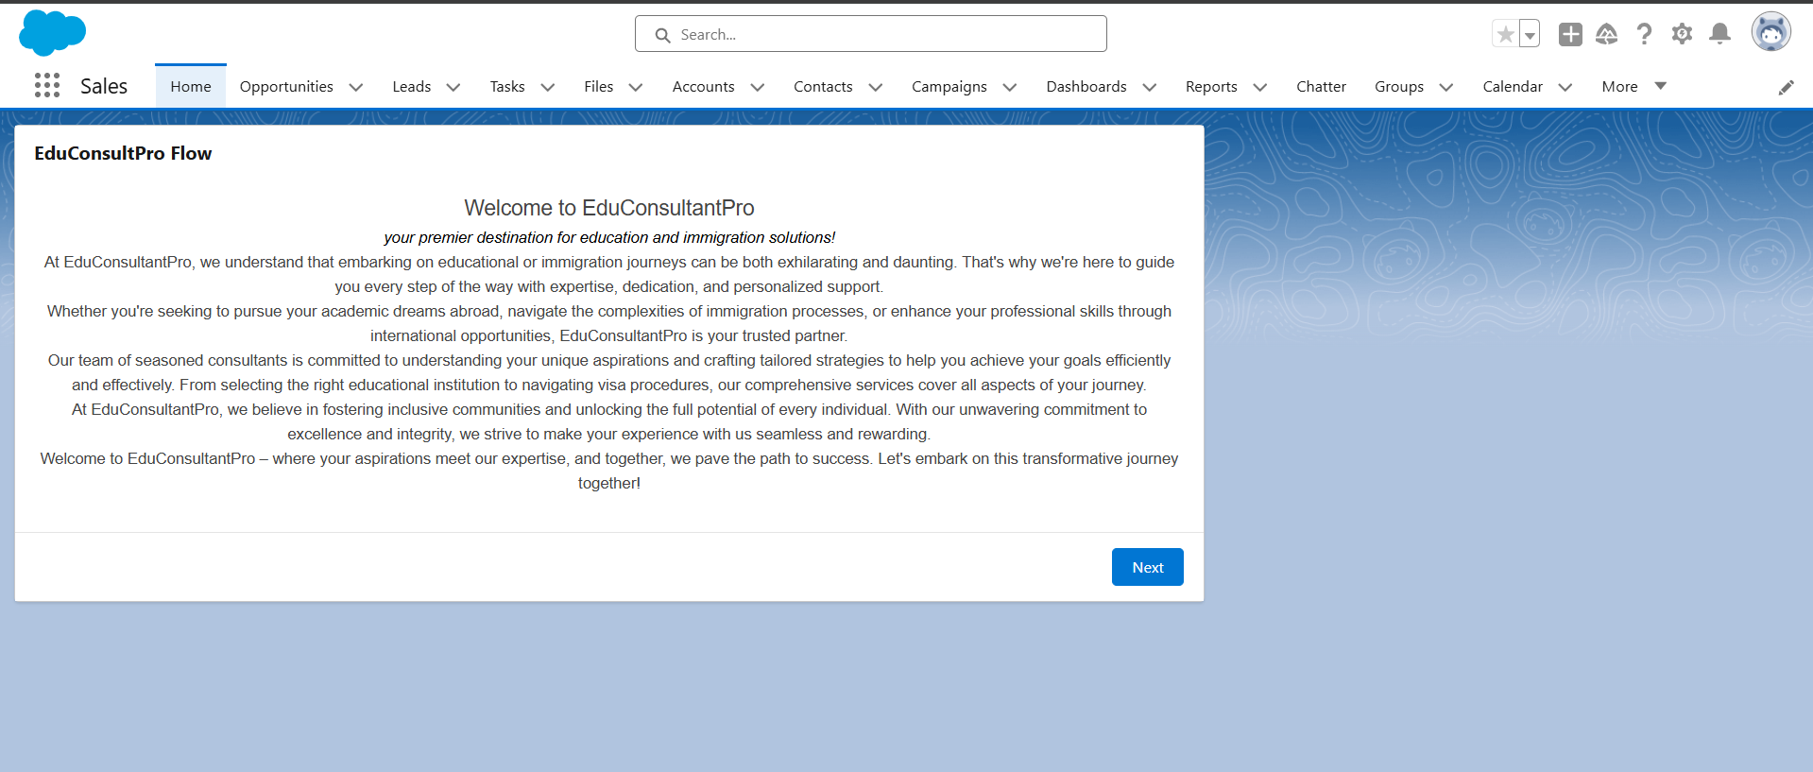

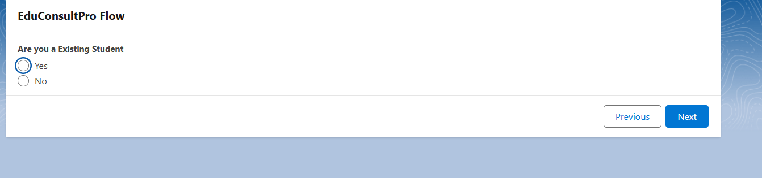

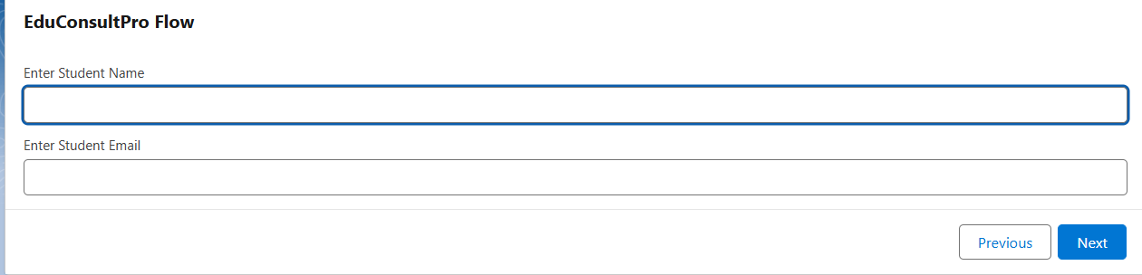

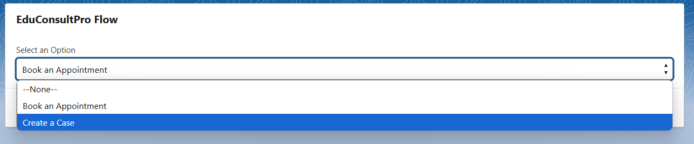

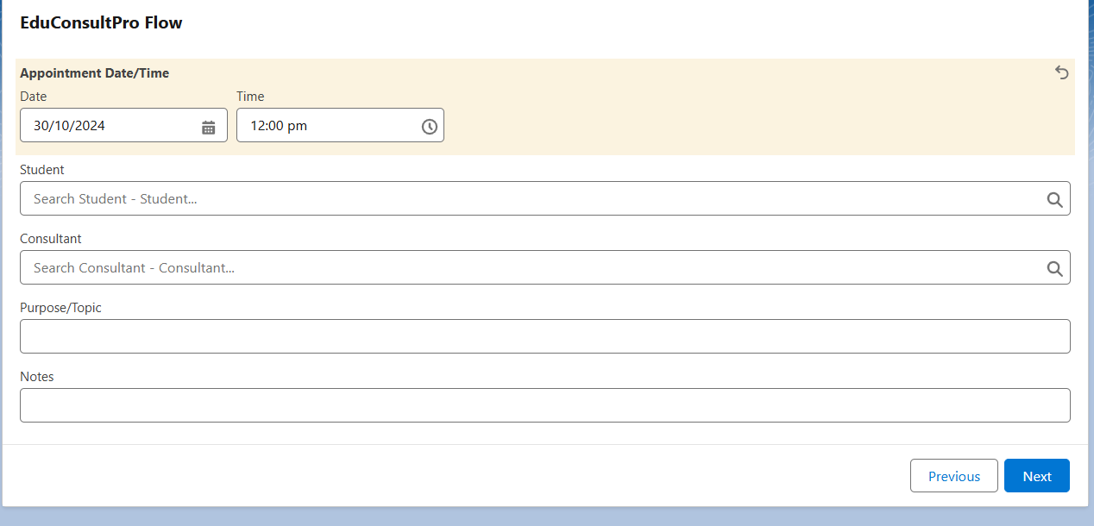

If I selected Create a Case:

