Significance and Inference

Divyang Vinubhai Hirpara

11/02/2023

*It will clear all the plots, the console and the work-space.* *It also sets the overall format for numbers.*

if(!require(HSAUR)){install.packages("HSAUR")}

## Loading required package: HSAUR

## Loading required package: tools

library("HSAUR")  
  
if(!require(pastecs)){install.packages("pastecs")}

## Loading required package: pastecs

library("pastecs")  
  
if(!require(lattice)){install.packages("lattice")}

## Loading required package: lattice

library("lattice")

## 1. Data Transformation and Preparation

### 1. Initial Transformation

##### a. Rename all variables with your initials appended.

data_DVH <- read.table("PROG8430-23W-Assign02.txt",sep=",",header = TRUE)  
head(data_DVH)

## Index Manufacturer Server Conn RC ST SMBR SMBT BR BT UC FA  
## 1 1 Lled MB5755 5571 10 253 39806 91685 11 17 2000 1526223  
## 2 2 Lled MB3406 6684 12 282 56410 115100 15 22 2000 1799882  
## 3 3 Ovonel RQ8547 4790 10 83 55891 98534 15 18 2000 1361793  
## 4 4 Lled MB3406 6163 10 247 49546 116361 14 22 2000 2365969  
## 5 5 Lled MB5755 8939 12 252 61578 104176 17 20 2000 2222282  
## 6 6 Ovonel RP6354 7446 8 263 47692 102983 13 19 2000 2006826

**Interpretation**

* The text(.txt) file shall be read with ‘read.table’ function in R.
* Text file is comma separated hence, sep=” ,” is used to identify a rows and column.
* Header=TRUE is used due to the text file is generated with header in first line.
* By default, 6 records are displayed with ‘head()’ function as shown above.
* There are total 12 columns with manufacturer and serve of Character data type, and index, conn,RC, ST, SMBR, SMBT, BR, BT, UC, FA of integer datatype.

***Rename Variables of column name***

#Append data_DVH initials to column names  
colnames(data_DVH) <- paste(colnames(data_DVH), "DVH", sep = "_")  
head(data_DVH,10)

## Index_DVH Manufacturer_DVH Server_DVH Conn_DVH RC_DVH ST_DVH SMBR_DVH  
## 1 1 Lled MB5755 5571 10 253 39806  
## 2 2 Lled MB3406 6684 12 282 56410  
## 3 3 Ovonel RQ8547 4790 10 83 55891  
## 4 4 Lled MB3406 6163 10 247 49546  
## 5 5 Lled MB5755 8939 12 252 61578  
## 6 6 Ovonel RP6354 7446 8 263 47692  
## 7 7 Ovonel RP6354 8618 13 118 50814  
## 8 8 Ovonel RP6354 7319 3 271 49125  
## 9 9 Lled MB5755 5853 7 283 62117  
## 10 10 Ovonel RL3777 7667 12 256 58279  
## SMBT_DVH BR_DVH BT_DVH UC_DVH FA_DVH  
## 1 91685 11 17 2000 1526223  
## 2 115100 15 22 2000 1799882  
## 3 98534 15 18 2000 1361793  
## 4 116361 14 22 2000 2365969  
## 5 104176 17 20 2000 2222282  
## 6 102983 13 19 2000 2006826  
## 7 102608 14 19 2000 1043945  
## 8 99735 13 19 2000 1283390  
## 9 127959 17 24 2000 1795163  
## 10 109037 16 20 2000 1121878

**Interpretation**  
Every column are replaced with initials.  
Index –> Index_DVH  
Manufacturer –> Manufacturer_DVH  
Server –> Server_DVH  
Conn –> Conn_DVH RC –> RC_DVH  
ST –> ST_DVH  
SMBR –> SMBR_DH  
SMBT –> SMBT_DH  
BR –> BR_DVH  
BT –> BT_DVH  
UC –> UC_DVH  
FA –> FA_DVH

##### b. Transform character variables to factor variables.

data_DVH$Manufacturer_DVH <- as.factor(data_DVH$Manufacturer_DVH)  
data_DVH$Server_DVH <- as.factor(data_DVH$Server_DVH)  
  
head(data_DVH,8)

## Index_DVH Manufacturer_DVH Server_DVH Conn_DVH RC_DVH ST_DVH SMBR_DVH  
## 1 1 Lled MB5755 5571 10 253 39806  
## 2 2 Lled MB3406 6684 12 282 56410  
## 3 3 Ovonel RQ8547 4790 10 83 55891  
## 4 4 Lled MB3406 6163 10 247 49546  
## 5 5 Lled MB5755 8939 12 252 61578  
## 6 6 Ovonel RP6354 7446 8 263 47692  
## 7 7 Ovonel RP6354 8618 13 118 50814  
## 8 8 Ovonel RP6354 7319 3 271 49125  
## SMBT_DVH BR_DVH BT_DVH UC_DVH FA_DVH  
## 1 91685 11 17 2000 1526223  
## 2 115100 15 22 2000 1799882  
## 3 98534 15 18 2000 1361793  
## 4 116361 14 22 2000 2365969  
## 5 104176 17 20 2000 2222282  
## 6 102983 13 19 2000 2006826  
## 7 102608 14 19 2000 1043945  
## 8 99735 13 19 2000 1283390

**Interpretation**  
Manufacture_DVH and Server_DVH are character data type. hence it is changed to factor data type by using as.factor() function.

### 2. Reduce Dimensionality

##### a. Apply the Missing Value Filter to remove appropriate columns of data.

summary(data_DVH)

## Index_DVH Manufacturer_DVH Server_DVH Conn_DVH RC_DVH   
## Min. : 1 Lled :41078 MB3406:15610 Min. : 1133 Min. :-7   
## 1st Qu.:20540 Ovonel:41078 MB5755:17663 1st Qu.: 5914 1st Qu.: 8   
## Median :41079 MG9696: 7805 Median : 6792 Median :10   
## Mean :41079 RL3777:11913 Mean : 6793 Mean :10   
## 3rd Qu.:61617 RP6354:16431 3rd Qu.: 7668 3rd Qu.:12   
## Max. :82156 RQ8547: 6162 Max. :12321 Max. :27   
## RX8838: 6572   
## ST_DVH SMBR_DVH SMBT_DVH BR_DVH   
## Min. : 9.0 Min. : 8455 Min. : 30139 Min. : 2.00   
## 1st Qu.:215.0 1st Qu.:43180 1st Qu.: 90356 1st Qu.:12.00   
## Median :242.0 Median :49952 Median : 99940 Median :14.00   
## Mean :237.4 Mean :49969 Mean : 99975 Mean :13.63   
## 3rd Qu.:264.0 3rd Qu.:56723 3rd Qu.:109513 3rd Qu.:15.00   
## Max. :433.0 Max. :93437 Max. :158247 Max. :25.00   
##   
## BT_DVH UC_DVH FA_DVH   
## Min. : 6.00 Min. :2000 Min. : 4412   
## 1st Qu.:17.00 1st Qu.:2000 1st Qu.:1399343   
## Median :19.00 Median :2000 Median :1671136   
## Mean :18.75 Mean :2000 Mean :1685073   
## 3rd Qu.:21.00 3rd Qu.:2000 3rd Qu.:1954341   
## Max. :30.00 Max. :2001 Max. :3656283   
##

**Interpretation**  
The Summary () function displays statistical information such as min, 1st Quarter, 3rd Quarter, Median, Mean, Max, and missing values.  
Looking at the above summary table of all columns, it seems there is no missing value available in any column.  
If any missing value is available in any column, it is supposed to look like this - NA’s 2. where 2 represents the number of missing values.

##### b. Apply the Low Variance Filter to remove appropriate columns of data.

stat.desc(data_DVH) #Consider coef of var

## Index_DVH Manufacturer_DVH Server_DVH Conn_DVH  
## nbr.val 82156.0000000 NA NA 82156.0000000  
## nbr.null 0.0000000 NA NA 0.0000000  
## nbr.na 0.0000000 NA NA 0.0000000  
## min 1.0000000 NA NA 1133.0000000  
## max 82156.0000000 NA NA 12321.0000000  
## range 82155.0000000 NA NA 11188.0000000  
## sum 3374845246.0000000 NA NA 558117390.0000000  
## median 41078.5000000 NA NA 6792.0000000  
## mean 41078.5000000 NA NA 6793.3856322  
## SE.mean 82.7430762 NA NA 4.5418248  
## CI.mean.0.95 162.1758387 NA NA 8.9019441  
## var 562474207.6666666 NA NA 1694728.1198515  
## std.dev 23716.5386949 NA NA 1301.8172375  
## coef.var 0.5773468 NA NA 0.1916301  
## RC_DVH ST_DVH SMBR_DVH  
## nbr.val 82156.00000000 82156.0000000 82156.0000000  
## nbr.null 3.00000000 0.0000000 0.0000000  
## nbr.na 0.00000000 0.0000000 0.0000000  
## min -7.00000000 9.0000000 8455.0000000  
## max 27.00000000 433.0000000 93437.0000000  
## range 34.00000000 424.0000000 84982.0000000  
## sum 821839.00000000 19506663.0000000 4105257983.0000000  
## median 10.00000000 242.0000000 49952.0000000  
## mean 10.00339598 237.4344296 49969.0586567  
## SE.mean 0.01106041 0.1447164 34.8499149  
## CI.mean.0.95 0.02167833 0.2836431 68.3055844  
## var 10.05036885 1720.5789760 99779823.2606699  
## std.dev 3.17023167 41.4798623 9988.9850966  
## coef.var 0.31691554 0.1747003 0.1999034  
## SMBT_DVH BR_DVH BT_DVH  
## nbr.val 82156.0000000 82156.000000000 82156.000000000  
## nbr.null 0.0000000 0.000000000 0.000000000  
## nbr.na 0.0000000 0.000000000 0.000000000  
## min 30139.0000000 2.000000000 6.000000000  
## max 158247.0000000 25.000000000 30.000000000  
## range 128108.0000000 23.000000000 24.000000000  
## sum 8213533053.0000000 1119635.000000000 1540088.000000000  
## median 99940.0000000 14.000000000 19.000000000  
## mean 99974.8411924 13.628158625 18.745898048  
## SE.mean 49.3149953 0.009557366 0.009305629  
## CI.mean.0.95 96.6570387 0.018732369 0.018238966  
## var 199800825.6032747 7.504395567 7.114276278  
## std.dev 14135.0919913 2.739415187 2.667260069  
## coef.var 0.1413865 0.201011396 0.142284998  
## UC_DVH FA_DVH  
## nbr.val 82156.00000000000 82156.0000000  
## nbr.null 0.00000000000 0.0000000  
## nbr.na 0.00000000000 0.0000000  
## min 2000.00000000000 4412.0000000  
## max 2001.00000000000 3656283.0000000  
## range 1.00000000000 3651871.0000000  
## sum 164312167.00000000000 138438884066.0000000  
## median 2000.00000000000 1671136.0000000  
## mean 2000.00203271824 1685073.3247237  
## SE.mean 0.00015713747 1452.4037204  
## CI.mean.0.95 0.00030798831 2846.7009225  
## var 0.00202861099 173306156834.8027344  
## std.dev 0.04504010426 416300.5606948  
## coef.var 0.00002252003 0.2470519

**Interpretation**  
From the above stat values, it seems UC_DVH (0.00002252) is likely very low in terms of Coef.var.

table(data_DVH$UC_DVH)

##   
## 2000 2001   
## 81989 167

**Interpretation**  
From the above output, a high number of repeating values occurred for ‘2000’, which is 81989. And, only 167 numbers appeared for ‘2001’. To conclude, it needs more balanced data for column ‘UC_DVH.’ for analysis.

##### c. Apply the High Correlation Filter to remove appropriate columns of data.

numeric_data_DVH <- data_DVH[-c(2:3)]  
head(numeric_data_DVH,3)

## Index_DVH Conn_DVH RC_DVH ST_DVH SMBR_DVH SMBT_DVH BR_DVH BT_DVH UC_DVH  
## 1 1 5571 10 253 39806 91685 11 17 2000  
## 2 2 6684 12 282 56410 115100 15 22 2000  
## 3 3 4790 10 83 55891 98534 15 18 2000  
## FA_DVH  
## 1 1526223  
## 2 1799882  
## 3 1361793

**Interpretation**  
Removed non numeric column to find high correlation of data. And, Stored numeric columns to variable ‘numeric_data_DVH’ for further analysis.

cor(numeric_data_DVH,method="spearman")

## Index_DVH Conn_DVH RC_DVH ST_DVH SMBR_DVH  
## Index_DVH 1.0000000000 0.0042298416 0.002637313 0.0039510097 -0.0072618256  
## Conn_DVH 0.0042298416 1.0000000000 0.002553713 -0.0051813266 -0.0007441048  
## RC_DVH 0.0026373131 0.0025537135 1.000000000 0.0040373249 0.0048533195  
## ST_DVH 0.0039510097 -0.0051813266 0.004037325 1.0000000000 -0.0000386051  
## SMBR_DVH -0.0072618256 -0.0007441048 0.004853319 -0.0000386051 1.0000000000  
## SMBT_DVH -0.0069800768 -0.0009864149 0.003980611 -0.0005576250 0.7476258171  
## BR_DVH -0.0079967459 -0.0005187586 0.004454767 -0.0001081305 0.9938996733  
## BT_DVH -0.0063522475 -0.0016882428 0.004523766 -0.0008330024 0.7430656692  
## UC_DVH 0.0037172910 0.0017831677 0.004990823 -0.0044092114 -0.0017005879  
## FA_DVH 0.0005723258 0.0074740748 -0.002028123 0.0025137913 0.0016462715  
## SMBT_DVH BR_DVH BT_DVH UC_DVH FA_DVH  
## Index_DVH -0.0069800768 -0.0079967459 -0.0063522475 0.0037172910 0.0005723258  
## Conn_DVH -0.0009864149 -0.0005187586 -0.0016882428 0.0017831677 0.0074740748  
## RC_DVH 0.0039806108 0.0044547674 0.0045237655 0.0049908235 -0.0020281233  
## ST_DVH -0.0005576250 -0.0001081305 -0.0008330024 -0.0044092114 0.0025137913  
## SMBR_DVH 0.7476258171 0.9938996733 0.7430656692 -0.0017005879 0.0016462715  
## SMBT_DVH 1.0000000000 0.7438861976 0.9935613424 -0.0017384137 0.0014519063  
## BR_DVH 0.7438861976 1.0000000000 0.7393055744 -0.0021123454 0.0015287512  
## BT_DVH 0.9935613424 0.7393055744 1.0000000000 -0.0012851327 0.0019115184  
## UC_DVH -0.0017384137 -0.0021123454 -0.0012851327 1.0000000000 -0.0002994613  
## FA_DVH 0.0014519063 0.0015287512 0.0019115184 -0.0002994613 1.0000000000

**Interpretation**  
With Correlation function cor(), method=“spearman” basically it refers to calculation of the Spearman’s rank correlation coefficient. It helps find the high correlation between two variable.  
From above values, there are variable with highly correlated values displayed below.  
*SMBR_DVH –> BR_DVH (0.99389967)*  
*SMBT_DVH –> BT_DVH(0.9935613)*  
*BR_DVH –> SMBR_DVH (0.99389967)*  
*BT_DVH –> SMBT_DVH(0.99356134)*

Hence, there is no need of considering all variables for analysis, it be any two need either **SMBR_DVH and SMBT_DVH** or **BR_DVH and BT_DVH**.

##### d. Drop any variables that do not contribute any useful analytical information at all.

data_DVH <- data_DVH[, !colnames(data_DVH) %in% c("UC_DVH")]  
data_DVH <- data_DVH[, !colnames(data_DVH) %in% c("BR_DVH")]  
data_DVH <- data_DVH[, !colnames(data_DVH) %in% c("BT_DVH")]  
data_DVH <- data_DVH[, !colnames(data_DVH) %in% c("Index_DVH")]  
head(data_DVH,3)

## Manufacturer_DVH Server_DVH Conn_DVH RC_DVH ST_DVH SMBR_DVH SMBT_DVH FA_DVH  
## 1 Lled MB5755 5571 10 253 39806 91685 1526223  
## 2 Lled MB3406 6684 12 282 56410 115100 1799882  
## 3 Ovonel RQ8547 4790 10 83 55891 98534 1361793

**Interpretation**  
From (b), there is low variance of UC_DVH column, which is 0.00002252. From (c), high correlation found between SMBR_DVH - BR_DVH and SMBT_DVH - BT_DVH.  
Hence, There are total 4 variables UC_DVH, BR_DVH, Index_DVH and BT_DVH are dropped as they do not contribute any useful analytical information at all.

### 3. Outliers

##### a. Use an appropriate technique demonstrated in class to identify outliers.

boxplot(data_DVH$Manufacturer_DVH, horizontal=TRUE, pch=4, col=5, border = 2, main="Box plot of Manufacturer")

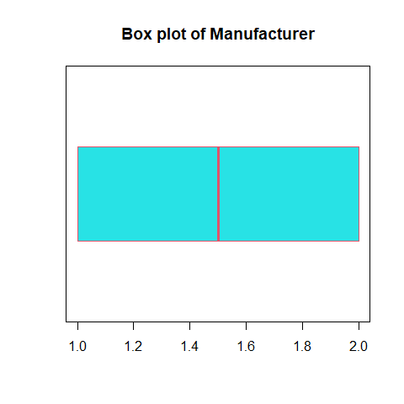

boxplot(data_DVH$Server_DVH, horizontal=TRUE, pch=4,col=5, border = 2, main="Box plot of Server Model")

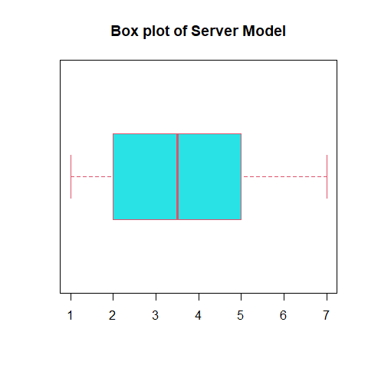

boxplot(data_DVH$Conn_DVH, horizontal=TRUE, pch=4,col=5, border = 2, main="Box plot of No of connection made")

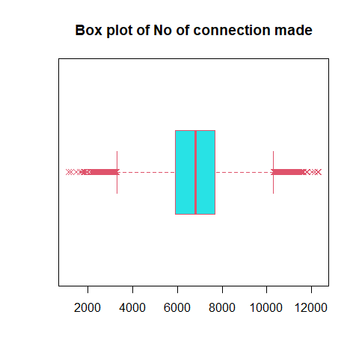

boxplot(data_DVH$RC_DVH, horizontal=TRUE, pch=4,col=5, border = 2, main="Box plot of Reconnection made")

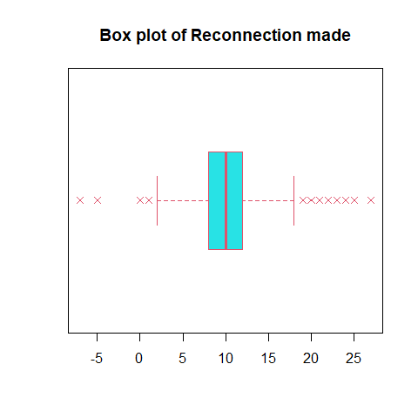

boxplot(data_DVH$ST_DVH, horizontal=TRUE, pch=4,col=5, border = 2, main="Box plot of session time out")

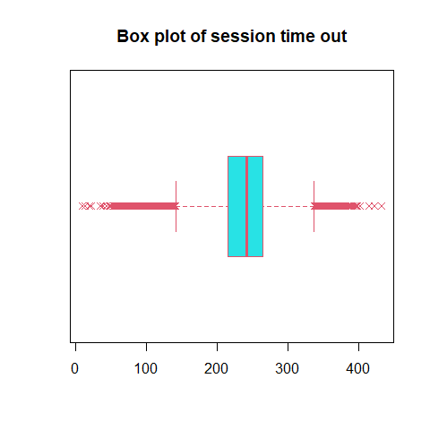

boxplot(data_DVH$SMBR_DVH, horizontal=TRUE, pch=4,col=5, border = 2, main="Box plot of server message block received")

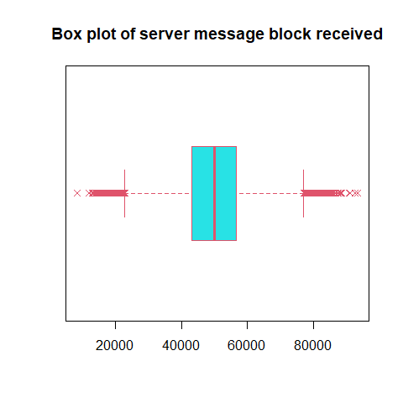

boxplot(data_DVH$SMBT_DVH, horizontal=TRUE, pch=4,col=5, border = 2, main="Box plot of server message block transmitted")

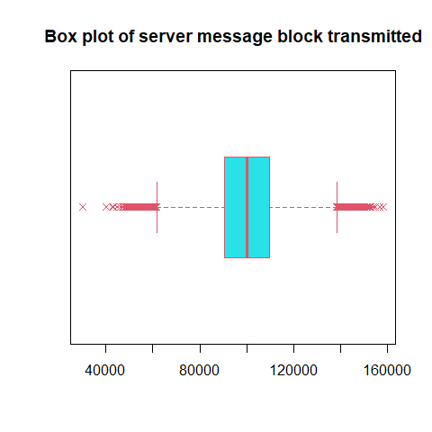

boxplot(data_DVH$FA_DVH, horizontal=TRUE, pch=4,col=5, border = 2, main="Box plot of Files Accessed")

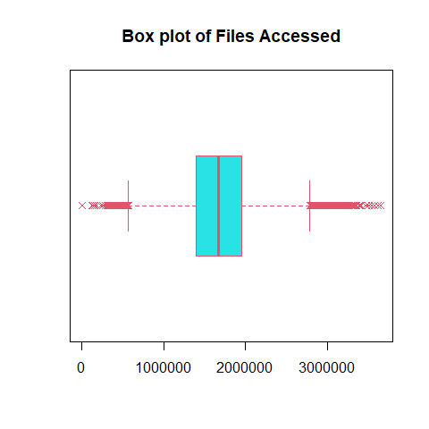

**Interpretation**  
To find a outliers from data, there are different techniques used. Here box plot is displayed for all variables.  
By focusing more on numeric variables from box plot, each variable has outliers present in data.  
Re-connection made and server message block transmitted have some outliers which are more separated from other outliers as seen in box plot. Let’s dig deeper on outliers with density plot.

densityplot( ~ data_DVH$Conn_DVH, pch=8,main="density plot of Connection Made",xlab="Connection Made")

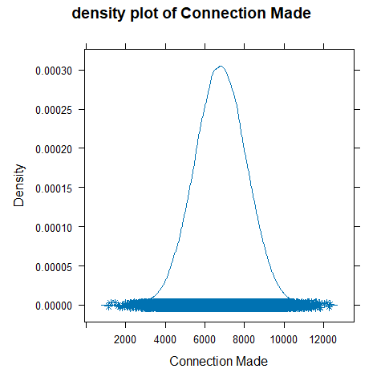

densityplot( ~ data_DVH$RC_DVH, pch=8,main="density plot of Reconnection Made",xlab="Reconnection Made")

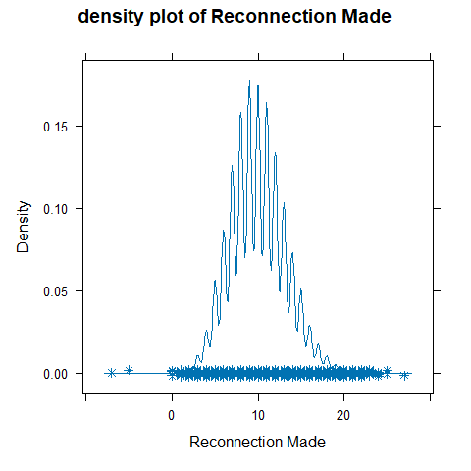

densityplot( ~ data_DVH$ST_DVH, pch=8,main="density plot of session time out",xlab="session time out")

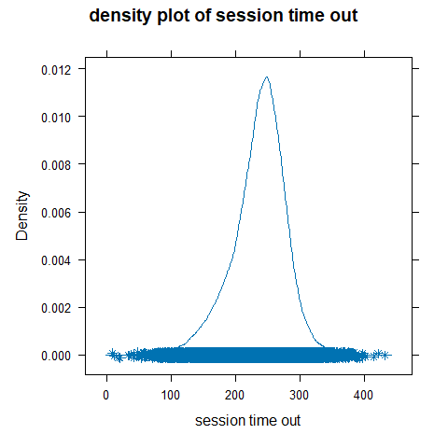

densityplot( ~ data_DVH$SMBR_DVH, pch=8,main="density plot of server message block received",xlab="server message block received")

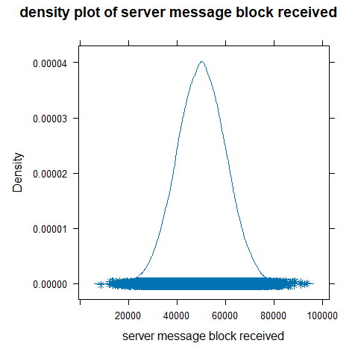

densityplot( ~ data_DVH$SMBT_DVH, pch=8,main="density plot of server message block transmitted",xlab="server message block transmitted")

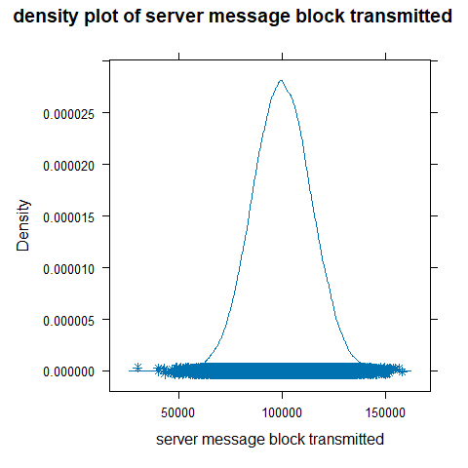

densityplot( ~ data_DVH$FA_DVH, pch=8,main="density plot of Files Accessed",xlab="Files Accessed")

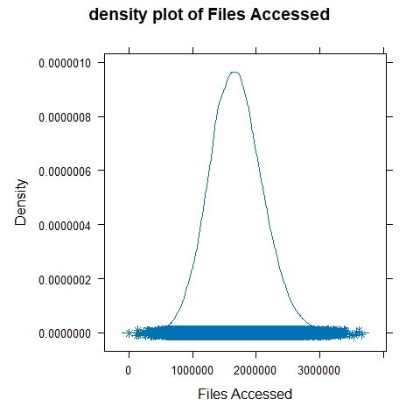

**Interpretation**  
From the above density plot, Reconnection Made has two outliers which is way far from cluster.  
To visualize of Reconnection Made with other variables on outliers, there are scatter plot displayed below.

##### b. Comment on any outliers you see and deal with them appropriately. Make sure you explain why you dealt with them the way you decided to.

plot(data_DVH$RC_DVH,data_DVH$Conn_DVH, main='Hunting Hiding outliers',pch=20,xlab = "Reconnection Made",ylab = "Connection Made",col=4)

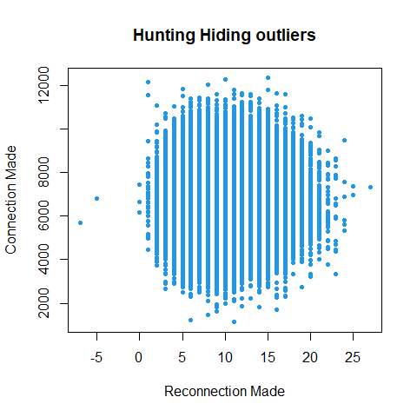

plot(data_DVH$RC_DVH,data_DVH$ST_DVH, main='Hunting Hiding outliers',pch=20,xlab = "Reconnection Made",ylab = "Sessions Timed-Out",col=4)

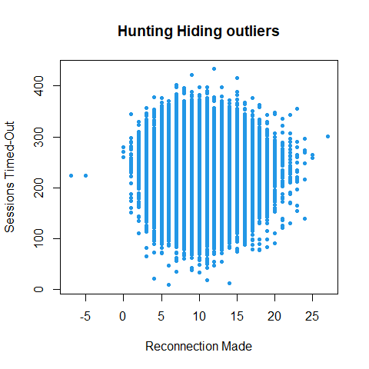

plot(data_DVH$RC_DVH,data_DVH$SMBR_DVH, main='Hunting Hiding outliers',pch=20,xlab = "Reconnection Made",ylab = "Server Message Blocks Received",col=4)

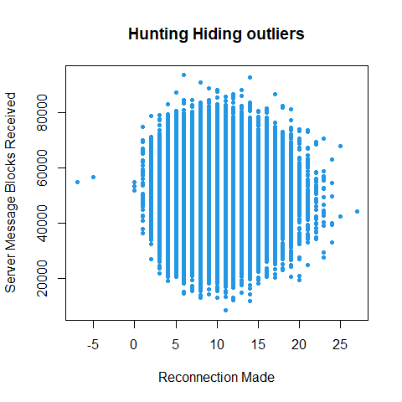

plot(data_DVH$RC_DVH,data_DVH$SMBT_DVH, main='Hunting Hiding outliers',pch=20,xlab = "Reconnection Made",ylab = "Server Message Blocks Transmitted",col=4)

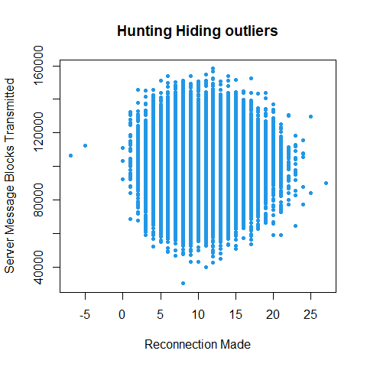

plot(data_DVH$RC_DVH,data_DVH$FA_DVH, main='Hunting Hiding outliers',pch=20,xlab = "Reconnection Made",ylab = "Files Accessed",col=4)

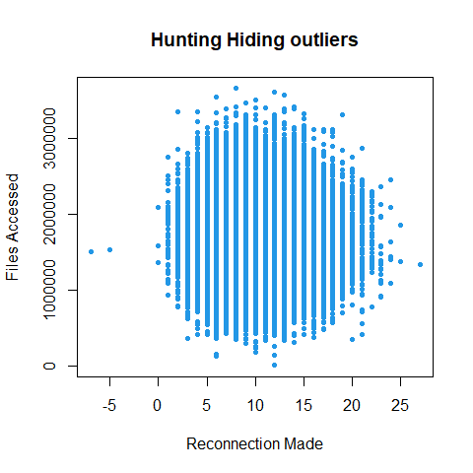

**Interpretation**  
From the above scatter plot, it is clearly seen that Reconnection made has two outliers which is lower than ~ 0 and get separated from cluster.  
As it is only two data and add no value for analysis, it is good decision to remove them from dataset.

nr <- which(data_DVH$RC_DVH < 0) #Find row number with RC_DVH < 0  
data_DVH <- data_DVH[-c(nr),]  
densityplot( ~ data_DVH$RC_DVH, pch=8,main="density plot of Reconnection Made",xlab="Reconnection Made")

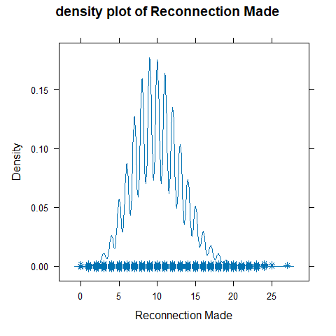

**Interpretation**  
Above code filter data which are lower than ~ -5 as and remove filtered value from original dataset.  
Above density plot is evidence that two outliers are successfully removed from dataset.

## 2. Organizing Data

### 1. Scatter Plots

##### a. Create a histogram for Server Message Blocks Received.

hist(data_DVH$SMBR_DVH,  
 col=2,  
 border = 1,  
 main="Histogram of Server Message Blocks Received",  
 xlab = "SMBR",  
 breaks = 10  
 )

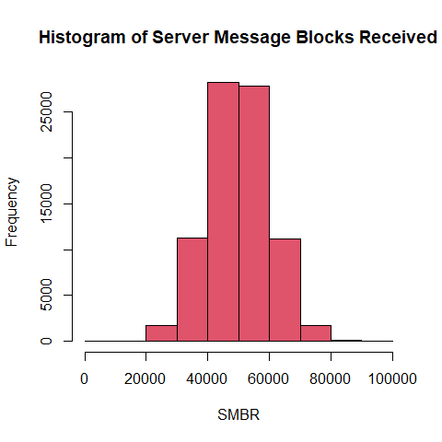

##### b. Create a histogram for Server Message Blocks Transmitted.

hist(data_DVH$SMBT_DVH,  
 col=2,  
 border = 1,  
 main="Histogram of Server Message Blocks Transmitted",  
 xlab = "SMBT",  
 breaks = 10  
 )

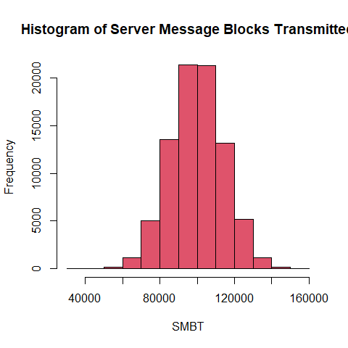

##### c. Create a scatter plot showing the relationship between SMBR and SMBT. (note: SMBR should be on the x-axis, SMBT should be the y-axis).

plot(data_DVH$SMBR_DVH,data_DVH$SMBT_DVH,  
 pch=9,  
 xlab = "Server Message Blocks Received",  
 ylab = "Server Message Blocks transmitted",  
 col=6  
 )

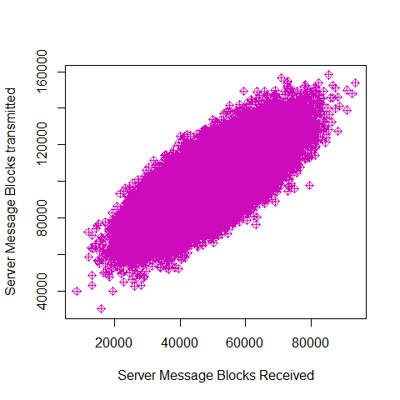

##### d. What conclusions, if any, can you draw from the chart?

**Ans.**  
The histograms will show the frequency distribution of the Server Message Blocks Received and Server Message Blocks Transmitted variables, respectively. The scatter plot will show the relationship between the two variables, and any outliers will be visible.  
From scatter plot, it is clear that data trend is increasing in positive direction.

##### e. Calculate a correlation coefficient between these two variables. Why did you choose the correlation coefficient you did? What conclusion you draw from it?

round(cor(data_DVH$SMBR_DVH,data_DVH$SMBT_DVH),3)

## [1] 0.763

**Interpretation**  
Reason for choosing coefficient is to measures the linear relationship between two variables.  
To Conclude, correlation coefficient is 0.763, it means that there is a strong positive linear relationship between the server message block received and server message block transmitted.

## 3. Inference

### 1. Normality

##### a. Create a QQ Normal plot of for Sessions Timed Out.

qqnorm(data_DVH$ST_DVH, main="Is Session Time Out good?", pch=20)  
qqline(data_DVH$ST_DVH)

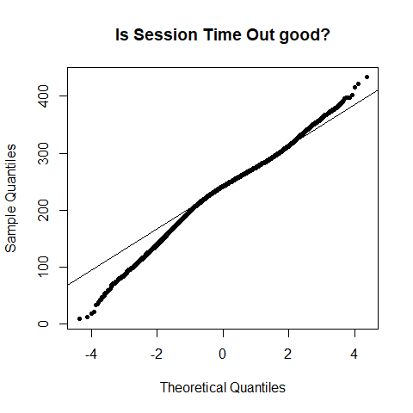

##### b. Conduct a statistical test for normality on Sessions Timed Out.

sample_ST_DVH <- sample(data_DVH$ST_DVH,5000)  
shapiro.test(sample_ST_DVH)

##   
## Shapiro-Wilk normality test  
##   
## data: sample_ST_DVH  
## W = 0.97901, p-value < 2.2e-16

##### c. Is Sessions Times Out normally distributed? What led you to this conclusion?

**Ans.**  
Session Times out is not normally distributed. Because, the QQ Normal plot for Sessions Timed Out shows that the data is not quite normally distributed. There is some deviation from the diagonal line in both tails of the plot, indicating that the data may be skewed.  
A Shapiro-Wilk test for normality was also conducted. The null hypothesis is that the data is normally distributed, and the alternative hypothesis is that the data is not normally distributed. The p-value for the test was less than 0.05, which means that we can reject the null hypothesis and conclude that the data is not normally distributed.

### 2. Statistically Significant Differences

##### a. Compare Sessions Times Out between the two major Manufacturers in your dataset using a suitable hypothesis test.

manufacturer_Lled_DVH <- data_DVH$ST_DVH[data_DVH$Manufacturer_DVH == "Lled"]  
manufacturer_Ovonel_DVH <- data_DVH$ST_DVH[data_DVH$Manufacturer_DVH == "Ovonel"]  
  
  
var.test(manufacturer_Lled_DVH, manufacturer_Ovonel_DVH)

##   
## F test to compare two variances  
##   
## data: manufacturer_Lled_DVH and manufacturer_Ovonel_DVH  
## F = 0.24907, num df = 41076, denom df = 41076, p-value < 2.2e-16  
## alternative hypothesis: true ratio of variances is not equal to 1  
## 95 percent confidence interval:  
## 0.2443023 0.2539378  
## sample estimates:  
## ratio of variances   
## 0.2490734

wilcox.test(ST_DVH ~ Manufacturer_DVH,data=data_DVH ,var.equal = FALSE)

##   
## Wilcoxon rank sum test with continuity correction  
##   
## data: ST_DVH by Manufacturer_DVH  
## W = 1139390793, p-value < 2.2e-16  
## alternative hypothesis: true location shift is not equal to 0

##### b. Explain why you chose the test you did.

**Ans.**  
T-test can not be applied as variance is not close to 1.

##### b. Do you have strong evidence that Sessions Times Out are different between Manufacturers

boxplot( ST_DVH ~ Manufacturer_DVH,  
data=data_DVH,  
main="Sessions Times Out by Manufacturers")

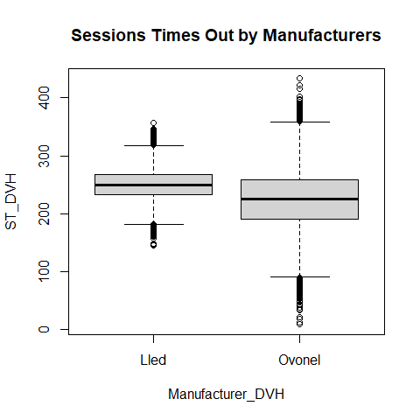

**Ans.**  
Since Wilcoxon Test resulted to p-value < 2.2e-16. Null Hypothesis can be rejected and we have strong evidence to go with Alternate Hypothesis. Therefore, Sessions Times Out are different between Manufacturers.

### 3. Multiple Statistical Differences

##### a. Determine if Files Accessed varies by Server using ANOVA (statistical) and a sequence of boxplots (graphical).

# One Way ANOVA  
summary(aov(FA_DVH~Server_DVH, data=data_DVH))

## Df Sum Sq Mean Sq F value Pr(>F)   
## Server_DVH 6 1877294907018140 312882484503023 2079 <2e-16 ***  
## Residuals 82147 12360616982600226 150469487414   
## ---  
## Signif. codes: 0 '***' 0.001 '**' 0.01 '*' 0.05 '.' 0.1 ' ' 1

**Interpretation**  
Based on the ANOVA output, there is strong evidence to suggest that the mean number of Files Accessed varies by Server, with a very low p-value of less than 0.001. The F-value of 2079 also indicates a large difference in means between the groups, which reinforces the statistical significance of the result.  
These results suggest that there is a statistically significant difference in the number of Files Accessed across different servers, and further investigation may be warranted to explore the nature of this difference.

#Comparing Files by server  
  
boxplot(FA_DVH~Server_DVH, data=data_DVH,  
 main="File Accessed by Server",  
 xlab="Server",  
 ylab ="No of Files",  
 range=0)

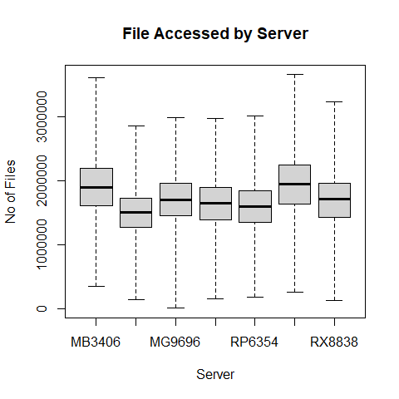

**Interpretation**  
The boxplot show the distribution of Files Accessed for each Server. There is a significant difference between the means of the groups, as we are able to see it in the above boxplot.

##### b. Determine if Connections Made varies by Server using ANOVA and a sequence of boxplots.

# One Way ANOVA  
summary(aov(Conn_DVH~Server_DVH, data=data_DVH))

## Df Sum Sq Mean Sq F value Pr(>F)  
## Server_DVH 6 6715799 1119300 0.66 0.682  
## Residuals 82147 139222450571 1694797

**Interpretation**  
The output shows the results of an ANOVA test for the variable “Connections Made” across different servers. The null hypothesis in this test is that there is no significant difference in the mean number of connections made across the different servers.  
Based on the output provided, the p-value for the F-test is 0.682, which is greater than the significance level of 0.05. Therefore, we fail to reject the null hypothesis, and there is not enough evidence to suggest that the mean number of connections made varies significantly across the different servers.

#Comparing Files by server  
  
boxplot(Conn_DVH~Server_DVH, data=data_DVH,  
 main="Connection Made by Server",  
 xlab="Server",  
 ylab ="Connection Made",  
 range=0)

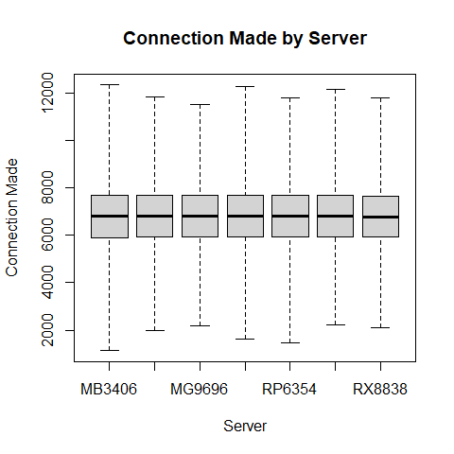

**Interpretation**  
The boxplot show the distribution of Connection made for each Server. There is no such significant difference between the means of the groups, as we are able to see it in the above boxplot.