MINI PROJECT REPORT
STUDENT STRESS ANALYZER & COPING ADVISOR
(Unit 4: Stress and Coping Strategies)
A report submitted in partial fulfillment of the requirements for the Award of Degree of
BACHELOR OF TECHNOLOGY
in
COMPUTER SCIENCE AND ENGINEERING
by
[Your Name]
Roll No.: [Your Roll Number]
Under Supervision of
Mr. A. Kathiresan

DEPARTMENT OF COMPUTER SCIENCE AND ENGINEERING
SRM INSTITUTE OF SCIENCE AND TECHNOLOGY
NCR Campus Delhi, Meerut Road, ModiNagar, Uttar Pradesh 201204

DEPARTMENT OF COMPUTER SCIENCE AND ENGINEERING
SRM INSTITUTE OF SCIENCE AND TECHNOLOGY
NCR Campus Delhi, Meerut Road, ModiNagar, Uttar Pradesh 201204
CERTIFICATE
This is to certify that the "mini project report" titled "Student Stress Analyzer & Coping Advisor" submitted by [Your Name] (Roll No.: [Your Roll Number]) is work done by her/him and submitted during 2026 – 2027 academic year, in partial fulfillment of the requirements for the award of the degree of BACHELOR OF TECHNOLOGY in COMPUTER SCIENCE AND ENGINEERING.

Mr. A. Kathiresan
Supervisor

ACKNOWLEDGEMENT
I express my sincere gratitude to my supervisor, Mr. A. Kathiresan, for his valuable guidance, encouragement and support throughout this mini project. The lessons on stress, emotional intelligence and coping strategies in the course Understanding Self for Effectiveness and Personality Development inspired the topic of this project.
I also thank the Department of Computer Science and Engineering, SRM Institute of Science and Technology, NCR Campus, my friends and my family for their constant support while I completed this work.

[Your Name]
ABSTRACT
Stress is a part of every student's life. Exams, assignments, career worries and social pressure can affect health, concentration and relationships when stress is not managed properly. This mini project presents the Student Stress Analyzer and Coping Advisor, a Python program that measures a student's perceived stress using the standard Perceived Stress Scale (PSS-10) questionnaire.
The program takes ten answers on a 0 to 4 scale, applies reverse scoring to four positively worded items, calculates a total score between 0 and 40, and classifies the result as Low, Moderate or High stress. It then shows the matching stage of Selye's General Adaptation Syndrome, suggests personalised stress management techniques and draws a dashboard chart that compares the student with a group. The project connects the theory of Unit 4 (concepts, stages, causes, symptoms and management of stress) with a practical tool.
Keywords: stress, PSS-10, coping strategies, stress management, Python, self-awareness.
INDEX
S.no | CONTENTS | Page no
1 | INTRODUCTION | 6
2 | SYSTEM ANALYSIS | 7
3 | SOFTWARE REQUIREMENTS SPECIFICATIONS | 10
4 | TECHNOLOGY | 11
5 | SCREENSHOTS | 15
6 | CONCLUSION | 17
7 | BIBLIOGRAPHY | 18
8 | WEBLINKS | 19

1. INTRODUCTION

1.1 What is stress?
Stress is the body's and mind's response to any demand or pressure that is felt to be greater than the resources available to deal with it. A small amount of stress (eustress) can motivate a student to study and perform better. Too much stress (distress) over a long period harms physical health, emotions and performance.

1.2 Need for the project
Most students notice stress only when it becomes serious. A simple self-assessment tool increases self-awareness, which is the first step of personality development. If a student knows the level of stress early, suitable coping strategies can be applied before the problem grows.

1.3 Problem statement
To design a simple, reliable and easy-to-use computer program that measures the perceived stress level of a student, classifies it, and recommends suitable coping strategies.

1.4 Objectives
- To understand the concepts, causes, symptoms and stages of stress.
- To measure perceived stress using the standard PSS-10 questionnaire.
- To classify stress as Low, Moderate or High using a scoring formula.
- To suggest stress management strategies according to the stress level.
- To present the result visually through charts.

1.5 Scope and limitations
The tool is meant for self-awareness and learning purposes. It is not a medical diagnosis. Students with high scores or with problems that affect daily life should consult a counsellor or doctor. The group data used in the charts is simulated (randomly generated) to demonstrate the analysis and does not belong to real people.

2. SYSTEM ANALYSIS

2.1 Existing system
At present, students usually judge their stress only by feeling, or fill paper questionnaires that must be checked and calculated by hand. This takes time, can give calculation mistakes (especially with reverse-scored questions), gives no immediate advice and cannot be compared with a group easily.

2.2 Proposed system
The proposed system is a Python program that automates the whole process: it asks the questions, validates the answers, applies the formulas, classifies the result, gives coping strategies and draws charts in a few seconds. It is free, simple and works on any computer.

2.3 Feasibility study
Type | Analysis
Technical | Uses only Python and matplotlib, which are free and easy to install.
Economic | No cost; no special hardware or paid software is needed.
Operational | Simple text input; any student can use it without training.

2.4 Theoretical background (Unit 4)
This project is based on Unit 4: Stress and Coping Strategies of the syllabus, and also uses ideas from Unit 1 (self-awareness, emotional competence) and Unit 3 (life skills and resilience).
Stages of stress: General Adaptation Syndrome (Hans Selye)
Stage | What happens | Example for a student
1. Alarm | Body reacts to the stressor (fight or flight); heart rate and adrenaline rise. | Hearing that a surprise test is tomorrow.
2. Resistance | Body tries to adapt and cope; stress continues at a managed level. | Studying late nights for a week of exams.
3. Exhaustion | Resources run out; health and performance suffer. | Constant tiredness, illness and loss of interest.

Causes of stress
- Academic: exams, marks, heavy syllabus, deadlines, fear of failure.
- Personal: relationship problems, low self-esteem, health issues, poor sleep.
- Social and family: peer pressure, family expectations, conflicts, loneliness.
- Environmental and financial: noise, hostel life, lack of money, uncertain career.
Symptoms of stress
Type | Symptoms
Physical | Headache, tiredness, muscle tension, poor sleep, change in appetite.
Emotional | Anxiety, irritability, sadness, mood swings, feeling overwhelmed.
Behavioural | Procrastination, avoiding people, overeating, excessive screen time.
Cognitive | Poor concentration, forgetfulness, negative thinking, indecision.

Models of stress
- Stimulus model: stress is an external event or situation (for example an exam).
- Response model (Selye): stress is the body's reaction, described by the GAS.
- Transactional model (Lazarus and Folkman): stress depends on how a person appraises the situation and whether they believe they can cope with it. The PSS-10 follows this idea.
Strategies of stress management
- Time management and planning, breaking big tasks into small steps.
- Relaxation: deep breathing, meditation, yoga, progressive muscle relaxation.
- Healthy lifestyle: regular exercise, balanced diet, 7-8 hours of sleep.
- Positive thinking and optimism; reframing negative thoughts.
- Social support: talking to friends, family, mentors and counsellors.
- Building resilience and emotional intelligence (Units 1 and 3).

2.5 Methodology and formulas
The Perceived Stress Scale (Cohen, Kamarck and Mermelstein, 1983) has 10 questions about the last month. Each answer is scored from 0 (Never) to 4 (Very often). Questions 4, 5, 7 and 8 are positively worded (for example, 'felt confident about your ability to handle problems'), so a high answer means low stress and they are reverse scored.
Reverse scoring of positive items (Q4, Q5, Q7, Q8):
Adjusted score = 4 - X
Total PSS-10 score, where x_i is the adjusted score of question i:
PSS = Σ (i = 1 to 10) x_i (range 0 to 40)
Stress Index in percentage:
Stress Index (%) = ( PSS / 40 ) × 100
For group analysis, the mean, standard deviation and category percentage are calculated:
Mean μ = ( Σ scores ) / n
Standard Deviation s = √ [ Σ ( score - μ )² / ( n - 1 ) ]
Category share (%) = ( students in category / n ) × 100
Classification table
PSS score | Category | GAS stage (simplified)
0 to 13 | Low Stress | Normal / Alarm (manageable)
14 to 26 | Moderate Stress | Resistance (coping under strain)
27 to 40 | High Stress | Exhaustion risk (prolonged stress)

Worked example
Answers given by the student (Q1 to Q10): 2, 2, 3, 2, 2, 3, 2, 2, 2, 3. Reverse items: Q4 = 4 - 2 = 2, Q5 = 4 - 2 = 2, Q7 = 4 - 2 = 2, Q8 = 4 - 2 = 2.
PSS = 2+2+3+2+2+3+2+2+2+3 = 23
Stress Index = (23 / 40) × 100 = 57.5 %
Since 14 ≤ 23 ≤ 26, the category is Moderate Stress.

2.6 System design
Function | Purpose
ask_questions() | Takes and validates the 10 answers from the user.
score_pss() | Applies reverse scoring and returns the total score.
categorize(), stress_index() | Gives the stress category and percentage.
gas_stage() | Maps the score to Selye's stage.
ADVICE dictionary | Stores coping strategies for each category.
class_statistics() | Calculates mean, standard deviation, median, min and max.
simulate_students() | Generates sample group data for comparison.
make_dashboard() | Draws the three-part chart and saves it as an image.

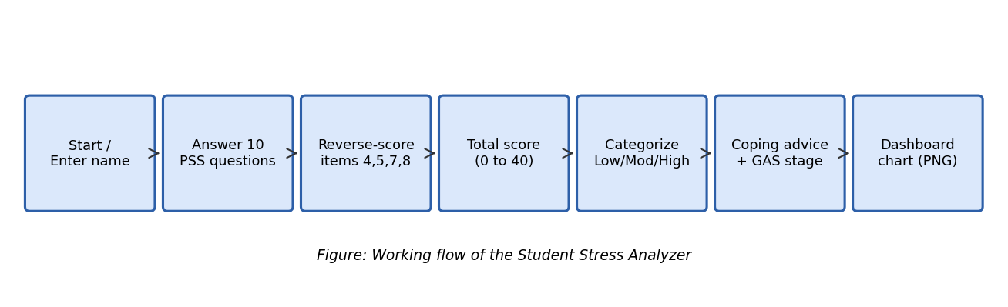
Figure 2.1: Flowchart of the project

3. SOFTWARE REQUIREMENTS SPECIFICATIONS

3.1 Purpose
This section lists what the software must do and the hardware and software needed to run it.

3.2 Hardware requirements
Component | Requirement
Processor | Any dual-core processor (1 GHz or higher)
RAM | 2 GB or more
Storage | 100 MB free space
Input / Output | Keyboard and monitor

3.3 Software requirements
Software | Requirement
Operating system | Windows 10/11, Linux or macOS
Language | Python 3.8 or higher
Library | matplotlib (for charts)
Editor (optional) | VS Code, IDLE or PyCharm

3.4 Functional requirements
- FR1: The system shall ask the user for a name and ten questionnaire answers.
- FR2: The system shall accept only whole numbers from 0 to 4 and ask again for invalid input.
- FR3: The system shall calculate the PSS-10 score using reverse scoring.
- FR4: The system shall display the stress index, category and GAS stage.
- FR5: The system shall recommend coping strategies for the category.
- FR6: The system shall calculate group statistics and save a dashboard image.

3.5 Non-functional requirements
- Usability: simple text interface with clear instructions.
- Accuracy: scoring follows the standard PSS-10 method and is checked by test cases.
- Performance: the result is displayed in less than one second.
- Portability: runs on any operating system that supports Python.
- Privacy: no personal data is stored or sent anywhere.

4. TECHNOLOGY

4.1 Technologies used
Technology | Use in this project
Python | Main programming language; easy to read and has a rich library support.
matplotlib | Draws the bar, histogram and pie charts and saves the dashboard image.
statistics module | Calculates mean, median and standard deviation.
random module | Generates simulated group scores (fixed seed for repeatable results).

4.2 Source code (stress_analyzer.py)
"""
Student Stress Analyzer & Coping Advisor
Mini Project - Unit 4: Stress and Coping Strategies
Based on the Perceived Stress Scale (PSS-10, Cohen et al., 1983)
"""
import random
import statistics
import matplotlib
matplotlib.use("Agg")
import matplotlib.pyplot as plt

# ---------------------------------------------------------------- DATA
QUESTIONS = [
"Been upset because of something that happened unexpectedly?",
"Felt unable to control the important things in your life?",
"Felt nervous and stressed?",
"Felt confident about your ability to handle personal problems?", # reverse
"Felt that things were going your way?", # reverse
"Found that you could not cope with all the things you had to do?",
"Been able to control irritations in your life?", # reverse
"Felt that you were on top of things?", # reverse
"Been angered because of things outside your control?",
"Felt difficulties were piling up so high you could not overcome them?",
]
REVERSE_ITEMS = {3, 4, 6, 7} # zero-based index of Q4, Q5, Q7, Q8
SCALE = "0=Never 1=Almost never 2=Sometimes 3=Fairly often 4=Very often"

CATEGORIES = [(13, "Low Stress"), (26, "Moderate Stress"), (40, "High Stress")]

ADVICE = {
"Low Stress": [
"Keep your routine: sleep 7-8 hours and exercise regularly.",
"Practise gratitude journaling to maintain optimism.",
"Use free time for hobbies and social activities.",
],
"Moderate Stress": [
"Use time management: make a daily to-do list with priorities.",
"Practise deep breathing or progressive muscle relaxation daily.",
"Talk to a friend, mentor or family member about your worries.",
"Take short breaks (5 min every 45 min of study).",
],
"High Stress": [
"Meet a college counsellor or doctor - seeking help is a strength.",
"Practise meditation / yoga for 15-20 minutes every day.",
"Break big tasks into small steps; avoid multitasking.",
"Limit caffeine and screen time; protect your sleep.",
"Build a support network and avoid isolating yourself.",
],
}

# ------------------------------------------------------------- FUNCTIONS
def score_pss(answers):
"""Total PSS-10 score. Reverse items use (4 - x)."""
if len(answers) != 10 or any(a not in range(5) for a in answers):
raise ValueError("Need 10 answers, each between 0 and 4")
return sum(4 - a if i in REVERSE_ITEMS else a for i, a in enumerate(answers))

def categorize(score):
for limit, name in CATEGORIES:
if score <= limit:
return name

def stress_index(score):
"""Stress Index (%) = score / 40 * 100"""
return round(score / 40 * 100, 1)

def gas_stage(score):
"""Map score to Selye's General Adaptation Syndrome stage (simplified)."""
if score <= 13:
return "Normal / Alarm (short-term, manageable)"
if score <= 26:
return "Resistance (body is coping but under strain)"
return "Exhaustion risk (prolonged stress)"

def class_statistics(scores):
mean = statistics.mean(scores)
sd = statistics.stdev(scores)
return {"n": len(scores), "mean": round(mean, 2), "sd": round(sd, 2),
"median": statistics.median(scores), "min": min(scores), "max": max(scores)}

def simulate_students(n=40, seed=7):
"""Simulated dataset (NOT real people) to demonstrate group analysis."""
random.seed(seed)
return [max(0, min(40, round(random.gauss(19, 7)))) for _ in range(n)]

# ------------------------------------------------------------- INTERFACE
def ask_questions():
print("\n" + SCALE)
answers = []
for i, q in enumerate(QUESTIONS, 1):
while True:
try:
a = int(input(f"Q{i}. In the last month, how often have you {q[0].lower()+q[1:]} "))
if a in range(5):
answers.append(a); break
except ValueError:
pass
print(" Please enter a number from 0 to 4.")
return answers

def print_report(name, answers):
s = score_pss(answers)
cat = categorize(s)
print("\n" + "=" * 56)
print(f" STRESS REPORT FOR: {name}")
print("=" * 56)
print(f" PSS-10 Score : {s} / 40")
print(f" Stress Index : {stress_index(s)} %")
print(f" Category : {cat}")
print(f" GAS Stage : {gas_stage(s)}")
print(" Recommended coping strategies:")
for tip in ADVICE[cat]:
print(" -", tip)
print("=" * 56)
return s, cat

def make_dashboard(student_score, scores, filename="dashboard.png"):
colors = {"Low Stress": "#4caf7d", "Moderate Stress": "#f2b134", "High Stress": "#e4572e"}
fig, ax = plt.subplots(1, 3, figsize=(15, 4.6))

# 1. Gauge-style bar for the student
cat = categorize(student_score)
ax[0].barh(["Low", "Moderate", "High"], [13, 13, 14], left=[0, 14, 27],
color=[colors["Low Stress"], colors["Moderate Stress"], colors["High Stress"]], alpha=.45)
ax[0].axvline(student_score, color="black", lw=3)
ax[0].set_xlim(0, 40); ax[0].set_xlabel("PSS-10 score")
ax[0].set_title(f"Your score: {student_score}/40 ({cat})", fontsize=11)

# 2. Histogram of group
ax[1].hist(scores, bins=range(0, 42, 4), color="#4a7fc1", edgecolor="white")
ax[1].axvline(statistics.mean(scores), color="red", ls="--", label="Mean")
ax[1].axvline(student_score, color="black", label="You")
ax[1].set_xlabel("PSS-10 score"); ax[1].set_ylabel("Students")
ax[1].set_title("Class score distribution (simulated)"); ax[1].legend()

# 3. Pie of categories
counts = [sum(1 for x in scores if categorize(x) == c) for c in colors]
ax[2].pie(counts, labels=colors.keys(), autopct="%1.0f%%", colors=colors.values(), startangle=90)
ax[2].set_title("Stress category share")

fig.suptitle("Student Stress Analyzer - Dashboard", fontsize=14, fontweight="bold")
plt.tight_layout()
plt.savefig(filename, dpi=150)
plt.close()

def main():
print("STUDENT STRESS ANALYZER & COPING ADVISOR")
name = input("Enter your name: ")
answers = ask_questions()
s, _ = print_report(name, answers)
group = simulate_students()
print("\nClass statistics (simulated):", class_statistics(group))
make_dashboard(s, group)
print("Dashboard saved as dashboard.png")

if __name__ == "__main__":
main()

4.3 Test code (tests.py)
from stress_analyzer import *
assert score_pss([0]*10) == 16 # reverse items give 4 each
assert score_pss([4,4,4,0,0,4,0,0,4,4]) == 40
assert score_pss([0,0,0,4,4,0,4,4,0,0]) == 0
assert categorize(13)=="Low Stress" and categorize(14)=="Moderate Stress" and categorize(27)=="High Stress"
assert stress_index(20)==50.0
print("All tests passed")

4.4 Test cases
No. | Input answers (Q1 to Q10) | Expected score | Result
1 | All 0 | 16 (four reverse items give 4 each) | Pass
2 | 4,4,4,0,0,4,0,0,4,4 | 40 (maximum) | Pass
3 | 0,0,0,4,4,0,4,4,0,0 | 0 (minimum) | Pass
4 | Score 13 / 14 / 27 | Low / Moderate / High | Pass
5 | Score 20 | Stress Index = 50.0 % | Pass
6 | Answer 7 or text | Error / re-ask the question | Pass

Running tests.py printed 'All tests passed'.

5. SCREENSHOTS

5.1 Program output
The screenshot shows the program run for a sample student. It accepted the ten answers, calculated the PSS-10 score of 23 out of 40 (Stress Index 57.5 %) and displayed Moderate Stress with suitable strategies.
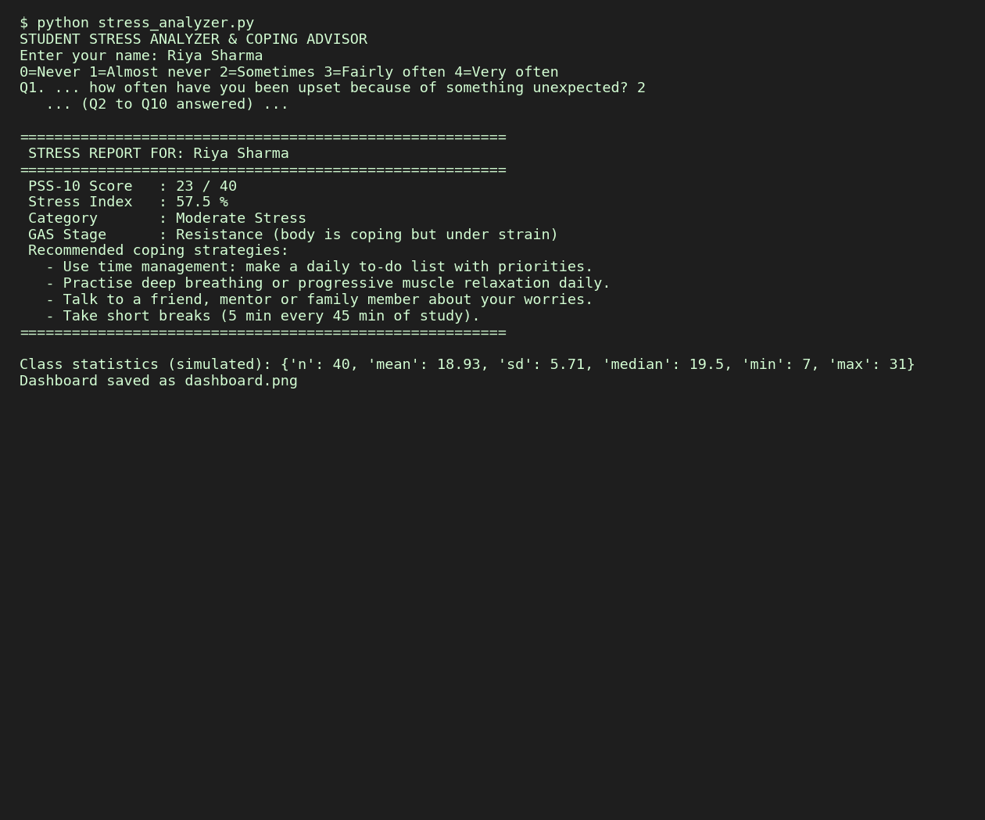
Figure 5.1: Console output of the program

5.2 Dashboard
The dashboard has three parts: (a) the position of the student's score on the Low, Moderate and High ranges, (b) a histogram of the simulated group of 40 students with the group mean and the student's score, and (c) a pie chart of the category share.
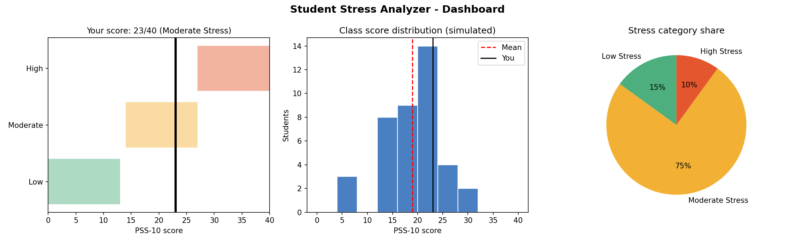
Figure 5.2: Dashboard generated by the program

5.3 Group statistics (simulated data, n = 40)
Measure | Value
Number of students (n) | 40
Mean (μ) | 18.93
Standard deviation (s) | 5.71
Median | 19.5
Minimum / Maximum | 7 / 31
Low / Moderate / High share | 15 % / 75 % / 10 %

5.4 Interpretation
The sample student scored 23, which is above the group mean of 18.93 but below one standard deviation above the mean (about 24.6). This means the stress is slightly higher than the group average and falls in the Moderate range, the Resistance stage. The advice shown (time management, relaxation, talking to someone trusted and regular breaks) matches the strategies learned in Unit 4.

6. CONCLUSION
The project successfully measures perceived stress with the PSS-10 method, classifies it, links it to Selye's stages and suggests practical coping strategies. It shows that stress can be understood in a scientific way and managed with simple daily habits. Using the tool improves self-awareness, one of the key goals of this subject.

Future scope
- Add a graphical window (Tkinter) or a mobile app.
- Store weekly scores in a file to track progress over time.
- Add a guided breathing timer and a mood diary.
- Collect real anonymous class data with permission for analysis.

Learning outcomes
Through this project I learned the causes, symptoms and models of stress, how to apply a standard psychological scale, how to write and test a Python program, and how to present data using formulas, tables and charts.

7. BIBLIOGRAPHY
- Cohen, S., Kamarck, T. and Mermelstein, R. (1983). A global measure of perceived stress. Journal of Health and Social Behavior, 24, 385-396.
- Selye, H. (1956). The Stress of Life. McGraw-Hill.
- Lazarus, R. S. and Folkman, S. (1984). Stress, Appraisal, and Coping. Springer.
- Course syllabus: Understanding Self for Effectiveness and Personality Development, Unit 4.

8. WEBLINKS
- https://www.python.org
- https://docs.python.org/3/library/statistics.html
- https://matplotlib.org

