
GROUP NO 16
Automated Routing and Classification of Customer Complaints drafted in Multiple Languages
AUTOMATED ROUTING AND CLASSIFICATION OF CUSTOMER COMPLAINTS DRAFTED IN MULTIPLE LANGUAGES
This project report is submitted to
Yeshwantrao Chavan College of Engineering
(An Autonomous Institution Affiliated to Rashtrasant Tukdoji Maharaj Nagpur University)

In partial fulfillment of the requirement
For the award of the degree

Of

Bachelor of Technology in Computer Science and Engineering

By

Kunal Parkhade
Abhijeet Sahu
Manthan Lute
Vedant Khursange
Divyani Thakare

Under the guidance of
Dr. Nileshsingh V. Thakur
DR. NILESHSINGH V. THAKUR

Department Of Computer Science and Engineering
Nagar Yuwak Shikshan Sanstha’s
YESHWANTRAO CHAVAN COLLEGE OF ENGINEERING,
(An autonomous institution affiliated to Rashtrasant Tukadoji Maharaj Nagpur University, Nagpur)
2024-25

Automated Routing and Classification of Customer Complaints drafted in Multiple Languages
This project report is submitted to Yeshwantrao Chavan College of Engineering
(An Autonomous Institution Affiliated to Rashtrasant Tukdoji Maharaj Nagpur University)

In partial fulfilment of the requirement
For the award of the degree
Of

Bachelor of Technology in Computer Science and Engineering

By

Kunal Parkhade
Abhijeet Sahu
Manthan Lute
Vedant Khursange
Divyani Thakare

Under the guidance of
Dr. Nileshsingh V. Thakur

Department Of Computer Science and Engineering
Nagar Yuwak Shikshan Sanstha’s
YESHWANTRAO CHAVAN COLLEGE OF ENGINEERING,
(An autonomous institution affiliated to Rashtrasant Tukadoji Maharaj Nagpur University, Nagpur)

CERTIFICATE OF APPROVAL

Certified that the project report entitled “Automated Routing and Classification of Customer Complaints drafted in Multiple Languages” has been successfully completed by Kunal Parkhade, Abhijeet Sahu, Manthan Lute, Vedant Khursange, Divyani Thakare under the guidance of Dr. Nileshsingh V. Thakur in recognition to the partial fulfilment for the award of the degree of Bachelor of Technology in Computer Science and Engineering, Yeshwantrao Chavan College of Engineering (An Autonomous Institution Affiliated to Rashtrasant Tukdoji Maharaj Nagpur University)

Signature | Signature | Signature | Signature
Dr. Nileshsingh V. Thakur | Prof. Amruta T. Paul | Prof. Priyanka More | Dr. Lalit B. Damahe
(Guide) | (Co-ordinator) | (Co-ordinator) | (HoD)

ACKNOWLEDGEMENT

We extend our heartfelt gratitude to Dr. Nileshsingh V. Thakur, our esteemed guide for their unwavering support, invaluable guidance, and encouragement throughout this project on Automated Routing and Classification of Customer Complaints drafted in Multiple Languages. Their expertise and insights have been instrumental in shaping the direction and execution of this research. We are also grateful to Dr. Lalit B. Damahe Head of the CSE Department, for providing essential resources and facilities crucial for the successful completion of this project. Additionally, we appreciate Dr. U. P. Waghe, Principal of YCCE, for fostering an environment conducive to academic exploration and innovation. Special thanks are due to Prof. Amruta Tapas Paul and Prof. Priyanka More Coordinator of CSE Department, for overseeing the coordination and administrative aspects of this project. Lastly, we would like to thank all the faculty and non-teaching staff members who helped us directly or indirectly for the successful completion of this project.

DECLARATION

We certify that

- The work contained in this project has been done by us under the guidance of my supervisor(s).
- The work has not been submitted to any other Institute for any degree or diploma.
- We have followed the guidelines provided by the Institute in preparing the project report.
- We have conformed to the norms and guidelines given in the Ethical Code of Conduct of the Institute.
- Whenever we have used materials (data, theoretical analysis, figures, and text) from other sources, we have given due credit to them by citing them in the text of the report and giving their details in the references. Further, we have taken permission from the copyright owners of the sources, whenever necessary.

Name of the Student Signature of the Student

Kunal Parkhade

Abhijeet Sahu

Manthan Lute

Vedant Khursange

Divyani Thakare

TABLE Of CONTENTS Page No.

Title Page
Certificate of Approval i
Acknowledgement ii
Declaration iii
Table of Contents iv
List of Tables vi
List of Figures vii
List of Abbreviations viii
Abstract ix
Project CO-PO Matrix x
Chapter 1 Introduction 1-2
  - Overview 1
  - Problem Statement 1
  - Thesis Objectives 2
Chapter 2 Review of Literature 3-25
  - Overview 4
  - Problem Identification 24
  - Research Gap 24
Chapter 3 Work Done 26-34
  - Dataset Preparation 27
  - Software Development 30
3.3 Technologies Used 31
  - Flow of the System 32

Chapter 4 Result and Discussion | 35-48
4.1 Result and Evaluation of System | 36
4.1.1 Training and Classification | 36
4.1.2 Real-time Deployment and Testing | 36
4.1.3 Evaluation Metrics | 40
4.1.4 Screenshots and Output Logs | 46
4.1.5 Summary | 48
Chapter 5 Summary and Conclusions | 49-59
5.1 Social Utility | 50
5.2 Summary | 51
5.3 Conclusion | 56
5.4 Future Scope | 59
References | 60-67
Appendix | 68-74
Appendix A | 69
Appendix B | 70
Societal Impact of Project | 75-78
Preliminary Investigation Report (PIR) | 79-85

List of Tables

Table No. | Table Name | Page No.
2.1 | Literature Review Table | 18
4.1 | Classification Report of Random Forest | 40
4.2 | Classification Report for Logistic Regression | 42
4.3 | Classification Report for SVM | 44

List of Figures

Figure No. | Figure Name | Page No.
3.1 | Dataset Organization | 29
3.2 | Flow of system | 32
4.1 | Confusion Matrix for Random Forest | 41
4.2 | Confusion Matrix for Logistic Regression | 43
4.3 | Confusion Matrix for SVM | 45
4.4 | User Interface of proposed System | 46
4.5 | Bar Chart of Precision, Recall, and F1-Score per Class for SVM | 47
4.6 | Bar Chart of Precision, Recall, and F1-Score per Class for Logistic Regression | 47
4.7 | Bar Chart of Precision, Recall, and F1-Score per Class for Random Forest | 48

List of Abbreviations

NLP | Natural Language Processing
ML | Machine Learning
SVM | Support Vector Machine
CSV | Comma Separated Values
IR | Information Retrieval
NMT | Neural Machine Translation
TF-IDF | Term Frequence – Inverse Document Frequency
IMAP | Internet Message Access Protocol
SMTP | Simple Mail Transfer Protocol
BERT | Bidirectional Encoder Representational Transformer
NLTK | Natural Language Toolkit
NER | Named Entity Recognition

Abstract

In today’s technology-driven world, managing complaints manually has become a significant challenge, particularly for educational institutions and customer service sectors. As volume of the complaint written in different languages are growing exponentially across multiple departments, traditional manual systems fail to meet the increasing demand, leading to inefficiencies, delays, and reduced satisfaction. This problem is currently poorly handled manually leading to delays or mismanagement. Several groups are affected by this problem including students, citizens, educational institutions, government offices, private companies, etc.
This research focuses on developing an automated system for the classification and routing of the complaints written in different languages like English, Hindi, Marathi, etc. The study investigates the problem of matching complaints to specific departments such as Administration, Hostel, Library, etc., based on the content of the complaint.
The methodology which we are using includes preprocessing complaint data, text vectorization techniques like TF-IDF and applying classifiers such as Support Vector Machine (SVM), Logistic Regression (LR) and Random Forest. The implication is a more efficient complaint management system that reduces manual effort and can be applied in various sectors.

Keywords: Machine Learning, Complaint Classification, Department Categorization, Grievance Redressal System, Automated Complaint Routing.

Project CO-PO Matrix
CO-PO/PSO Articulation Matrix

 | PO 1 | PO 2 | PO 3 | PO 4 | PO 5 | PO 6 | PO 7 | PO 8 | PO 9 | PO 10 | PO 11 | PO 12 | PSO 1 | PSO 2
CO-1:  Investigate  the Problem domain knowledge  in their area of study and analyse the problem domain for executing the  projects. | 3 | 3 |  | 3 |  |  |  |  |  |  |  |  | 3 | 3
CO-2: Design and develop the solution using appropriate tools and techniques and communicate effectively with society at large for betterment. |  |  | 3 |  | 3 | 3 | 2 |  |  | 3 |  |  | 3 | 3
CO-3: Analyse and interpret the obtained results using acquired research-based knowledge. |  |  |  | 3 |  |  |  |  |  |  |  | 3 | 3 | 3
CO-4: Function effectively as an individual, and as a member or leader in a team under multidisciplinary settings following ethical practices. |  |  |  |  |  |  |  |  | 3 |  | 2 | 3 | 3 | 3

CHAPTER 1
INTRODUCTION

Chapter 1
Introduction

Overview
In the educational institutions, students frequently make complaints related to different departments such as Admin, Hostel, Library, Examination, etc. These complaints are usually submitted through written forms or emails in multiple languages, especially in English and regional languages like Hindi, Marathi, etc.
The non-automatic handling of complaints in multilingual setting tends to delays, errors in routing and poor grievance redressal. With the increasing demand for digital and efficient systems, automating this process becomes vital. Most of the existing systems are not capable of processing multilingual complaints. They also lag behind by automation in routing the complaints. There is also a lack of intelligent classification based on the complaint content.
Several stakeholders are affected like student face delays in resolution of the complaints, administrative employees struggle with sorting and forwarding, and institutions suffer from inefficiency and reduced trust. While some systems exist for complaint management, they are mostly monolingual, domain-specific and require manual categorization. A very little work has been done on multilingual automation in complaint systems.
This thesis proposes an NLP and machine learning solution to automate the multilingual complaints which can improve speed, accuracy and efficiency of the redressal process.

Problem Statement
The problem is the lack of an automated system that can classify and route student complaints written in Hindi or Marathi to the correct department in a timely manner. This problem is critical to solve due to delays is getting responses which can lead to dissatisfaction and poor institutional reputation. If we automate the process, it can ensure fairness and responsiveness.

As businesses expand globally, the volume and variety of customer complaints increase, often arriving in languages other than the primary operational language of the support team. This problem can directly impact customer satisfaction as immediate attention to issues is a key driver of positive customer experience.

If this problem left unresolved, institutions will continue to face administrative inefficiencies, student trust and satisfaction will decline, possibly affecting admissions and rankings. The focus is on automating the routing of complaints written in English, Hindi, Marathi, etc. received from the students in a college environment, and directing them to departments like Training & Placement, Hostel, Administration, etc.

  - Thesis Objectives
The main objective of this thesis are as follows:
- To develop a system that can understand and classify complaints written in different languages.
- To automatically route complaints to the appropriate department based on the classification.
- To improve efficiency and response time in handling grievances.
The desired outcome of this project is an end-to-end automated complaint classification and routing system capable of handling multilingual complaint data with high accuracy and low processing time. This solution will save the administrative time, reduce human error, and improve student satisfaction by ensuring faster and more accurate responses to complaints.

CHAPTER 2
REVIEW OF LITERATURE

Chapter 2
Review of Literature
2.1 Overview
I have reviewed various research papers regarding the routing and classification of complaints. The integration of Natural Language Processing (NLP) and machine learning (ML) techniques in the automation of complaint management systems has gained significant attention in recent years. Various studies have explored different aspects of customer complaint systems, particularly those involving classification, sentiment analysis, and language processing for low-resource languages, which are directly applicable to the scope of the Automated Routing and Classification of Customer Complaints
[1] T. Roy et al. focuses on categorizing railway-related customer complaints extracted from tweets using machine learning techniques. It employs models like SVM, Naive Bayes, and Random Forest, achieving around 75% accuracy. Data preprocessing and feature extraction were key steps in the pipeline. The system shows potential in prioritizing and streamlining complaint responses. However, real-time deployment and improving accuracy remain open challenges.
[2] P. Bhattacharya et al. explores POS tagging for underrepresented languages like Angika, Magahi, and Bhojpuri, using Hindi as a reference. It uses multilingual pretrained models like MuRIL, XLM-R, and RemBERT. A look-back mechanism is introduced to handle tokenization errors during transfer. While results are promising, the absence of domain and language diversity limits the system’s broader applicability. Future work could involve extending the method to other low-resource languages.
[3] S. Haq et al. introduces IndicIRSuite, a large-scale neural information retrieval framework for 11 Indian languages. Using 6.4 million training triplets from the INDIC-MARCO dataset, it fine-tunes multilingual BERT-based models. Indic-ColBERT shows 20% better performance over baselines for Bengali, but underperforms in Telugu. The study emphasizes IndicIRSuite’s value in advancing neural IR, yet its effectiveness varies across languages. Comprehensive evaluations are needed for wider adoption.
[4] In this paper, P. Ghosh et al. investigates how positional encodings impact deep learning models handling linguistically complex languages. Using datasets like XNLI and PAWS-X, it evaluates model behavior when positional encodings are removed. It finds that as morphological complexity increases, the necessity of such encodings diminishes. However, training such models from scratch is resource-intensive. The study reveals gaps in our understanding of model architecture and linguistic interaction.
[5] S. D. Deoghare et al. proposes a multilingual Automatic Post-Editing (APE) system, viewing APE as a multi-source translation task. It uses both authentic and synthetic data in English-Marathi, improving translation quality significantly. Quality Estimation (QE) helps enhance correction accuracy, especially in domain-specific texts. Despite its success, the model is only tested on two language pairs. Broader testing and baseline evaluation remain future directions.
[6] K. Maity et al. presents a multimodal framework for detecting toxicity in Hindi YouTube content using text and video features. It uses Whisper for transcription and employs HingRoBERTa for text encoding, achieving an F1 score of 86.98%. The model aligns features from text and video to predict sentiment, severity, and toxicity. While effective, it fails to capture implicit or contextual toxicity. Future work should focus on deeper video understanding.
[7] N.R. Sahoo et al. introduces a benchmark for evaluating social biases in language models using adapted Indian CrowS-Pairs and sentence templates. It measures stereotype and anti-stereotype dominance via scoring metrics. Findings show minimal gender-age bias in XLM-R, but translation inaccuracies and small datasets limit conclusions. The system does not account for implicit or intersectional biases. Expanding the dataset and bias dimensions is suggested for future work.
[8] S. Settaluri et al. presents a novel Visual Question Answering (VQA) system in the Indian cuisine domain. Using image-question-answer triplets and the IndiFoodKG knowledge graph, it evaluates instruction-tuned models like InstructBlip and LLaVA. InstructBlip achieves the highest accuracy due to its training alignment with classification tasks. The system shows promise but depends on English and proprietary APIs. Accessibility and multilingual support remain challenges.
[9] N. R. Sahoo et al. proposes a model to generate counter-narratives (CNs) against hate speech (HS) in multiple languages. It trains on CN-HS pairs and evaluates performance using relevance, diversity, and toxicity reduction metrics. Conditioning on HS and CN types yields the best results, producing more relevant responses. The study highlights the model's capability in reducing toxicity. However, it lacks experimentation on additional Indian languages and models.
[10] A. Kunchukuttan et al. develops high-quality monolingual corpora and word embeddings for multiple Indian languages. Evaluated across sentiment analysis, analogy, and text classification tasks, IndicNLP embeddings outperform publicly available ones. Diverse datasets such as BBC News and Soham Bengali News are used for evaluation. The study identifies potential in using these embeddings for building morphological analyzers. Future work may include multilingual embeddings and richer pretrained models.
[11] D. Banga and K. Peddireddy explores the development of an AI-based system for managing customer complaints gathered from social media and email platforms. It focuses on improving classification accuracy, reducing response time, and boosting customer satisfaction. The system automates complaint resolution and identifies recurring issues. However, it still requires fine-tuning for personalization and performance across various industries. Key gaps include scalability and adapting the system for broader applications.
[12] G. Alarifi et al. analyzes financial complaints using TF-IDF and machine learning algorithms to convert textual data into numerical form. The study emphasizes complaints as valuable feedback to enhance services. Although promising, it is limited to one financial institution’s data. It suggests incorporating diverse models and industry data for better representation. Future work should explore expanded datasets and more complex algorithms.
[13] S. Nath et al. introduces reinforcement learning (RL) for query-focused summarization (QfS) and compares it to supervised learning (SL). Using datasets like ELI5 and RQFT, RL models demonstrate superior performance in generating relevant and coherent summaries. The paper highlights challenges like training stability and action-space exploration in RL. It concludes that RL, paired with semantic feedback, enhances summarization tasks. However, long-text generation still poses technical limitations.
[14] F. A. Alifat et al. presents a web-based complaint management system developed using PHP, JavaScript, and MySQL, tailored for educational institutions. The system simplifies complaint registration, tracking, and resolution processes. It significantly reduces paperwork and manual intervention. However, its functionality is limited to desktop platforms. The authors recommend developing a mobile application for greater accessibility and usability.
[15] V. Bhat et al. addresses disfluency correction (DC) in multi-language spoken utterances using the DISCO dataset. It employs CRF and RNN models with the FlairNLP framework to convert disfluent speech to fluent text. Results show effective handling of complex disfluencies and speech plan shifts. Limitations include fewer test samples for English and French and a lack of cross-dataset comparisons. Nonetheless, the research contributes to improving readability and translation quality.
[16] A. P. Singh et al. classifies tweets using sentiment analysis techniques like Naive Bayes and regression models. Data collected via the Tweepy library is preprocessed and analyzed to distinguish between positive and negative sentiments. The system achieves an average accuracy of 95.8%, demonstrating its reliability. A future enhancement includes integrating PNR detection for more specialized analysis. The study also encourages exploring more sophisticated models and datasets.
[17] Q. ul Ain et al. proposes an NLP-based approach for automatic complaint classification using two distinct datasets. It applies preprocessing and feature extraction techniques, followed by classification using Multinomial Naive Bayes. The model achieves high accuracy, reducing manual workload in categorizing complaints. However, it lacks feature selection and fails to scale effectively across broader datasets. The authors suggest incorporating deep learning for improved performance.
[18] S. Sarkar et al. evaluates Universal Sentence Encoders (USE) in zero-shot classification tasks across various domains. While USE performs well in many scenarios, it struggles with overlapping label semantics. Topic-based inference models outperform USE in handling zero-shot tasks. Simpler architectures like DAN also show competitive results against transformers. The study highlights a need for optimizing sentence encoders for better semantic understanding.
[19] A. Ladkat et al. explores different fine-tuning methods for BERT models in text classification. Techniques like Task-Adaptive Pretraining (TAPT) and restricted fine-tuning are evaluated on datasets like IMDB and AG-News. Freezing layers reduces computational cost while maintaining accuracy. The paper finds embedding layer fine-tuning effective for domain adaptation. It recommends further evaluation on large, diverse datasets to validate scalability.
[20] X. Tian et al. applies NLP techniques to automate complaint handling for a Dutch water utility company. It processes complaints from five service categories using lexical and syntactic analysis. The study successfully extracts context and intent, showing the strength of NLP in understanding user sentiment. However, deeper automation, including text generation and real-time dialogue, remains unexplored. Future work should focus on integrating richer linguistic structures and digital databases.
[21] R. Murthy et al. builds a Named Entity Recognition (NER) system for Hindi using models like mBERT and XLM-R. It evaluates the models on tourism and news domain datasets using F-score. Challenges include free word order and lack of capitalization in Hindi.
Common errors involve entity boundaries and misclassification of Location and Organization types. Future work includes dataset expansion and better annotation strategies.
[22] R. Kundu et al. explores disfluency detection in Indian languages using the MuRIL model. Trains models on synthetic and manually verified datasets across four Indian languages. Achieves an F1 score of 93.62 in sequence labeling tasks. Demonstrates the success of cross-lingual transfer without target-language labeled data. Struggles with synonym correction and diverse disfluency types.
[23] D. S. Chauhan et al. enhances humor recognition using sentiment-emotion aware embeddings in Hindi and English. Uses XLM-R and Context Transformer (Contrans) on the M2H2 dataset of TV dialogues. Introduces SE-Embedding for improved humor detection. Outperforms baseline systems, except on first utterances. Suggests future work on multiparty dialogue generation in Hindi.
[24] A. Ekbal et al. presents a multimodal sentiment analysis method effective in low-resource settings. Uses datasets like YouTube, MOUD, and ICT-MMMO. Applies grid search, Softmax classifier, and Adam optimizer. Excludes acoustic modality due to limited contribution. Proposes future applications in machine translation and question answering.
[25] G. V. Singh et al. develops a Hindi emotion recognition dataset based on victim-assistance dialogues. Tests bcLSTM, Attention-based LSTM, and Conversational Memory Networks. Focuses on context-based emotional interpretation in dialogues. Finds C-F-Trans model performs best. Future plans include expanding to other Indian languages like Marathi and Bengali.
[26] R. Dabre et al. introduces IndicBART to improve NLG for Indian languages via script similarity transfer. Trained on IndicCorp with support for major Indian scripts. Enhances summarization and translation tasks through script unification. Plans include expanding to 22 languages and using larger corpora. Highlights improved performance with fine-tuned language-specific models.
[27] G. Ramesh et al. creates the largest parallel corpora for 11 Indic languages and English. Uses article extraction, sentence alignment, and BLEU score evaluation. Trained IndicTrans outperforms existing models for both translation directions. Suggests improvements in linguistic similarity and long sentence handling. Supports low-resource machine translation system development.
[28] S. Bhosale et al. proposes a complaint classification system using Random Forest and TF-IDF. Dataset from Bojnourd municipality’s IT department in Excel format. Uses TextBlob for sentiment polarity scores. Achieves 75% accuracy but struggles with spelling errors and complex sentences. Highlights need for better handling of linguistic challenges.
[29] A. Borg et al. automates classification of telecom support emails using LSTM with BoW and Word2Vec. Uses a dataset of 105,195 emails covering various customer issues. Points out low label accuracy and scope for emotion detection. Notes gaps in NLP model selection and LSTM configuration. Highlights the lack of focused research on email classification.
[30] P. Hake et al. focuses on automating complaint handling in the medical tech sector using ML. Trains models on 15,817 customer complaints about medical products. Sampling strategy impacts performance more than early stopping. Outperforms keyword-based classifiers significantly. Identifies challenges in data availability and model generalization.
[31] X. Tang et al. addresses label imbalance in customer complaints by using hierarchical labeling. Shallow labels are verified with BERT, and deeper ones with Word2Vec similarity. It improves auto-labeling accuracy using hierarchical relationships. Tested on a power company’s complaint dataset, it shows promising results. However, generalizability is limited due to unique data characteristics.
[32] A. Banerjee et al. focuses on Neural Machine Translation (NMT) for English–Marathi in low-resource settings. Uses datasets like ILCI, Bible, and PMIndia, with techniques like back-translation and pivoting. Finds that Hindi as a pivot language boosts performance. Corpus mixing and Phrase Table Injection enhance translation quality. Future work may include other Indian languages and transfer methods.
[33] K. Saunack et al. studies monolingual lemmatization in low-resource settings. The model uses inflected forms, lemmas, and morphological tags for training. With data augmentation, good accuracy was achieved even with small datasets. It performs competitively against rule-based systems. Linguistic knowledge and character-level modeling are suggested for future enhancement.
[34] T. Dhamecha et al. explores the effect of language relatedness on multilingual model fine-tuning. Related language subsets like Bhojpuri, Magahi, and Hindi yield better results than unrelated ones. Fine-tuning improves performance, especially in low-resource languages like Oriya. Script similarity and transliteration further enhance accuracy. Recommends automatic selection of related languages for optimal tuning.
[35] D. Bansal et al. introduces MuRIL, a multilingual BERT model for 17 Indian languages. It supports code-mixed and transliterated text, especially in social media settings. MuRIL outperforms mBERT across all XTREME benchmark datasets. Still, it requires broader cross-lingual evaluations and task expansions. The model is a strong step toward inclusive Indian language NLP.
[36] K. Zahoor et al. analyzes customer sentiment in 4,000 English reviews from restaurants in Karachi. Applies machine learning classifiers after data preprocessing. Random Forest achieved over 90% accuracy in sentiment and category classification. Recommends expanding data from more platforms and using deep learning. Shows potential in service improvement through sentiment analysis.
[37] K. Zerrouki et al. classifies tweet sentiment using the Sentiment140 dataset with over 1 million tweets. Models tested include Naive Bayes, KNN, and Decision Tree. KNN performed well, but Decision Tree achieved over 90% accuracy. Emphasizes Twitter’s polarity-rich nature for sentiment analysis. Suggests future use of multilingual tweets and bio-inspired models.
[38] K. Ganesan et al. examines linguistic differences between complaints and praises in user reviews. Finds complaints use more nouns and longer sentences, while praises use more adjectives. Negation and causation are stronger in complaints. Data comes from TripAdvisor, Yelp, Walmart, and Sephora. Proposes these features for developing better sentiment classifiers.
[39] Tom B. Brown et al. evaluates GPT-3’s performance on various NLP tasks using few-shot, one-shot, and zero-shot settings. Finds GPT-3 often outperforms fine-tuned models, like T5-11B, in zero-shot learning. Highlights limitations like repetition and inefficient pretraining sample usage. Uses Common Crawl as a training dataset. Suggests GPT-3 is a flexible but resource-heavy model.
[40] A. Mabrouk et al. surveys deep learning methods for sentiment classification in reviews. Analyzes performance across datasets like Amazon, Rotten Tomatoes, and Yelp. Notes GloVe performs better than Word2Vec in these tasks. Multiclass classification adds complexity and needs more labeled data. Future work will compare various DL architectures and embeddings.
[41] A. Benlahbib et al. introduces a unified reputation scoring system using data like review ratings, time, helpfulness, and sentiment. Data is gathered from IMDB, TripAdvisor, and Amazon, covering various domains. Sentiment analysis and score aggregation help compute a comprehensive reputation value. The system received high satisfaction ratings from both users and experts. However, challenges include fake reviews, user credibility, and irrelevant content filtering.
[42] B. Haddow et al. constructs a parallel corpus for Indian languages using OPUS. Processes include crawling, sentence alignment, normalization, tokenization, and truecasing. Two alignment methods are compared with preliminary results for NMT tasks. Translation challenges are more due to language complexity than corpus quality. A multi-parallel version is planned to improve multilingual support.
[43] S. Agarwal et al. presents an automated helpdesk email assignment system using LSTM and large-scale datasets. Stages include preprocessing, classification, retraining, and deployment. Outperforms traditional ML and DL models, especially with large datasets. However, it lacks full automation, ignores email attachments, and misses runtime artifacts. Future enhancements could address attachment handling and full system integration.
[44] J. Khatri et al. evaluates cross-lingual word embeddings (VecMap, MUSE, Indic embeddings) for Indian languages. Uses bilingual dictionaries and transliteration techniques for testing. Indic embeddings generally outperform others, except in Hi-Ta due to low word overlap. Accuracy remains low for cognates in current mapping methods. Calls for better embedding techniques for languages with little shared vocabulary.
[45] D. Kakwani et al. presents NLP resources for 11 major Indian languages using corpora like Leipzig and HindEnCorp. IndicBERT outperforms XLMR and mBERT in most tasks, except on Wikipedia-based ones. Resources aim to support tasks like NER, QA, and text classification Highlights gaps in comprehensive NLP development for Indian languages.
Encourages further research into inclusive and robust NLP tools.
[46] S. Siripragada et al. develops parallel corpora using modern MT for Indian languages like Hindi, Punjabi, Marathi, and Urdu. Combines PIB (training) and Mann Ki Baat (testing) corpora with NMT for alignment. Cross-lingual retrieval and deep neural networks enhance translation quality. Performance remains inconsistent in generic translation settings. Calls for improvements in Hindi-English and intra-Indian language translation quality.
[47] K. Saurav et al. uses ILCI, Wikipedia dumps, and HinMonoCorp to generate word embeddings for Indian languages. Focuses on improving NLP tasks like MT and Word Sense Disambiguation. Finds BERT pretraining accuracy still has room for improvement. Masked LM achieves 31.8% accuracy; NSP achieves 67.9%.
Identifies gaps in evaluating embeddings for tagging, NER, and analogy tasks.
[48] A. Borg et al. applies Conformal Prediction (CP) to classify 51,682 customer service emails from a Swedish telecom firm. Uses SVM for classification and provides statistical confidence through p-values. Finds CP improves classification certainty but overlooks section-level importance. Emphasizes CP’s usefulness in boosting service efficiency.
Future work should explore prioritizing key parts of emails in classification.
[49] M. S. Tootooni et al. proposes CCMapper for mapping free-text chief complaints (CCs) to structured lists. Uses preprocessing, spell-check, auto-correction, and validation on Mayo Clinic ED data. Achieves over 94% precision, sensitivity, and F1-score; excels in multiple-complaint cases. Handles 78,000 patient visits with high specificity (99.8%). Challenges include residual human error and limited preprocessing refinement.
[50] Shilpa G. V. et al. focuses on Cross-Lingual Sentiment Analysis (CLSA) using the BRAE model and POS analysis. Model is trained on WordNet data and supports naïve translation-based sentiment transfer. Handles grammatical and polysemous phrases well, but struggles with contextual subtleties. Unsupervised and supervised training phases enhance prediction accuracy. Future research should focus on phrase embeddings across multiple languages.
[51] R. Cardenas et al. proposes an unsupervised method for POS tagging using clustering, decipherment, and multilingual parsing. It maps clusters to POS tags through grounding and evaluates performance with extrinsic metrics. Datasets include Universal Dependencies, Helsinki Corpus of Swahili, and Universal Treebank. The method works well for key tags like nouns and modifiers. However, accuracy depends heavily on the chosen deciphering language and clustering quality.
[52] D. Kondratyuk introduces a two-stage fine-tuning process for lemmatization and morphology tagging using multilingual BERT. Combines tokenization, character-level embeddings, and BERT-based encoding. Trained on Treebank datasets, it shows better accuracy than monolingual fine-tuning. Emphasizes the benefits of cross-lingual learning for morphologically rich languages. Requires deeper analysis to separate the effects of BERT pretraining and fine-tuning.
[53] Y. Yang presents an evidential reasoning-based model for classifying telecom customer complaints. Uses 1,433 complaints to extract 16 textual features and assign weights. Outperforms traditional ML classifiers in accuracy and reliability. Highlights challenges in converting unstructured data into actionable evidence. Encourages future work on integrating structured and unstructured sources for improved performance.
[54] T. Young et al. reviews deep learning’s impact on NLP, focusing on distributed representations like embeddings. Covers CNNs, RNNs, and reinforcement learning in tasks such as parsing and dialogue systems. Emphasizes memory module integration for improved model performance. Showcases state-of-the-art results across key NLP benchmarks.
Identifies future potential in memory-based and unsupervised sentence representations.
[55] K. V. Deshmukh et al. proposes a framework for managing citizen complaints in Pune using sentiment analysis and classification. Includes text segmentation, concept labeling, and intensity evaluation.
Utilizes both static and dynamic datasets to enhance system learning.
Improves response time and administrative efficiency in handling complaints.
Still in early stages; full implementation and testing are pending.
[56] C. S. Kulkarni et al. develops a chatbot system for bank customer service using pre-processing, vectorization, and classification. Handles FAQs and mimics human responses for efficient service delivery. Based on real queries from bank inquiry desks. Improves convenience and reduces human workload in customer interaction. Needs further development and real-world testing for deployment readiness.
[57] M. M. Lopez et al. explores the use of Convolutional Neural Networks (CNNs) in NLP tasks. Highlights their performance in tasks like sentence classification and sentiment detection. Notes that deep learning's breakthroughs in NLP are not as dramatic as in computer vision. Speech recognition is the area with most impact so far. Suggests more exploration of CNN potential in NLP contexts.
[58] A. Arunagiri et al. presents a modular email routing system to automate segregation and improve efficiency. Pipeline includes ingestion, content extraction, enrichment, logging, and routing. Offers integration with native mail apps and reduces operational costs. Does not detail datasets or SME-specific routing enhancements. Future versions may tailor routing for SME availability and performance.
[59] In this paper S. S. Akhtar et al. builds manually annotated word similarity datasets for Indian languages like Marathi, Urdu, and Telugu. Uses large monolingual corpora and introduces new datasets for evaluation. FastText with OOV tokens outperformed standard FastText models. Future work for expansion to Punjabi, Tamil, and Gujarati datasets. It aims to improve embeddings through larger and cleaner corpora.
[60] In this study, Y. Goldberg highlights the transformative potential of neural networks in NLP. It discusses capabilities like non-linear modeling and learning complex linguistic patterns. It encourages broader adoption of neural models in NLP research. Notes limited exploration in sequence/tree modeling using these architectures. Advocates for more experiments using neural nets in various NLP domains.
[61] This paper explores how Deep Neural Networks (DNNs) improve Machine Translation (MT) through sequence modeling and feature extraction. Despite DNNs' success with continuous variables, they struggle with the discrete nature of natural language.
The study highlights a gap between continuous learning capabilities and linguistic representation. It emphasizes the need for better techniques to bridge this symbolic-abstract divide. DNNs show promise but need adaptation for language-specific challenges.
[62] D. Zhang et al. focuses on enhancing translation prediction using both local and global sentence-level semantics. Trains on 2.1 million bilingual sentence pairs using chunk-based partitioning. Finds that chunk-based models outperform traditional pooling techniques. Suggests extending the model to tasks like QA and paraphrase detection. Identifies refinement in semantic chunking as a key research direction.
[63] D. Bahdanau et al. introduces RNNsearch, an attention-based neural MT model, improving over standard encoder-decoder models. Attention aligns source and target words dynamically during translation. Trained on the WMT’14 English-French dataset with strong results, especially on long sentences. Outperformed older models in coherence and alignment accuracy. Limitations include handling rare or unknown words effectively.
[64] T. Luong et al. addresses rare/OOV word translation challenges in Neural Machine Translation. Evaluates models using BLEU scores on WMT’14 English-French data subset. Finds improvements up to 2.8 BLEU points across architectures. Effective in rare word handling, but fails on unseen vocabulary. Suggests future work in developing robust OOV solutions.
[65] A. Kunchukuttan et al. proposes a framework for transliteration across 13 Indo-Aryan, 4 Dravidian languages, and English. Uses a bridge language to handle lack of parallel corpora. Improves translation quality significantly, demonstrated by BLEU scores. Highlights need for extending to non-Brahmi scripts and phonetically distinct languages. Supports linguistic interoperability but has limited language scope.
[66] O. Bojar et al. introduces HindEnCorp and HindMonoCorp corpora for statistical machine translation in Indian languages. Includes preprocessing steps like language detection, sentence segmentation, and normalization. Datasets used in WMT 2014 shared tasks. Freely available for non-commercial use, aiding MT system training. Future work aims to improve quality via filtering and annotation.
[67] T. Mikolov et al. presents the Skip-gram model to learn high-quality word embeddings. Uses Hierarchical Softmax and Negative Sampling for efficiency. Evaluated on a 1B word Google dataset, capturing syntactic and semantic relationships. Finds that subsampling frequent words improves rare word representations. Lays the foundation for future distributed representation work.
[68] P. Bhattacharyya et al. develops IndoWordNet to unify lexical knowledge across Indian languages. Uses core and common synsets with Hindi as the pivot. Supports MT and cross-lingual search in India’s multilingual context. Highlights the need for a unified background ontology for quality improvement. Promotes inter-language lexical alignment but needs standardization.
[69] F. Sangati et al. combines discriminative and generative models for dependency parsing in a two-phase framework. Discriminative models generate parse candidates; generative models re-rank them. Tested on WSJ corpus with improved performance and flexibility. Allows testing of various generative models without new parser implementation. Future work includes BERT/ELMo integration and multilingual datasets.
[70] K. Coussement et al. enhances email classification for customer complaints using linguistic style features. Uses preprocessing, vectorization, and dimensionality reduction for modeling. Integrating linguistic cues boosts predictive accuracy. Manual label verification still required post-classification. Generalizability to other tasks remains uncertain.
[71] S. K. Subramanian et al. uses association rule mining for categorizing customer emails in service settings. Includes preprocessing, classifier building, validation, and evaluation. Automation reduces workload for service managers and speeds responses. Suggests incorporating confidence-based algorithms to improve results. Demonstrates effective email handling with room for optimization.
[72] S. Buchholz et al. analyzes factors influencing multilingual dependency parsing. Examines impact of annotations like lemmas, morphological features, and CPOSTAG. Finds performance varies significantly based on annotation presence. Notes the absence of consistent lemma use in treebanks limits parser generalizability. Advocates for standardized annotations in multilingual datasets.
[73] H. Khosravi et al. detects speech acts in emails using phrase matching and pattern detection. He analyzes email headers, identifies focus sentences, and evaluates results. Performs well in extracting pragmatic content despite lacking theoretical grounding. Limited to predefined domains; augmenting with linguistic theories is suggested. Demonstrates practical use of phrase matching in speech act identification.

Table 2.1: Literature Review Table
Author | Methodology | Dataset Used | Models Used | Results and Claims by Author(s) | Identified Research Gap
T. Roy  et al.  [1] | 1. Data Collection  2. Data Preprocessing  3. Training and evaluation of ML models to classify complaints into different categories. | Dataset of railway comlaints collected from the internet. | SVM, Random Forest, Naïve Bayes, Decision Tree | Prioritize urgent tweets based on their urgency. Achieved around 75% accuracy using voting classifier. | Potential to offer multilingual support.
S. Kumar et al.  [2] | 1. Tokenization  2. Fine-tuned three multilingual pre-trained language models (PLMs)  3. All three PLMs are pretrained on 100-110 languages | Contains tokenized text and their corresponding Universal Part-of-Speech (UPOS) tags in four different regional languages: Hindi, Angika, Magahi, and Bhojpuri. | XLM-R-large, RemBERT, MuRIL | Reduce tokenization errors in low-resource languages. Mitigation of hindrance of cross-lingual transfer using look-back schema. | Small dataset limits domain diversity
S. Haq  et al.  [3] | 1. Trained 11 distinct Indic-ColBERT (iCol) models for 50k iterations.  2. Optimized the pairwise softmax cross-entropy loss function.  3. Fine-tuned the mBERT encoder from the "bert-base-multilingual-uncased" checkpoint | INDIC-MARCO dataset | Indic-ColBERT | IndicIRSuite is the first attempt at building large-scale Neural Information Retrieval resources for a large number of Indian languages. Indic-ColBERT (iCol) outperforms baseline models (BM25, BM25-T, mDPR, mCol) by 20% in MRR@100 for Bengali on the Mr. Tydi test-set. | Absence of a comprehensive comparison of the trained IR  models
P. Ghosh et al.  [4] | 1. Quantify morphological complexity  2. Study the effect of  removal of positional encodings during fine-tuning | XNLI, PAWS-X (paraphrasing) |  | Deep learning models effectively  handle languages with diverse morphology despite not being directly integrated into them. | Process of training language models from  scratch (without positional encoding) for a large  number of languages requires significant computational power and financial resources.
S. D. Deoghare et al.  [5] | 1. APE Problem as a Multi-source translation task  2. APE is trained in a supervised fashion  3. Data Augmentation | WMT22 datasets with 18K authentic and 2.5M synthetic APE triplets. |  | Multilingual Automatic Post-Editing (APE) systems can significantly improve the quality of machine translations for low-resource Indo-Aryan languages. | The study does not explore MAPE improvements for baseline models of varying quality.
K. Maity et al.  [6] | 1. Encoder Module  2. Cross Modal Synchronization Module  3. Multitask Module | Utilized the Youtube API to scrape Indian web series and Hindi “roasted videos. | HingRoberta | HingRoberta (text modality) attains the highest F1 score of 86.98% for toxicity detection | Implicit or indirect toxic expressions were excluded from this study
N. R. Sahoo  et al.  [7] | 1. Calculate the number of sentence pairs where score(S1) > score(S2) (stereo label) as n1 and where score(S2) > score(S1) (antistereo label) as n2.  2. Calculate Bias Percentage. | CrowS-Pairs sentence pairs for India, sentences generated with IndiBias tuples, and template-based sentences using LLMs. | XLMR | Numerous instances where  the machine translations were either incorrect or  did not appropriately represent the desired intent of the source sentence. | The size of Indian CrowS-Pairs is a limitation.
S. Settaluri  et al.  [8] | 1. Create templates for different types of questions.  2. Extract information from the images in natural language form.  3. Methodology for knowledge extraction to get triples T from IndiFoodKG which are relevant to the image and the type of question  4. Zero shot Baselines  5. Fine-tune Baselines | The dataset consists of an image, a question based on the image, 4 possible answer choices, a correct answer out of the 4,  and a reason for why the answer choice is correct. | mPLUGOwl, LLaVA and InstructBlip | 15% improvement in accuracy with a fine-tuned LLaVA  model over the best-performing zero-shot VLM. InstructBlip achieves the highest accuracy due to its training paradigm’s  effective support for classification tasks. | Limits its  accessibility and usability for non-English speakers.
G. P. Beria  et al.  [9] | 1. Trained the model to learn CNs (ci) conditioned  2. Different metrics to measure the diversity of generated CN.  3. XLMR model to calculate the perplexity of generated CNs. | Pairs comprising hate speech and corresponding counternarratives | XLMR | Pipeline (M4), conditioned on hate speech, hate speech type, and CN type, shows superior performance for both languages. ii) Relevance metrics are higher when generation is conditioned on CN type (M2 and M4). | Explore the capabilities of other multilingual autoregressive models for CN generations.
D. Banga  et al.  [10] | 1. The system will be trained and tested.  2. The system's performance will be measured using metrics such as accuracy of classification, response time, and customer satisfaction level. | Customer Complaint Dataset collected from various sources such as social media, email, etc. |  | Better accuracy in providing answers. The AI-powered complaint handling system enhances efficiency by automating responses, analyzing complaint patterns, and suggesting improvements, boosting customer satisfaction. | Can fine-tune the system for better complaint classification and personalized responses.
G. Alarifi  et al.  [11] | 1. Filtered dataset  2. Data Preprocessing  3. Feature transformation  4. Training-Testing  5. TF-IDF to transform  the categorical text into numerical data. | Control of Pollution Bureau dataset |  | A customer complaint is a valuable form of feedback that reflects dissatisfaction but also provides an opportunity for organizations to address concerns. | Could include diverse models like K Neighbors Classifier, Naive Bayes, kNN, and Random Forest.
F. A. Alifat  et al.  [12] | 1. The system consists of an administrator backend (PHP) and a user frontend (HTML, CSS, and JavaScript).  2. The database is implemented using MySQL. | School Complaint dataset |  | Simplifies complaint tracking and identifies trouble spots. Reduces paperwork and improves problem-solving. | May include the  implementation of this system using an android application
A. P. Singh  et al.  [13] | 1. Data Processing  2. Feature Extraction  3. Tweets are then classified in respective classes (positive and negative)  using Naïve Bayes, Regression and Correlation. | Twitter dataset using Tweepy library. | Naïve Bayes | Government to Citizen (G2C)  can help in improvising the government services by increasing  their availability. The final accuracy  comes out to be 95.8% which is the average accuracy of both  the confusion matrices. | Integration of PNR detection can be done in future.
Q. ul Ain  et al.  [14] | - Data Collection  - Preprocessing  - Feature Extraction  - Classification | Dataset I: 10 divisions/classes (e.g., scholarship, IT, attestation, coordination) with 10,000 closed complaints.  Dataset II: International dataset with 162,421 complaints, available on Kaggle and GitHub. | Multinomial Naïve Bayes, All classifiers. | The proposed model is helpful in saving a lot of time, as there is no need to go through each complaint and categorizing manually. | For dataset I, 70% accuracy is achieved with all classifiers.  For dataset II, 86.5% training recall accuracy is achieved with Multinomial Naïve Bayes and Count Vectorizer technique.
X. Tian  et al.  [15] | 1. Data Collection  2. Lexical Analysis  3. Syntactic Analysis  4. Vectorization  5. Discourse Analysis | Dataset I: Repair/replacement requests  Dataset II: Payment investigation requests  Dataset III: Water leakage/noise investigation requests  Dataset IV: Water pressure issue investigation requests  Dataset V: Water quality issue investigation requests |  | NLP can parse language structures and extract intents and sentiments from customer complaints. Syntactic analysis is more useful when attempting to extract structured information. | Automate text processing further and more deeply, including text generation, interaction with humans, and connection to digital databases.
S. Bhosale  et al.  [16] | 1. Preprocessing includes Tokenization, Tfidf Transformer and Stemming.  2. Random Forest Classifier categorizes complaints.  3. TextBlob computes polarity scores (-1 to +1) to analyze sentiment of complaints. | The raw data were provided in Excel format by the IT department of the Bojnourd municipality. | SVM, KNN, Random Forest | Nearest Neighbor classifier underperforms compared to SVMs and Random Forest. Random Forest achieved accuracy of 75% | The system may not detect spelling mistakes in non-English languages.
A. Borg  et al.  [17] | 1. Preprocessing  2. Bag of Words (BoW)  3. Word2Vec  4. Classification | The e-mail dataset used in the experiments contains 105,195 e-mails from a large telecom corporation's support environment | LSTM | Efficient customer service processes for handling high volumes of daily customer emails are essential for large corporations. | Limited research explores how NLP model choice, corpora, label aggregation, and LSTM network size and depth impact classification performance.
P. Hake  et al.  [18] | 1. Data Preparation  2. Training and Testing evaluation | It contains 15,817 customer complaints about products, including both massproducts and products manufactured according to the cus-tomer’s requirements. | LSTMC | The author identify the automation potentials in the 8D reference process for complaint management and discuss their organizational and technical challenges. The performance of our approach was 3 times better than the keyword based naïve classiﬁer which we used as a baseline comparison. | - Data Availability  - Data Quality
K. Ganesan  et al.  [19] | 1. Sentence Length Analysis  2. Noun analysis  3. Adjective analysis  4. Past Tense Analysis  5. Negation Analysis | Dataset of 2500 reviews from various sources including TripAdvisor, Yelp, Walmart and Sephora |  | Traditional sentiment analysis has been focused on predicting the polarity of texts as positive or negative at different granularity. | Test the power of some of the prominent features in our study to understand the value of these features in developing a fine-grained sentiment classifier.
A. Mabrouk  et al.  [20] | i) Data Preparation ii) Feature Representation iii) Applied Classification Techniques  iv) Performance Appraisal | i) Customer Reviews extracted from Amazon. ii) Movie Reviews from Rotten-Tomatoes. iii) Stanford Sentiment Treebank. iv) Stanford polarity movie review dataset. v) Yelp dataset |  | GloVe outperforms Word2Vec in Sentiment Classification tasks. | More classes in a dataset make Sentiment Classification (SC) problems harder
S. Agarwal  et al.  [21] | 1. Data Preparation  2. Text Preprocessing  3. Classification Models  4. Retraining  5. Evaluation  6. Deployment and Maintenance | IIT-Patna Sentiment Analysis dataset, BBC News Articles classification dataset | LSTM, MLP | The assignment engine outperforms traditional machine-learning and deep-learning models. | The rule engine is not fully automated. Email attachments need to be included in classification.
M. S. Tootooni  et al.  [22] | 1. Pre-Processing  2. Mapping  3. Validation | Data from the Mayo Clinic ED in Rochester, MN, which is an academic Level I trauma center with approximately 78,000 patient  visits (83% adult) per year. |  | CCMapper achieved excellent results with 94.2% sensitivity, 95.3% precision, 99.8% specificity, and a 94.7% F-score. For multiple-complaint cases, it maintained 82.3% sensitivity, precision, and F-score, with 99.1% specificity. | Strong agreement between two experienced EM physicians, who reported human error based on their judgments.
K. V. Deshmukh  et al.  [23] | - Text Segmentation  - Type Detection  - Concept labeling  - Text Classification Evaluation  - Sentence similarity is calculated  - Sentiment Analysis  - Calculate the intensity (negativity) of the user input text in percentage on the basis of the sentiment analysis score. | The static database contains user-submitted questions and system-provided answers, while the dynamic database includes other questions managed by the administrator. |  | This system minimize the time and effort of the citizen as well as PMC to better serve their citizens. | Various implementations still not done. Too forward to implement this system.
A. Arunagiri  et al.  [24] | 1. Ingestion layer  2. Email content extraction  3. Data enrichment module  4. Email logging  5. Segregated mail routing |  |  | The framework automates email segregation and routing, improving performance and minimizing overhead costs, and can be integrated with any native mail application. | The future  versions of the system can include the characterization of SMEs (w.r.t availability and performance) to optimize the  routing and allocation of emails.

2.2 Problem Identification
In modern academic institutions, the grievances are often obstructed by traditional and inefficient mechanisms. Complaint resolving systems are typically either manual or lack the appropriate intelligence like having knowledge about education system (in the case of academic institutions) to classify and route submissions effectively. This usually results in responses get delayed, mismanagement of complaints, and a general lack of responsibility within the system.

A significant concern arises when complaints are submitted in regional languages such as Hindi as everyone unable to speak English and they have the right to speak their mother tongue or any dialect as they wish. Nowadays, majority of the systems which exist regarding the complaint or grievance (in the case of education system) are designed to handle only complaints which are written in English, but in the country like India which is a very diverse country in various ways specifically if we talk in the context of the language. Such platforms which do not consider multilingual complaints often fail to interpret or appropriately route multilingual complaints, necessitating manual translation and intervention. This not only hampers operational efficiency but also poses a barrier to inclusivity and user engagement.

Given India’s rich linguistic diversity and the increasing digitization of institutional communication, there is an urgent need for intelligent systems that can process, classify, and route complaints drafted in regional languages. An automated, multilingual solution would contribute significantly to the enhancement of grievance management within educational institutions.

  - Research Gap
Although prior research has been done and various development initiatives has been taken which have examined the use of Natural Language Processing (NLP) for complaint classification, sentiment analysis, creating synthetic multilingual datasets. But these efforts have primarily been restricted to the English language and have largely based on comprehensive customer complaint datasets. Moreover, such studies rarely address the unique context and linguistic diversity of academic institutions or government companies in multilingual regions such as India.
A thorough review of existing literature and systems highlights some critical gaps:
- Limited or no support for multilingual text processing.
- Traditionally, there hasn’t been a system which automatically route the complaints automatically to the designated destination, they are called as static complaint classification system as those systems do not extend to automated responses such as email routing or system driven redirection to the concerned departmental authority.
- Domain-specific models are very rarely customized to handle the nature, structure, and context of complaints typically observed in academic setting.
- Inability to handle unstructured, brief, and informal complaint text often used by students, especially in local or mixed language formats like Hinglish (Hinglish), etc.

Actually, existing solutions stop at categorization and do not implement any form of automation, thereby requiring manual intervention for faster or further action. This presents a significant operational bottleneck in real world deployment scenarios.
The proposed project aims to bridge those gaps by designing and implementing a multilingual complaint classification and routing system that not only categorizes complaints with accuracy but also automates the subsequent routing via email to the relevant institutional department. This innovative integration of classification and email-based redirection through routing represents a significant step toward fully automated, efficient and inclusive grievance management in educational institutions.

CHAPTER 3 WORK DONE

Chapter 3 Work Done

Dataset Preparation
The work done in this project integrates multiple components – data collection, preprocessing, model training, testing, evaluation, and deployment of a multilingual complaint classification and routing system. The system was designed to automate how complaints are handled in academic institutions, particularly in multilingual contexts like India, where complaints may be written in English, Hindi, or Marathi.

Dataset

A custom dataset was created consisting of over 9000 complaints collected from realistic institutional scenarios. Each complaint was tagged with one of several categories such as:

Administration

Admission

Hostel

Library

Finance

Canteen

Examination

Transport

Sports

Training and Placement

The dataset included English entries. Categories were carefully curated to reflect actual institutional departments, ensuring relevance and applicability in real-world deployment.

Preprocessing and Translation

To handle multilingual input, the following preprocessing pipeline was implemented:

Language Detection: Automatically identifies whether a complaint is in English or another language (Hindi or Marathi).

Translation: Non-English complaints are translated to English using a Python Package named googletrans.

Text Normalization: Includes lowercasing, punctuation removal, and digit filtering.

Tokenization: Converts sentences into words/tokens.

Stopword Removal and Lemmatization: Reduces noise and simplifies word forms.

Vectorization: TF-IDF was used to convert cleaned text into numerical features for machine learning models.

Dataset Organization
The dataset used in this project was structured into a well-defined schema to facilitate easy processing, model training, and evaluation. It consisted of a complaint record, categorized into multiple departments such as Administration, Hostel, Library, Canteen, Finance, Exam, Transport, Admission, Training and Placement, and Sports.
Each complaint entry had the following attributes:
- Raw Text – The original text of the complaint.
- Department Label – The manually assigned correct department/category.

The organized structure helped in:
- Ensuring consistency across training and testing phases,
- Facilitating multilingual processing,
- Supporting both supervised learning and evaluation.

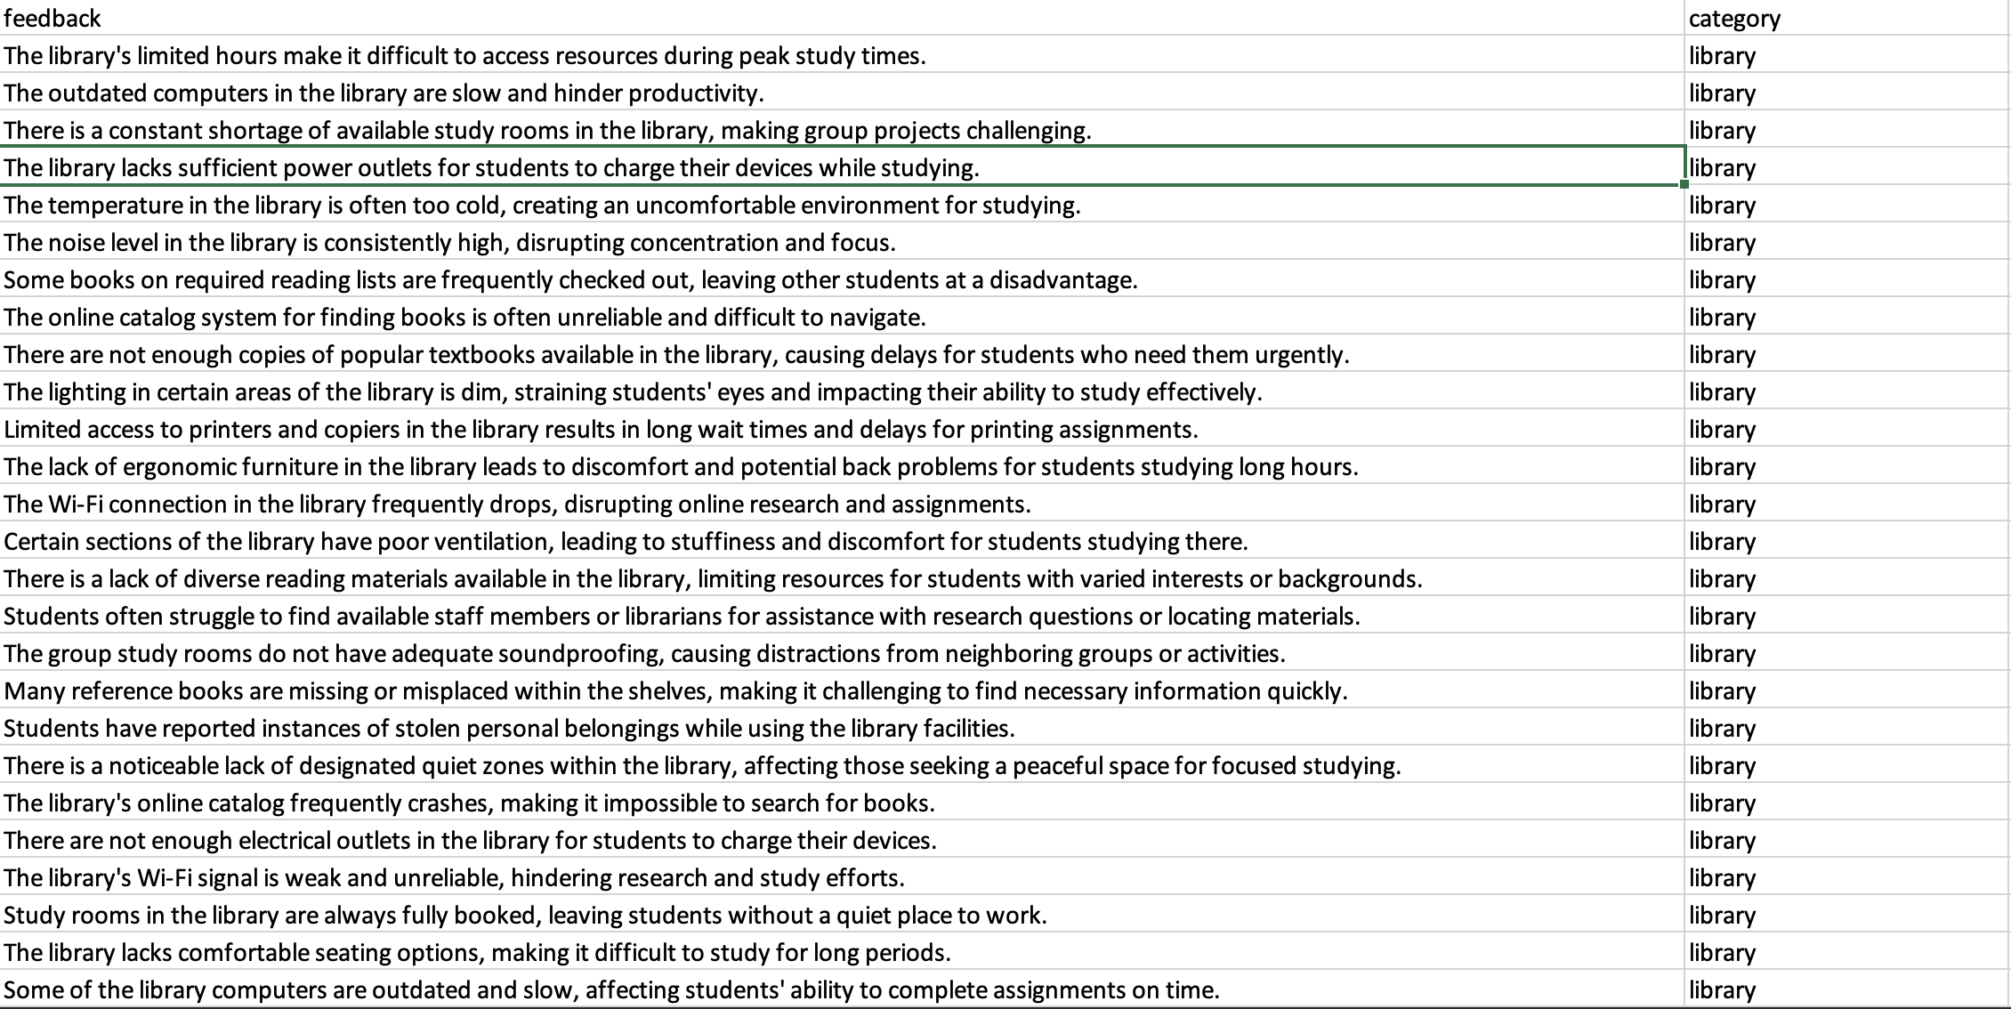
Figure 3.1: Dataset Organization

Data Utilization
The preprocessed dataset was divided into training and testing sets. The cleaned and normalized text was transformed into numerical vectors using TF-IDF vectorization.

The structured dataset served three primary purposes:
- Model Training: Used to train SVM, Logistic Regression, and Random Forest classifiers.
- Model Evaluation: Separate test data helped assess generalization and performance.
- Routing Simulation: Based on predicted labels, complaints were routed to the respective departments through an email automation script.

Software Development

Application Structure
The project was developed as a modular software application with the following components:
- Frontend Interface (Flask-based GUI): Allows users to input complaints through a Gmail or upload files (CSV).
- Backend Engine: Handles preprocessing, classification, and routing using trained ML models.
- Language Translator Module: Detects non-English complaints and translates them using a translation module.
- Routing Logic: Sends classified complaints to department-specific emails.
- Model Pipeline: Integrates preprocessing, TF-IDF vectorization, and classification model prediction.
The Flask framework provided lightweight but powerful supports for building the application interface, while Python libraries like scikit-learn, googletrans, and smtplib were used for implementing the backend logic.

Testing and Debugging

The application was tested using a combination of:

Units Test for individual components like translation and classification.

Integration Tests for the complete pipeline (input to routing).

Manual Testing through realistic complaint samples to validate usability and routing accuracy.

Test cases ensured that complaints were correctly categorized and delivered to the appropriate department emails without manual intervention.

Technologies Used

Programming Language
Python
Python was the core programming language for the project due to its versatility, large ecosystem, and support for rapid prototyping in areas such as machine learning, GUI development, hardware interfacing, and computer vision. Python allowed rapid development and testing of various components in the system.

Machine Learning

The system employed supervised machine learning for classification. The models used were:

Support Vector Machine (SVM): Best-performing model for text classification in high-dimensional feature space.

Logistic Regression: A fast and reliable baseline model.

Random Forest: Used for comparison and to handle non-linear patterns in the data.

These models were trained using TF-IDF vectors and evaluated with accuracy, precision, recall, and F1-score metrics. The use of classical ML ensured fast training and explainable decisions, important for institutional deployment.
.

Flow of the System

The flow of the system is illustrated in below figure, which shows.
    - Input Complaints: User submits a complaint through a Gmail or fiel.
    - Language Detection: Complaint language is detected.
    - Translation: If the complaint is in Hindi or Marathi, it’s translated to English using a translation module.
    - Test Preprocessing: Lowercasing, punctuation removal, stopword removal, and lemmatization.
    - IF-IDF Vectorization: Converts cleaned text into feature vectors.
    - Model Predictions: Classifier (SVM, LR, or RF) predicts the complaint’s category.
    - Routing: Complaint is forwarded via email to the corresponding department.

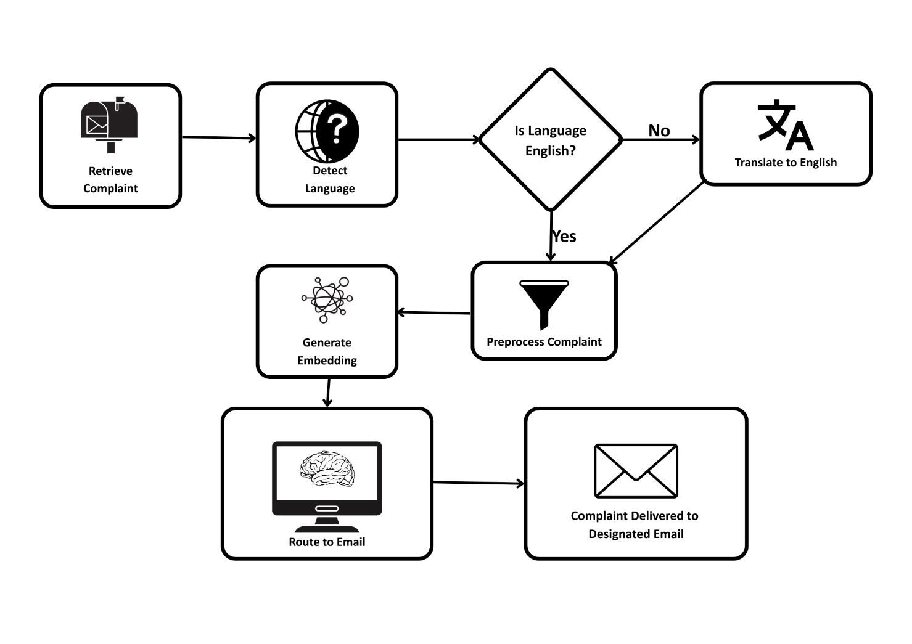
Figure 3.2: Flow of the System

The systematic flow of the complaint classification and routing mechanism, which is visually represented in the diagram above. The process is composed of several interconnected stages that collectively automate the journey of a complaint from email retrieval to appropriate departmental routing.

- Retrieve Complaint
The workflow begins with the retrieval of complaints submitted by users via email or file. Using a secure protocol such as IMAP, the system periodically accesses the inbox and fetches new emails. From each email, only the body content is extracted, as it contains the core message or complaint submitted by the user. This raw input becomes the starting point for the downstream processing pipeline.

- Detect Language
The system performs automatic language detection using a trained model. This step is crucial because users may submit complaints in various languages, especially in multilingual regions. The detection mechanism identifies whether the language used in the complaint is English or regional language such as Hindi, Marathi, or Telugu.

- Translate to English
If the language detected is not English, the content is passed through a translation module. This component uses a machine translation API to convert the complaint text into English. This ensures that the rest of the pipeline, which is standardized on English input, can process the text effectively. If the detected language is English, this step is bypassed.

- Preprocess Complaint
This process involves cleaning the text by converting it to lowercase, removing punctuation and special symbols, eliminating stopwords, and performing lemmatization. The goal of preprocessing is to retain only the essential information that contributes to the semantic understanding of the complaint.

- Generate Embedding
The cleaned text is then transformed into a numerical representation using embedding techniques. This step captures the semantic meaning of the complaint and converts it into a format that machine learning models can interpret. TF-IDF is used here to generate high-dimensional vectors that represent the content of the complaint effectively.

- Machine Learning Classification
The embedding is passed into a machine learning classification module. Two models—Support Vector Machine (SVM) and Logistic Regression—have been trained on a labeled dataset to categorize feedback into predefined departments such as “library”, “hostel”, “academics”, etc. The dataset is in CSV format and contains two columns:
• feedback: textual student feedback
• category: label representing the responsible department
Example entries include:
feedback: "The library's limited hours make it difficult to access resources during peak study times."
category: library
SVM, Logistic Regression and Random Forest classifiers are trained using this data, and their performance is evaluated using metrics such as accuracy, precision, recall, and F1-score. The best-performing model (or a hybrid approach) is deployed in the system for real-time prediction.

- Route to Email
Based on the classification result, the system determines the target department for each feedback. It then automatically routes the email to the appropriate recipient or department via email forwarding or database tagging. This eliminates the need for manual sorting and ensures that each query or complaint reaches the right authority in a timely manner.

CHAPTER 4
RESULTS AND DISCUSSIONS

Chapter 4
Result and Discussion

4.1 Result and Evaluation of System

The following is the result and performance of the system.

Training and Classification

The established system was assessed through both offline methods (by analyzing the performance of the classification model) and online methods (through its implementation and email routing). The system exhibited strong capabilities in classifying complaints in multiple languages and proved its capacity to automatically direct them to the correct departments with minimal mistakes.

Real-Time Deployment and Testing

The experimental results presented in this study demonstrate the effectiveness of the proposed system for automated complaint classification. The system's primary objective is to classify college complaints into predefined categories such as administration, admission, exam-related issues, hostel facilities, and others, accurately. Three machine learning classifiers - Support Vector Machine (SVM), Logistic Regression, and Random Forest - were employed to evaluate the performance of the system. This section presents a detailed analysis of the results, highlighting the strengths and limitations of the classifiers used, followed by an in-depth discussion on the errors and areas for further enhancement.
Data Preparation:
The dataset is structured in CSV format with two columns: “feedback” and “category.” Each row represents a feedback message and its corresponding category (e.g., library, hostel, academics). The classifiers learn patterns and associations from the dataset to accurately predict the category of new, unseen email content.
Dataset Overview
The dataset used for training consists of feedback entries labeled with categories. Each entry has:
• feedback: A student’s complaint or suggestion.
• category: The department to which it belongs, such as library, hostel, or academic.
Sample Entries:
Complaints | category
The library's limited hours make it difficult to access resources during peak study times | library
The outdated computers in the library are slow and hinder productivity. | library
There is a constant shortage of available study rooms in the library. | library

Model Evaluation:
Once pre-processed, the complaint text is transformed into a numerical representation. These numerical vectors are fed into machine learning models for classification.
For feature extraction, we use the TF-IDF technique, which captures the importance of words in a complaint. Its output is a sparse matrix that reflects word significance for each complaint. After feature extraction, we train multiple models to identify the best one for our system.
In our implementation, the Random Forest Classifier was found to perform best. This classifier leverages an ensemble of decision trees to provide robust predictions. Model optimization was achieved through hyperparameter tuning techniques such as Grid Search and Cross-Validation. The classification model was evaluated using metrics such as Precision, Accuracy, Recall and F1-score.
Performance Analysis:
The evaluation of classifier performance was conducted using key metrics such as precision, recall, F1-score, and overall accuracy. These metrics provide a comprehensive overview of the model's ability to classify complaints into the correct categories. The SVM classifier consistently outperformed the other models in terms of accuracy.
In contrast, the Support Vector Machine (SVM) classifier achieved a better accuracy of 98%, and Logistic Regression followed closely with 97%. While SVM demonstrated solid performance in some categories, such as transport, its overall ability to handle the diverse range of complaint categories was more optimized compared to Random Forest. Logistic Regression, on the other hand, exhibited suboptimal performance in certain categories, such as sports-related complaints, where it failed to classify correctly. Both Random Forest and Logistic Regression struggled with the imbalance of data across categories, particularly when some categories had very few samples.

Why SVM Performed the Best:
The performance capability of SVM is due to its ability to effectuate handling high-dimensional feature spaces of TF-IDF. Its robust mathematical foundation ensures that even when complaints are similar or overlap in content, the model will indeed detect very tiny distinctions. Besides, SVM minimizes mis-classification by adjusting the width of decision boundaries while taking into consideration the distribution of data points.

Misclassification Analysis:
Error analysis showed that misclassifications often stemmed from overlapping keywords and ambiguous language in complaint texts. For instance, complaints in "Hostel" and "Administration" categories frequently shared terms like "room," "facility," and "staff," leading to occasional confusion. Similarly, terms like "service" and "quality" were common in both "Canteen" and "Transport" complaints, causing some mislabeling between these categories.
These patterns highlight a limitation of classical models in capturing contextual nuances. While the metrics are strong, especially for SVM, errors due to semantic overlap persist. This suggests the need for deeper contextual understanding of the text.
Improving Accuracy with Contextual Embeddings:
To address these issues, integrating context-aware embeddings such as BERT (Bidirectional Encoder Representations from Transformers) is recommended. Unlike traditional models, BERT captures the contextual relationship between words, allowing it to differentiate complaints that use similar vocabulary but refer to different categories. This can significantly reduce misclassification caused by keyword overlap and improve overall model performance.

Evaluation Metrics

To evaluate the efficiency of the suggested complaint classification system, the models were assessed using conventional classification metrics such as Precision, Recall, F1-score, and Support for each category of complaints. These metrics offer a thorough insight into the performance of each model, not only regarding accuracy but also in recognizing pertinent complaints across various departments.

Definitions of Metrics:

Precision measures the percentage of correct positive predictions:

$Precision=\frac{(TP+FP)}{TP}$​

A high precision means that the model makes very few false positive errors.

Recall (Sensitivity) measures the ability of the model to detect all relevant complaints:

$Recall= \frac{(TP+FN)}{TP}$

A high recall ensures that most actual complaints in a category are correctly captured.

F1-Score is the harmonic mean of Precision and Recall:
$$F1-score=2×\frac{(Precision+Recall)}{Precision ×Recall}$$
It provides a balance between Precision and Recall, especially useful in cases of imbalanced data.

Table 4.1: Classification Report of Random Forest
Category | Precision | Recall | F1-score | Support
administration | 0.98 | 0.97 | 0.98 | 206
admission | 0.98 | 0.95 | 0.97 | 198
canteen | 1.00 | 0.97 | 0.99 | 195
exam | 0.98 | 0.99 | 0.98 | 213
finance | 0.95 | 0.97 | 0.96 | 223
hostel | 0.99 | 0.98 | 0.99 | 185
library | 0.99 | 0.98 | 0.99 | 204
sports | 0.93 | 0.95 | 0.94 | 171
training and placement | 0.98 | 0.98 | 0.98 | 201
transport | 0.93 | 0.97 | 0.95 | 194

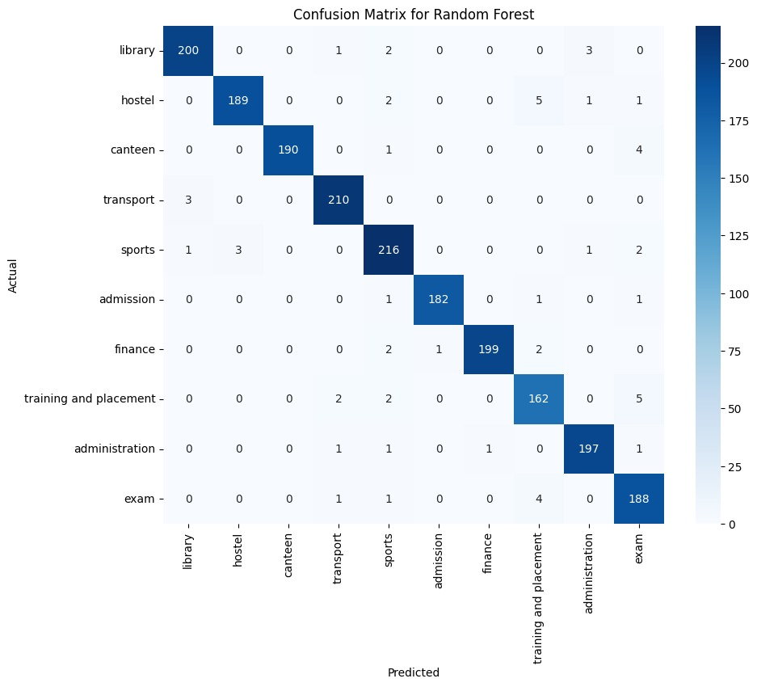
Figure 4.1: Confusion Matrix of Random Forest

Table 4.2: Classification Report of Logistic Regression
Category | Precision | Recall | F1-score | Support
administration | 0.98 | 0.95 | 0.96 | 206
admission | 0.98 | 0.95 | 0.97 | 198
canteen | 1.00 | 0.98 | 0.99 | 195
exam | 0.99 | 0.99 | 0.99 | 213
finance | 0.94 | 0.97 | 0.95 | 223
hostel | 0.99 | 0.99 | 0.99 | 185
library | 1.00 | 0.98 | 0.99 | 204
sports | 0.94 | 0.98 | 0.96 | 171
training and placement | 0.98 | 1.00 | 0.99 | 201
transport | 0.96 | 0.97 | 0.96 | 194

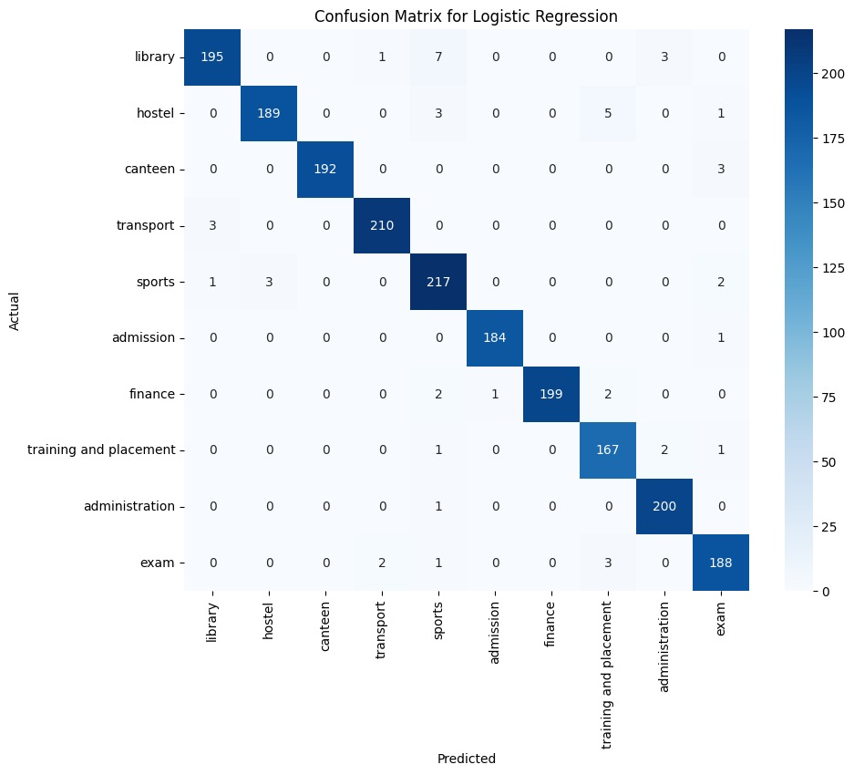
Figure 4.2: Confusion Matrix of Logistic Regression

Table 4.3: Classification Report of Support Vector Machine (SVM)
Category | Precision | Recall | F1-score | Support
administration | 0.98 | 0.97 | 0.98 | 206
admission | 0.98 | 0.97 | 0.98 | 198
canteen | 1.00 | 0.99 | 0.99 | 195
Exam | 0.98 | 0.99 | 0.98 | 213
finance | 0.97 | 0.97 | 0.97 | 223
hostel | 0.99 | 1.00 | 1.00 | 185
library | 1.00 | 0.99 | 1.00 | 204
sports | 0.95 | 0.99 | 0.97 | 171
training and placement | 0.99 | 0.99 | 0.99 | 201
transport | 0.98 | 0.97 | 0.97 | 194

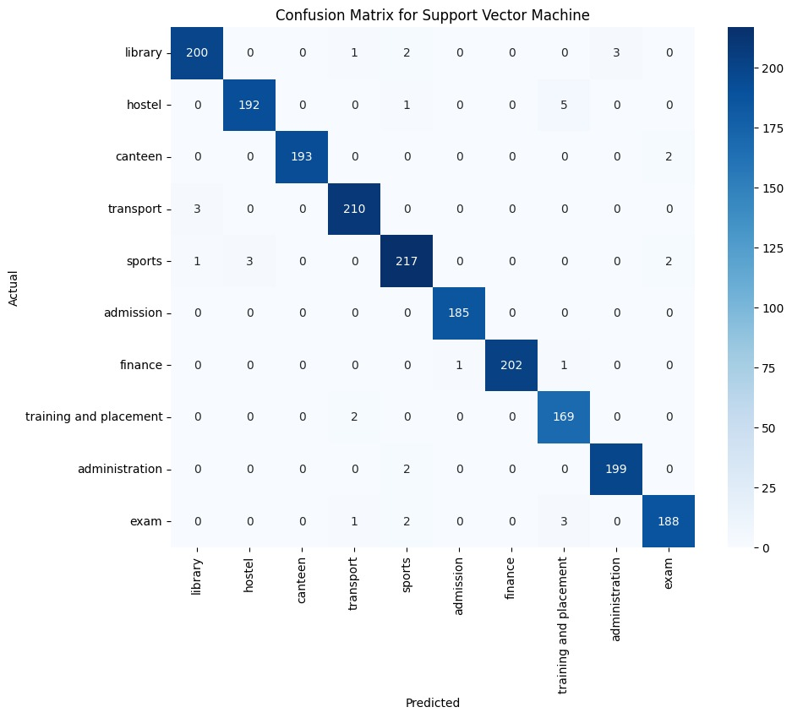
Figure 4.3: Confusion Matrix of Support Vector Machine (SVM)

The classifier proved to be strong in good lighting conditions and could separate between persons with very high accuracy. Small variations in accuracy were noticed in heavily dim lighting or partial face occlusion.

Screenshots and Output Logs

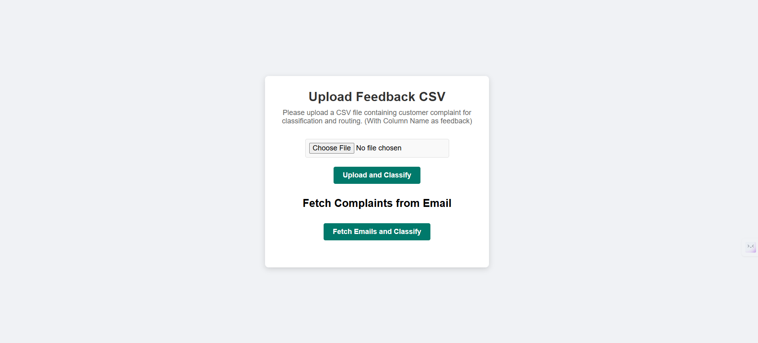
Figure 4.4: User Interface of the Proposed System

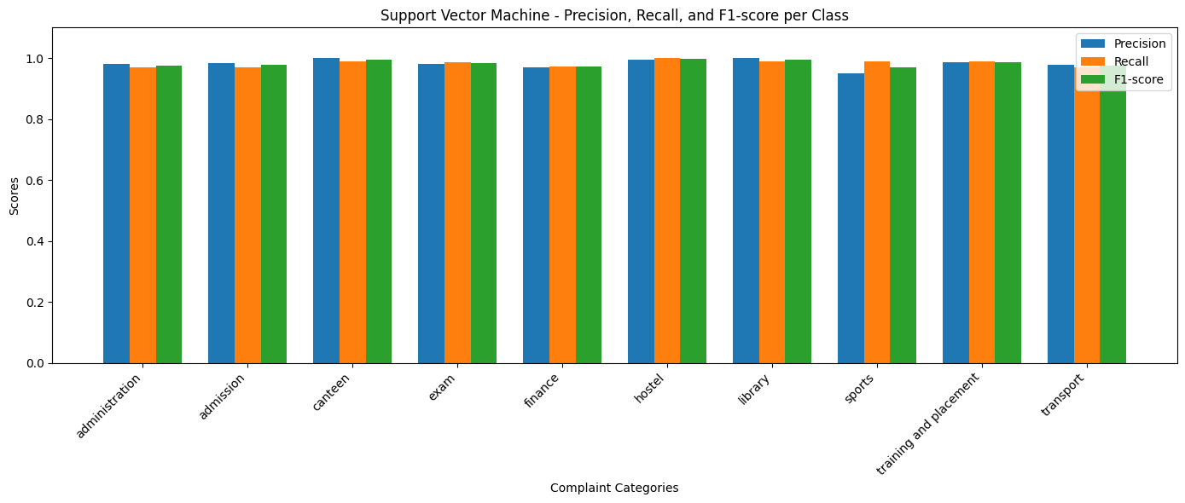
Figure 4.5: Bar Chart of Precision, Recall, and F1-Score per Class for SVM

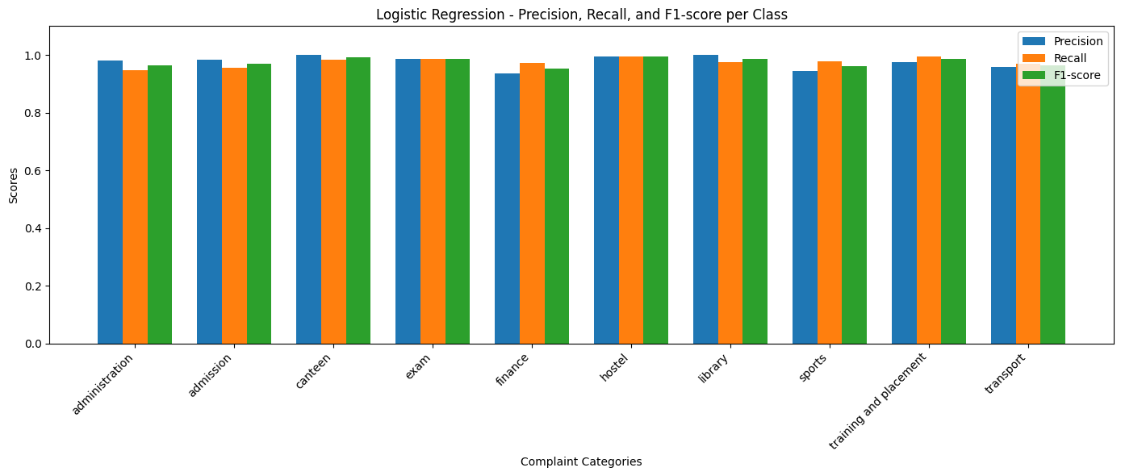
Figure 4.6: Bar Chart of Precision, Recall, and F1-Score per Class for Logistic Regression

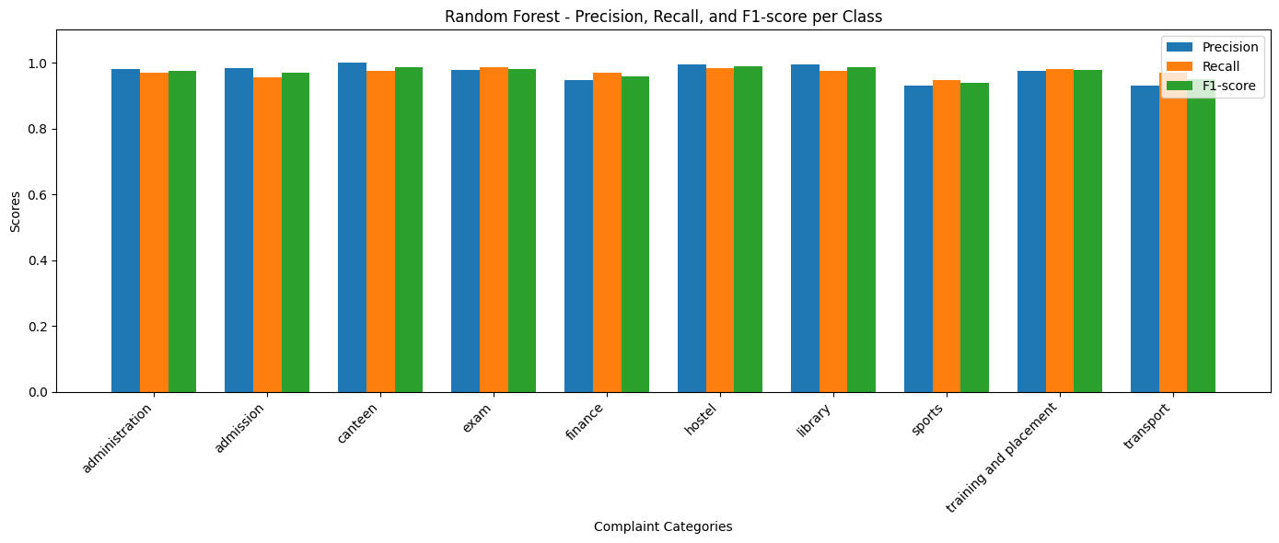
Figure 4.7: Bar Chart of Precision, Recall, and F1-Score per Class for Random Forest

Summary

From the Figure 4.4, we can see the User Interface of the System. We have designed a very simple interface as our sole focus on achieving the goal of the system which is classification and routing.

Figure 4.5 represents Bar Chart of Precision, Recall, F1-score for Support Vector Machine (SVM). We can clearly see that Precision, Recall and F1-score values are high for all the categories.

Figure 4.6 represents Bar Chart of Precision, Recall, F1-score for Logistic Regression (LR). We can clearly see that Precision, Recall and F1-score values are high for all the categories.

Figure 4.7 represents Bar Chart of Precision, Recall, F1-score for Random Forest. We can clearly see that Precision, Recall and F1-score values are high for all the categories.

CHAPTER 5

SUMMARY AND CONCLUSIONS

Chapter 5
Summary and Conclusions

Social Utility

The automated system for routing and classifying customer complaints offers significant advantages for societal well-being and public service efficiency. Its implementation can lead to:

Enhanced Public Service Delivery: Municipalities, which handle numerous departments and daily complaints, can use this system to streamline operations, thereby improving public services and accountability.

Support for Government Initiatives: The system can assist various government departments. For example, it could aid the Ministry of Women and Child Development in India by more effectively managing complaints concerning women's safety.

Improved Efficiency in Educational Institutions: By automating the handling of student feedback and complaints, particularly those in regional languages, the system fosters better communication between students and administrative departments. This contributes to operational efficiency and student satisfaction within academic settings.

Increased Accessibility and Inclusivity: The system's capacity to process complaints in multiple languages (English, Hindi, Marathi, and Telugu) promotes linguistic inclusivity. This allows individuals to voice concerns in their regional languages without hindering the system's effectiveness.

Faster Resolution and Satisfaction: By automating classification and routing, the system significantly reduces manual workload and response times. This ensures that concerns are promptly directed to the appropriate authorities, potentially leading to quicker resolutions and improved public or customer satisfaction.

Foundation for Smarter Administration: In educational contexts, particularly for creating smart campuses, this system provides a fundamental tool for intelligent automation in academic administration.

Minimizing Human Error and Potential Bias in Initial Complaint Processing:

Manual handling of complaints is not only time-consuming but also susceptible to human errors and potential unintentional biases during the critical initial stages of categorization and routing. By automating these processes, the system ensures a more consistent, objective, and standardized approach to the preliminary handling of all complaints, regardless of their origin or perceived sentiment, thereby promoting fairer and more equitable treatment of grievances from the outset.

Summary
This project tackled a widespread and ongoing problem common to many organizations: the challenge of effectively managing and replying to customer grievances. In the past, handling complaints was a manual task, often leading to significant time consumption, delays, and instances of misdirection. The creation of an automated system for classifying and routing complaints marks a substantial step forward in making the entire procedure more efficient—from the moment a complaint is lodged to its swift and precise delivery to the correct departmental unit.
By leveraging machine learning to categorize complaints based on their specific content and the language used, this system eases the workload for administrative teams while also markedly boosting response speeds and overall organizational productivity. Essentially, this initiative paves the way for more intelligent, quicker, and adaptable customer support in situations where resolving issues in a timely manner is paramount.
Comprehensive Dataset Development and Implementation
A cornerstone of this project was the development of a well-structured and representative dataset tailored to complaints within a college or institutional setting. It included diverse complaint categories like Administration, Hostel, Canteen, Exam, Finance, Transport, and more, reflecting real-world departmental concerns.
Initially focused on English-language data, dataset is still in English but now system can handle different languages. This shift is especially important in a diverse country or organization where users might raise concerns in various languages. Now, the system can understand and classify complaints across languages, making it far more inclusive and practical for real-world deployment.
Building the dataset wasn’t without its challenges—many complaints overlapped thematically, making it difficult to assign a single category. For instance, a complaint mentioning "room condition" might belong to either Hostel or Administration. Still, through careful annotation and thoughtful categorization, the dataset became a powerful training resource for machine learning models, allowing them to learn and adapt to the complexities of natural, unstructured complaint text.

Leveraging Machine Learning Models

To power the classification engine, several machine learning models were trained and evaluated—Logistic Regression, Random Forest, and Support Vector Machine (SVM). Each model was tested using performance metrics like precision, recall, F1-score, and accuracy across multiple complaint categories.

The success of Among them, the Support Vector Machine emerged as the top performer, achieving exceptional precision and recall across nearly all categories. In some cases—like "Hostel," "Library," and "Canteen"—it even achieved near-perfect scores, showcasing its ability to understand subtle differences in complaint language and context.

Logistic Regression and Random Forest also delivered strong results, with consistently high performance in most categories. Precision and recall scores were above 90% for the majority of complaint types, demonstrating that the models weren’t just accurate—they were also dependable.

That said, some challenges remained. Misclassifications tended to occur in categories with semantic overlap or vague language. For example, complaints using the word “facility” could relate to Hostel, Administration, or even Canteen depending on context. These edge cases highlight the importance of contextual understanding—something that basic keyword matching alone can’t solve.

Looking forward, further improvements can come from integrating context-aware models like BERT, which understand not just individual words but how they relate to each other. These upgrades would help the system navigate ambiguity more effectively, reducing errors and improving the overall user experience.

Addressing Challenges with Advanced NLP Techniques

A critical insight from the error analysis phase was the realization that machine learning models need to be enhanced to better capture the contextual and semantic information in complaints. Current models, although effective at handling structured data, struggle to deal with the inherent ambiguity in natural language. For instance, complaints often involve varied expressions and vocabulary, which can lead to misclassifications if the model only relies on keywords or shallow semantic features. During the error analysis phase, one thing became clear: complaints are rarely straightforward. They often contain informal language, mixed sentiments, overlapping topics, and nuanced context. While our machine learning models have performed impressively so far, they occasionally struggle to grasp the deeper meaning behind ambiguous or context-rich complaints.

To overcome this, we're looking to integrate more advanced Natural Language Processing (NLP) techniques. A major step forward is using context-aware models like BERT, which understand the meaning of words based on their placement in a sentence. Unlike traditional models that depend heavily on keywords, BERT can detect the underlying intent—whether a student says “the food is cold” or “the mess isn’t hygienic,” both get accurately linked to the Canteen category. BERT is a pre-trained deep learning model capable of understanding the context of words in a sentence, making it an ideal solution for handling the ambiguity present in customer complaints. By leveraging BERT’s contextual embeddings, the system will be able to better capture the intent behind each complaint, leading to more accurate classification and routing.

Moreover, the deployment of deep learning models such as Transformers is another avenue for improving classification accuracy. Transformers have revolutionized the field of NLP by allowing models to learn long-range dependencies in text, which could prove invaluable for classifying complex, multi-sentence complaints. These models promise not only better accuracy but also a richer, more human-like understanding of complaint language.

System Performance and Real-World Application

The primary goal of this system is to reduce the workload on human operators, improve response times, and ensure more accurate classification of complaints. At its core, this system is built to make life easier—for both institutions and the people who rely on them. By automating the process of complaint routing, the system not only saves time but also improves the overall customer service experience. Human operators are no longer required to sift through large volumes of complaints manually, allowing them to focus on more complex tasks and ensuring a faster response time to urgent issues.

Furthermore, the use of machine learning ensures that the system can learn and adapt over time. As more complaints are processed and classified, the model continues to improve, which results in increasingly accurate classifications. This makes the system not just a static solution but one that evolves to meet the changing nature of complaints and customer needs. This not only improves response times but also ensures fairer, more consistent decisions. No more human biases or oversights—just data-driven routing based on the actual content of each complaint.

The use of machine learning models for complaint routing and classification also helps mitigate human bias, which can often be a challenge in manual processes. By relying on data-driven insights, the system provides consistent and fair routing decisions based on the content of the complaints, rather than any subjective human interpretation.

Visualizations and Insights

To truly understand how the system performs, we didn’t just rely on accuracy scores—we used visual tools to dig deeper. Visualizations, such as confusion matrices and category-wise performance graphs, were used to provide insights into the system's behaviour and identify areas for improvement. These visualizations serve as an effective way to communicate the model’s performance and help developers understand where the model is performing well and where it may need further refinement. For instance, we observed strong performance in categories like Transport and Hostel, but some confusion in areas like Sports or Library, likely due to limited training samples or overlap in phrasing with other departments. These insights help guide further fine-tuning—whether it's tweaking model hyperparameters or revisiting how we define certain categories.

By analyzing these visualizations, future work can focus on fine-tuning the models to address specific areas where performance is suboptimal. This will involve adjusting hyperparameters, enhancing the feature set, and incorporating more sophisticated NLP techniques as previously discussed. Visual analytics also make it easier to communicate model behavior to stakeholders, ensuring that performance isn’t just a number but a story we can understand and act on.

Future Directions

While this project has successfully demonstrated the effectiveness of the automated complaint classification and routing system, there is still significant room for growth and enhancement. Several areas for future development have been identified:

Expanded Dataset (>9,000 Complaints and Growing): We've significantly expanded the dataset to include around 9,000 real-world complaints—covering more departments and a wider variety of issues. This richer dataset helps the model generalize better and perform more reliably across edge cases. We have increased the size of dataset from 200 to >9000 complaints which will help us to create a better system.

- Deep Learning Models: As mentioned earlier, deep learning models like BERT and Transformer architectures will be explored to improve the understanding of the semantic context within complaints. These models have been shown to outperform traditional machine learning techniques in many NLP tasks and hold the potential to further enhance the system’s classification accuracy.

- Real-Time Processing and Scalability: Currently, the system is designed for batch processing, where complaints are classified in a non-real-time manner. However, for many real-world applications, real-time processing is essential. Future work will involve deploying the system on cloud platforms, enabling it to handle complaints in real time. Cloud deployment will also facilitate scalability, allowing the system to handle large volumes of complaints as they are submitted, making it more suitable for deployment in larger institutions or companies.

- Multimodal Complaint Classification: Another avenue for future research is to explore the integration of multimodal data. For example, complaints could be submitted in various formats, such as text, voice, or even images. By incorporating speech-to-text technology and image recognition models, the system could process and classify complaints submitted in different forms, further enhancing its versatility. Complaints don’t always come in plain text. In the future, we aim to support multimodal input formats, such as voice notes and images.

- Continuous Improvement and Adaptation: Over time, the system will need to evolve to meet changing customer needs and address new complaint categories that may emerge. By incorporating techniques like active learning, the system can continuously update its model based on user feedback, ensuring that it remains effective and up to date.

Conclusion

In conclusion, this project has made significant strides in automating the process of complaint routing and classification. The development of a comprehensive dataset, coupled with the implementation of machine learning models, has demonstrated the feasibility and effectiveness of the proposed system. The ability to automatically classify and route complaints not only reduces the workload on human operators but also ensures quicker and more accurate responses to customers. The use of advanced NLP techniques, coupled with the promise of deep learning models and cloud-based deployment, points to a future where this system can be scaled and adapted to meet the demands of larger, more diverse organizations. By continuing to refine and expand the system, it holds great potential for revolutionizing customer service automation in various industries.

This project presents the design, development, and implementation of an intelligent email classification and routing system tailored for academic institutions, with a focus on handling multilingual feedback. The initiative originated as a mini project with limited scope but was significantly expanded in the major project to include advanced features such as language translation, text embeddings, and machine learning-based classification using Support Vector Machines (SVM) and Logistic Regression algorithms. The system demonstrates the effective use of Natural Language Processing (NLP) and machine learning to automate the classification of feedback emails and route them to the appropriate institutional departments, thus streamlining administrative workflows.

The project's workflow begins by retrieving emails from a designated mailbox. Recognizing the linguistic diversity in feedback, the system incorporates a language detection module that identifies whether the content is in Hindi, Marathi, or Telugu. If the email is in one of these supported regional languages, the content is translated into a common language (English) to ensure consistency in further processing. This multilingual capability significantly enhances the system's usability and applicability in Indian educational contexts, where students often communicate in their native languages.

Once the content is translated (if necessary), the system proceeds to convert the textual data into an embedding—a numerical vector representation—using appropriate embedding techniques. This step is crucial as it transforms unstructured text into a format that machine learning models can interpret and analyze. The resulting embeddings are then passed to a trained classification model. The system uses two popular algorithms—SVM and Logistic Regression—which have been trained on a well-curated dataset consisting of student Complaint and their corresponding categories, such as "library", "hostel", "academics", etc. The dataset is stored in a CSV format with two primary columns: "feedback" and "category".

The classification models were trained with the goal of accurately identifying the department or issue type associated with a particular piece of feedback. Both models were selected due to their proven performance in text classification tasks. SVM is known for its effectiveness in high-dimensional spaces and is well-suited for text classification. Logistic Regression, on the other hand, provides probabilistic interpretation and is computationally efficient for binary and multi-class classification problems. The training phase involved preprocessing the data, transforming text into embeddings, splitting the data into training and testing sets, and evaluating the models using appropriate metrics such as accuracy, precision, recall, and F1-score.

After classification, the system routes the email to the designated department. This final step ensures that the feedback reaches the appropriate authority without manual intervention. It closes the loop of automation by addressing the core objective of the project—reducing human workload, improving the response time to student concerns, and enhancing operational efficiency in academic administration.

One of the critical strengths of this project lies in its multilingual support. Many systems fail to accommodate feedback provided in native languages, leading to the exclusion of important inputs from students who are not comfortable communicating in English. By incorporating translation for Hindi, Marathi, and Telugu, this project bridges the language barrier and makes the solution more inclusive. It is important to note that sentiment analysis was intentionally excluded from the system to maintain focus on functional categorization of feedback. This decision was taken to keep the system lightweight and purpose-specific, ensuring that resources are directed toward accurate classification rather than subjective sentiment interpretation.

Throughout the course of this project, several technical challenges were encountered and successfully addressed. These included handling noisy textual data, managing the variance in expression due to language translation, optimizing classification accuracy, and ensuring that the system is scalable for institutional use. Rigorous testing and validation were conducted to assess the reliability and performance of the system under various conditions. The results indicated that the system performs reliably in terms of classification accuracy and response time, demonstrating its potential for real-world deployment.

In conclusion, this Project successfully delivers a practical and robust solution to the problem of automated email classification and routing in academic institutions. It integrates email retrieval, language translation, text embedding, and machine learning into a seamless workflow that is capable of handling multilingual inputs and routing feedback with minimal human oversight. The system not only enhances administrative efficiency but also fosters a more responsive and inclusive communication environment within educational institutions. With further improvements, such as the integration of more languages, better translation accuracy, and the incorporation of additional machine learning techniques, the system can be extended to other domains like corporate feedback management, customer support, or governmental grievance redressal platforms. Overall, the project stands as a significant contribution to smart educational infrastructure, promoting the adoption of intelligent automation in everyday institutional processes.

.

Future Scope

Expansion of Language Support: The system can be extended to include a broader range of regional and international languages beyond the current support for English, Hindi, Marathi, and Telugu, thereby increasing its applicability.

Integration with Existing Enterprise Systems:

The system could be integrated with existing campus management software, customer relationship management (CRM) tools, or institutional ticketing systems for a more seamless workflow.

Advanced Classification Capabilities: Future iterations could incorporate more complex classification tasks, potentially including finer-grained categorization or identifying interconnected issues within complaints.

Enhanced Prioritization Mechanisms: While the system combines automated classification, routing, and prioritization, the prioritization logic itself could be further developed, perhaps using machine learning to dynamically assess and rank complaint urgency based on various factors.

Continuous Model Improvement with More Data: The accuracy and robustness of the machine learning models can be continuously improved by training with larger and more diverse datasets of real-world academic or customer feedback.

Broader Domain Adaptability: The system's architecture could be adapted and fine-tuned for specialized complaint management in other sectors beyond education and government, such as healthcare, finance, or specific customer service industries.

REFERENCES

[1] T. Roy, G. Vasukidevi, M. Turlapati, U. Subramanian, and N. Namratha, "Automatic Classification of Railway Complaints using Machine Learning," E3S Web of Conferences, vol. 477, 2024, doi: 10.1051/e3sconf/202447700085
[2] S. Kumar, P. Jyothi, and P. Bhattacharyya, "Part-of-speech tagging for extremely low-resource Indian languages," in Findings of the Association for Computational Linguistics: ACL 2024, Bangkok, Thailand, Aug. 11-16, 2024, pp. 14422–14431.
[3] S. Haq, A. Sharma, O. Khattab, N. Chhaya, and P. Bhattacharyya, "IndicIRSuite: Multilingual Dataset and Neural Information Models for Indian Languages," in Proceedings of the 62nd Annual Meeting of the Association for Computational Linguistics (Volume 2: Short Papers), Bangkok, Thailand, Aug. 2024, pp. 501–509, doi: 10.18653/v1/2024.acl-short.46.
[4] P. Ghosh, S. Vashishth, R. Dabre, and P. Bhattacharyya, "A Morphology-Based Investigation of Positional Encodings," in Proceedings of EMNLP 2024, Miami, Florida, USA, 12-16 November 2024.
[5] S. D. Deoghare, D. Kanojia, and P. Bhattacharyya, "Together We Can: Multilingual Automatic Post-Editing for Low-Resource Languages," in Findings of EMNLP 2024, Miami, FL, USA, 12-16 Nov. 2024.
[6] K. Maity, A. S. Poornash, S. Saha, and P. Bhattacharyya, "Multimodal Toxicity Detection in Code-Mixed Video Content: Unveiling a Hindi-English Benchmark Dataset," in Proceedings of the ACL24 Findings, Bangkok, Thailand, Aug. 11-16, 2024.
[7] N. R. Sahoo, P. P. Kulkarni, A. Ahmad, T. Goyal, N. Asad, A. Garimella, and P. Bhattacharyya, "IndiBias: A Benchmark Dataset to Measure Social Biases in Language Models for Indian Context," in Proceedings of the NAACL 2024, Mexico City, Mexico, Jun. 16–21, 2024
[8] S. Settaluri, P. Agarwal, and P. Bhattacharyya, "IndiFoodVQA: Advancing Visual Question Answering and Reasoning with a Knowledge-Infused Synthetic Data Generation Pipeline," in EACL24 Findings, Malta, Mar. 17-22, 2024.
[9] N. R. Sahoo, G. P. Beria, and P. Bhattacharyya, "IndicCONAN: A multilingual dataset for combating Hate Speech in Indian Context," in AAAI24 AI for Social Impact (AISI), Vancouver, Canada, Feb. 20-27, 2024.
[10] A. Kunchukuttan, D. Kakwani, S. Golla, G. N. C., A. Bhattacharyya, M. M. Khapra, and P. Kumar, "AI4Bharat-IndicNLP Corpus: Monolingual Corpora and Word Embeddings for Indic Languages," arXiv preprint arXiv:2005.00085
[11] D. Banga and K. Peddireddy, "Artificial Intelligence for Customer Complaint Management," International Journal of Computer Trends and Technology, vol. 71, no. 3, pp. 1-6, Mar. 2023. doi: 10.14445/22312803/IJCTT-V71I3P101.
[12] G. Alarifi, M. F. Rahman, and M. S. Hossain, "Prediction and Analysis of Customer Complaints Using Machine Learning Techniques," International Journal of E-Business Research (IJEBR), vol. 19, no. 1, pp. 1-25, 2023. doi: 10.4018/IJEBR.319716.
[13] S. Nath, P. Bhattacharyya, and H. Khadilkar, "Reinforcement Replaces Supervision: Query Focused Summarization Using Deep Reinforcement Learning," in Proceedings of EMNLP, Singapore, Dec. 6-10, 2023.
[14] F. A. Alifat, O. A. Biodun, O. A. Oluwatobi, U. J. Ifeoma, and R. T. Amosa, “Web-based Campus Complaint Management System (WCCMS),” International Journal of Computer Trends and Technology, vol. 70, no. 10, pp. 28-36, 2022. [Online]. Available: https://doi.org/10.14445/22312803/IJCTT-V70I10P105.
[15] V. Bhat, P. Jyothi, and P. Bhattacharyya, "DISCO: A Large Scale Human Annotated Corpus for Disfluency Correction in Indo-European Languages," in EMNLP Findings, Singapore, Dec. 6-10, 2023.
[16] A. P. Singh, A. Goel, A. Goel, and D. Arya, "NLP based Grievance Redressal System," International Journal of Computer Applications, vol. 184, no. 12, pp. 44–49, May 2022
[17] Q. ul Ain, A. Shaukat, and U. Saif, "NLP based Model for Classification of Complaints: Autonomous and Intelligent System," in 2022 2nd International Conference on Digital Futures and Transformative Technologies (ICoDT2), May 2022, doi: 10.1109/ICoDT255437.2022.9787456
[18] S. Sarkar, D. Feng, and S. K. K. Santu, "Exploring Universal Sentence Encoders for Zero-shot Text Classification," in Proceedings of the 2nd Conference of the Asia-Pacific Chapter of the Association for Computational Linguistics and the 12th International Joint Conference on Natural Language Processing (Volume 2: Short Papers), 2022, pp. 135–147.
[19] A. Ladkat, A. Miyajiwala, S. Jagadale, R. Kulkarni, and R. Joshi, "Towards Simple and Efficient Task-Adaptive Pre-training for Text Classification," arXiv preprint arXiv:2209.12943, 2022
[20] X. Tian, I. Vertommen, L. Tsiami, P. van Thienen, and S. Paraskevopoulos, "Automated Customer Complaint Processing for Water Utilities Based on Natural Language Processing—Case Study of a Dutch Water Utility," Water, vol. 14, no. 4, p. 674, 2022. doi: 10.3390/w14040674.
[21] R. Murthy, P. Bhattacharjee, R. Sharnagat, J. Khatri, D. Kanojia, and P. Bhattacharyya, "A large Hindi Named Entity Recognition Dataset," in Proceedings of the LREC 2022, Marseille, France, June 20-25, 2022.
[22] R. Kundu, P. Jyothi, and P. Bhattacharyya, "Zero-shot Disfluency Detection for Indian Languages," in Proceedings of the 29th International Conference on Computational Linguistics, Gyeongju, Republic of Korea, 2022, pp. 4442–4454, International Committee on Computational Linguistics
[23] D. S. Chauhan, G. V. Singh, A. Arora, A. Ekbal, and P. Bhattacharyya, "A Sentiment and Emotion Aware Multimodal Multiparty Humor Recognition in Multilingual Conversational Setting," in Proceedings of the 29th International Conference on Computational Linguistics, Gyeongju, Republic of Korea, 2022, pp. 6752–6761, International Committee on Computational Linguistics.
[24] D. S. Chauhan, A. Ekbal, and P. Bhattacharyya, "An Efficient Fusion Mechanism for Multimodal Low-resource Setting," in Proceedings of the 45th International ACM SIGIR Conference on Research and Development in Information Retrieval (SIGIR '22), Madrid, Spain, Jul. 11–15, 2022, ACM, New York, NY, USA, 5 pages. https://doi.org/10.1145/3477495.3531900
[25] G. V. Singh, P. Priya, M. Firdaus, A. Ekbal, and P. Bhattacharyya, "EmoInHindi: A Multi-label Emotion and Intensity Annotated Dataset in Hindi for Emotion Recognition in Dialogues," in Proceedings of the Thirteenth Language Resources and Evaluation Conference, Marseille, France, 2022, pp. 5829–5837, European Language Resources Association
[26] R. Dabre, H. Shrotriya, A. Kunchukuttan, R. Puduppully, M. Khapra, and P. Kumar, "IndicBART: A Pre-trained Model for Indic Natural Language Generation," in Findings of the Association for Computational Linguistics: ACL 2022, Dublin, Ireland, 2022, pp. 1849–1863, Association for Computational Linguistics.
[27] G. Ramesh, S. Doddapaneni, A. Bheemaraj, M. Jobanputra, R. AK, A. Sharma, S. Sahoo, H. Diddee, M. J., D. Kakwani, N. Kumar, A. Pradeep, S. Nagaraj, K. Deepak, V. Raghavan, A. Kunchukuttan, P. Kumar, and M. S. Khapra, "Samanantar: The Largest Publicly Available Parallel Corpora Collection for 11 Indic Languages," Transactions of the Association for Computational Linguistics, vol. 10, pp. 145–162, 2022.
[28] S. Bhosale, S. Patankar, K. Kadam, R. Dhere, and M. Desai, "Civil Complaints Management System by using Machine Learning Techniques," International Research Journal of Engineering and Technology (IRJET), vol. 8, no. 6, pp. 299, June 2021. e-ISSN: 2395-0056, p-ISSN: 2395-0072.
[29] A. Borg, M. Boldt, O. Rosander, and J. Ahlstrand, "E-mail classification with machine learning and word embeddings for improved customer support," Neural Computing and Applications, vol. 33, pp. 1881-1902, 2021. doi: 10.1007/s00521-020-05058-4
[30] P. Hake, J.-R. Rehse, and P. Fettke, "Toward Automated Support of Complaint Handling Processes: An Application in the Medical Technology Industry," Journal on Data Semantics, vol. 10, pp. 41-56, 2021. doi: 10.1007/s13740-021-00124-z
[31] X. Tang, H. Mou, J. Liu, and X. Du, "Research on automatic labeling of imbalanced texts of customer complaints based on text enhancement and layer-by-layer semantic matching," Nature Scientific Reports, vol. 11, article 11849, 2021. doi: 10.1038/s41598-021-91121-4.
[32] A. Banerjee, A. Jain, S. Mhaskar, S. D. Deoghare, A. Sehgal, and P. Bhattacharya, "Neural Machine Translation in Low-Resource Setting: A Case Study in English-Marathi Pair," in Proceedings of the Machine Translation Summit 2021, Aug. 16–20, 2021.
[33] K. Saunack, K. Saurav, and P. Bhattacharyya, "How low is too low? A monolingual take on lemmatisation in Indian languages," in Proceedings of the 2021 Conference of the North American Chapter of the Association for Computational Linguistics: Human Language Technologies, Online, Jun. 2021, pp. 4088–4094, doi: 10.18653/v1/2021.naacl-main.322
[34] T. Dhamecha, R. Murthy, S. Bharadwaj, K. Sankaranarayanan, and P. Bhattacharyya, "Role of Language Relatedness in Multilingual Fine-tuning of Language Models: A Case Study in Indo-Aryan Languages," in Proceedings of the 2021 Conference on Empirical Methods in Natural Language Processing, Online and Punta Cana, Dominican Republic, 2021, pp. 8584–8595, Association for Computational Linguistics.
[35] S. Khanuja, D. Bansal, S. Mehtani, S. Khosla, A. Dey, B. Gopalan, D. K. Margam, P. Aggarwal, R. T. Nagipogu, S. Dave, S. Gupta, S. C. B. Gali, V. Subramanian, and P. P. Talukdar, "MuRIL: Multilingual Representations for Indian Languages," ArXiv, vol. abs/2103.10730, 2021. https://api.semanticscholar.org/CorpusID:232290691.
[36] K. Zahoor, N. Z. Bawany, and S. Hamid, "Sentiment Analysis and Classification of Restaurant Reviews using Machine Learning," in 2020 21st International Arab Conference on Information Technology (ACIT), Giza, Egypt, 2020, pp. 1-6, doi: 10.1109/ACIT50332.2020.9300098.
[37] K. Zerrouki, R. Hamou, and A. Rahmoun, "Sentiment Analysis of Tweets Using Naïve Bayes, KNN, and Decision Tree," International Journal of Organizational and Collective Intelligence, vol. 10, pp. 35-49, 2020. doi: 10.4018/IJOCI.2020100103
[38] K. Ganesan and G. Zhou, "Linguistic Understanding of Complaints and Praises in User Reviews," presented at the Annual Conference on Empirical Methods in Natural Language Processing (EMNLP), San Francisco, CA, USA, 2020
[39] Tom B. Brown, B. Mann et al., "Language Models are Few-Shot Learners," arXiv:2005.14165 [cs.CL], May 2020.
[40] A. Mabrouk, R. P. Díaz Redondo, and M. Kayed, "Deep Learning-Based Sentiment Classification: A Comparative Survey," IEEE Access, vol. 8, pp. 87487-87500, May 2020. doi: 10.1109/ACCESS.2020.2992013
[41] A. Benlahbib and E. Nfaoui, "Aggregating Customer Review Attributes for Online Reputation Generation," IEEE Access, vol. 8, no. 1, pp. 96550-96564, Dec. 2020. doi: 10.1109/ACCESS.2020.2996805.
[42] B. Haddow and F. Kirefu, "PMIndia -- A Collection of Parallel Corpora of Languages of India," arXiv preprint arXiv:2001.09907, Jan. 2020. doi: 10.48550/arXiv.2001.09907
[43] S. Agarwal, J. Bandlamudi, A. Mandal, A. Ray, and G. Sridhara, "Automated Assignment of Helpdesk Email Tickets: An Artificial Intelligence Life-Cycle Case Study," The Association for the Advancement of Artificial Intelligence, 2020.
[44] J. Khatri, R. Murthy, and P. Bhattacharyya, "A Study of Efficacy of Cross-lingual Word Embeddings for Indian Languages," in Proceedings of the 7th ACM IKDD CoDS and 25th COMAD (CoDS COMAD 2020), New York, NY, USA, 2020, pp. 347–348. https://doi.org/10.1145/3371158.3371219.
[45] D. Kakwani, A. Kunchukuttan, S. Golla, G. N. C., A. Bhattacharyya, M. M. Khapra, and P. Kumar, "IndicNLPSuite: Monolingual Corpora, Evaluation Benchmarks and Pre-trained Multilingual Language Models for Indian Languages," in Findings of the Association for Computational Linguistics: EMNLP 2020, pp. 4948–4961, Association for Computational Linguistics.
[46] S. Siripragada, J. Philip, V. P. Namboodiri, and C. V. Jawahar, "A Multilingual Parallel Corpora Collection Effort for Indian Languages," in Proceedings of the Twelfth Language Resources and Evaluation Conference, Marseille, France, 2020, pp. 3743–3751, European Language Resources Association.
[47] K. Saurav, K. Saunack, D. Kanojia, and P. Bhattacharyya, "“A Passage to India”: Pre-trained Word Embeddings for Indian Languages," in Proceedings of the 1st Joint Workshop on Spoken Language Technologies for Under-resourced languages (SLTU) and Collaboration and Computing for Under-Resourced Languages (CCURL), Marseille, France, 2020, pp. 352–357, European Language Resources Association.
[48] A. Borg, M. Boldt, and J. Svensson, "Using Conformal Prediction for Multi-label Document Classification in e-Mail Support Systems," in Advances and Trends in Artificial Intelligence. From Theory to Practice, vol. 308, pp. 308-322, Jun. 2019. doi: 10.1007/978-3-030-22999-3_28
[49] M. S. Tootooni, K. S. Pasupathy, H. A. Heaton, C. M. Clements, and M. Y. Sir, "CCMapper: An adaptive NLP-based free-text chief complaint mapping algorithm," Computers in Biology and Medicine, vol. 113, p. 103398, 2019. doi: 10.1016/j.compbiomed.2019.103398.
[50] Shilpa G. V., "Bilingually Constrained Recursive Auto Encoder (BRAE)," International Journal of Advance and Innovative Research, vol. 6, no. 1, pp. 7, Jan.-Mar. 2019. ISSN 2394-7780.
[51] R. Cardenas, Y. Lin, H. Ji, and J. May, "A Grounded Unsupervised Universal Part-of-Speech Tagger for Low-Resource Languages," in Proceedings of the 2019 Conference of the North American Chapter of the Association for Computational Linguistics: Human Language Technologies, Vol. 1 (Long and Short Papers), Minneapolis, MN, USA, 2019, pp. 2428–2439. Association for Computational Linguistics.
[52] D. Kondratyuk, "Cross-Lingual Lemmatization and Morphology Tagging with Two-Stage Multilingual BERT Fine-Tuning," in Proceedings of the 16th Workshop on Computational Research in Phonetics, Phonology, and Morphology, Florence, Italy, 2019, pp. 12–18, Association for Computational Linguistics.
[53] Y. Yang, D.-L. Xu, J.-B. Yang, and Y.-W. Chen, "An evidential reasoning-based decision support system for handling customer complaints in mobile telecommunications," Knowledge-Based Systems, vol. 159, pp. 57-65, 2018. doi: 10.1016/j.knosys.2018.09.029.
[54] T. Young, D. Hazarika, S. Poria, and E. Cambria, "Recent Trends in Deep Learning Based Natural Language Processing," arXiv:1708.02709v8 [cs.CL], Nov. 25, 2018.
[55] K. V. Deshmukh and S. Shiravale, "Priority Based Sentiment Analysis for Quick Response to Citizen Complaints," in 2018 3rd International Conference for Convergence in Technology (I2CT), 2018, doi: 10.1109/I2CT.2018.8529722.
[56] C. S. Kulkarni, A. U. Bhavsar, S. R. Pingale, and S. S. Kumbhar, "BANK CHAT BOT – An Intelligent Assistant System Using NLP and Machine Learning," International Research Journal of Engineering and Technology (IRJET), vol. 4, no. 5, pp. 2395-0056, May 2017
[57] M. M. Lopez and J. Kalita, "Deep Learning applied to NLP," arXiv preprint arXiv:1703.03091, 2017. doi: 10.48550/arXiv.1703.03091
[58] A. Arunagiri and A. Choudhury, "An Intelligent System for Email Segregation and Routing: A Cognitive Approach," Mphasis NextLabs, 2017.
[59] S. S. Akhtar, A. Gupta, A. Vajpayee, A. Srivastava, and M. Shrivastava, "Word Similarity Datasets for Indian Languages: Annotation and Baseline Systems," in Proceedings of the 11th Linguistic Annotation Workshop, Valencia, Spain, 2017, pp. 91–94, Association for Computational Linguistics.
[60] Y. Goldberg, "A Primer on Neural Network Models for Natural Language Processing," Journal of Artificial Intelligence Research, vol. 57, pp. 345-420, 2016.
[61] J. Zhang and C. Zong, "Deep Neural Networks in Machine Translation: An Overview," IEEE Intelligent Systems, vol. 30, no. 5, pp. 16-25, Sept. 2015. doi: 10.1109/MIS.2015.69.
[62] J. Zhang, D. Zhang, and J. Hao, "Local translation prediction with global sentence representation," in Proceedings of the 24th International Conference on Artificial Intelligence (IJCAI'15), Buenos Aires, Argentina, 2015, pp. 1398–1404, AAAI Press.
[63] D. Bahdanau, K. Cho, and Y. Bengio, "Neural Machine Translation by Jointly Learning to Align and Translate," in Proceedings of the International Conference on Learning Representations (ICLR), 2015.
[64] T. Luong, I. Sutskever, Q. Le, O. Vinyals, and W. Zaremba, "Addressing the Rare Word Problem in Neural Machine Translation," in Proceedings of 53rd Annual Meeting of the Association for Computational Linguistics and 7th International Joint Conference of Natural Language Processing (Volume 1: Long Papers), Beijing, China, 2015, pp. 11–19.
[65] A. Kunchukuttan, R. Puduppully, and P. Bhattacharyya, "Brahmi-Net: A transliteration and script conversion system for languages of the Indian subcontinent," in Proceedings of the 2015 Conference of the North American Chapter of the Association for Computational Linguistics: Demonstrations, Denver, Colorado, 2015, pp. 81–85, Association for Computational Linguistics.
[66] O. Bojar, V. Diatka, P. Rychlý, P. Straňák, V. Suchomel, A. Tamchyna, and D. Zeman, "HindEnCorp - Hindi-English and Hindi-only Corpus for Machine Translation," in Proceedings of the Ninth International Conference on Language Resources and Evaluation (LREC'14), Reykjavik, Iceland, 2014, pp. 3550–3555, European Language Resources Association (ELRA).
[67] T. Mikolov, I. Sutskever, K. Chen, G. Corrado, and J. Dean, "Distributed representations of words and phrases and their compositionality," arXiv preprint arXiv:1310.4546, Oct. 2013. doi: 10.48550/arXiv.1310.4546
[68] P. Bhattacharyya, "IndoWordNet," in Proceedings of the Seventh International Conference on Language Resources and Evaluation (LREC'10), Valletta, Malta, 2010, European Language Resources Association (ELRA).
[69] F. Sangati, W. Zuidema, and R. Bod, "A generative re-ranking model for dependency parsing," in Proceedings of the 11th International Workshop on Parsing Technologies (IWPT-2009), Paris, France, 7-9 October 2009, doi: 10.3115/1697236.1697285.
[70] K. Coussement and D. Van den Poel, "Improving customer complaint management by automatic email classification using linguistic style features as predictors," Decision Support Systems, vol. 44, no. 4, pp. 870-882, 2008. doi: 10.1016/j.dss.2007.10.010
[71] S. K. Subramanian and N. Ramaraj, "Automated Classification of Customer Emails via Association Rule Mining," Information Technology Journal, vol. 6, no. 4, pp. 567–572, Apr. 2007. doi: 10.3923/itj.2007.567.572.
[72] S. Buchholz and E. Marsi, "CoNLL-X shared task on multilingual dependency parsing," in Proceedings of the Tenth Conference on Computational Natural Language Learning (CoNLL-X '06), pp. 149-164, Jun. 2006
[73] H. Khosravi and Y. Wilks, "Routing email automatically by purpose not topic," Natural Language Engineering, vol. 5, no. 3, pp. 237-250, 1999

APPENDIX

Appendix A

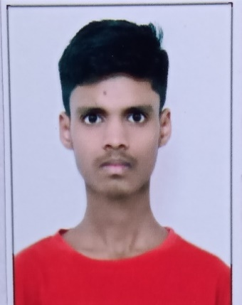
Appendix B

Kunal Padmakar Parkhade
Mobile No: 9307507914 Email: kunalparkhade@gmail.com DOB: 15-07-2004 Address: Prem Nagar, Nagpur
Academic Qualification:
Qualification | Institute | Year | Score
B. Tech 7th Sem | Yeshwantrao Chavan College of Engineering | 2025 | 8.03
B. Tech 6th Sem | Yeshwantrao Chavan College of Engineering | 2024 | 8.53
B. Tech 5th Sem | Yeshwantrao Chavan College of Engineering | 2024 | 8.47
B. Tech 4th Sem | Yeshwantrao Chavan College of Engineering | 2023 | 8.84
B. Tech 3rd Sem | Yeshwantrao Chavan College of Engineering | 2023 | 8.1
B. Tech 2nd Sem | Yeshwantrao Chavan College of Engineering | 2022 | 9.39
B. Tech 1st Sem | Yeshwantrao Chavan College of Engineering | 2022 | 8.52
Class XII (HSC) | Keshav Nagar Science Junior College, Nagpur | 2021 | 90.5
Class X (SSC) | Shri Rajendra High School | 2019 | 74.8

Skills: C/C++, Python, DSA, Git, SQL, Machine Learning, etc.

Projects:
  - Pencil Sketch Transformer: Designed a web-based app using Streamlit and OpenCV, enabling users to convert photos into pencil sketches with customizable options. Implemented a secure authentication system with Signup/Login validation to ensure data privacy. Delivered an intuitive user interface, increasing user engagement and ease of use with additional Download option.
  - Chatbot using Amazon Lex: Developed and deployed a functional chatbot using Amazon Lex with intents like WelcomeIntent and TransferFunds. Created a custom slot type and integrated it with the CheckBalance intent to gather user information before processing requests. Connected a chatbot with Lambda that facilitates managing servers without running code.


Abhijeet Sahu
Mobile No: 9922509022 Email: abhijeetbsahu@gmail.com DOB: 09-02-2003 Address: Manewada Road, Nagpur - 440027 Academic Qualification:
Qualification | Institute | Year | Score
B. Tech 7th Sem | Yeshwantrao Chavan College of Engineering | 2025 | 8.44
B. Tech 6th Sem | Yeshwantrao Chavan College of Engineering | 2024 | 7.96
B. Tech 5th Sem | Yeshwantrao Chavan College of Engineering | 2024 | 8.42
B. Tech 4th Sem | Yeshwantrao Chavan College of Engineering | 2023 | 8.82
B. Tech 3rd Sem | Yeshwantrao Chavan College of Engineering | 2023 | 9.52
B. Tech 2nd Sem | Yeshwantrao Chavan College of Engineering | 2022 | 9.47
B. Tech 1st Sem | Yeshwantrao Chavan College of Engineering | 2022 | 9.39
Class XII (HSC) | Radha Mahvidhyalaya | 2021 | 90.00
Class X (SSC) | Shahu’s Garden Convent | 2019 | 91.20

Skills: Python, C, R, SQL, Django, Flask, Tensorflow, Git, GitHub, VS Code, PyCharm, SQL, MongoDB

Projects:
- Django CRM Project: Developed a comprehensive Customer Relationship Management (CRM) system using Django and
Python to manage customer interactions and CRM functionalities.
Integrated MySQL database with Django, replacing the default SQLite, for better scalability and performance.
(HTML, CSS, Django, MYSQL)

- Hand Gesture Detection System Integrated with Flask: Developed an interactive web application using Flask for hand gesture recognition, leveraging a custom gesture dataset and Google Teachable Machine for model training. Improved skills in data collection and model training.
(Python, Flask, Tensorflow, Google Teachable Machine)


Manthan Lute

Mobile No: 7083404500 Email: lutemanthan@gmail.com
DOB: 06-05-2003 Address: Shivhshakti nagar, Manewada Road, Nagpur Academic Qualification:
Qualification | Institute | Year | Score
B. Tech 7th Sem | Yeshwantrao Chavan College of Engineering | 2025 | 7.71
B. Tech 6th Sem | Yeshwantrao Chavan College of Engineering | 2024 | 7.83
B. Tech 5th Sem | Yeshwantrao Chavan College of Engineering | 2024 | 7.24
B. Tech 4th Sem | Yeshwantrao Chavan College of Engineering | 2023 | 6.20
B. Tech 3rd Sem | Yeshwantrao Chavan College of Engineering | 2023 | 6.40
B. Tech 2nd Sem | Yeshwantrao Chavan College of Engineering | 2022 | 5.74
B. Tech 1st Sem | Yeshwantrao Chavan College of Engineering | 2022 | 7.02
Class XII (HSC) | Royal Gondwana High School | 2021 | 71
Class X (SSC) | Bhavans B.P Vidya Mandir | 2019 | 75

Skills: C/C++, Python, HTML,CSS,JS, SQL, DBMS, Front-End

Projects:
- Inventory Management System with POS: r an Inventory Management System with Point of Sale (POS) based on standard functionalities and the enhancements
Live Link: http://inventory.gristip.com/

- Real Estate Website: To develop a fully functional real estate website similar to 99 Acres and Magic Bricks that can be used to list and view properties in India as well as Dubai. The website as inbuilt features like loan calculator, referral system, cashback and bonus system, CRM functionalities.


Vedant Khursange
Mobile No: 9893757422 Email: khursangevedant@gmail.com

DOB: 22-11-2002 Address:Gurudev Ward, Pandhurna

Academic Qualification:
Qualification | Institute | Year | Score
B. Tech 7th Sem | Yeshwantrao Chavan College of Engineering | 2025 | 7.89
B. Tech 6th Sem | Yeshwantrao Chavan College of Engineering | 2024 | 7.29
B. Tech 5th Sem | Yeshwantrao Chavan College of Engineering | 2024 | 8.22
B. Tech 4th Sem | Yeshwantrao Chavan College of Engineering | 2023 | 6.39
B. Tech 3rd Sem | Yeshwantrao Chavan College of Engineering | 2023 | 7.15
B. Tech 2nd Sem | Yeshwantrao Chavan College of Engineering | 2022 | 7.66
B. Tech 1st Sem | Yeshwantrao Chavan College of Engineering | 2022 | 6.25
Class XII (HSC) | Macro Vision Academy,Burhanpur(CBSE) | 2021 | 85
Class X (SSC) | Ram Shanti Vidya Mandir, Pandhurna(CBSE) | 2019 | 87

Skills: Java, SQL, DSA, OPPs, DBMS, Web Development, Azure Cloud(Microsoft Certified)

Projects:

TaskWise: Systematic Management of Tasks in Remote Teams
Developed a MERN stack web app for efficient task assignment and collaboration in remote teams. Focused on front-end development with React and integrated it with backend features like user and task management.
(Technologies Used: MongoDB, Express.js, React, Node.js, Redux Toolkit, Tailwind CSS)

Live Link - https://taskwise-app.netlify.app/dashboard

Multi-Vendor E-commerce Platform
Built the customer-facing frontend of a multi-vendor e-commerce site using React and TypeScript. Integrated backend APIs and implemented the Razorpay payment workflow.
(Technologies Used: React (TypeScript), Redux Toolkit , Razorpay, Spring Boot, MySQL, Spring Security)


Divyani Thakare
Mobile No: 9145754461 Email: divyanit303@gmail.com

DOB: 30-03-2003 Address: Shri nagar colony ,Sakoli

Academic Qualification:
Qualification | Institute | Year | Score
B. Tech 7th Sem | Yeshwantrao Chavan College of Engineering | 2025 | 7.16
B. Tech 6th Sem | Yeshwantrao Chavan College of Engineering | 2024 | 6.66
B. Tech 5th Sem | Yeshwantrao Chavan College of Engineering | 2024 | 7.14
B. Tech 4th Sem | Yeshwantrao Chavan College of Engineering | 2023 | 7.26
B. Tech 3rd Sem | Yeshwantrao Chavan College of Engineering | 2023 | 7.40
B. Tech 2nd Sem | Yeshwantrao Chavan College of Engineering | 2022 | 7.82
B. Tech 1st Sem | Yeshwantrao Chavan College of Engineering | 2022 | 7.81
Class XII (HSC) | St.Xavier’s High School, Nagpur (CBSE) | 2021 | 70.4
Class X (SSC) | Royal Public School, Bhandara(CBSE) | 2019 | 82.4

Skills: C, C++, Java, DS, SQL, OOPs, Web Development

Projects:

Weather Dashboard

This project is a responsive Weather Dashboard web application that fetches and displays real-time weather data for any city entered by the user. Built using HTML, CSS, and JavaScript, the application integrates the OpenWeatherMap API to retrieve current weather conditions such as temperature, weather description, humidity, and wind speed. When a user inputs a city name and clicks the "Get Weather" button, the application sends a request to the API and dynamically updates the webpage with the latest weather information.

Live Link:-https://github.com/Divyani-30/Task1-API-Integration

Chat Application

This project is a real-time web-based chat application developed using Node.js, Express, and Socket.IO. It allows multiple users to join a chat room, exchange messages instantly, and see live updates without refreshing the page. The front-end interface is built using HTML, CSS, and JavaScript, offering a clean and responsive user experience. The real-time communication is powered by Socket.IO, which enables bi-directional WebSocket connections between the client and server.

SOCIETAL IMPACT OF THE PROJECT

Societal Impact of Project

Introduction

In today’s increasingly digital and multilingual society, addressing public grievances effectively is more important than ever. Traditional complaint redressal systems, especially in educational institutions and public sector organizations, are often plagued with inefficiencies—long processing times, manual misrouting, and a lack of linguistic inclusivity. These challenges undermine the core objective of a feedback system: to listen, respond, and improve based on user experiences.

Our final year project, "Automated Routing and Classification of Customer Complaints Drafted in Multiple Languages," stands at the intersection of machine learning, natural language processing (NLP), and social impact. By automating the categorization and forwarding of complaints to the appropriate departments—regardless of whether they are written in English, Hindi, or other regional languages—this system creates a more inclusive, efficient, and responsive feedback ecosystem. This innovation is not just technical; it addresses real-world societal challenges of communication barriers, departmental inefficiencies, and digital exclusion.

Technological Empowerment and Accessibility

The project empowers technology to bridge the language gap—a critical barrier in multilingual countries like India. Many citizens, students, and stakeholders may feel more comfortable expressing concerns in their native language, yet most complaint systems still cater to English or a dominant regional language. By integrating multilingual processing capabilities, our system democratizes access to services, ensuring that no voice goes unheard due to language constraints.

This technological inclusiveness enhances user trust and satisfaction. When individuals feel they can communicate in the language they are most fluent in, they are more likely to report issues accurately and timely. It also reduces the cognitive load on users, especially those from rural or non-English-speaking backgrounds, making systems more approachable and humane.

Incorporating Natural Language Processing for classification further empowers back-end operations. Departments receive only the complaints relevant to them, reducing human error and the time spent manually sorting grievances. This automation enables faster response times and better accountability, contributing to an ecosystem of continuous improvement.

Institutional and Governmental Efficiency

From an organizational perspective, this system strengthens the operational efficiency of institutions—be it universities, municipal bodies, or corporations. Routing complaints correctly not only saves time but also optimizes resource allocation. For instance, the administrative department isn’t overwhelmed with technical issues, and vice versa, resulting in a more focused and effective problem-resolution process.

When deployed at scale in public institutions, the system aligns well with Digital India and e-Governance initiatives. Many government platforms encourage feedback, yet the handling process is often bogged down by delays and mismanagement. Automating routing and enabling linguistic diversity directly supports goals of transparency, responsiveness, and smart governance.

Moreover, the proposed solution can significantly reduce the dependency on intermediaries or manual translation, which often introduce bias, delays, or inaccuracies. By empowering the system itself to interpret and sort complaints, you reduce friction, corruption, and inefficiencies within bureaucratic processes.

Inclusivity and Social Equity

One of the most profound societal impacts of this project lies in promoting social equity. Language should never be a barrier to justice, feedback, or service delivery. Our project recognizes the socio-linguistic diversity of a population and ensures that the system caters to everyone—not just the English-literate elite.

This approach is particularly transformative for marginalized communities and older individuals who may not be comfortable using English or navigating complex complaint systems. As a result, it amplifies the voices of those traditionally underrepresented in decision-making processes, strengthening participatory governance and inclusive development.

Also, by applying AI ethically and effectively, this project sets an example of how automation can be used for empowerment rather than exclusion. It illustrates how AI, when thoughtfully designed, can serve real social needs rather than being restricted to elite or commercial applications.

Future Readiness and Scalability

In a world rapidly moving toward digital-first interactions, your project lays the groundwork for scalable, future-ready systems. It can be expanded beyond colleges to cover civic complaints, healthcare feedback, transportation systems, and more. With growing adoption of chatbots, AI assistants, and digital portals, the underlying framework of your project can seamlessly integrate with modern platforms and serve as a modular plug-in.

Furthermore, with the rise in regional content and voice-based systems, the integration of speech-to-text engines in local languages could be a natural evolution of your model, further enhancing accessibility and usability.

Conclusion

In conclusion, your final year project doesn’t merely solve a technical problem—it offers a socially transformative solution. By automating the routing and classification of multilingual complaints, the system strengthens inclusivity, enhances efficiency, and bridges institutional gaps. It empowers users from diverse backgrounds to voice concerns confidently and ensures those concerns reach the right place at the right time. As digital platforms become the cornerstone of public interaction, your work contributes to building a more inclusive, responsive, and just society. This project exemplifies how engineering and data science can—and should—serve the greater good.

Preliminary Investigation Report (PIR)
Title of the Project:
AUTOMATED ROUTING AND CLASSIFICATION OF CUSTOMER COMPLAINTS
Area of Project Work:
The area of this project is
- Natural Language Processing
- Multilingual Text Classification (English – Hindi)
- Intelligent Complaint Routing via Email Automation
- AI Applications in Educational Administration
Problem Statement:
In many academic institutions, the process of handling student and staff complaints is manual, inefficient, and often language-restrictive, leading to delays, misrouting, and lack of accountability. Existing systems are not equipped to process complaints written in regional languages like Hindi, nor do they support automated routing to relevant departments. There is a need for an intelligent, multilingual system that can accurately classify complaints written in both English and Hindi and automatically route them to the appropriate department via email, thereby improving the efficiency, inclusivity, and responsiveness of institutional grievance redressal mechanisms.
Literature Review (Based on Latest Papers):
Title of Paper | Details of Publication with Date and Year | Literature Identified for Project
Automatic Classification of Railway Complaints using Machine Learning | E3S Web of Conferences, January 16, 2024 | Pre-processed the data to extract relevant features. Trained and evaluated several machines learning models, including  Support Vector Machine and Random Forest, to classify the complaints into different categories. SVM and a voting classifier, achieving around 75% accuracy and high reliability.
Part-of-speech tagging for extremely low-resource Indian languages | Findings of the Association for Computational Linguistics: ACL 2024, August 2024 | i) Proposed a look-back scheme to reduce tokenization errors in low-resource languages. ii) Helps develop parallel datasets with higher-resource languages like Hindi.
Artificial Intelligence for Customer Complaint Management | International Journal of Computer Trends and Technology,  March 1 – March 6 2023 | i) The system will be trained and tested. ii)The system's performance will be measured using metrics  such as accuracy of classification, response time, and customer satisfaction level.
Prediction and Analysis of Customer Complaints Using Machine Learning Techniques | International Journal of E-Business Research, March 10 2023 | Methodology used  i) Filtered dataset. ii) Data Preprocessing iii) Feature transformation iv) Training-Testing v) TF-IDF to transform  the categorical text into numerical data.
NLP based Grievance Redressal System | International Journal of Computer Applications, May 2022 | i) Data Processing ii) Feature Extraction iii) Tweets are then classified in respective classes (positive and negative)  using Naïve Bayes, Regression and Correlation.
Civil Complaints Management System by using Machine Learning Techniques | International Research Journal of Engineering and Technology (IRJET), June 2021 | The raw data were provided in Excel format by the IT department of the Bojnourd municipality. Preprocessing includes Tokenization, Tfidf Transformer and Stemming. Random Forest Classifier categorizes complaints. TextBlob computes polarity scores (-1 to +1) to analyze sentiment of complaints.
E-mail classification with machine learning and word embeddings for improved customer support | Neural Computing and Applications, March 01, 2021 | Methodology Used  i) Preprocessing ii) Bag of Words iii) Word2Vec iv) Classification
AI4Bharat-IndicNLP Corpus: Monolingual Corpora and Word Embeddings for Indic Languages | arXiv, April 30 2020 | i) Text Processing ii) Train pre-trained Word Embeddings iii) Word Similarity & Analogy Evaluation iv) Text Classification Evaluation

Current Limitations:
- No solution exists for Routing of Complaints in terms of any organization perspective.
- There are multilingual pretrained models exist but not any domain complaint specific.
- Existing solutions stop at categorization.
- Our solution considers multilingual complaints so that there will be no lack of communication.
- Our proposed solution includes email routing so that the appropriate authority will get the concerned complaint email.
Proposed Solution:

Objective and Scope of Work
Objectives:
- Accept complaints written in several languages.
- Accurately classify complaints into relevant departments.
- Automate the routing of classified complaints via email to the respective department.
- Enhance the efficiency, inclusivity, and accessibility of the grievance redressal process using Natural Language Processing and automation techniques.

Scope of Work:
- Implementing Natural Language Processing (NLP) techniques for text preprocessing and classification.
- Developing a machine learning-based model to classify complaints into predefined categories.
- Automating the routing of complaints through email based on the predicted category.
- Evaluating the system’s accuracy, efficiency, and reliability in real-world use cases.

Feasibility Assessment:
- Expected Outcomes of the Project
- A multilingual complaint classification system tailored for academic institutions.
- An automated email routing module that forwards complaints to the respective department based on classification results.
- A complete end-to-end solution deployable for real-world use in college-level grievance systems.
- Improved efficiency and responsiveness in complaint redressal processes.
- Innovation Potential
- Integration of regional language (Hindi) support in automated grievance redressal systems.
- Use of Natural Language Processing (NLP) for complaint classification in different languages.
- Novel automation layer that routes classified complaints directly via email to appropriate authorities.
- Application of machine learning and linguistic models to institutional administration.
- Scalable model architecture that can be adapted to other regional languages or sectors.
- Tasks Involved
- Dataset creation and labelling.
- Preprocessing and normalization.
- Embedding generation for semantic understanding.
- Model development for text classification.
- Integration of classification model with email automation scripts.
- Testing, validation, and refinement of the system.
- Documentation and preparation of thesis/poster.
- Expertise Required
- In-House Expertise
- Natural Language Processing
- Python Programming
- Machine Learning model training and evaluation
- Email automation using SMTP libraries
- Dataset annotation and preprocessing
- Report writing and academic documentation
- External Expertise
- Language translation and linguistic support for Hindi inputs.
- Facilities Required
- In-House Facilities
- Development environment (Jupyter Notebook / Google Colab)
- Access to email services (Gmail SMTP)
- Python libraries: scikit-learn, etc.
- External Facilities
- Email server access for testing automated routing
- Language resources or translators for multilingual data validation.

Milestones and Time Plan
 | Task | JULY  2020 | AUG  2020 | SEP  2020 | OCT  2020 | NOV  2020 | DEC  2020 | JAN  2021 | FEB  2021 | MAR  2021 | APR  2021
Design | Conceptual Design
Design | Detailed design
Design | Design Modifications
Design | Final Design
Develop | Procurement  (If any)
Develop | Prototyping
Develop | Modifications
Deliver | Testing and Validation
Deliver | Final Modifications
Deliver | IPR / patent draft
Deliver | Thesis and Poster

