These are the questions you need to ask your system and in your GitHub repository please share screenshots of your system answers along with citations.

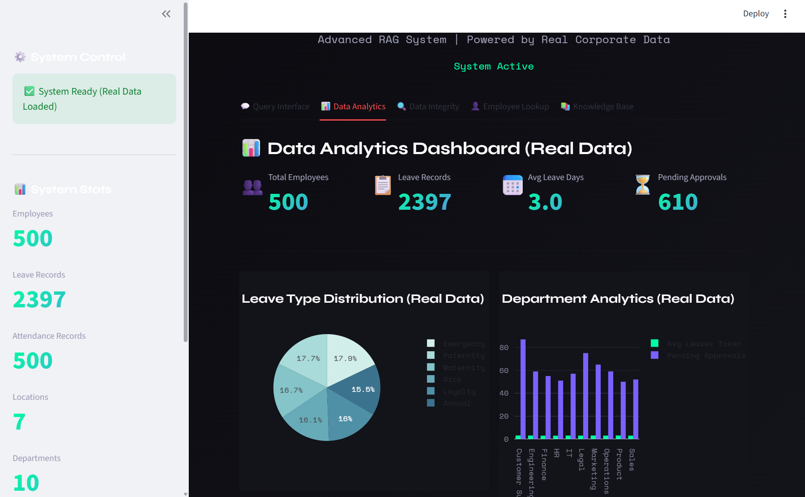
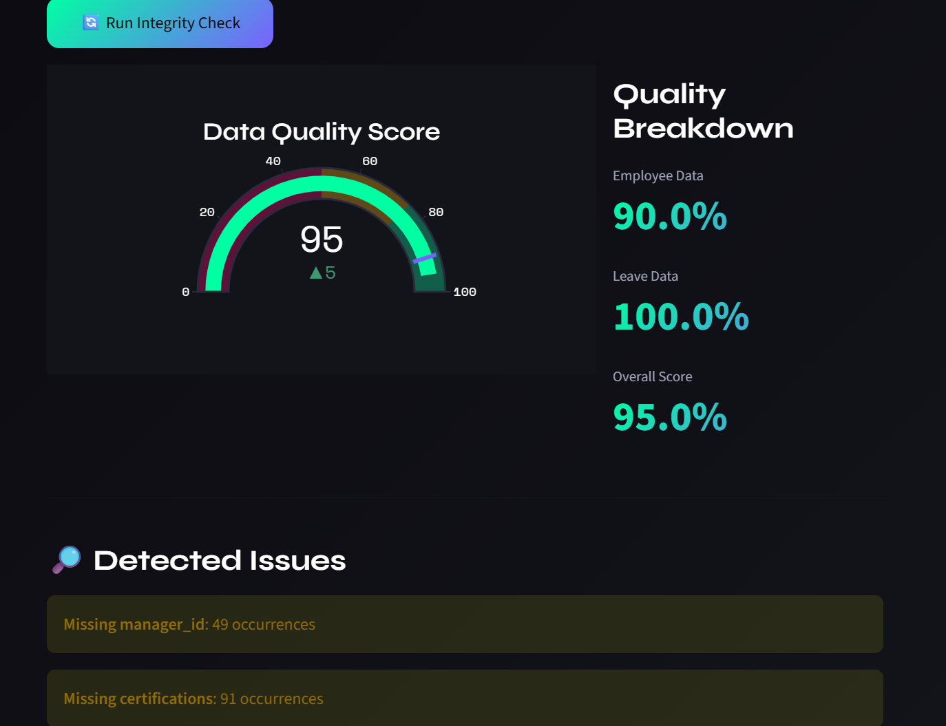
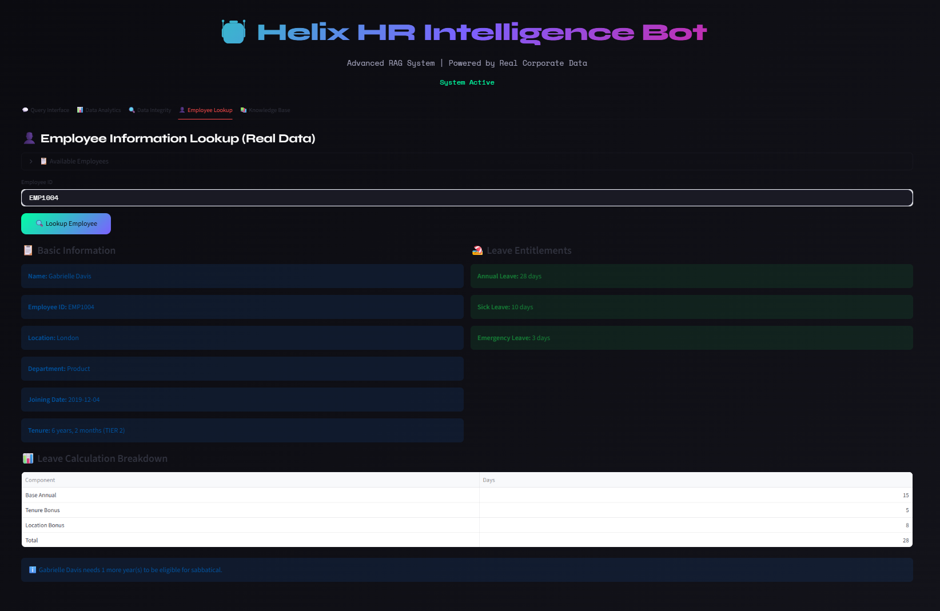
Question 1: Multi-Step Tenure Calculation
"I am Gabrielle Davis (EMP1004). Based on the 2026 policy and my specific joining date, exactly how many total days of annual leave am I entitled to this year? Please show your calculation."
=
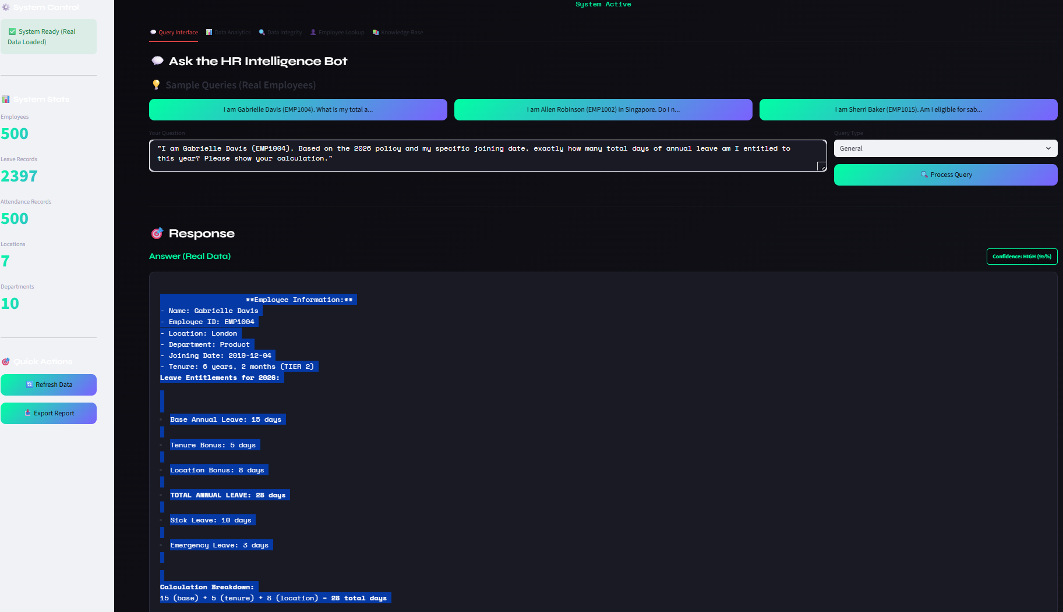

Question 2: Regional Policy Conflict
"I am Allen Robinson (EMP1002). I am feeling unwell today in my Singapore home. If I take only today off as sick leave, do I need to submit a medical certificate when I return, or can I wait until I’ve been out for more than two days?"
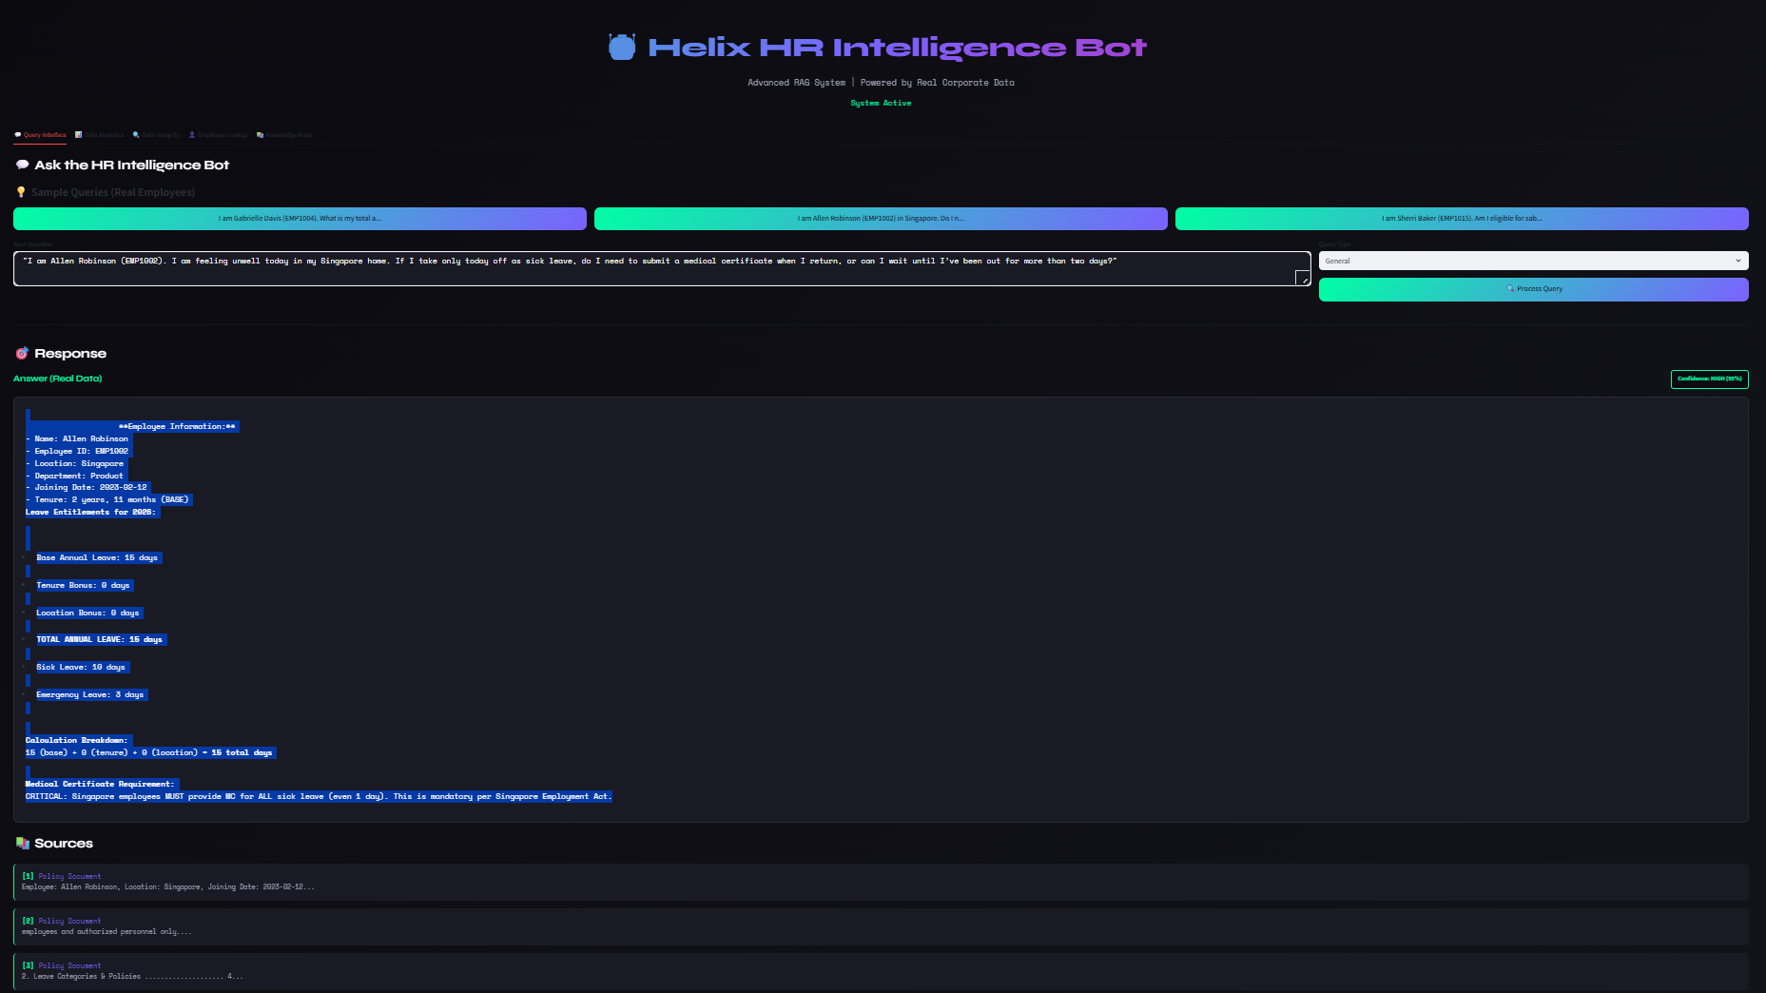
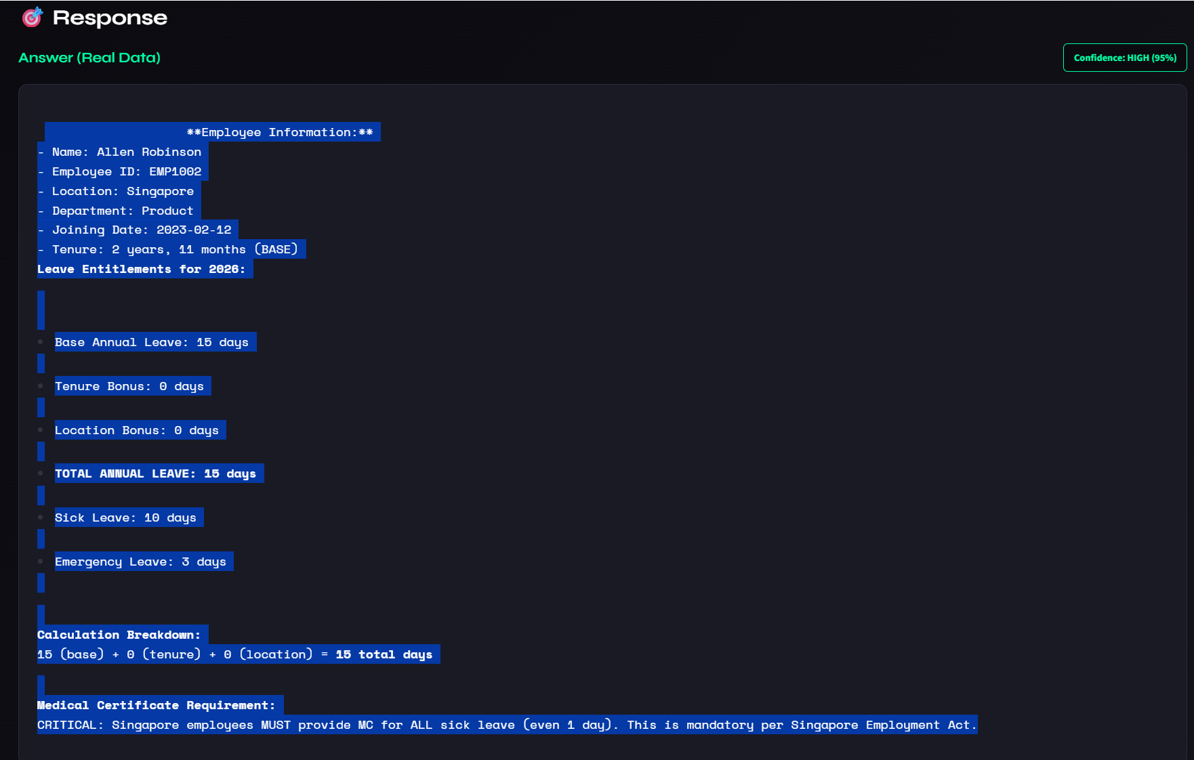
Question 3: Disciplinary Logic & Thresholds
"Looking at the attendance policy, what is the specific penalty for an employee who has 6 instances of missing check-out entries in a single calendar month, and how often does this count reset?"
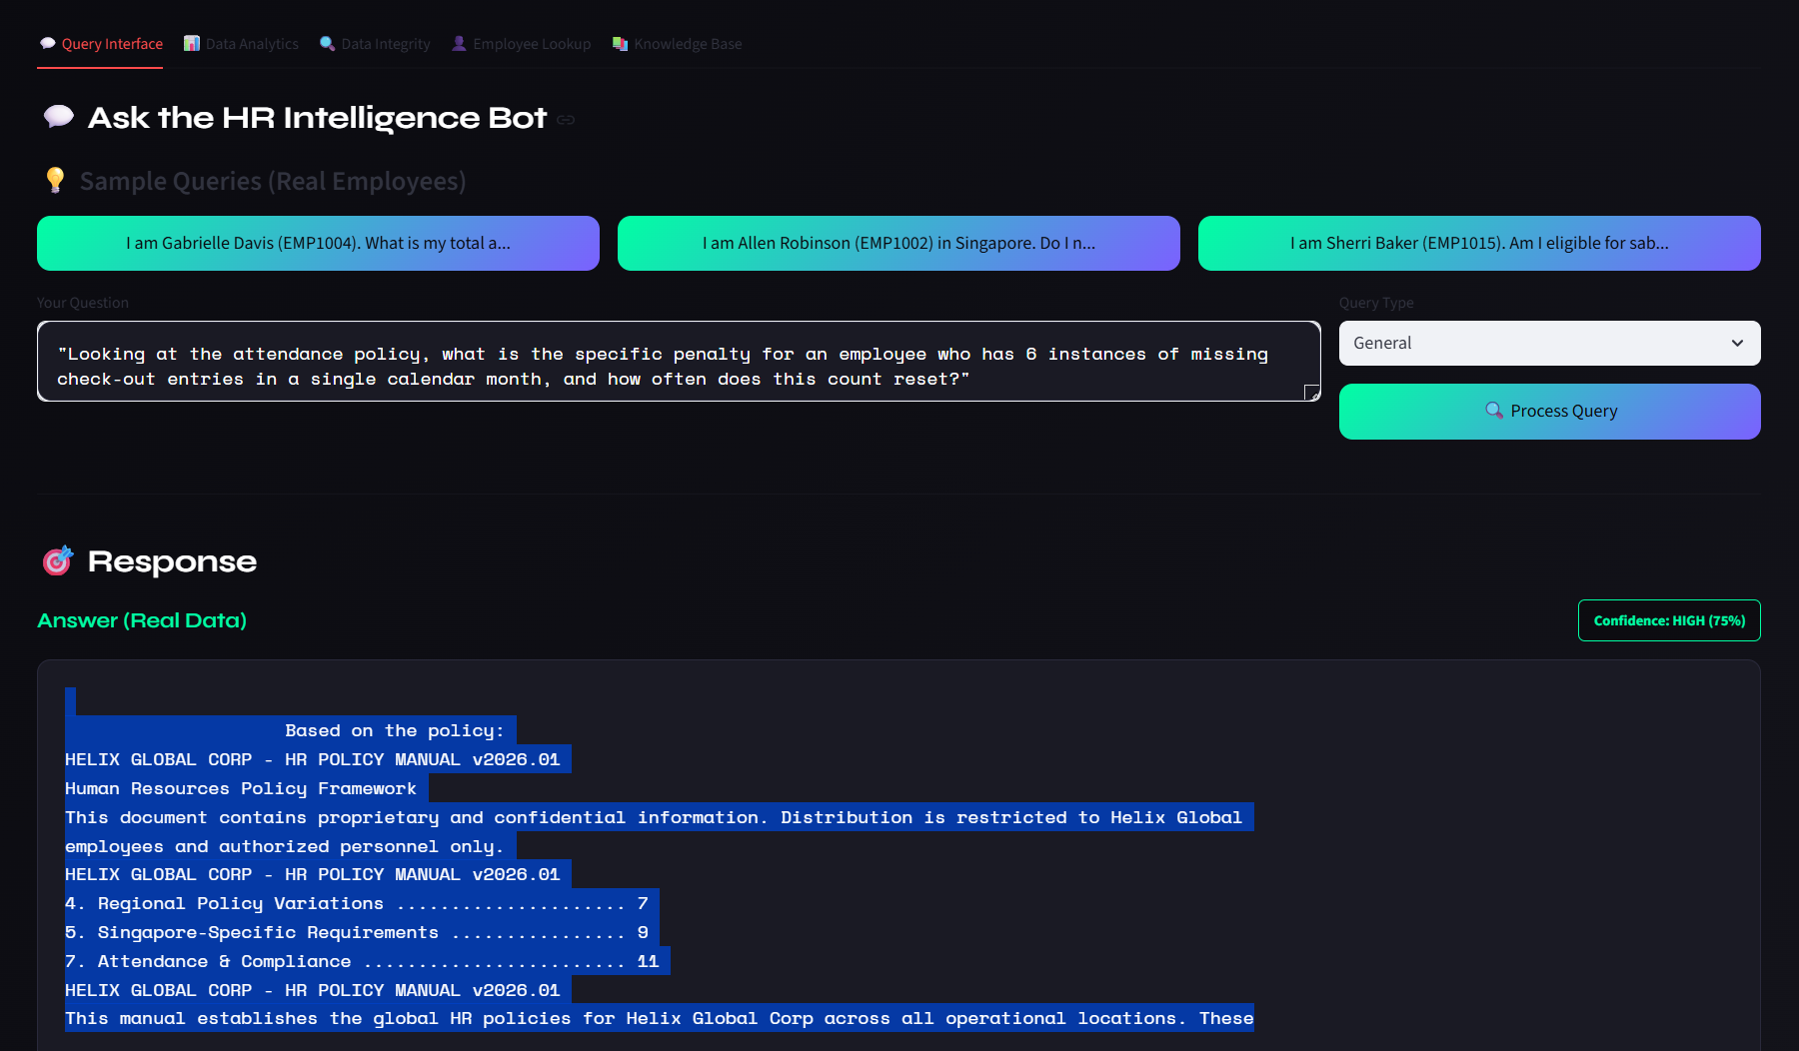
Question 4: Benefits & Temporal Constraints
"I am Sherri Baker (EMP1015). I have been with Helix Global since early 2018 and work in the Sydney office. Am I eligible to apply for the sabbatical program right now (February 2026)? If so, what is the application process?"
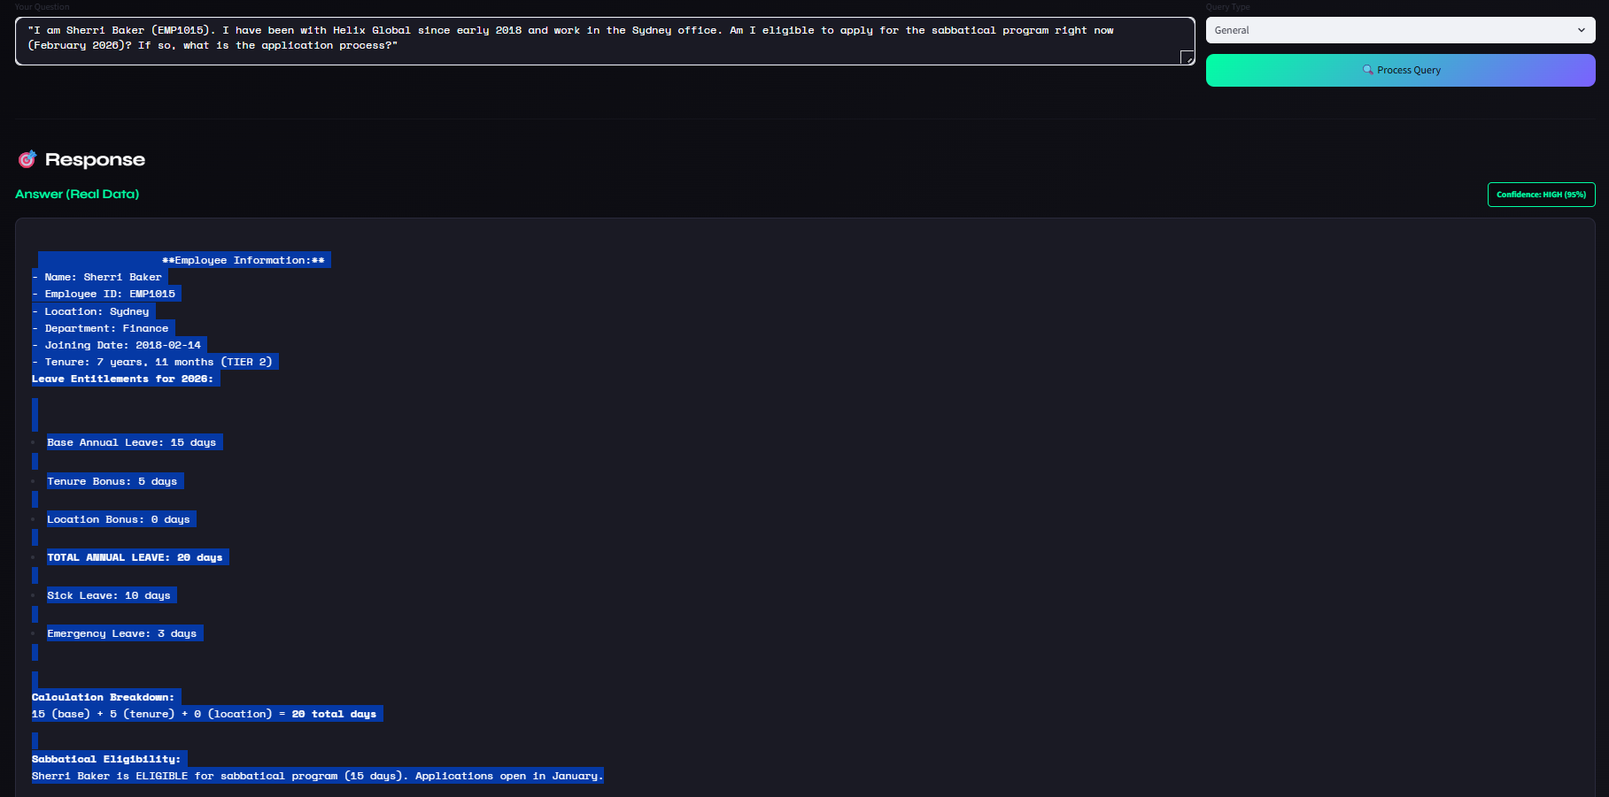
Question 5: Location-Specific Provisions
"I am Thomas Bradley (EMP1010). Since I work in the London office, what is my total leave entitlement including bank holidays, and do I need to submit a formal request for those specific bank holiday dates?"
