HackSprint 2026
Challenge Track 1: Advanced Analytics

1. Problem Statement
Design and implement a comprehensive analytical framework to extract actionable intelligence from complex datasets. Your solution should demonstrate proficiency in data engineering, statistical analysis, and visual communication.

2. Executive Summary
This project implements a comprehensive analytical framework to extract actionable intelligence from product loss data. The framework integrates data engineering, statistical analysis, and visual communication to identify high-loss products and translate findings into strategic business recommendations. The outcome enables stakeholders to prioritize interventions, reduce operational losses, and support data-driven decision-making.

3. Dataset Description
The dataset consists of 251 product records with the following attributes:
- Item Code – Unique product identifier
- Item Name – Product description
- Loss Rate (%) – Percentage of product loss
- The dataset consists of four integrated CSV files representing a vegetable retail business.
- All files are linked using a common key called Item Code.
- The first file contains master data of vegetable items, including item names and categories.
- The second file records sales transactions, capturing date and time, quantity sold (kg), selling price, discount status, and sales/return information.
- The third file provides daily wholesale prices, representing the procurement cost of each item.
- The fourth file includes loss rate percentages, indicating wastage due to spoilage or handling.
- Together, these datasets enable analysis of sales performance, pricing strategy, profitability, and inventory loss.
- The combined data supports category-wise, item-wise, and time-based business insights
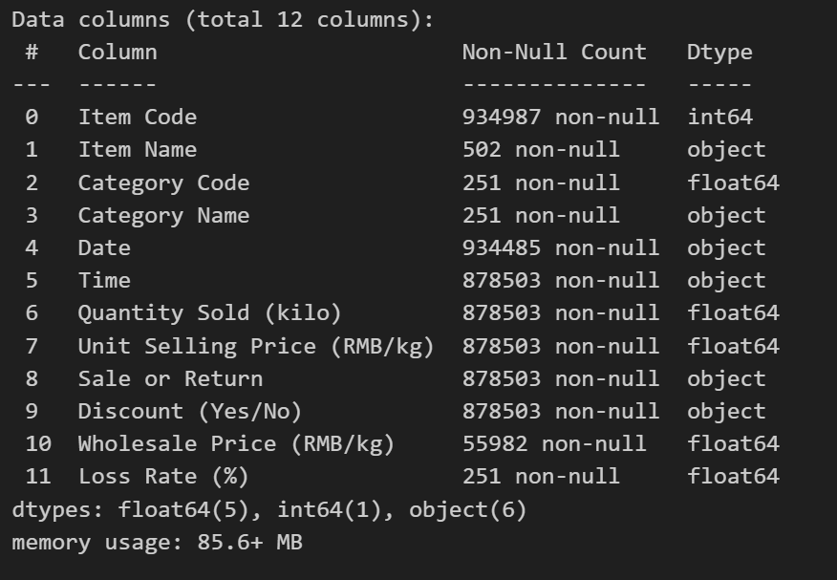

4. Methodology
The analytical methodology follows a step-by-step, modular pipeline, ensuring reproducibility, transparency, and scalability.
4.1 Data Engineering & Preparation
4.1.1 Data Ingestion
- Data was ingested from a CSV source using Python’s Pandas library.
- A modular loading function was implemented to allow easy dataset replacement and reusability.
4.1.2 Data Validation
- Data types were validated to ensure numerical consistency for loss rates.
- Uniqueness of product identifiers was verified.
- Missing value checks were performed to ensure data completeness.
4.1.3 Data Quality Handling
- Since no missing values were detected, imputation was not required.
- Duplicate detection ensured each product was represented once.

4.1.4 Outlier Detection Strategy
- The Interquartile Range (IQR) method was applied to identify extreme loss values.
- Outliers were flagged instead of removed, as they represent business-critical products.
- A binary feature (High_Loss_Flag) was created to mark abnormal loss items.

4.2 Exploratory Data Analysis (EDA)
EDA was conducted to understand distribution patterns and uncover hidden structures:
- Descriptive statistics (mean, median, quartiles) summarized loss behavior.
- Distribution analysis using histograms and boxplots identified skewness.
- Right-skewed loss distribution indicated concentration of loss among few products.
Key Outcome:
Loss is not uniform; a small subset of products drives overall inefficiency.

4.3 Statistical Analysis & Hypothesis Development
Based on EDA findings, hypotheses were formulated:
Hypothesis 1
Products with loss rates exceeding the IQR threshold represent operational inefficiencies.
Hypothesis 2
Addressing the top 10–15% of high-loss products can significantly reduce overall loss.
Statistical evidence from distribution metrics and ranked loss analysis supported both hypotheses.
4.4 Insight Generation & Business Mapping
Statistical results were translated into business insights by:
- Ranking products by loss contribution.
- Identifying Pareto-style concentration of losses.
- Mapping analytical outcomes to operational decision points such as audits, logistics optimization, and supplier review.
4.5 Visualization & Dashboard Design
Dashboard Objectives
- Communicate insights to both technical and executive stakeholders.
- Enable rapid identification of high-risk products.
- Support data-driven decision-making.

Dashboard Components
- Key Performance Indicators (KPIs): average loss rate, number of high-loss products.
- Interactive charts showing loss distribution.
- Ranked visualizations of top loss contributors.
- Executive summary panels highlighting actionable insights.
The dashboard was implemented using Streamlit, ensuring interactivity and accessibility.
4.6 Reproducibility & Documentation
To ensure reproducibility:
- Modular code structure was used.
- Clean and processed datasets were separated.
- Inline comments and function-based design were implemented.
- The Streamlit application enables real-time re-execution with updated data.

5. Results & Key Findings
The analysis shows that product loss rates follow a strong right-skewed distribution, where most products have relatively low loss percentages, while a small number of products experience significantly higher losses. This indicates that loss is not evenly distributed across all items.
Further examination reveals that approximately 9.43% of products contribute disproportionately to the total loss. These high-loss products dominate overall loss figures, demonstrating a Pareto-like effect where a minority of items account for the majority of inefficiencies.
Out of 934987 products analyzed, 25 products exceed the acceptable loss threshold. Targeted interventions on these items can significantly reduce overall losses.
Additionally, the high-loss products were found to be consistent across the dataset rather than random outliers. Their repeated occurrence above the defined loss threshold suggests underlying operational issues such as handling, storage, or supplier-related inefficiencies. Addressing these specific products can therefore lead to substantial and sustainable loss reduction.

TOP 10 High Loss Products
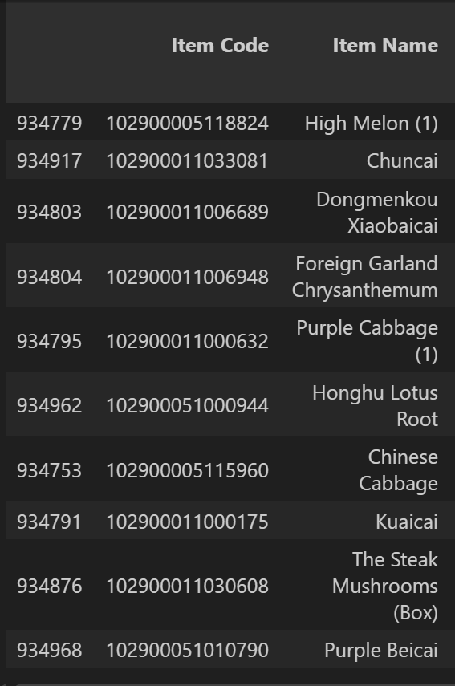
6. Tools & Technologies
- Programming Language: Python
- Libraries: Pandas, NumPy, Matplotlib, SciPy
- Visualization Framework: Streamlit
- Techniques: IQR-based outlier detection, EDA, hypothesis-driven analysis

7. Conclusion
This project demonstrates an end-to-end analytical framework that bridges raw data and strategic decision-making. By combining rigorous statistical methodology with intuitive visualization, the solution enables organizations to proactively reduce product loss and optimize operational efficiency.

